***version: 1.1***

# CHAPTER 1 FUNCTIONS AND LIMITS

*Animation 1.1: Function Machine*

*Source and credit:* [*eLearn.Punjab*](http://elearn.punjab.gov.pk/)

**1. Quadratic Equations eLearn.Punjab 1. Quadratic Equations eLearn.Punjab *1. Functions and Limits eLearn.Punjab 1. Functions and Limits eLearn.Punjab***

## 1.1 INTRODUCTION

Functions are important tools by which we describe the real world in mathematical terms. They are used to explain the relationship between variable quantities and hence play a central role in the study of calculus.

### **1.1.1 Concept of Function**

The term **function** was recognized by a German Mathematician **Leibniz** (1646 - 1716) to describe the dependence of one quantity on another. The following examples illustrates how this term is used:

1. The area “*A*” of a square depends on one of its sides “*x*” by the formula *A* = *x*2, so we say that *A* is a function of *x*.
2. The volume “ *V* ” of a sphere depends on its radius “*r*” by the formula V = p*r*3, so we say that *V* is a function of *r*.

A function is a **rule** or **correspondence**, relating two sets in such a way that each element in the irst set corresponds to one and only one element in the second set.

Thus in, (i) above, a square of a given side has only one area.

And in, (ii) above, a sphere of a given radius has only one volume. Now we have a formal deinition:

### **1.1.2 Deinition (Function - Domain - Range)**

A **Function** *f* from a set *X* to a set *Y* is a rule or a correspondence that assigns to each element *x* in *X* a unique element *y* in *Y*. The set *X* is called the **domain** of *f*.

The set of corresponding elements *y* in *Y* is called the **range** of *f*.

Unless stated to the contrary, we shall assume hereafter that the set *X* and *Y* consist of real numbers.

### **1.1.3 Notation and Value of a Function**

If a variable *y* depends on a variable *x* in such a way that each value of *x* determines exactly one value of *y*, then we say that **“*y* is a function of *x*”**.

Swiss mathematician Euler (1707-1783) invented a symbolic way to write the statement “*y* is a function of *x*” as *y* = *f*(*x*) , which is read as “*y* is equal to *f* of *x*”.

**Note:** Functions are often denoted by the letters such as *f, g, h , F, G, H* and so on.

A function can be thought as a computing machine *f* that takes an input *x*, operates on it in some way, and produces exactly one output *f*(*x*). This output *f(x)* is called the value of *f* at *x* or image of *x* under *f.* The output *f*(*x*) is denoted by a single letter, say *y*, and we write *y* = *f*(*x*).

The variable *x* is called the **independent variable** of *f*, and the variable *y* is called the **dependent variable** of *f*. For now onward we shall only consider the function in which the variables are real numbers and we say that *f* is a **real valued function of real numbers**.

4

3

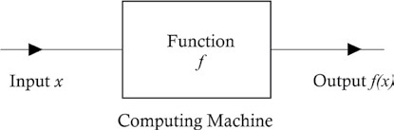

**Example 1:** Given *f*(*x*) = *x*3 - 2*x*2 + 4*x* - 1, ind

(i) *f*(0) (ii) *f*(1) (iii) *f*(-2) (iv) *f*(1 + *x*) (v) *f*(1/*x*), *x* ≠ 0

**Solution:** *f*(*x*) = x3 - 2*x*2 + 4*x* - 1

(i) *f*(0) = 0 - 0 + 0 - 1 = - 1

1. *f*(1) = (1)3 - 2(1)2 + 4(1) - 1 = 1 - 2 + 4 -1 = 2
2. *f*(-2) = (- 2)3 - 2 (-2 )2 + 4 (-2) - 1 = - 8 - 8 - 8 - 1 = -2 5
3. *f*(1 + *x*) = (1 + *x*)3 -2(1 + *x*)2 + 4(1 + *x*)- 1

= 1 + 3*x* + 3*x*2 + *x*3 - 2 - 4*x* - 2*x*2 + 4 + 4*x* - 1 = *x*3 + *x*2 + 3*x* + 2

### 2 3

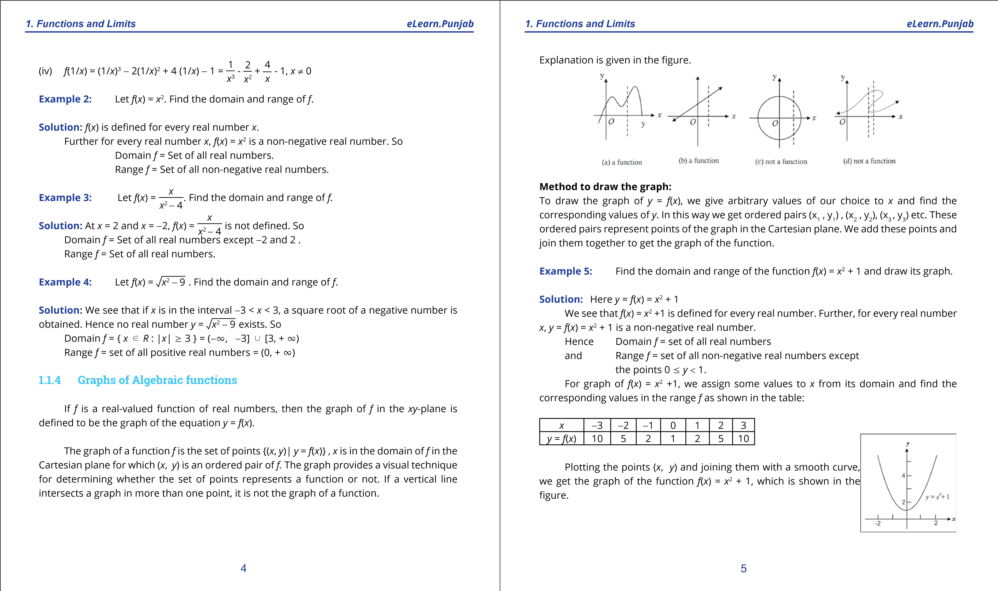

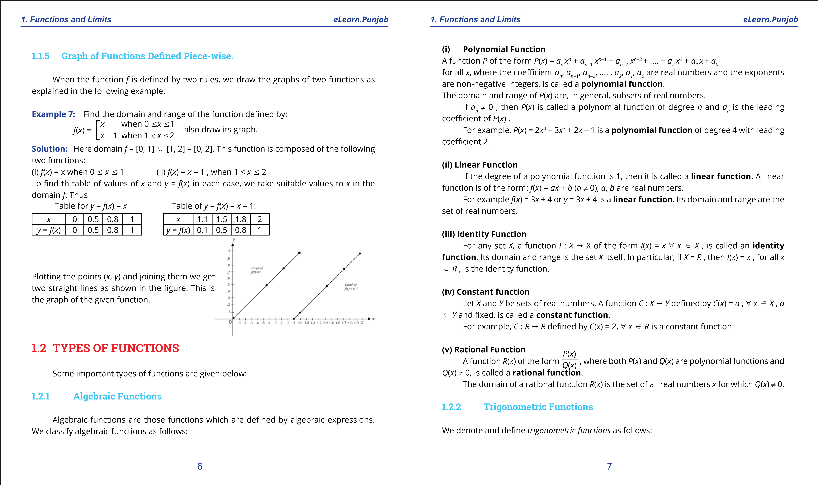

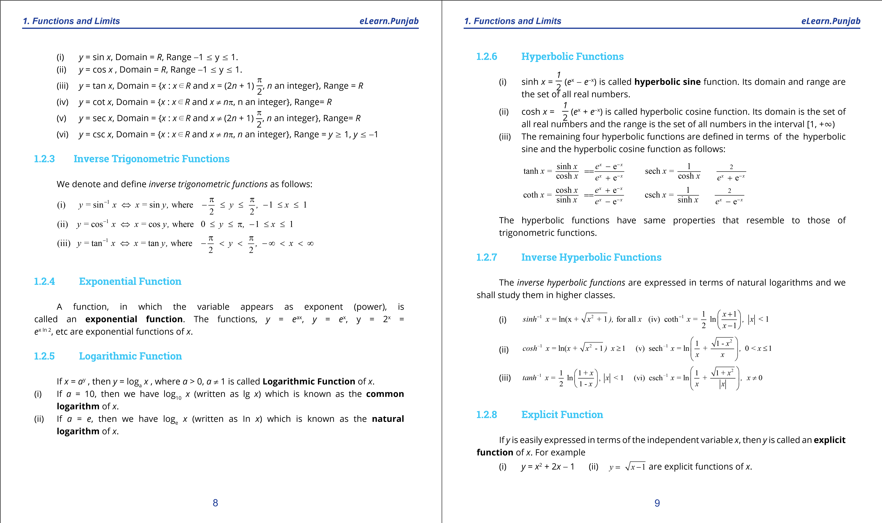

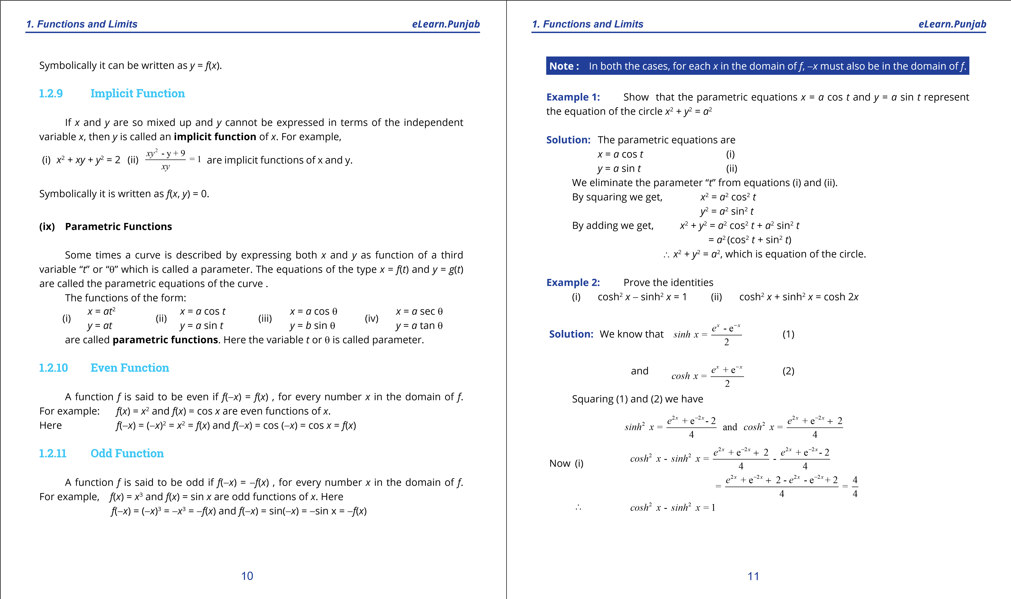

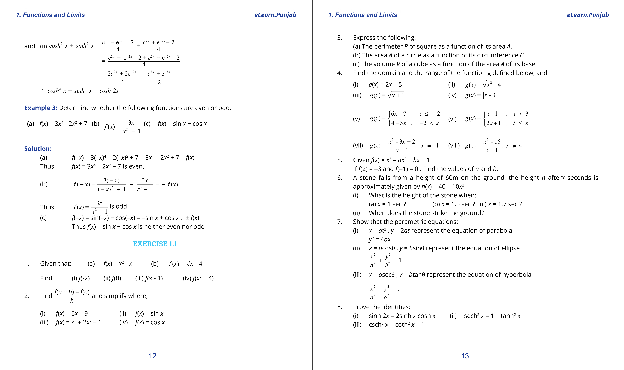

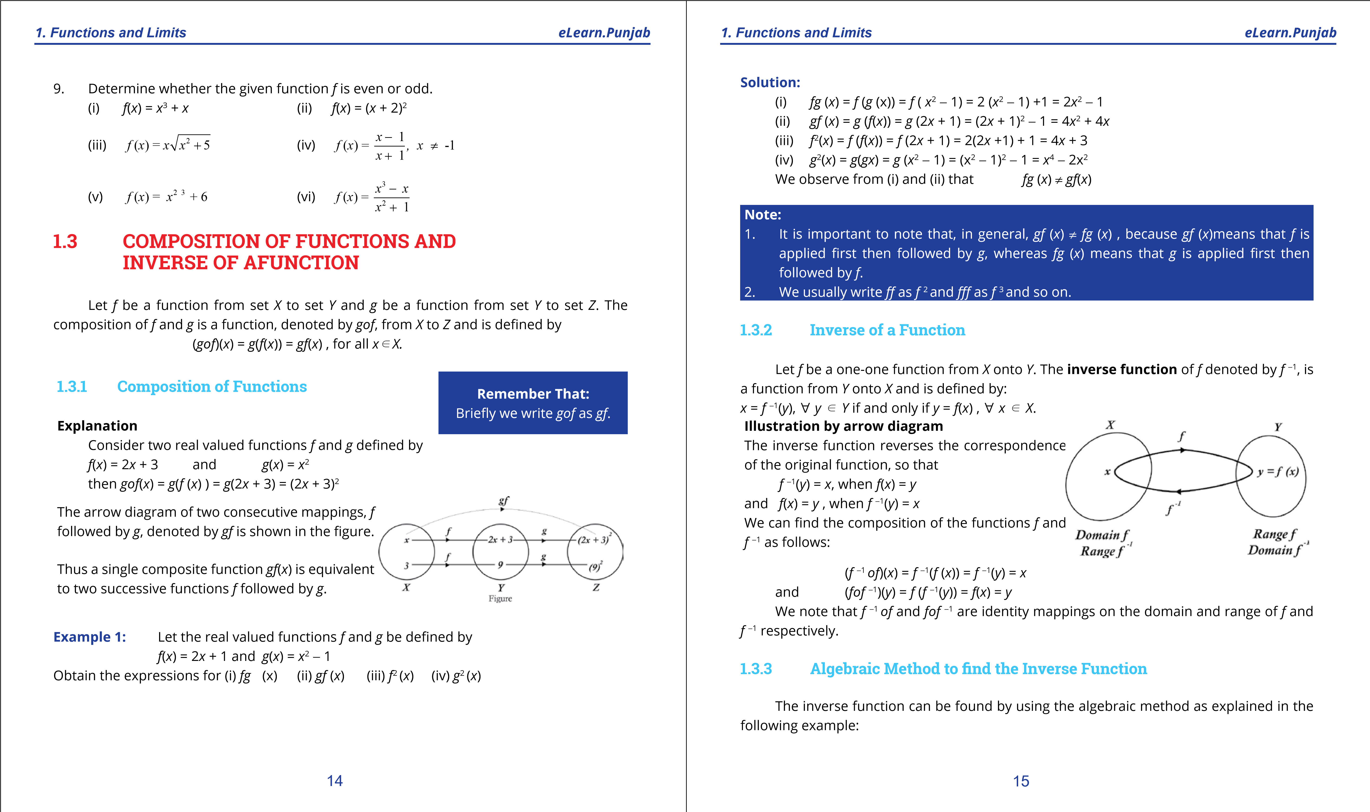

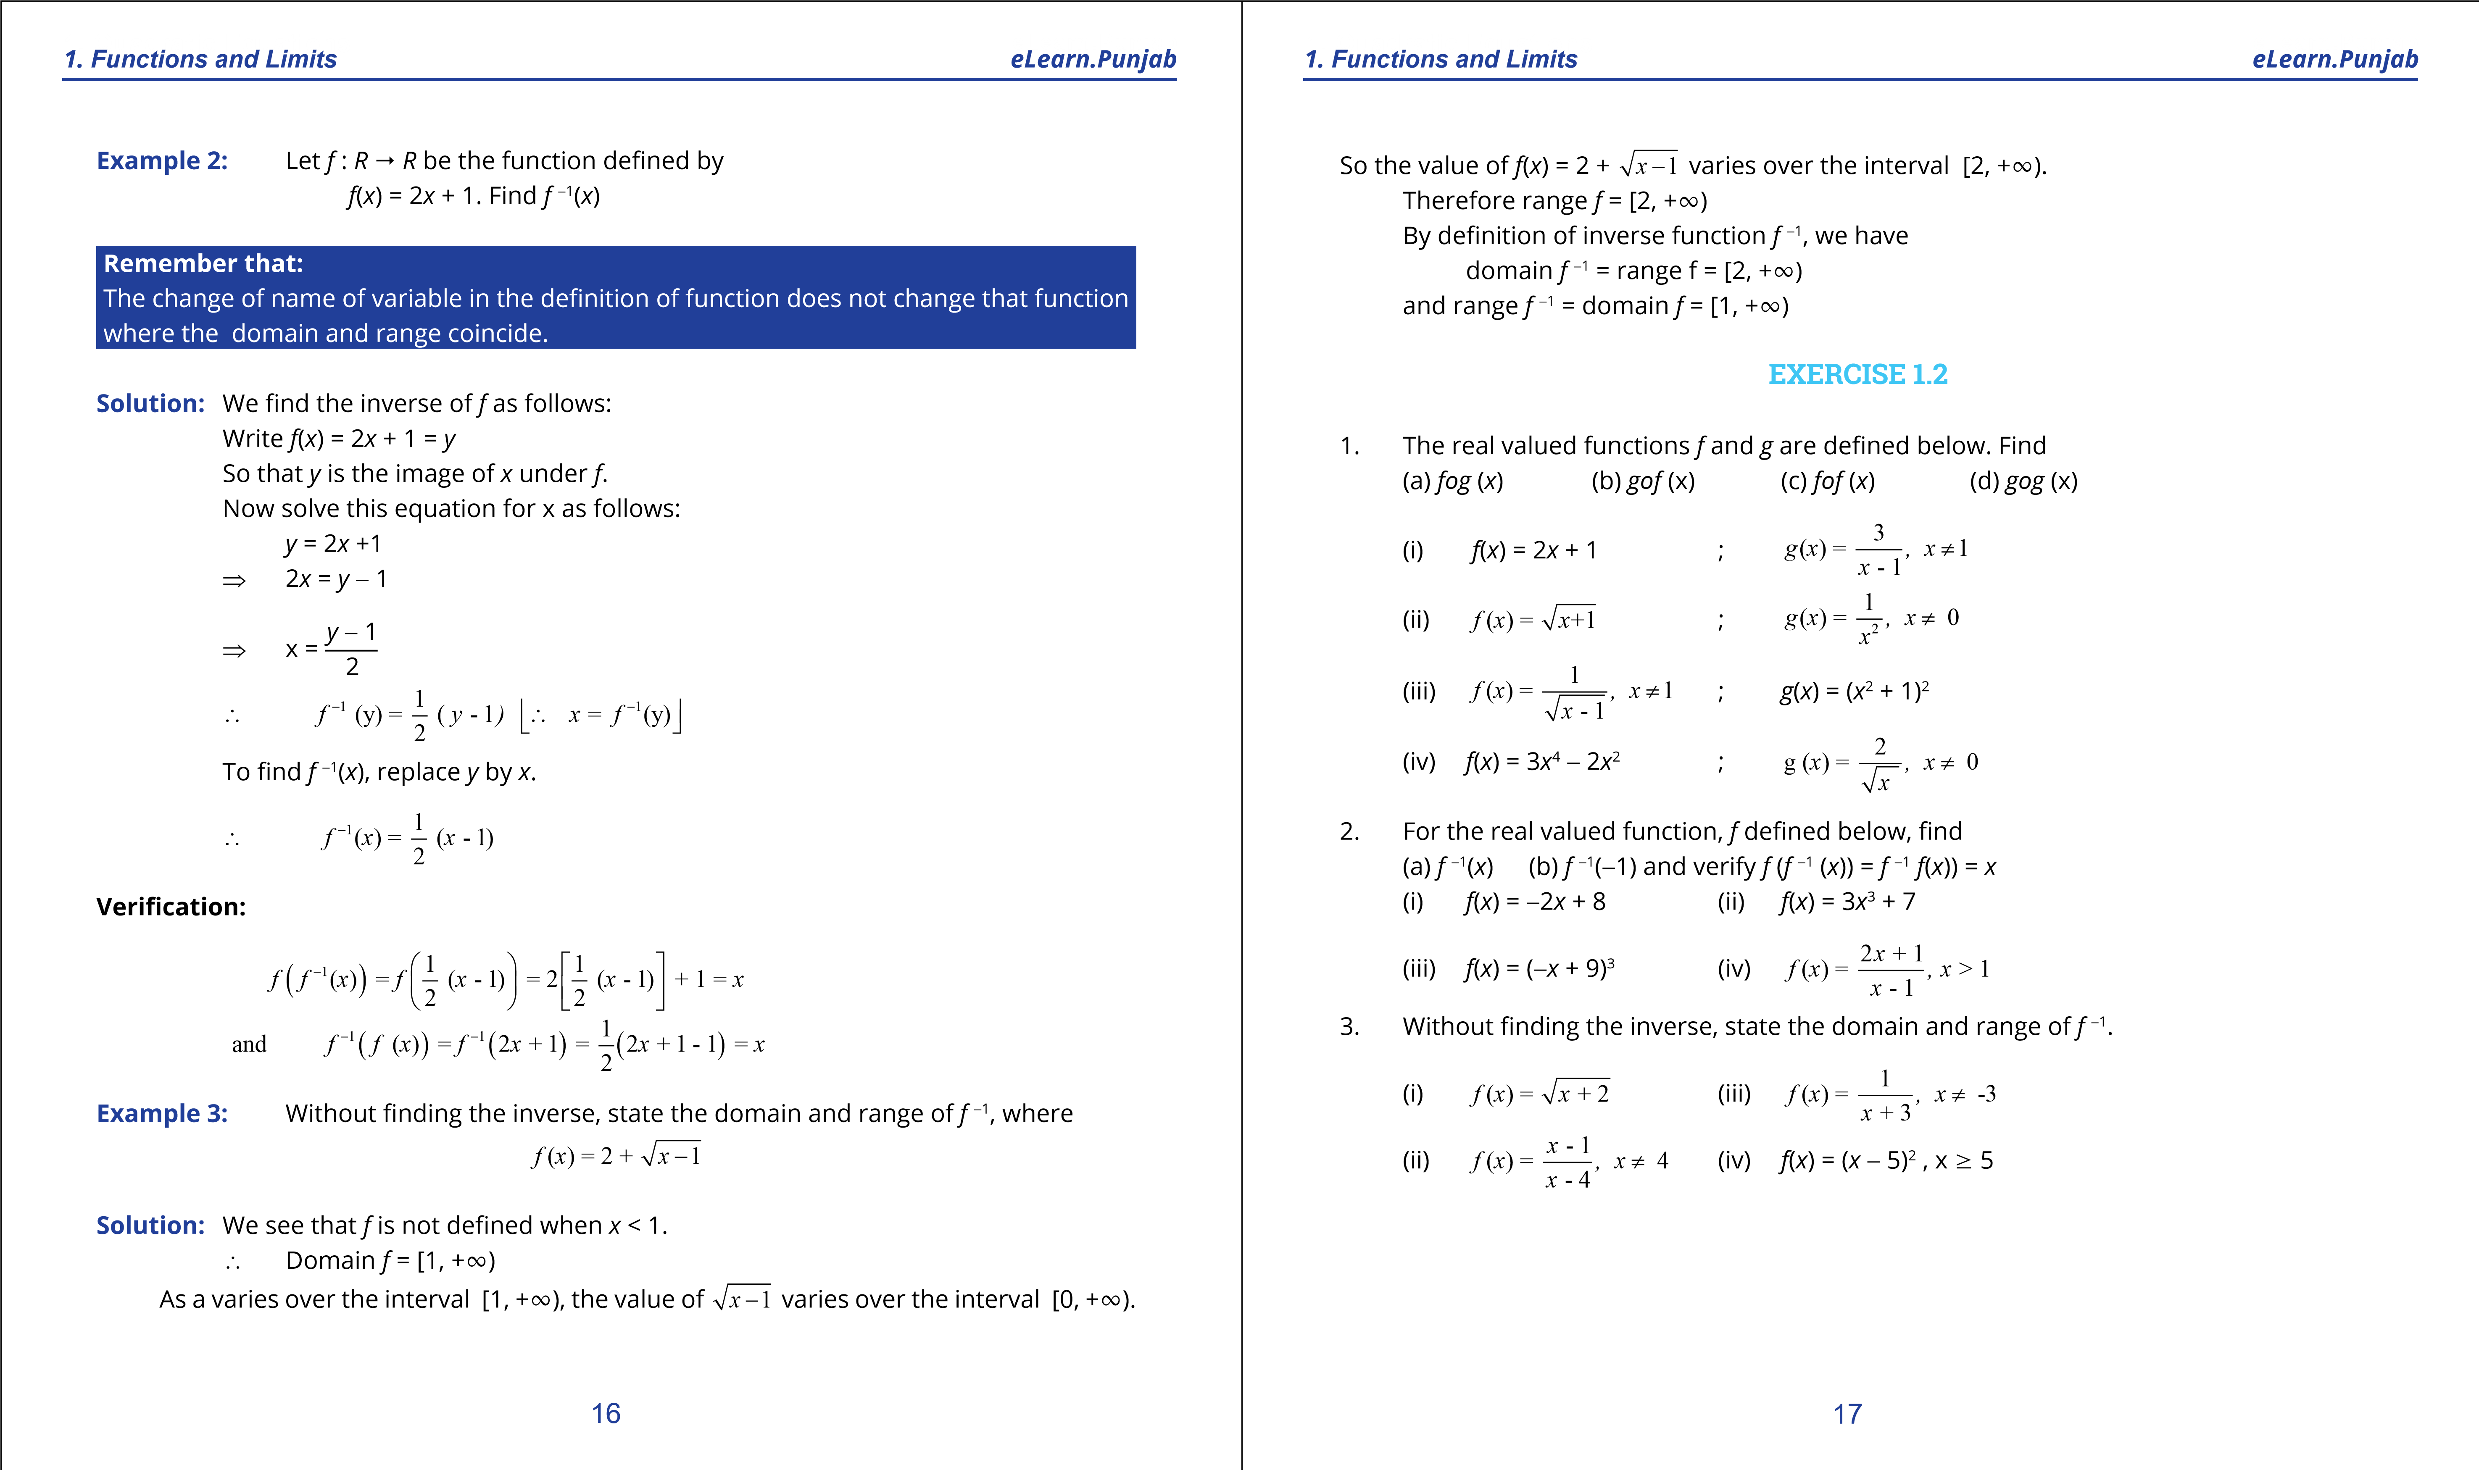

1. **Quadratic Equations eLearn.Punjab 1. Quadratic Equations eLearn.Punjab *1. Functions and Limits eLearn.Punjab 1. Functions and Limits eLearn.Punjab***

**1.4 LIMIT OF A FUNCTION AND THEOREMS**

**ON LIMITS**

The concept of limit of a function is the basis on which the structure of calculus rests. Before the deinition of the limit of a function, it is essential to have a clear understanding of the meaning of the following phrases:

#### 1.4.1 Meaning of the Phrase “x approaches zero”

Suppose a variable *x* assumes in succession a series of values as

1, , , , ,... i.e., 1, , , , , ... , 1 ,...

2*n*

We notice that *x* is becoming smaller and smaller as *n* increases and can be made as small as we please by taking *n* suiciently large. This unending decrease of *x* is symbolically written as *x*  0 and is read as “*x* approaches zero” or “*x* tends to zero”.

**Note:** The symbol *x*  0 is quite diferent from *x* = 0 (i) *x*  0 means that *x* is very close to zero but not actually zero. (ii) *x* = 0 means that *x* is actually zero.

#### 1.4.2 Meaning of the Phrase “x approaches ininity”

Suppose a variable *x* assumes in succession a series of values as 1 ,10 ,100 ,1000 ,10000 .... i.e., 1,10,102,103.......,10n,...

It is clear that *x* is becoming larger and larger as *n* increases and can be made as large as we please by taking *n* suiciently large. This unending increase of *x* is symbolically written as “*x* T” and is read as “*x* approaches ininity” or “*x* tends to ininity”.

#### 1.4.3 Meaning of the Phrase “x approaches a”

Symbolically it is written as “*x*  *a*” which means that *x* is suiciently close to but diferent from the number *a*, from both the left and right sides of *a* i.e; *x* - *a* becomes smaller and smaller as we please but x - a ≠ 0.

#### 1.4.4 Concept of Limit of a Function

**(i) By inding the area of circumscribing regular polygon**

Consider a circle of unit radius which circumscribes a square (4-sided regular polygon) as shown in igure (1).

The side of square is 2 and its area is 2 square unit. It is clear that the area of inscribed 4-sided polygon is less than the area of the circum-circle.

Bisecting the arcs between the vertices of the square, we get an inscribed 8-sided polygon as shown in igure 2. Its area is 2 2 square unit which is closer to the area of circum-circle. A further similar bisection of the arcs gives an inscribed 16-sided polygon as shown in igure (3) with area 3.061 square unit which is more closer to the area of circumcircle.

1

2

1

4

1

8

1

16

1

2

1

2

2

1

2

3

1

2

4

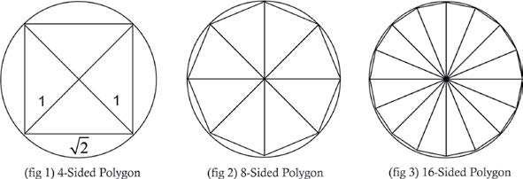

It follows that as ‘*n’* , the number of sides of the inscribed polygon increases, the area of polygon increases and becoming nearer to 3.142 which is the area of circle of unit radius i.e., p*r*2 = p(1)2

= p c 3.1 42.

We express this situation by saying that the limiting value of the area o f the inscribed

polygon is the area of the circle as n approaches ininity, i.e., Area of inscribed polygon  Area of circle

as *n* T

Thus area of circle of unit radius = p = 3.142 (approx.)

**(ii) Numerical Approach**

Consider the function *f*(*x*) = *x*3

The domain of *f*(*x*) is the set of all real numbers.

Let us ind the limit of *f*(*x*) = *x*3 as *x* approaches 2.

### 18 19

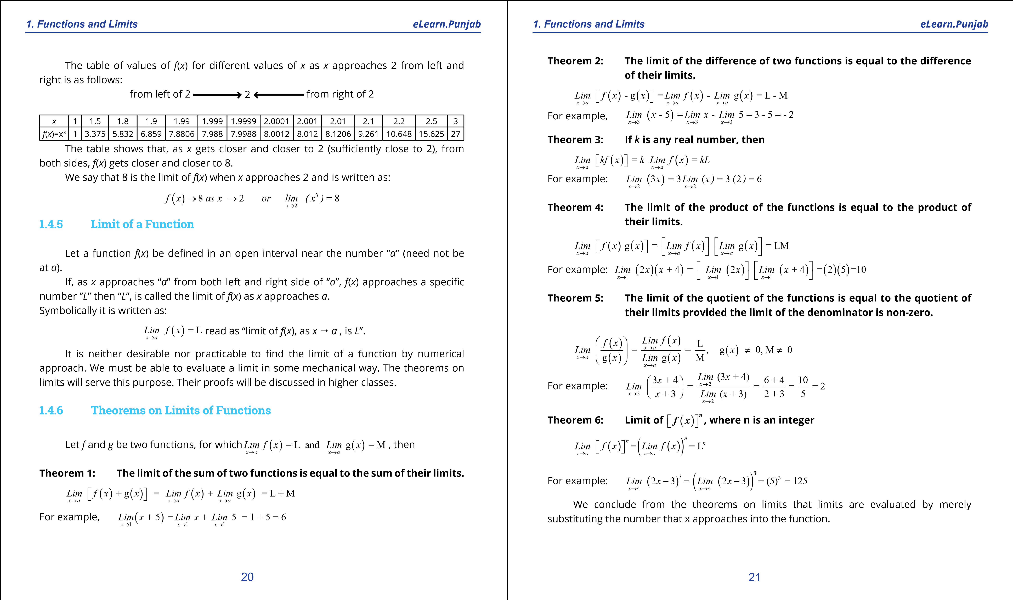

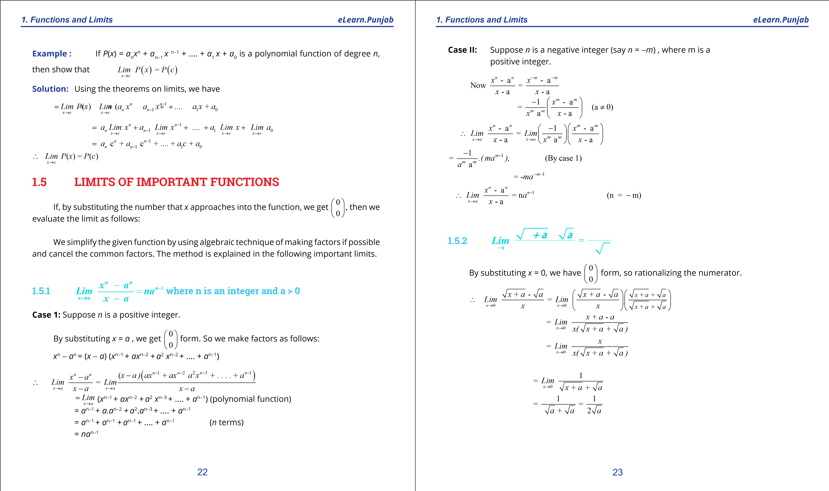

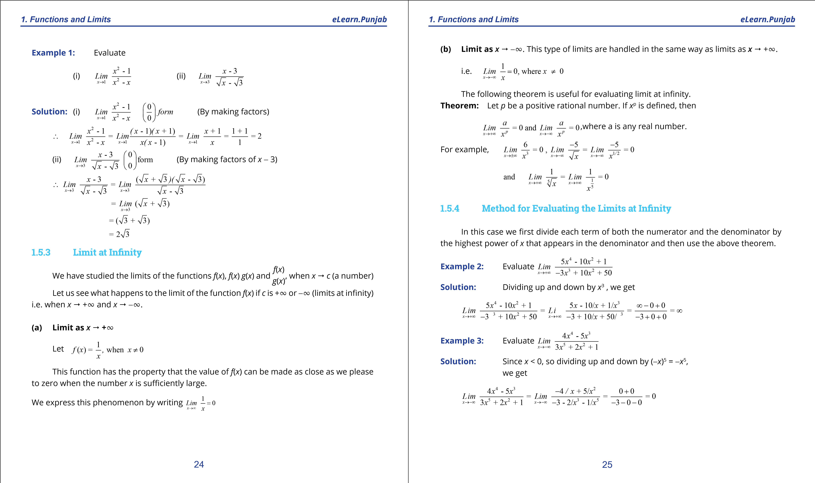

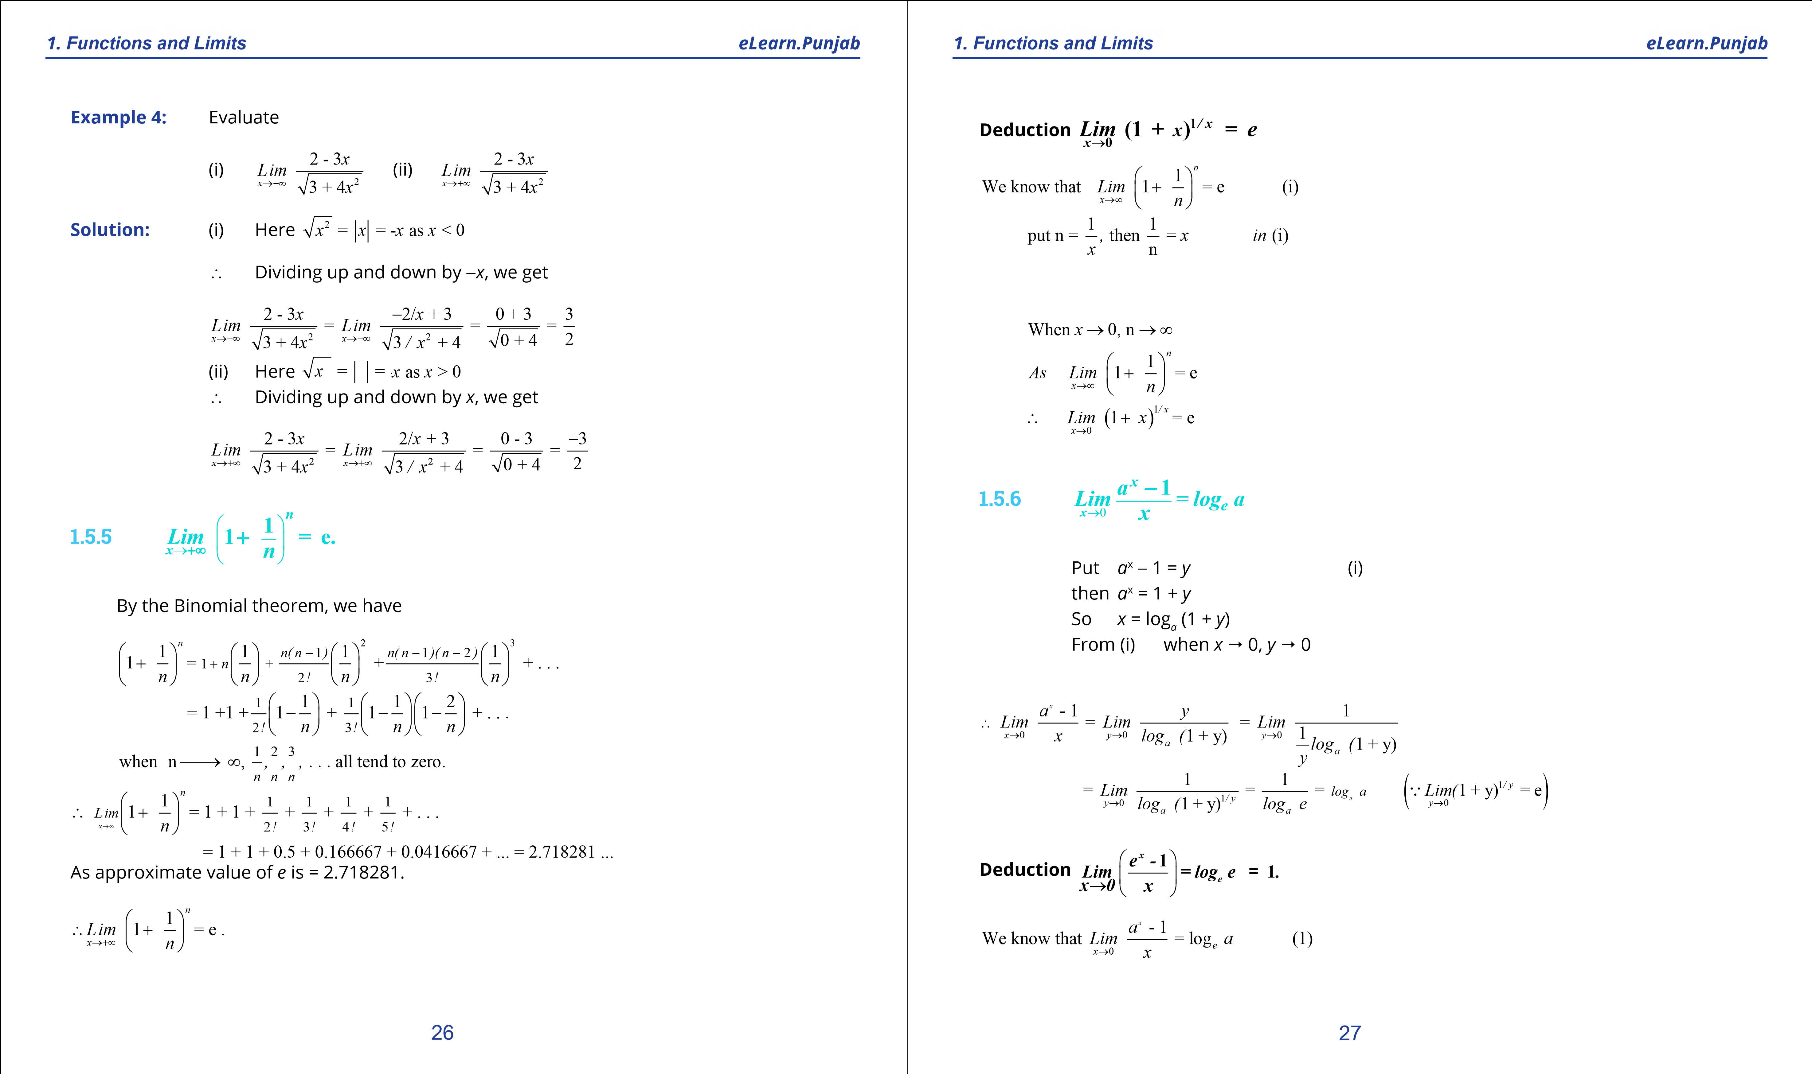

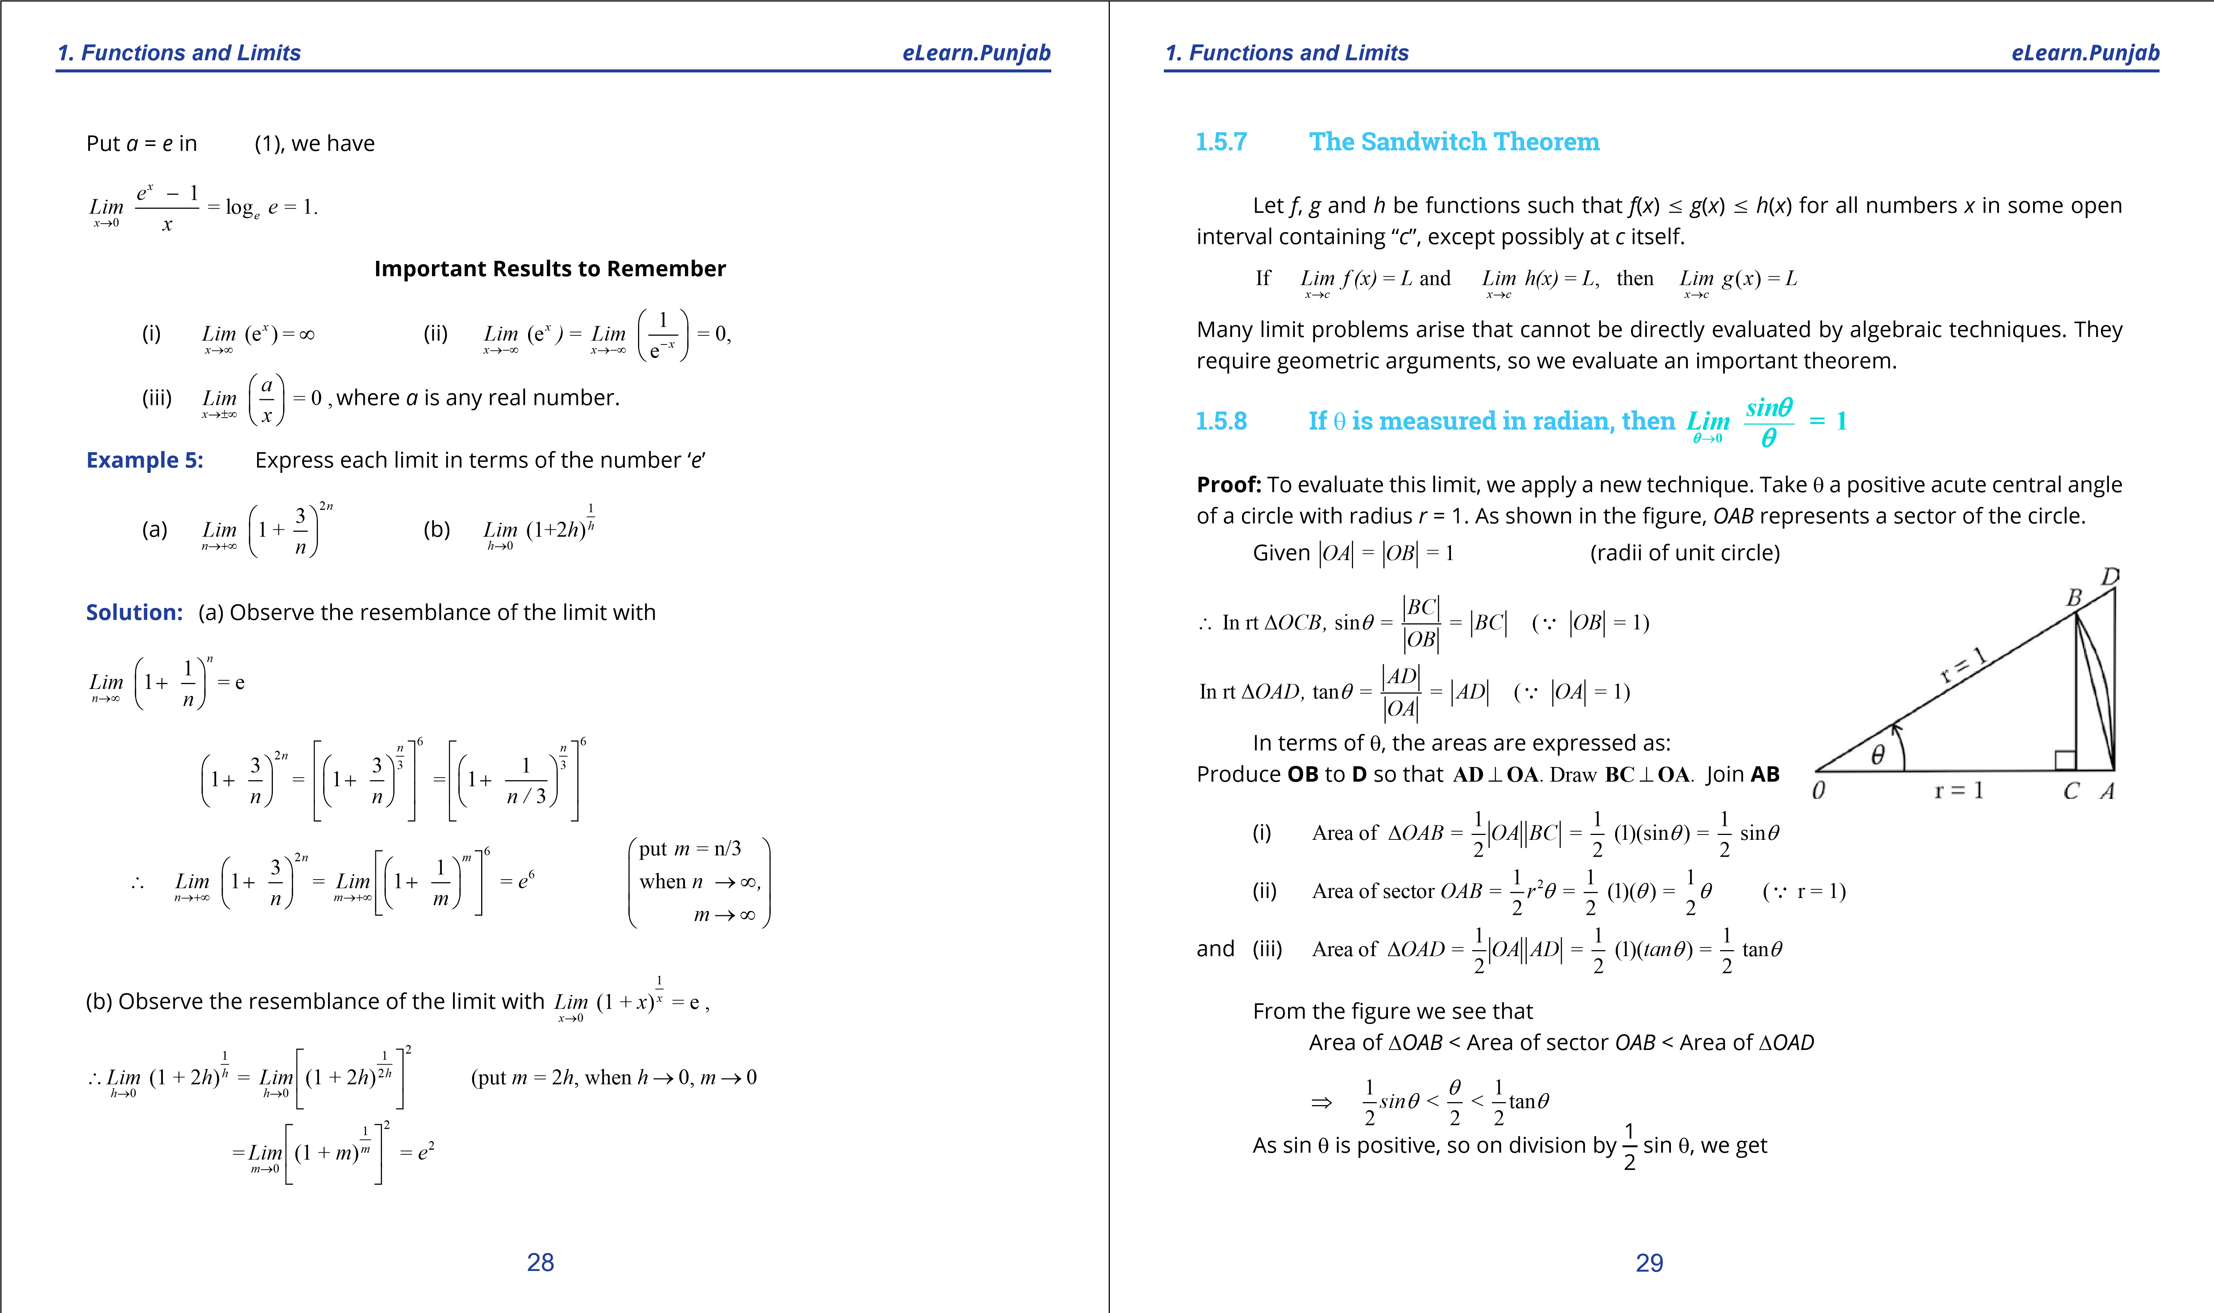

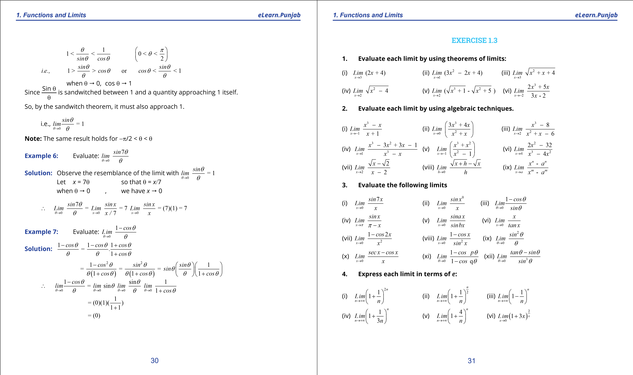

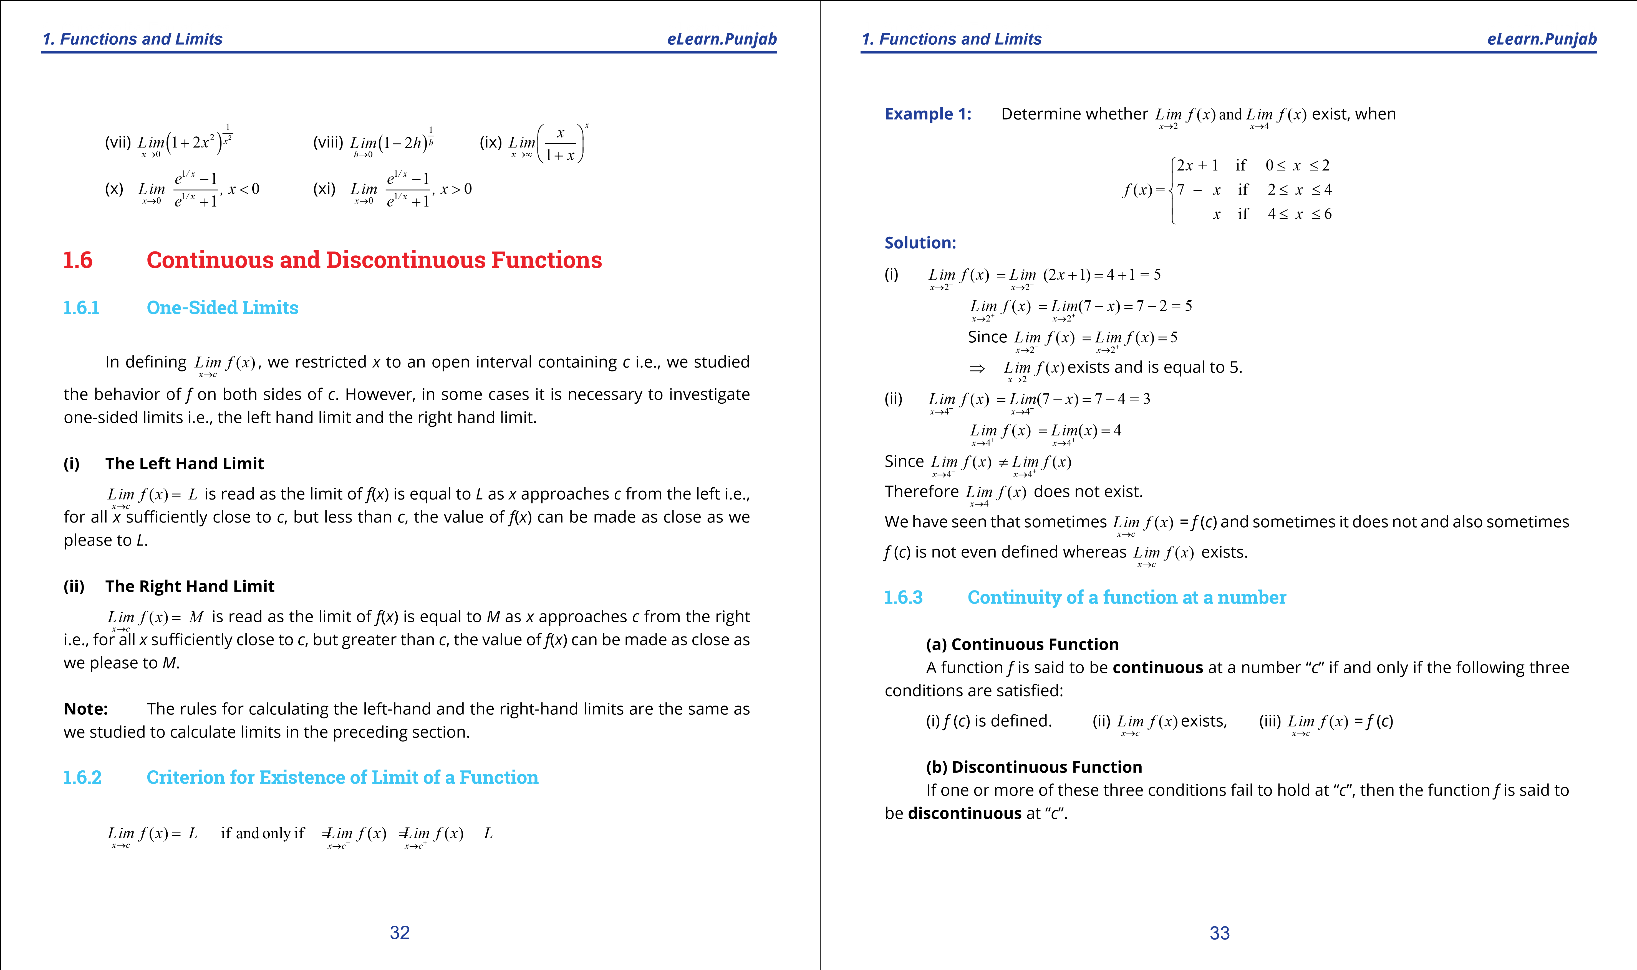

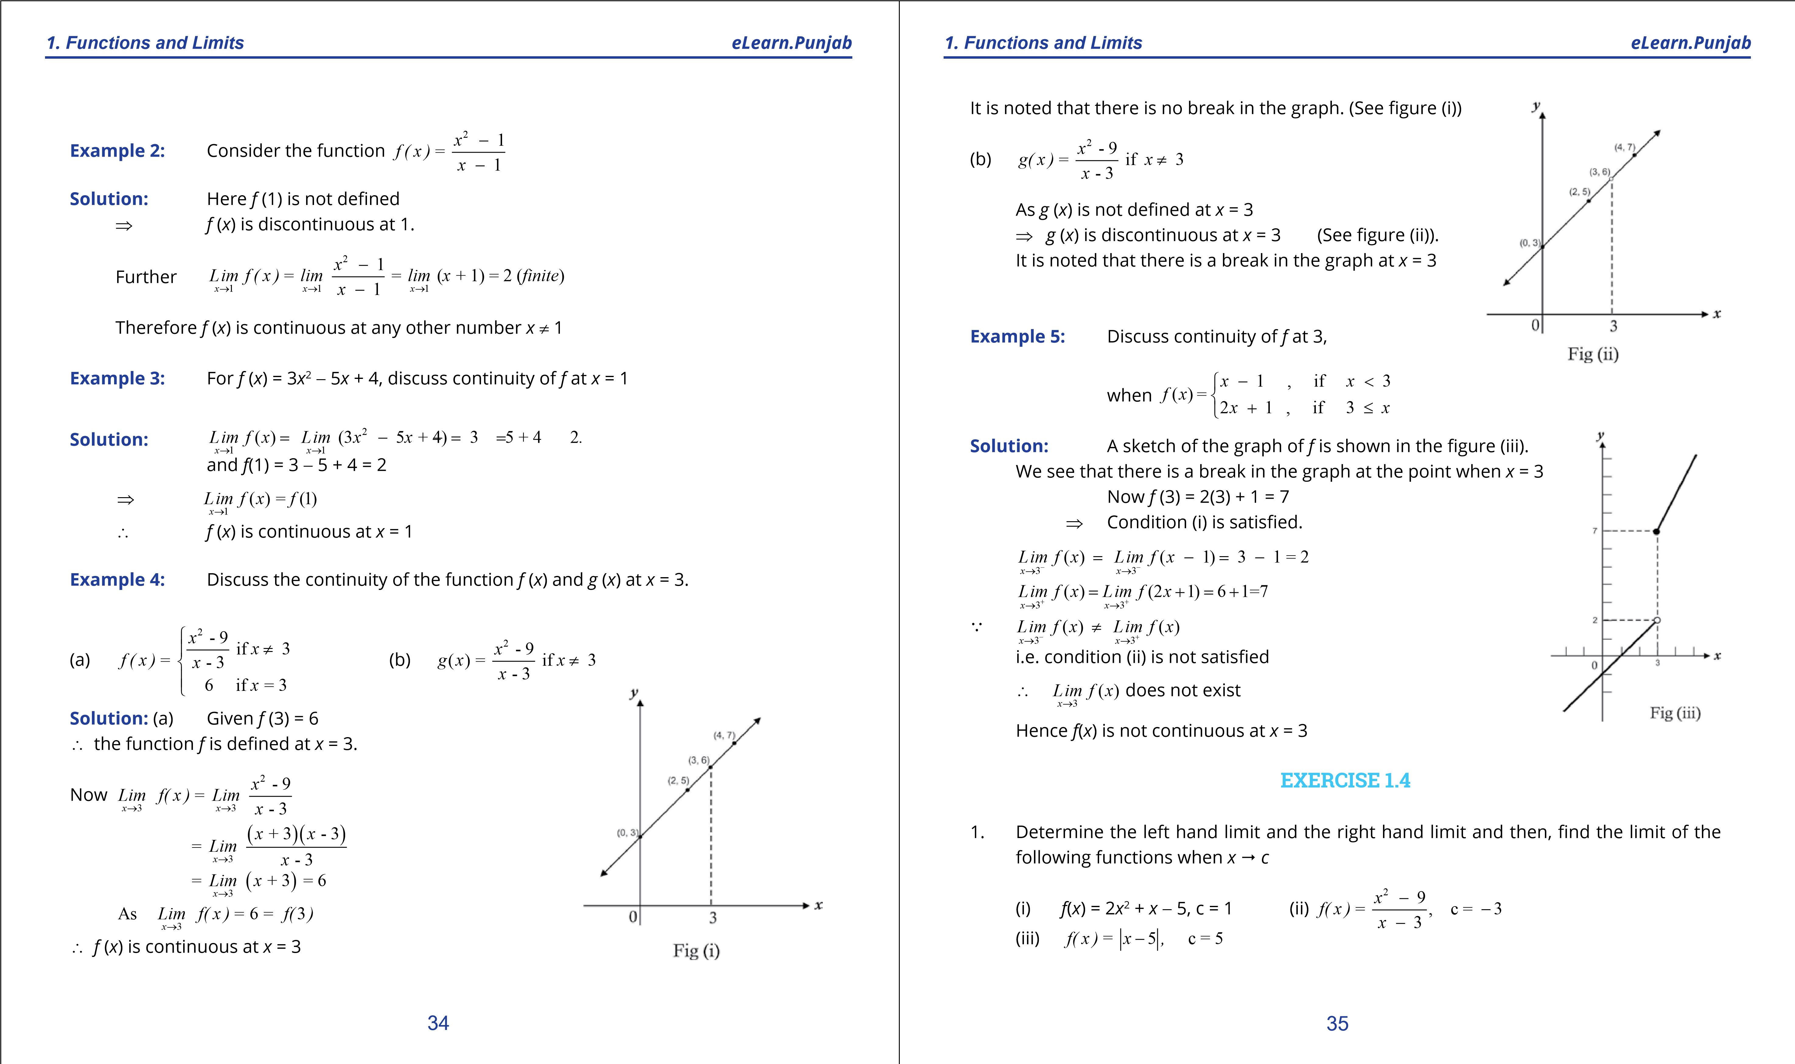

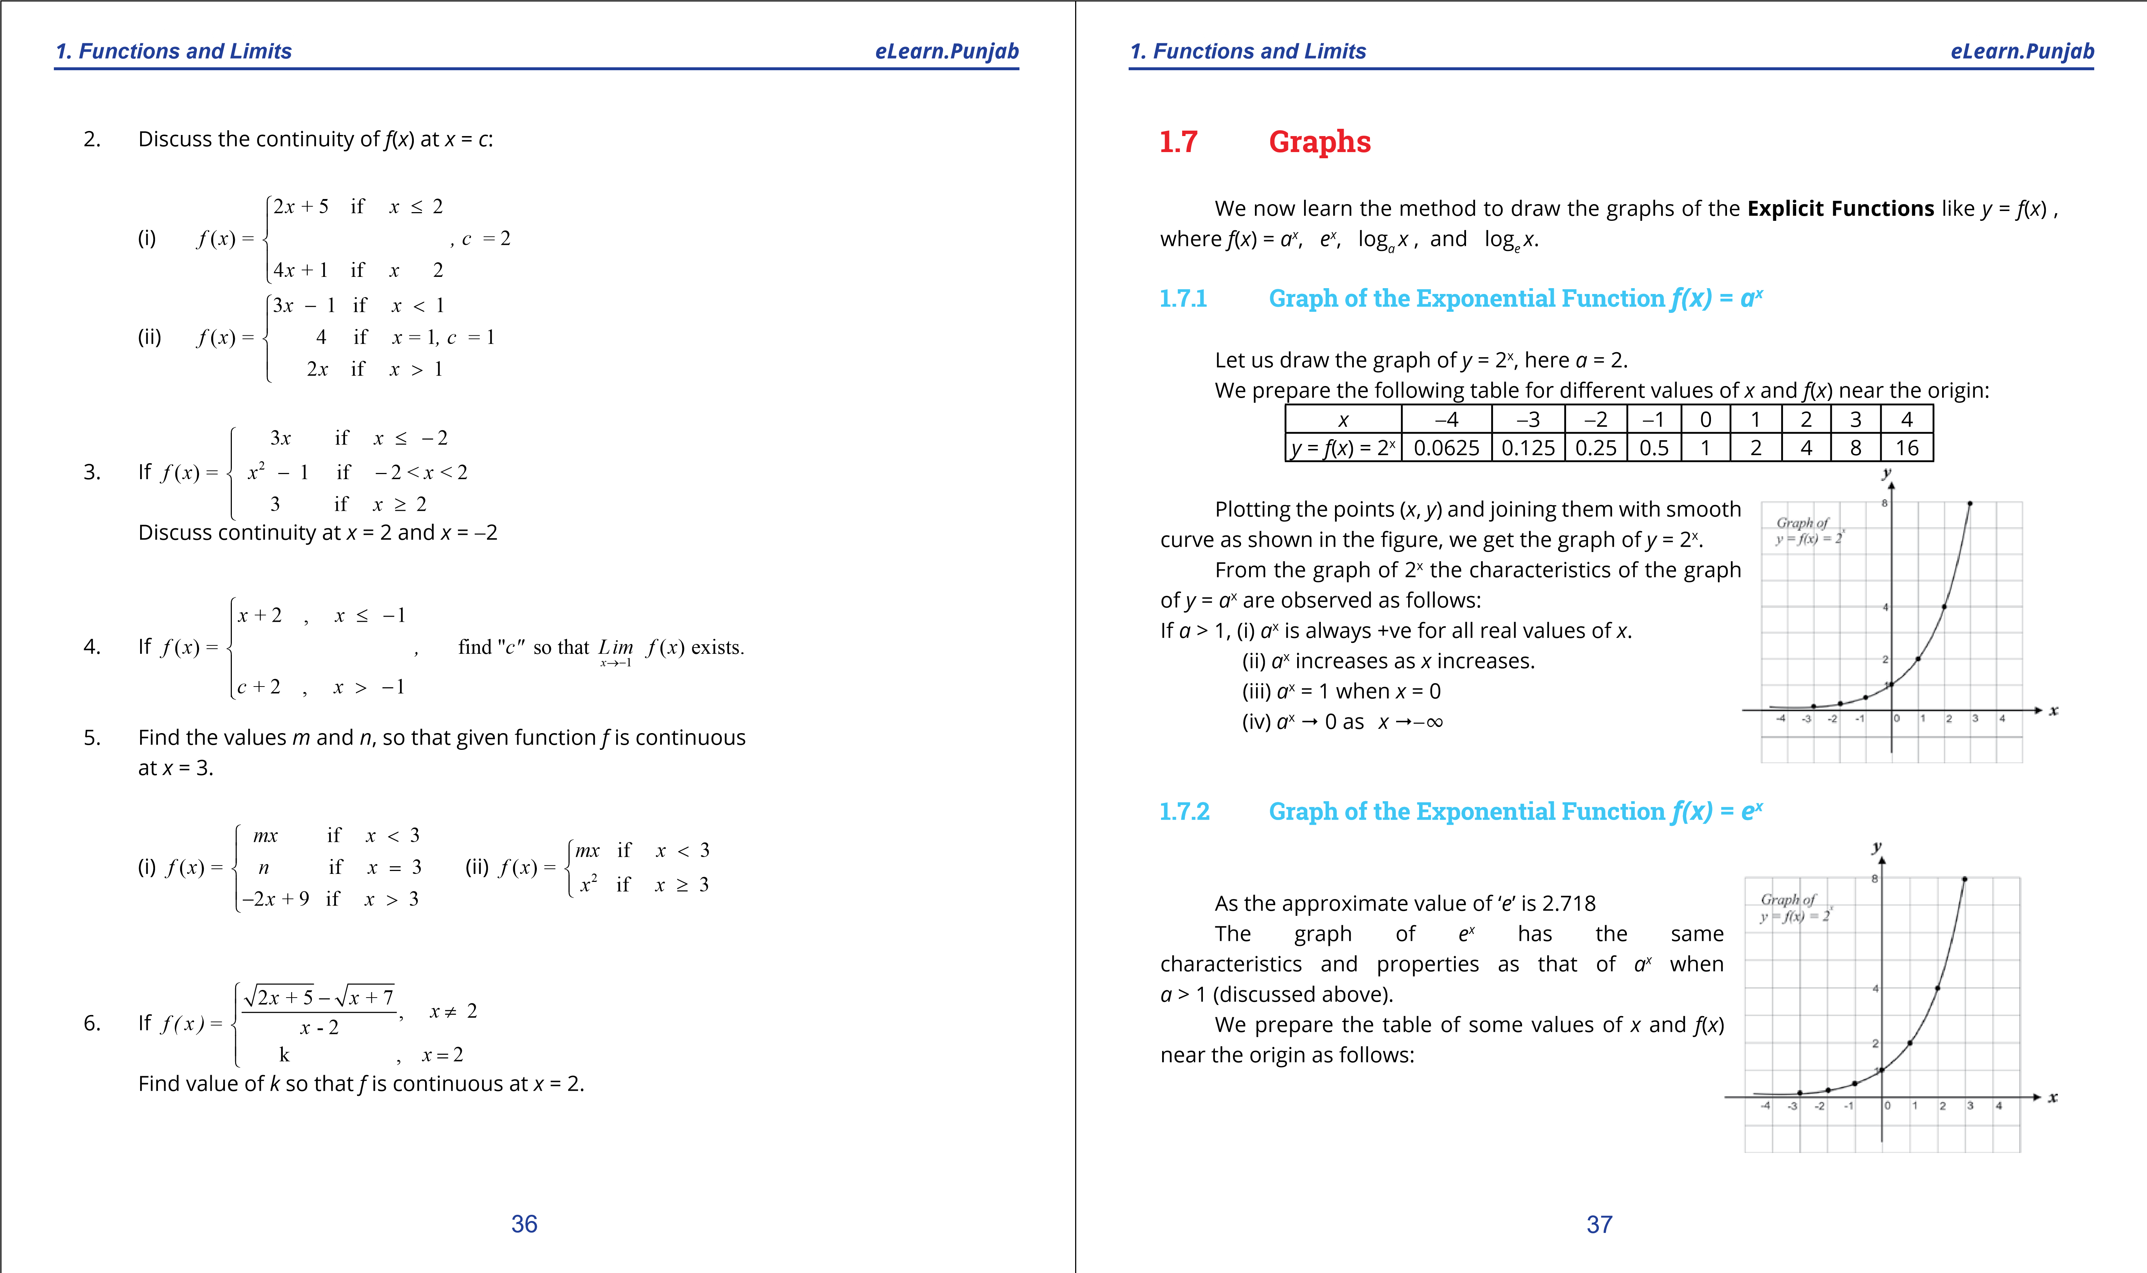

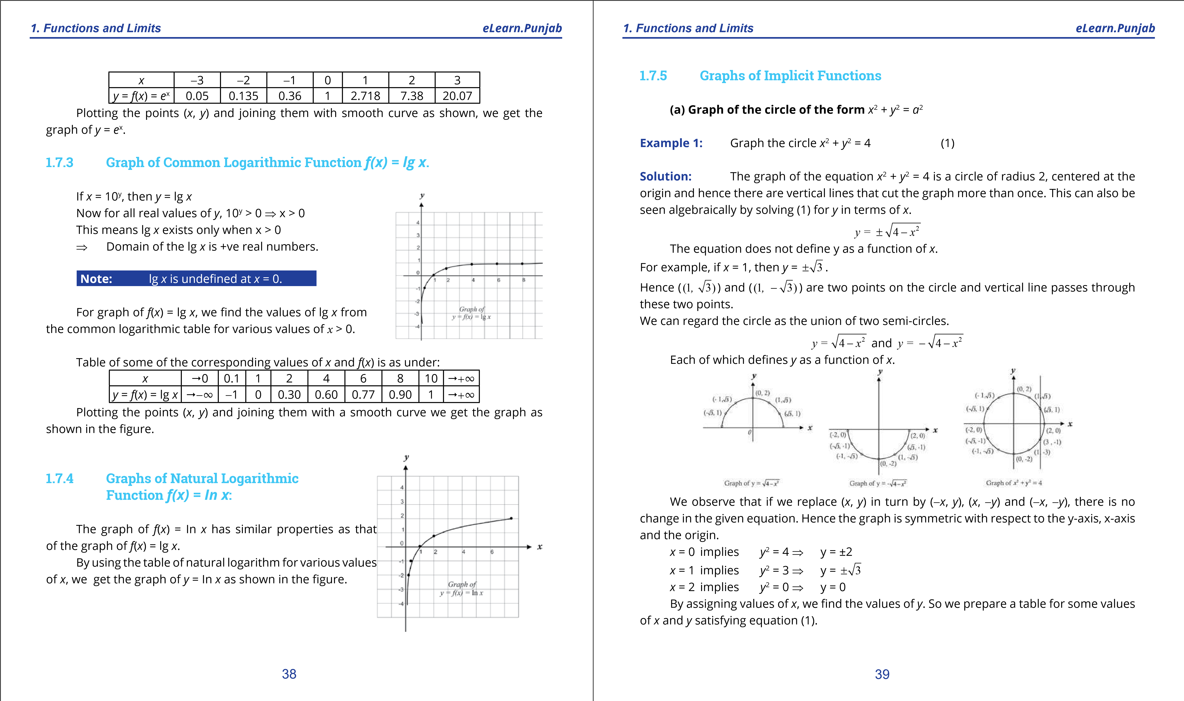

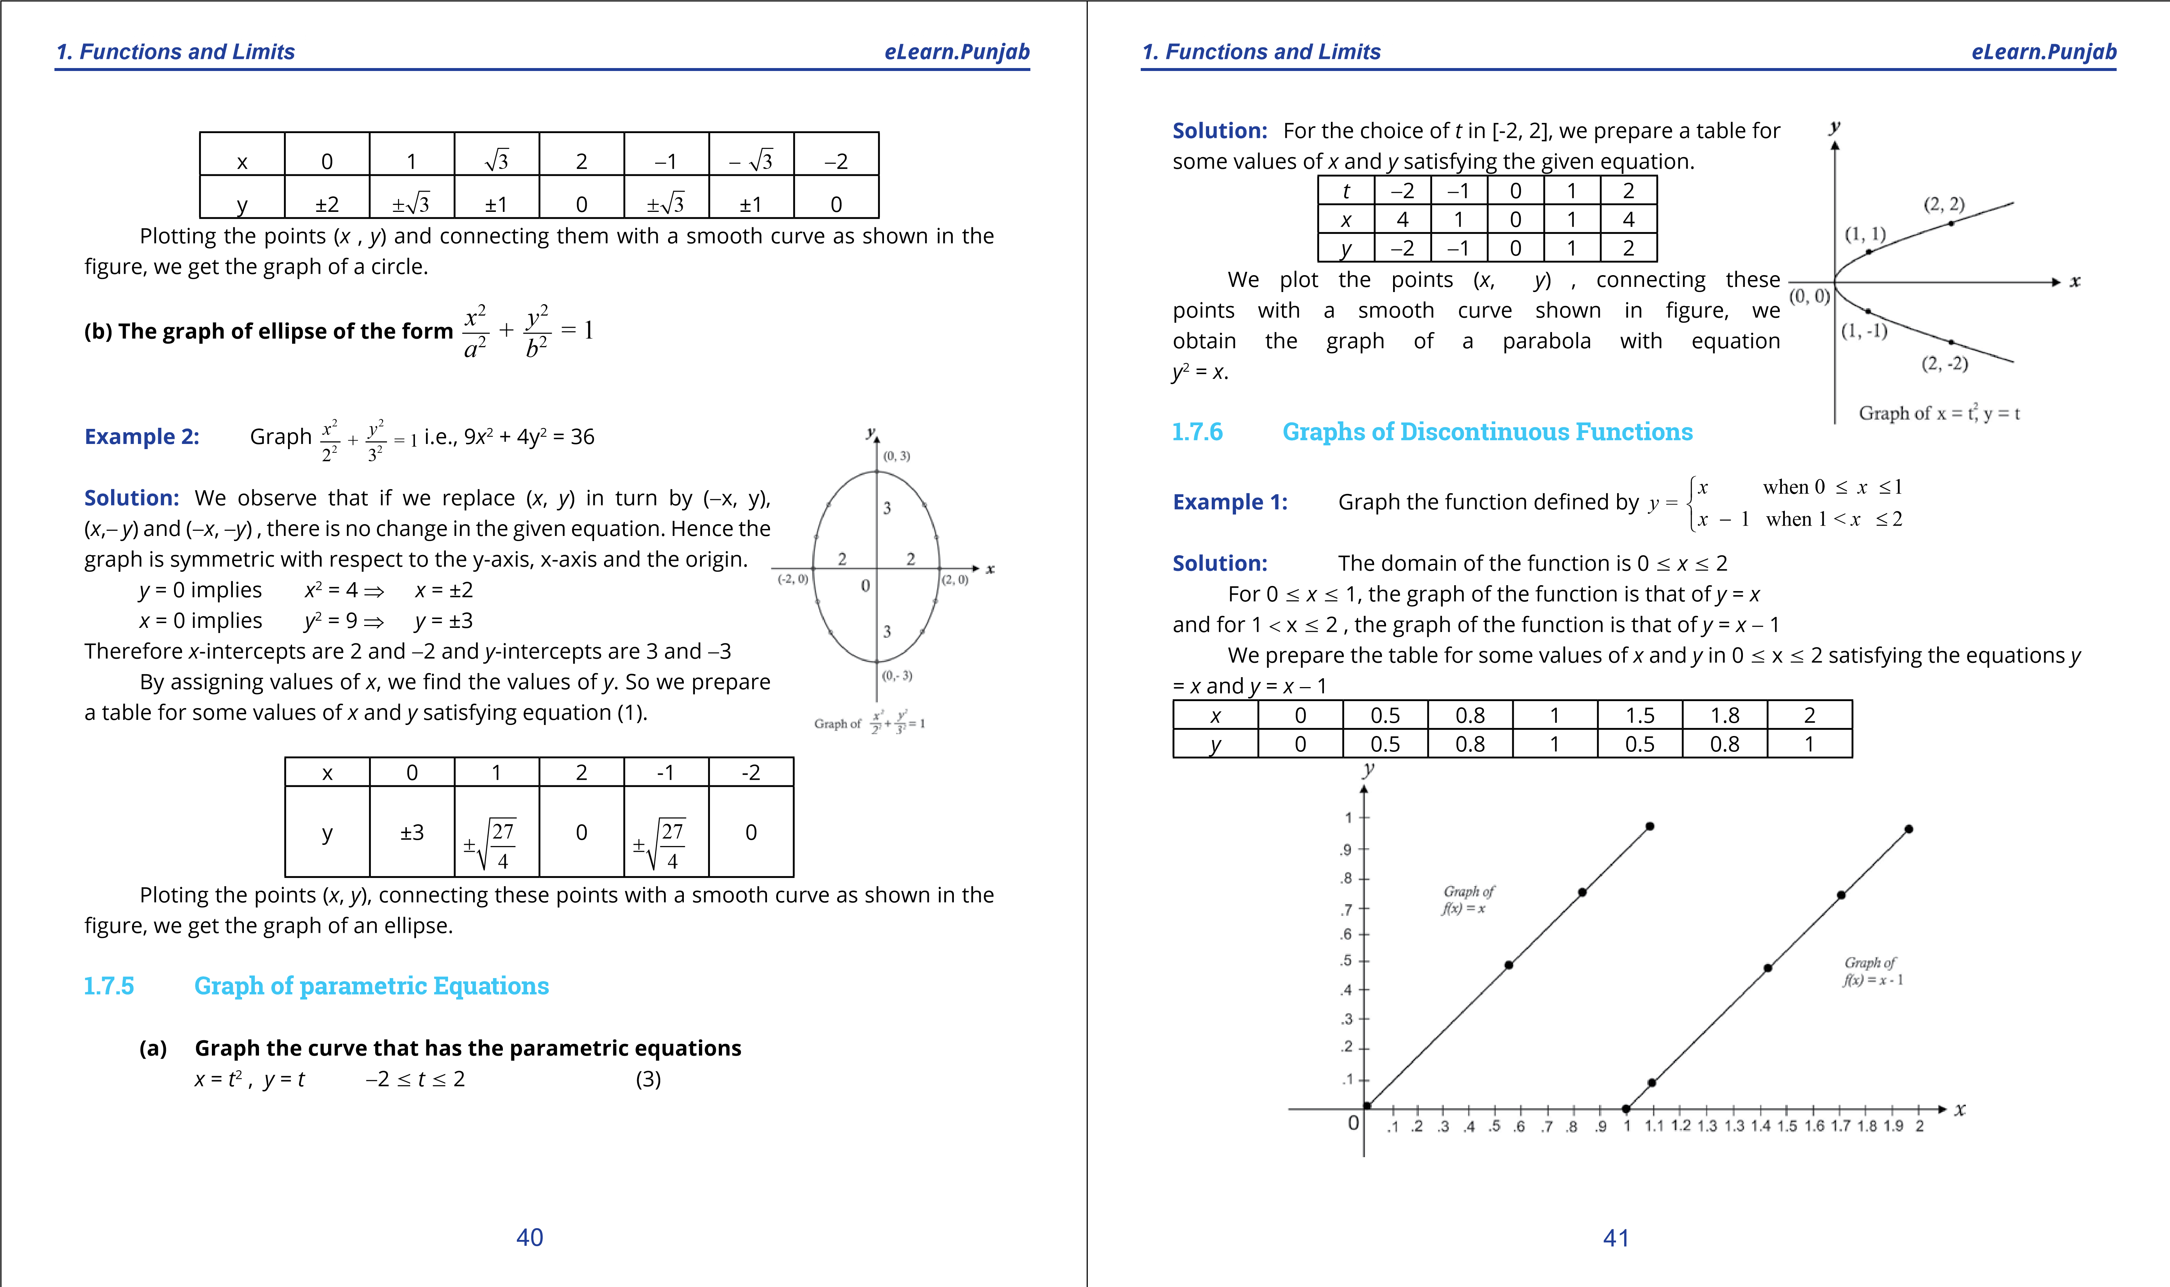

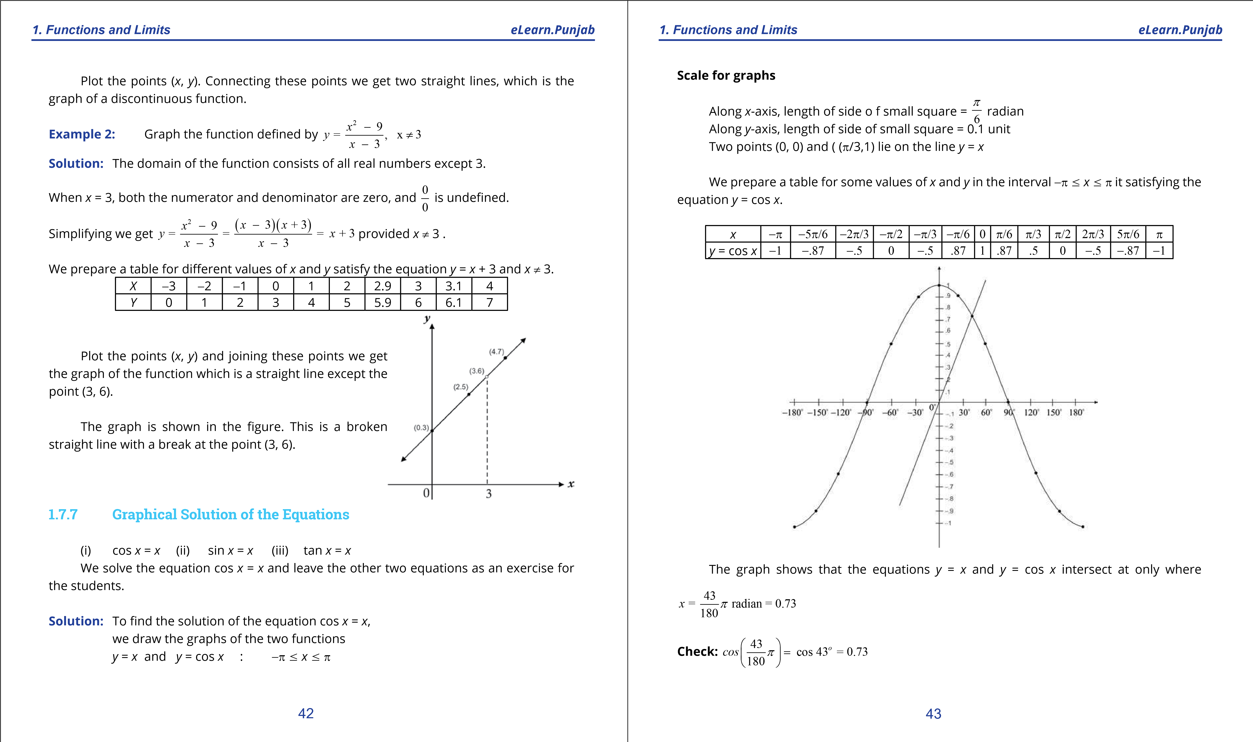

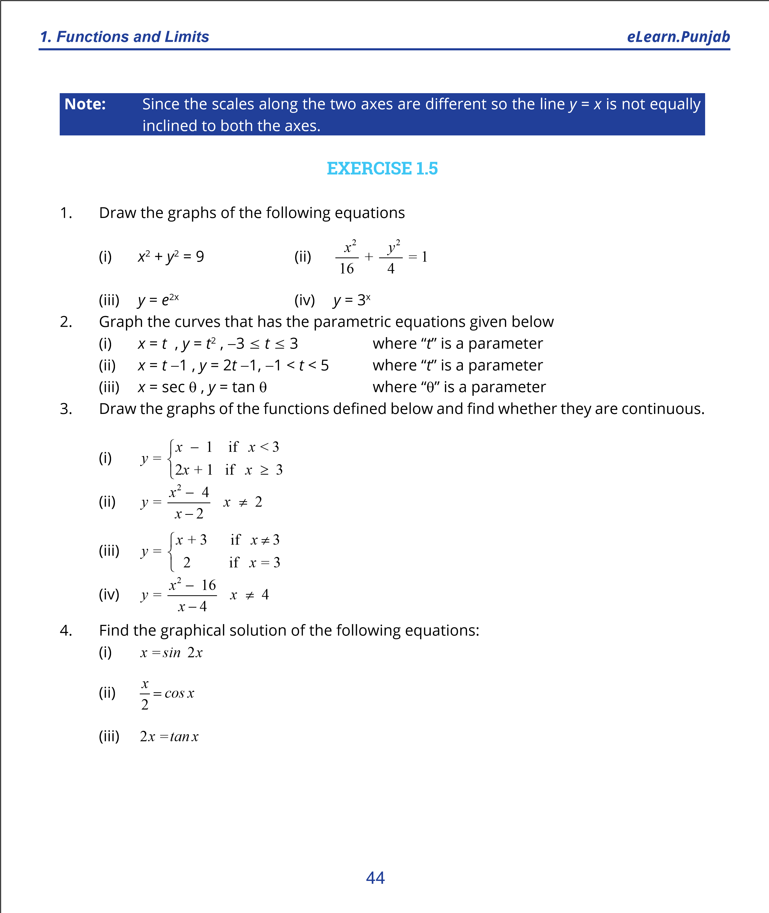

***version: 1.1***

# CHAPTER 2 DIFFERENTIATION

*Animation 2.1: Increasing and Decreasing Functions Source and credit: eLearn.Punjab*

**1. Quadratic Equations eLearn.Punjab 1. Quadratic Equations eLearn.Punjab *2. Diferentiation eLearn.Punjab 2. Diferentiation eLearn.Punjab***

## 2.1 INTRODUCTION

The ancient Greeks knew the concepts of area, volume and centroids etc. which are related to integral calculus. Later on, in the seventeenth century, Sir Isaac Newton, an English mathematician (1642-1727) and Gottfried Whilhelm Leibniz, a German mathematician, (1646-1716) considered the problem of instantaneous rates of change. They reached independently to the invention of diferential calculus. After the development of calculus, mathematics became a powerful tool for dealing with rates of change and describing the physical universe.

**Dependent and Independent Variables**

In diferential calculus, we mainly deal with the rate of change of a dependent variable with respect to one or more independent variables. Now, we irst explain the terms dependent and independent variables.

We usually write *y* =∈*f* ( )*x* where *f* ( )*x* is the value of at *f x Df* (the domain of the function

*f* ). Let us consider the functional relation *v* = *f* (*x*) = *x*2 +1....... (A)

For diferent values of *x*∈*Df* , *f* ( )*x* or the expression *x*2 +1 assumes diferent values. For example; if *x* = 1, 1.5, 2 etc., then

*f* ( ) ( )1 = 1 2 + =1 2*, f* (1 5*.* ) (= 1 5*.* )2 + =1 2 25*.* + =1 3 25*.* *f* ( ) ( )2 = 2 2 + =1 4 + =1 5

We see that for the change 1.5 - 1 = 0.5 in the value of *x*, the corresponding change in the value of *y* or *f* ( )*x* is given by

*f* (1 5*.* ) - *f* ( )1 = 3 25*.* - 2 =1 25*.*

It is obvious that the change in the value of the expression *x*2 +1 (or *f* ( )*x* ) depends upon the change in the value of the variable *x*. As *x* behaves independently, so we call it the independent variable. But the behaviour of *y* or *f* ( )*x* depends on the variable *x*, so we call it the dependent variable.

The change in the value of *x* (positive or negative) is called the increment of *x* and is denoted by the symbol d*x* (read as delta *x*). The corresponding change in the dependent variable *y* or *f* ( )*x* for the change d*x* in the value of *x* is denoted by d d*y* or *f* = *f* (*x* +d*x*) - *f* ( )*x* .

Usually the small changes in the values of the variables are taken as increments of variables.

**Note:** In this Chapter we shall discuss funcions of the form *y* = *f*(*x*) where *xdDf* and is called an independent variable while *y* is called the dependent variable.

### **2.1.1 AVERAGE RATE OF CHANGE**

Suppose a particle (or an object) is moving in a straight line and its positions (from some ixed point) after times *t* and *t*1 are given by *s t*( ) and *s t*( )1 , then the distance traveled in the time interval *t*1 - *t* where *t*1 > *t* is *s t*( )1 - *s t*( )

and the diference quotient *s t*( )1 - *s t*( ) (i) *t*1 -*t*

represents the average rate of change of distance over the time interval *t*1 - *t* .

If *t*1 - *t* is not small, then the average rate of change does not represent an accurate rate of change near t. We can elaborate this idea by a moving particle in a straight line whose position in metres after t seconds is given by *s t*( ) = *t*2 + *t*

We construct a table for diferent values of t as under:

**Interval Average rate of change (i.e. average speed)** *t* = 3 secs to = 5 secs *t s*( )5 - *s*( )3 = (25+ 5) (- 9 + 3) = 30 -12 =9

5-3 2 2

*t* = 3 secs to = 4 secs *t s*( )4 - *s*( )3 = (16 + 4) -12 = 20 -12 = 8

4 -3 1 1

*t* = 3 secs to = 3.5 secs*t* *s*(3.5)- *s*( )3 =  494 + 72 -12 = 154 =7.5

3.5-3 0.5 0.5

We see that none of average rates of change approximates to the actual speed of the particle after 3 seconds.

#### 2 3

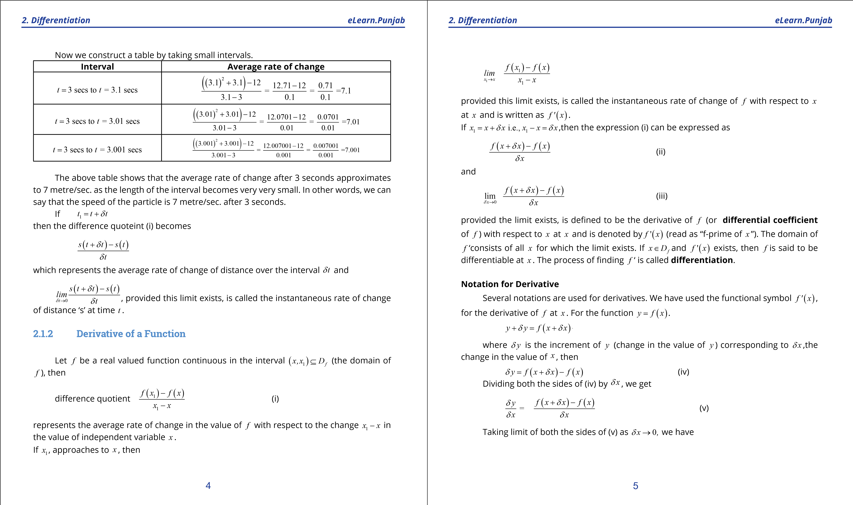

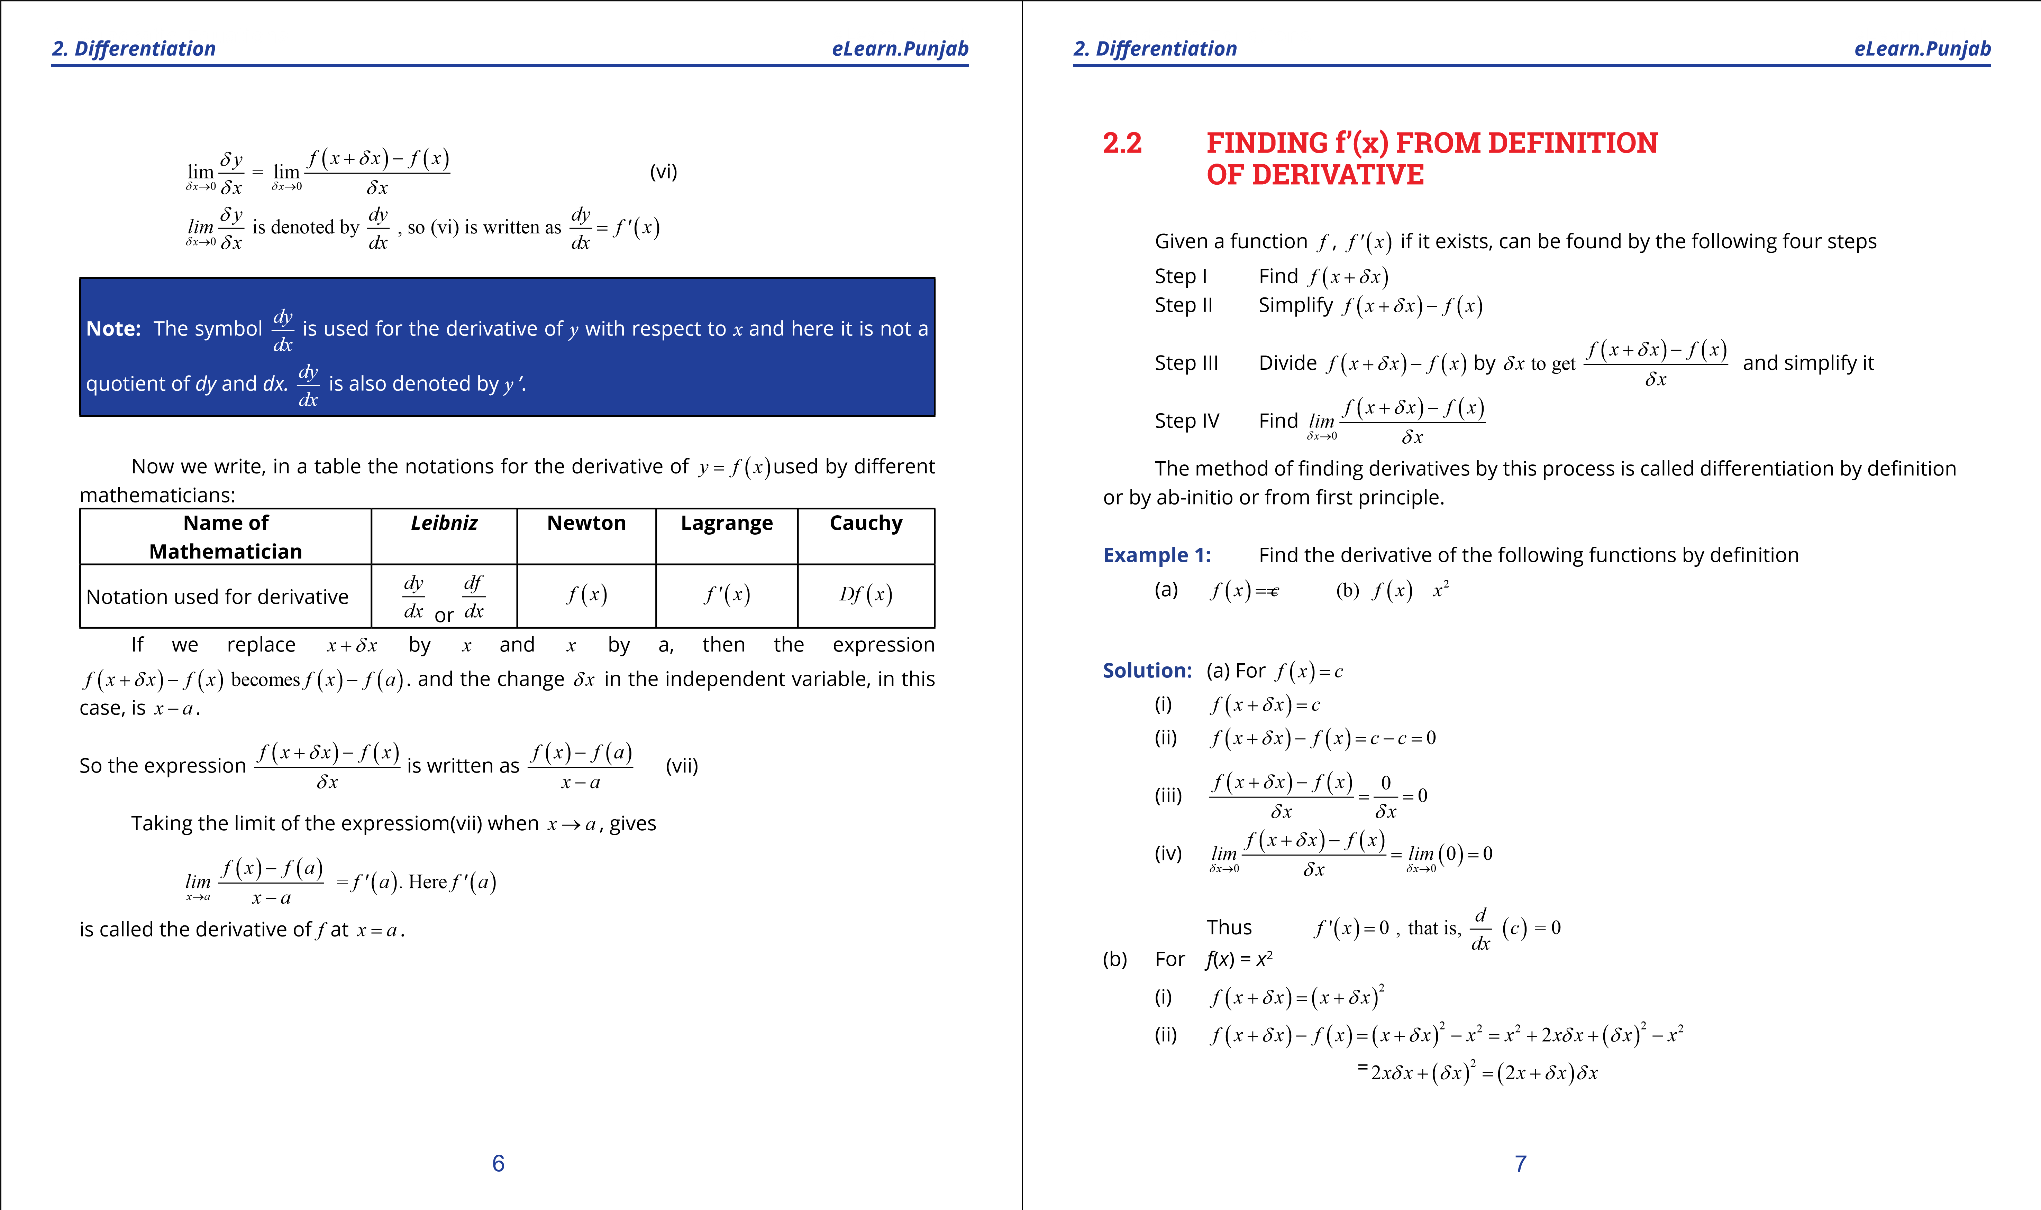

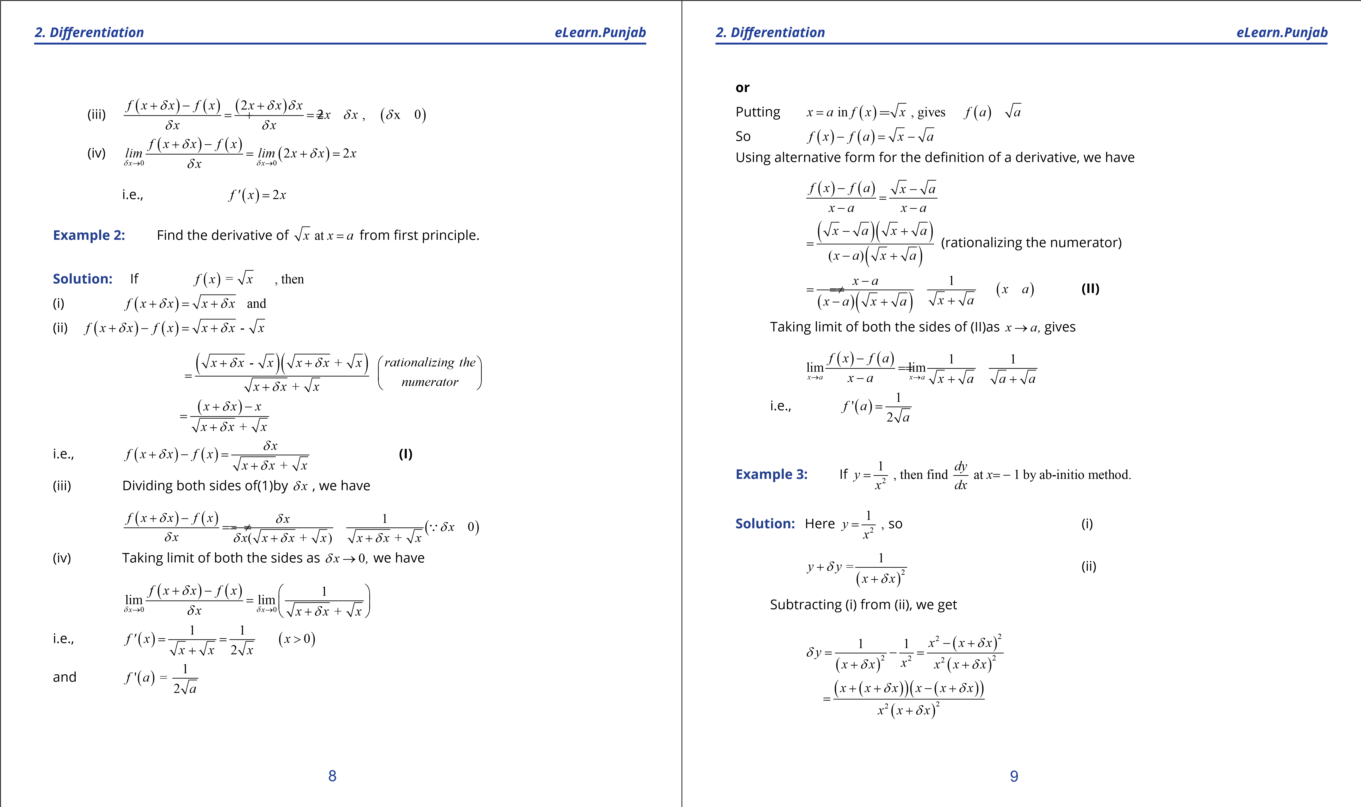

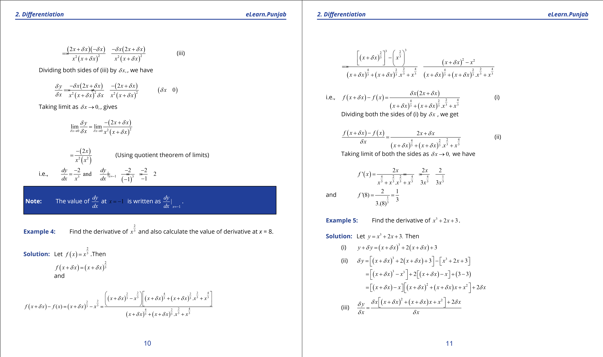

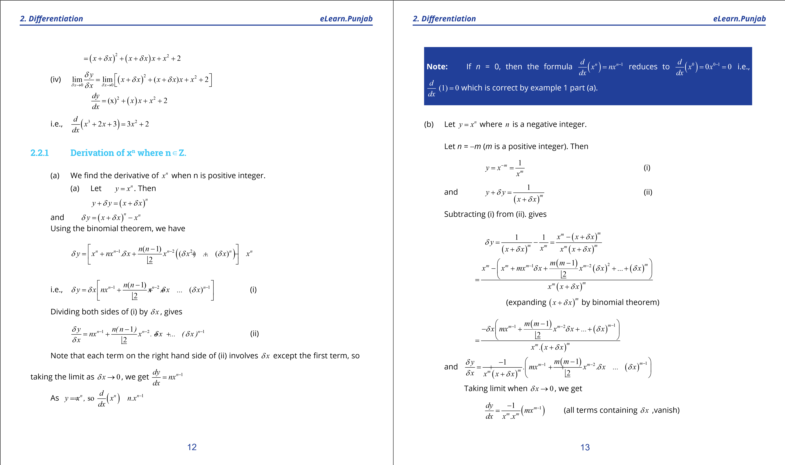

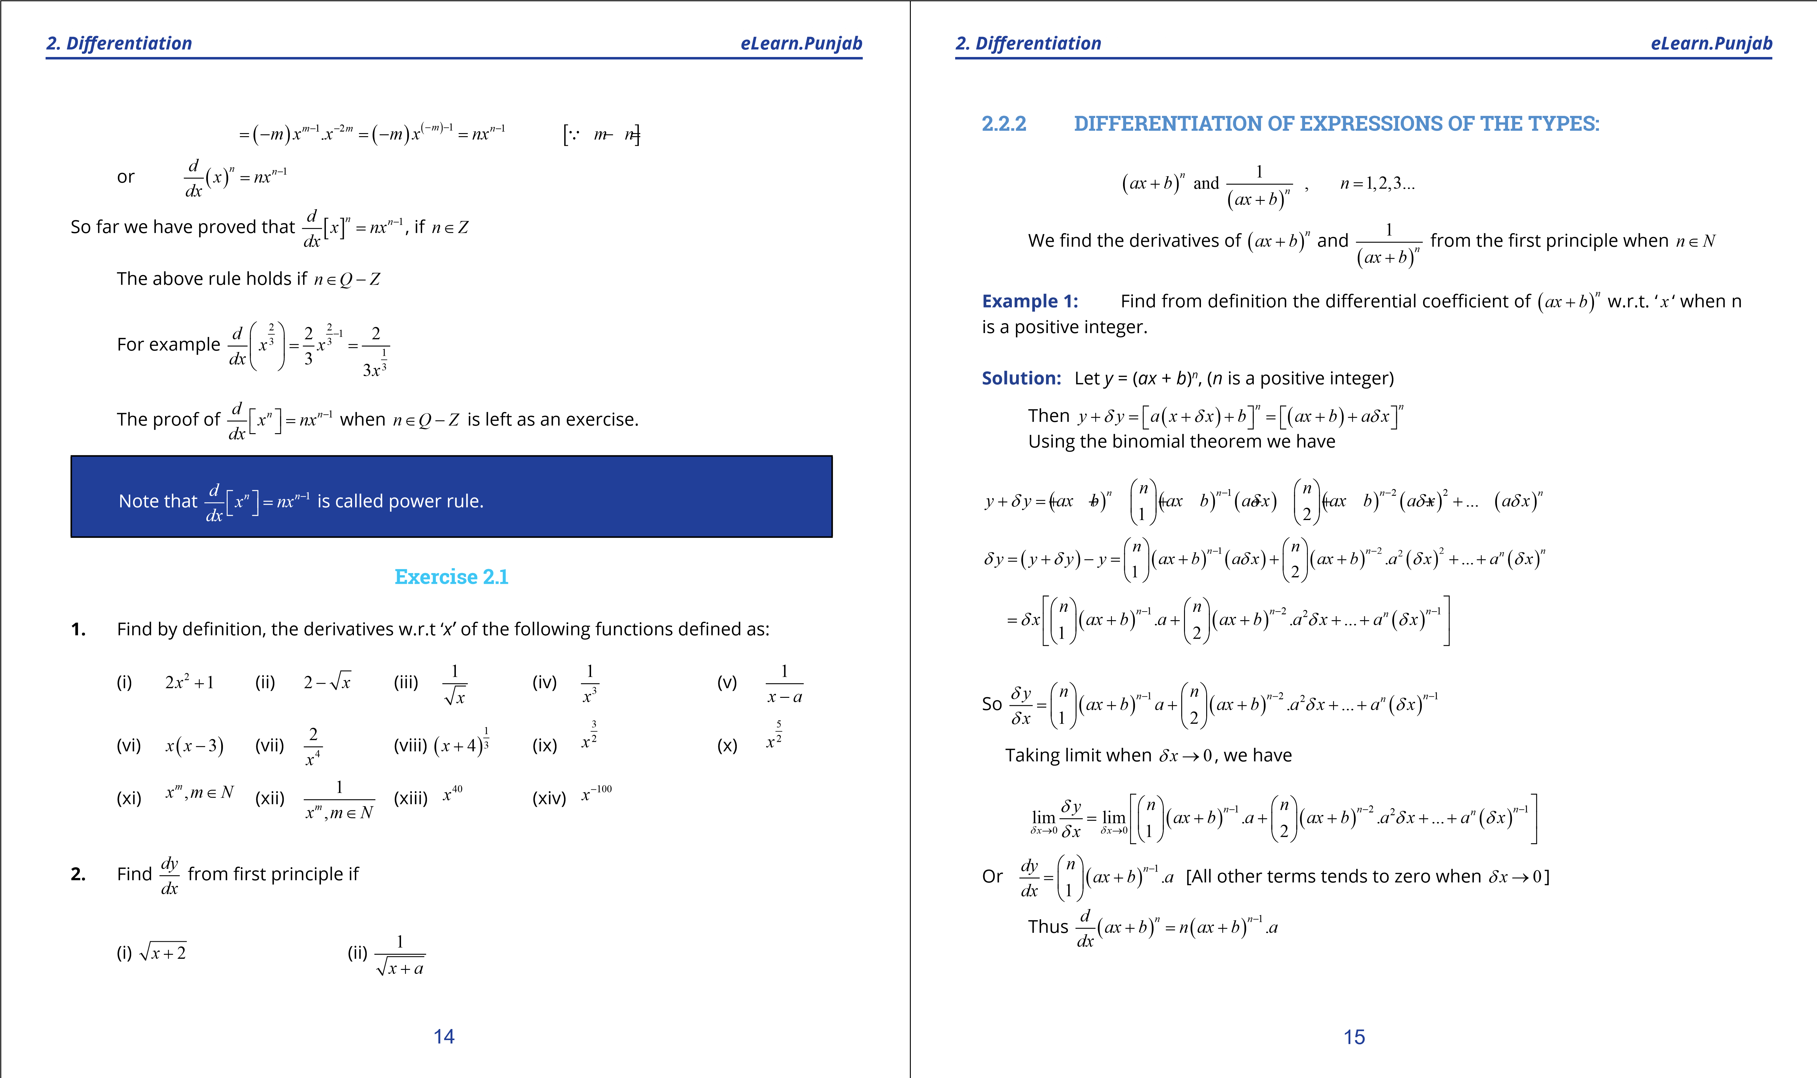

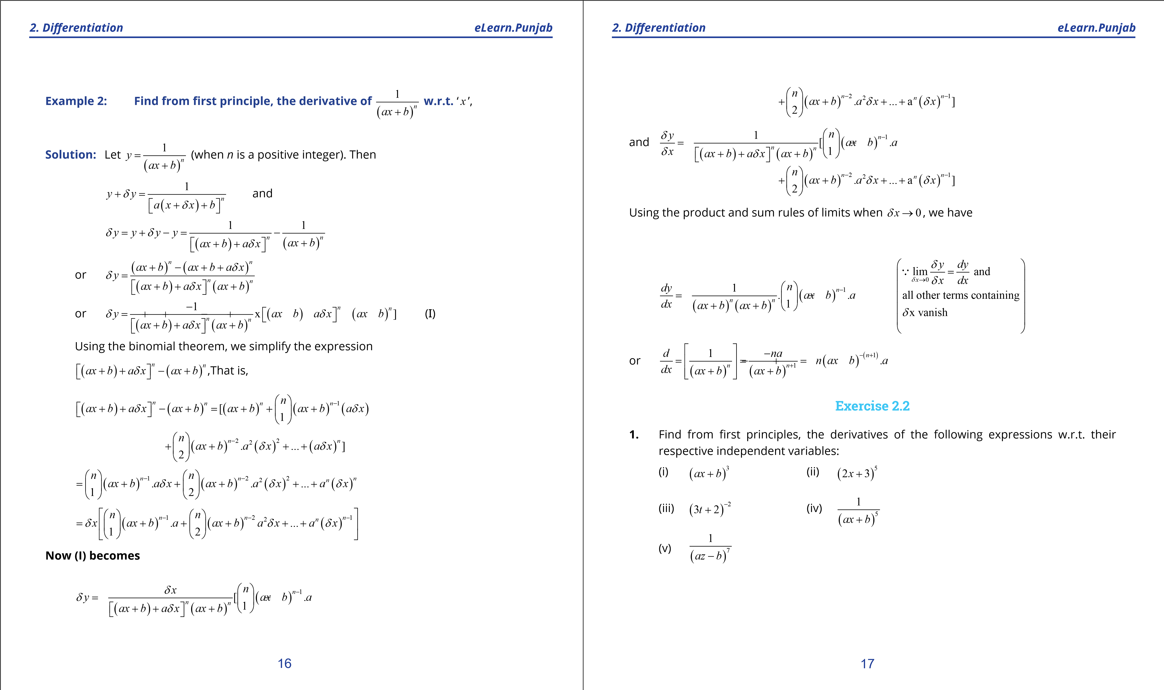

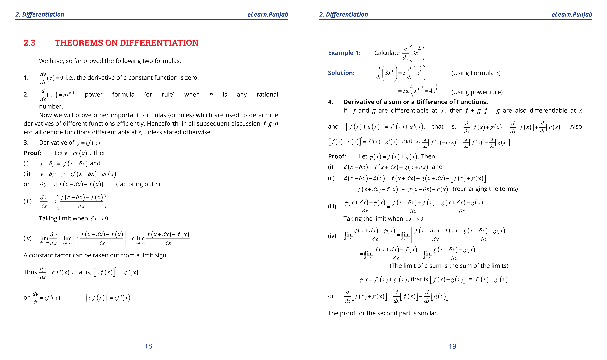

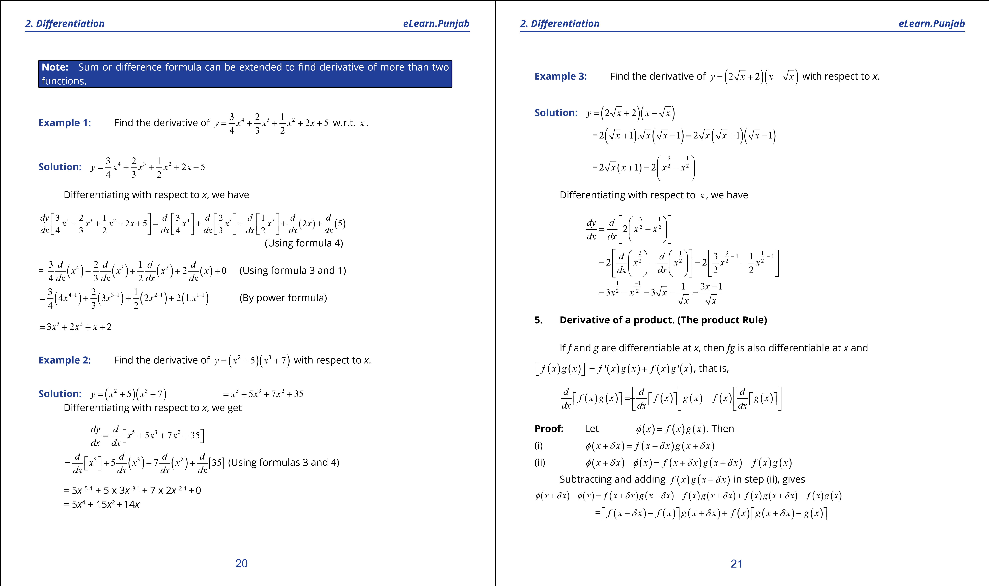

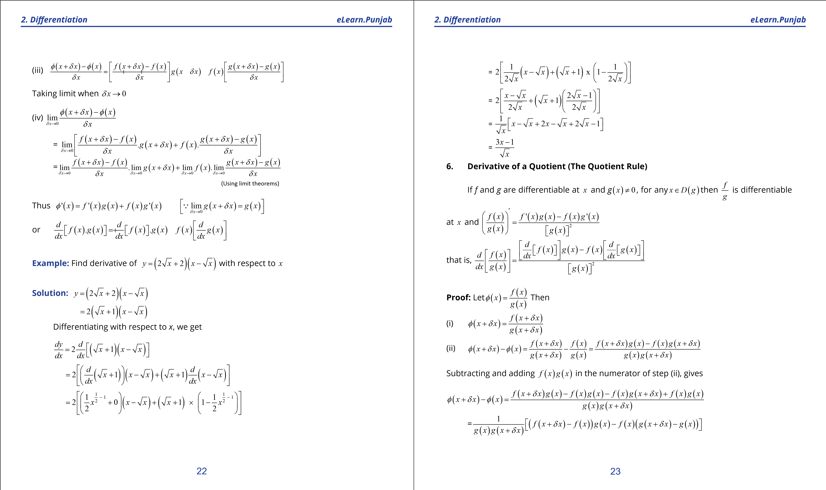

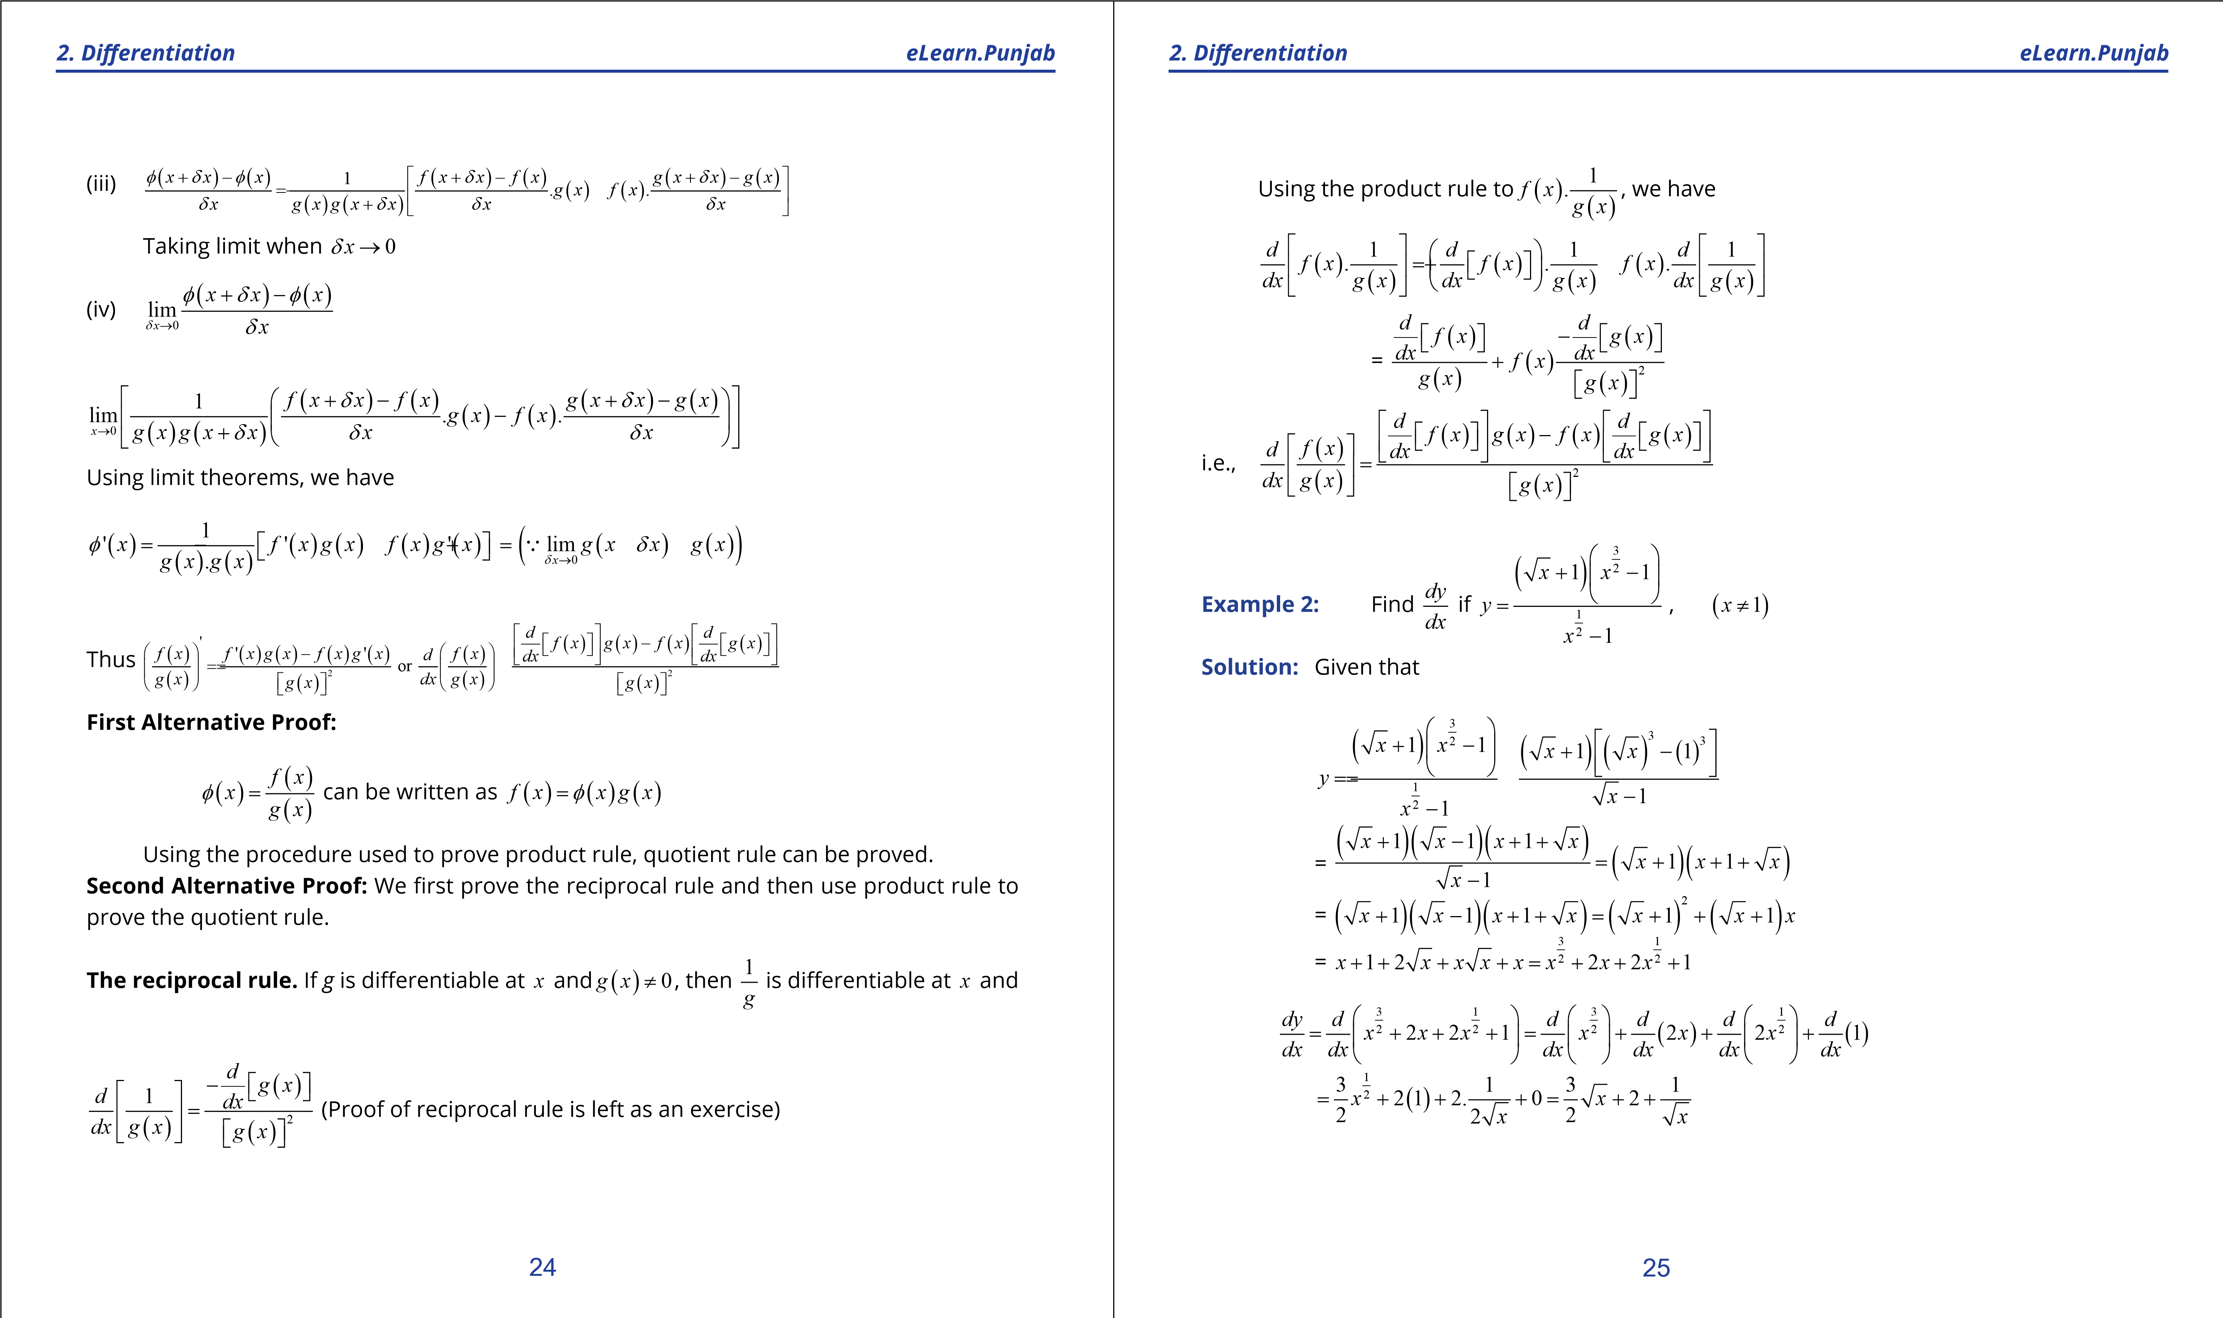

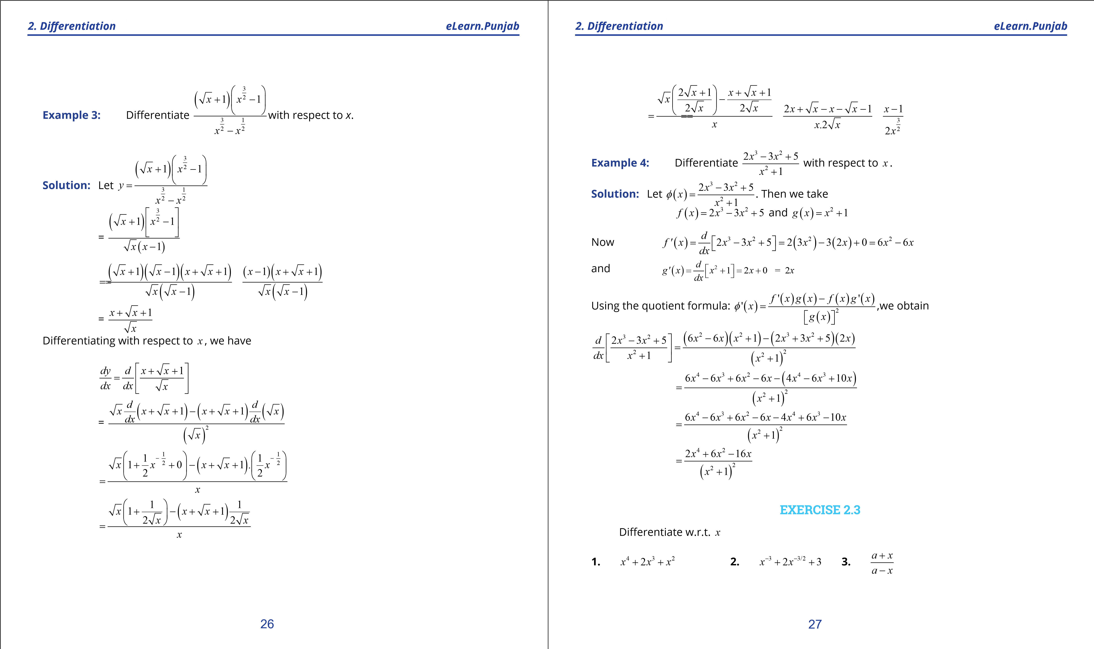

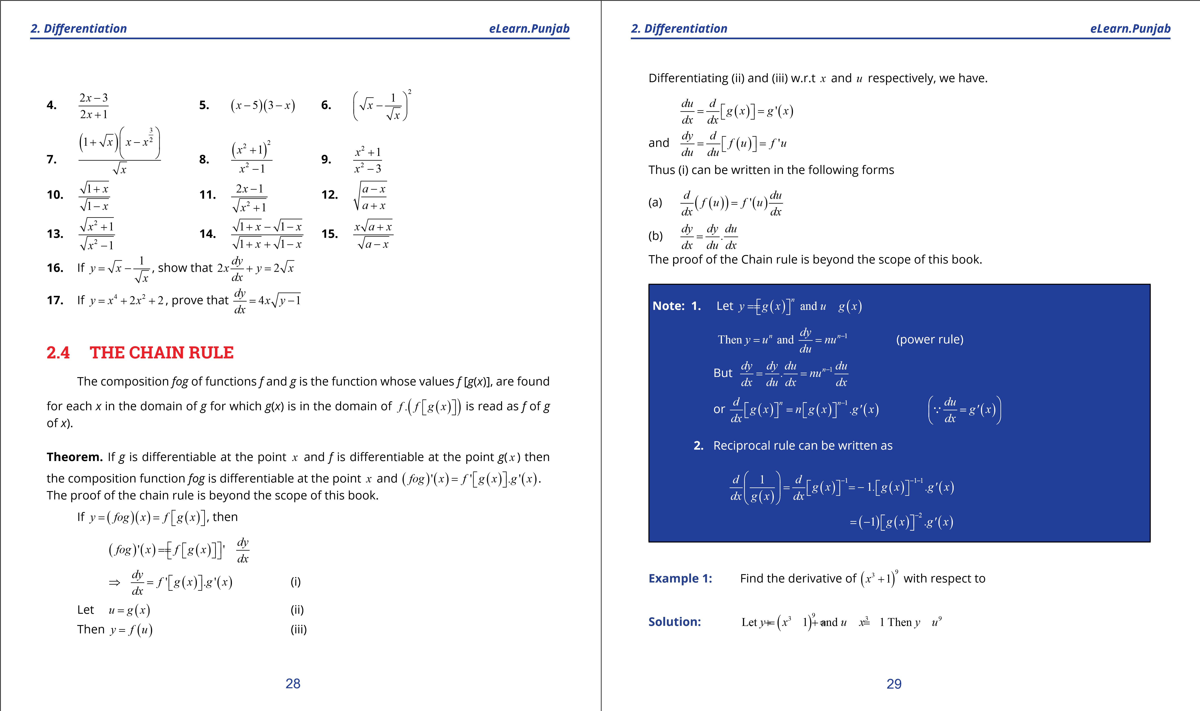

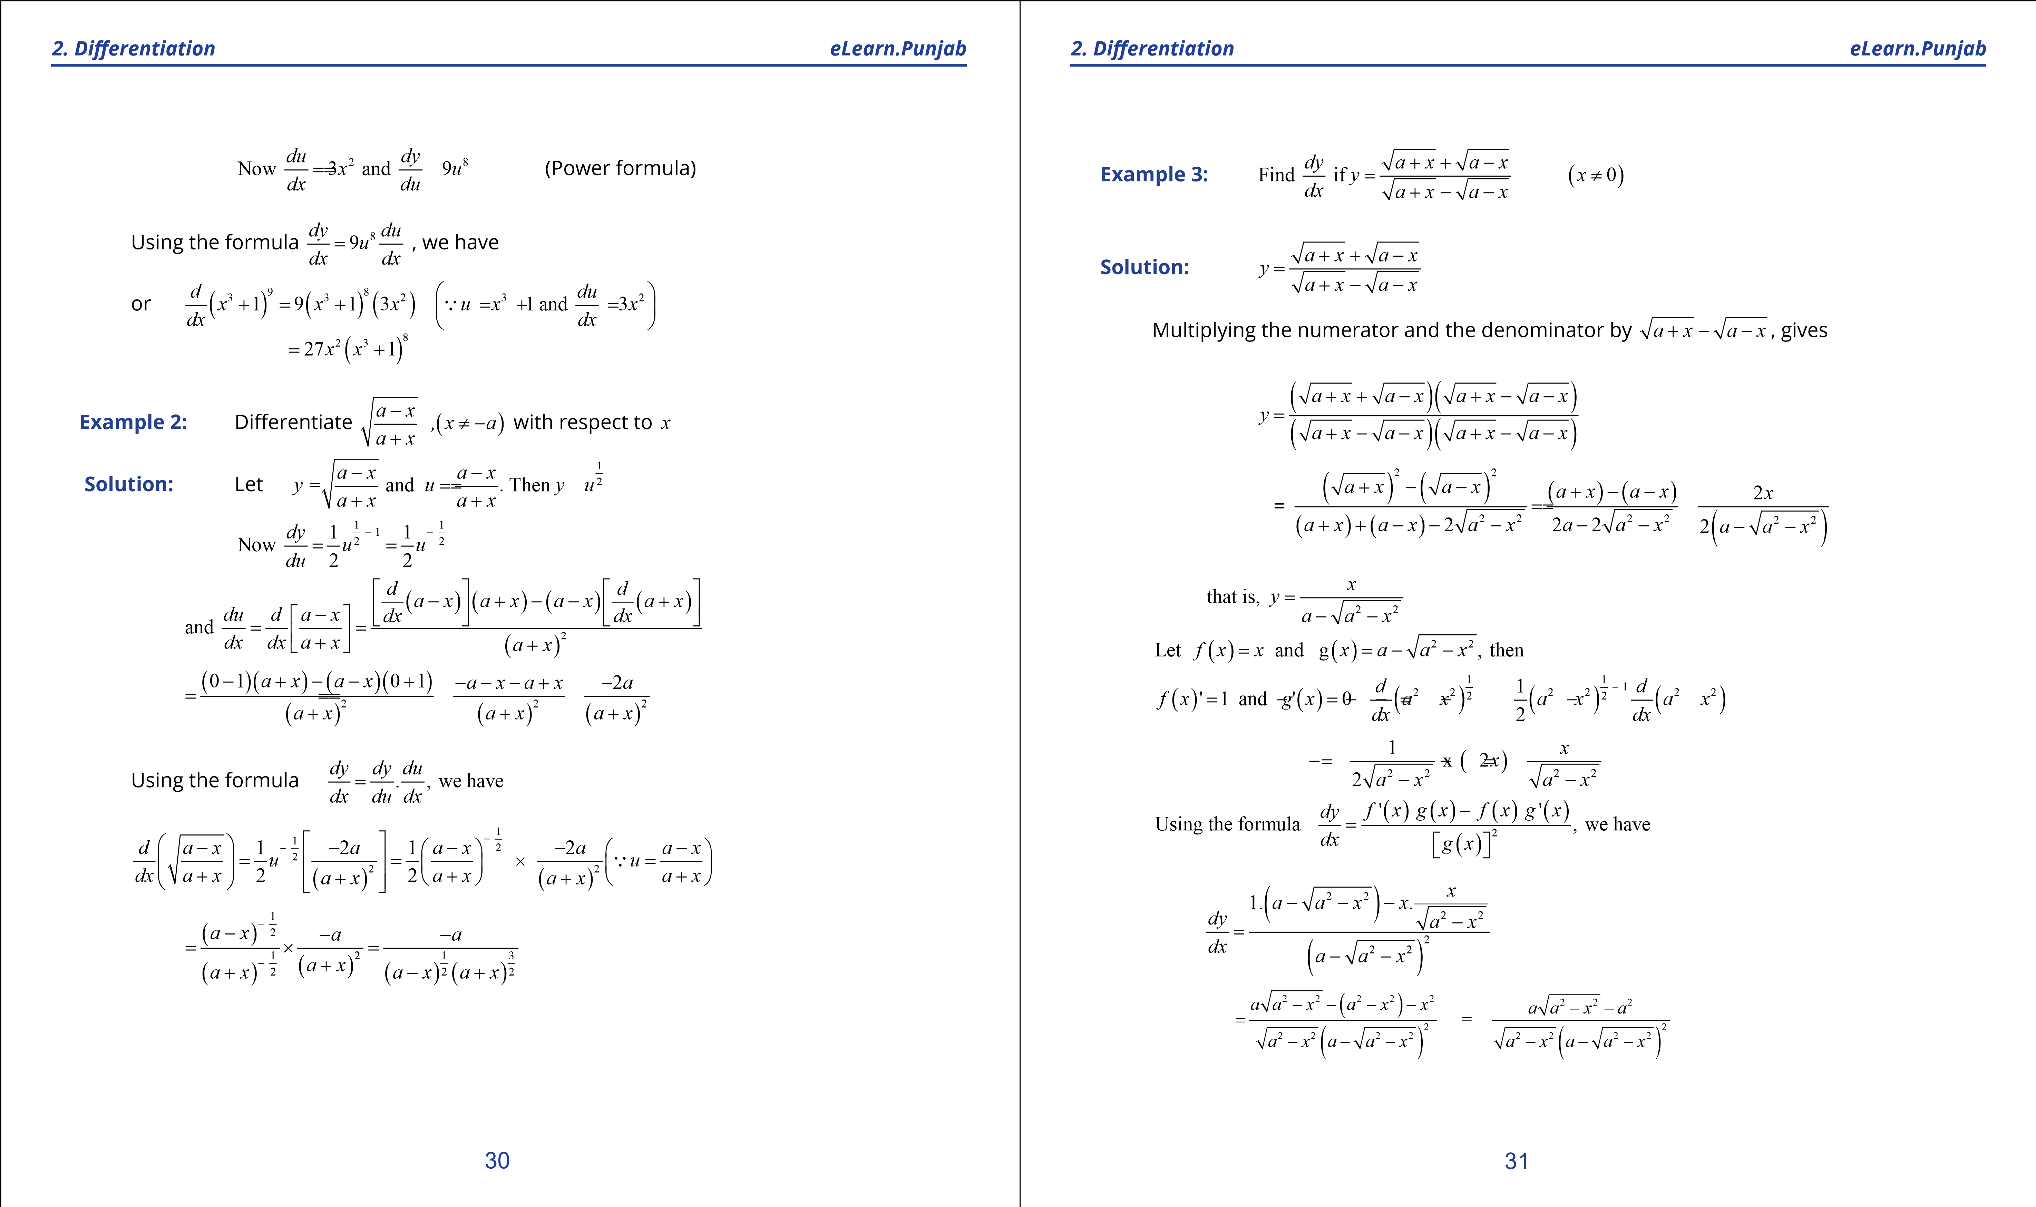

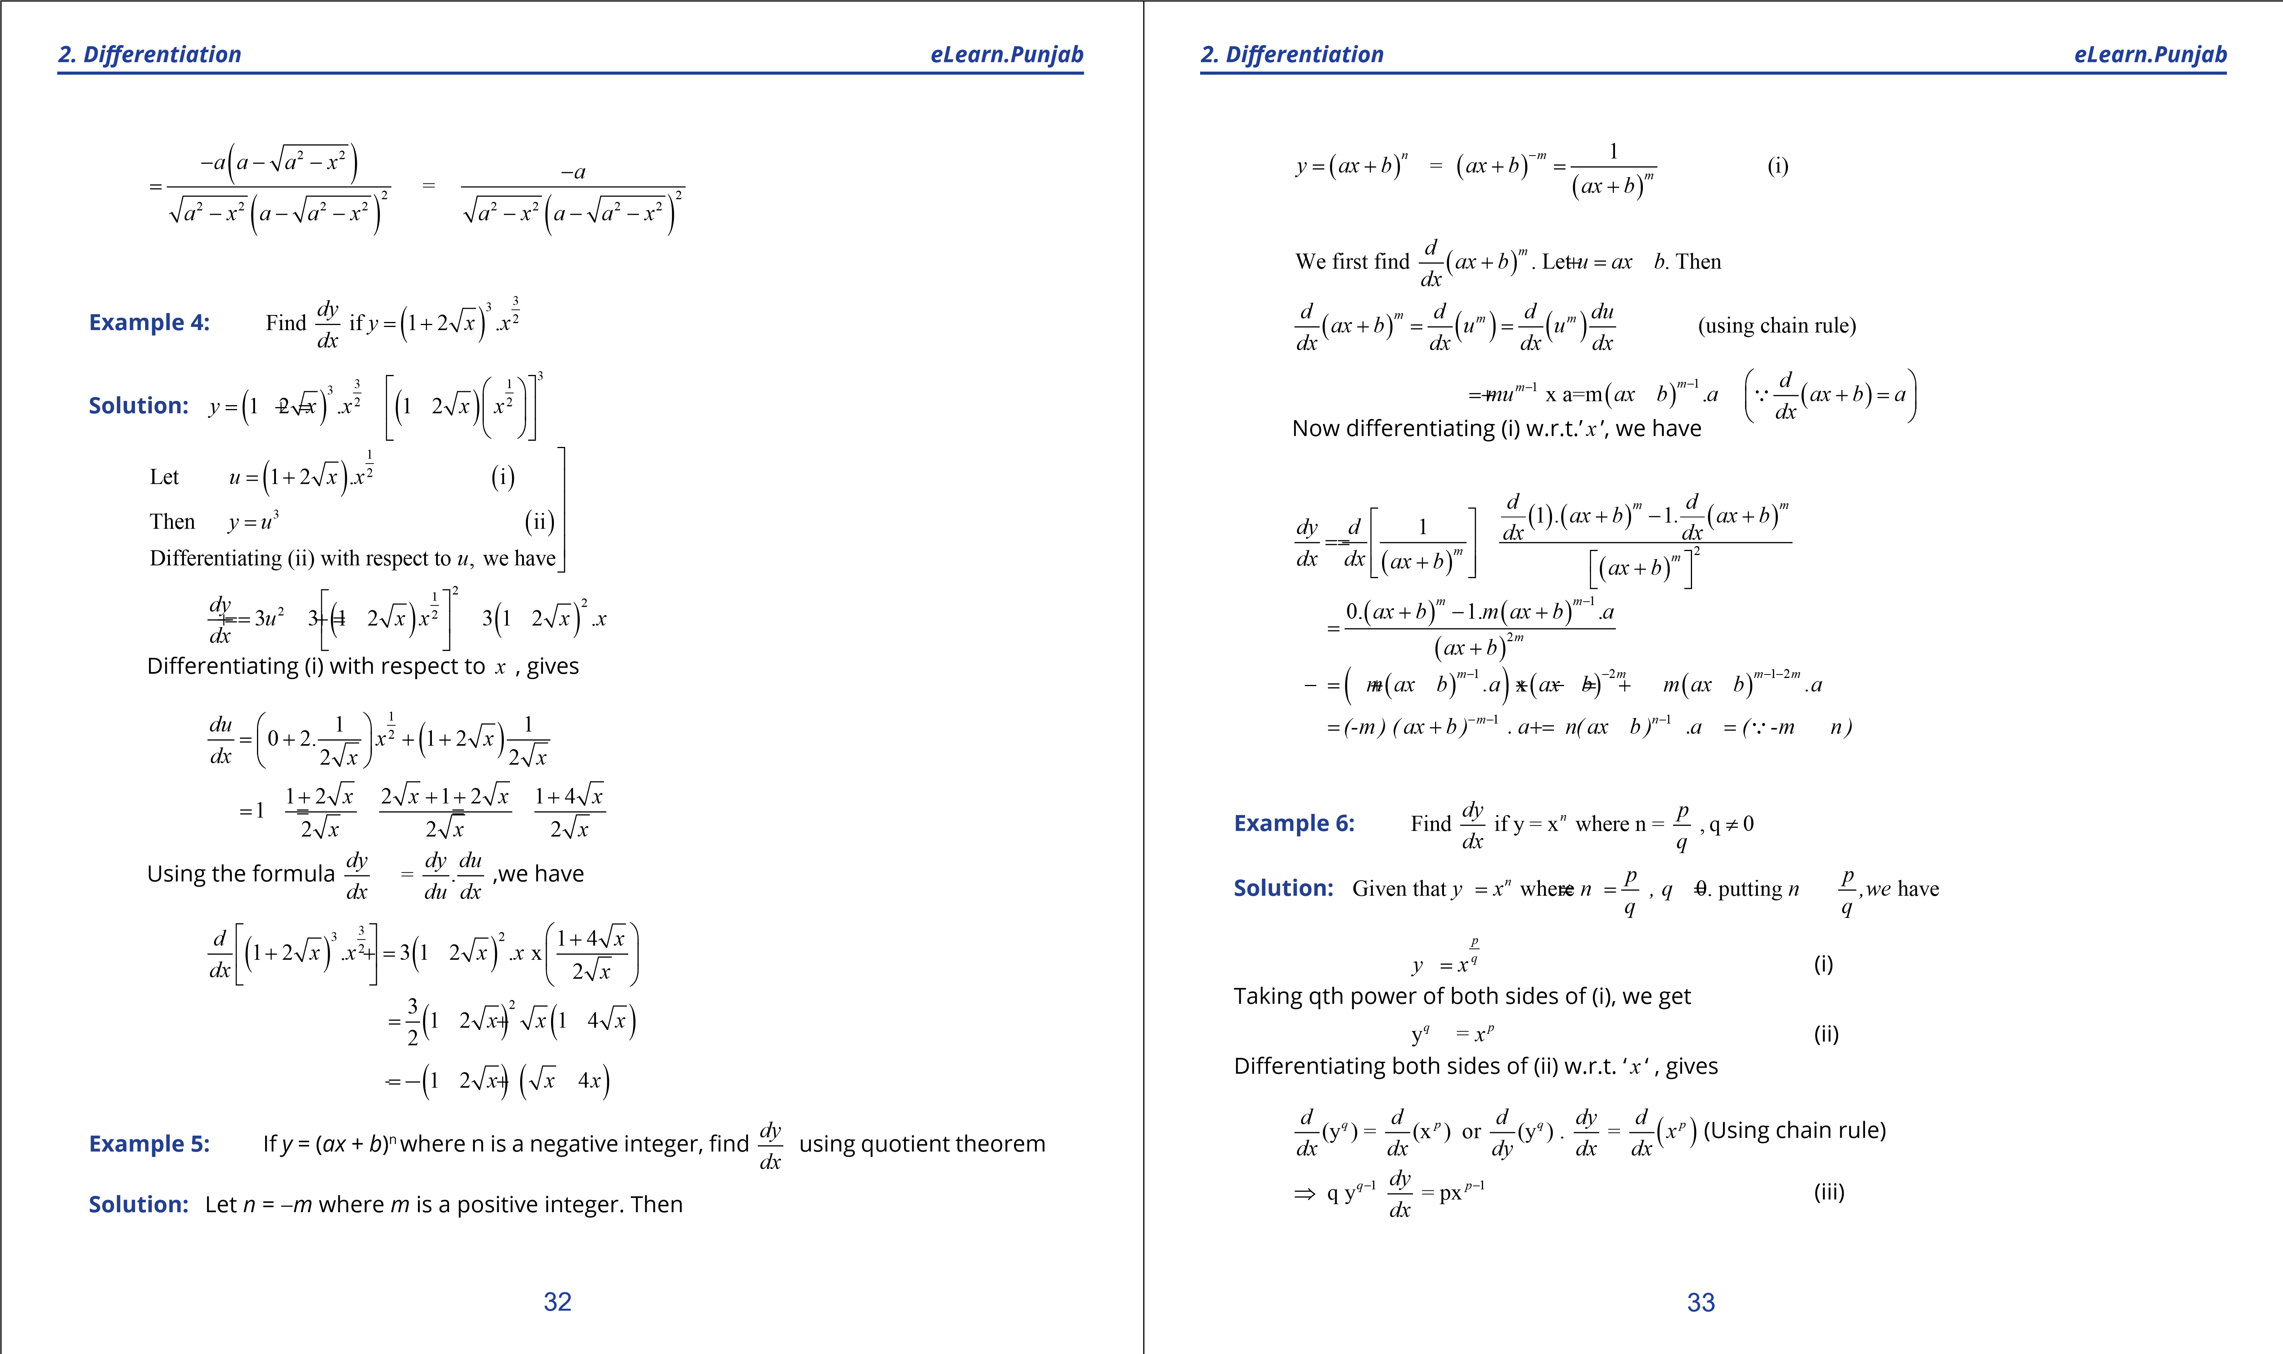

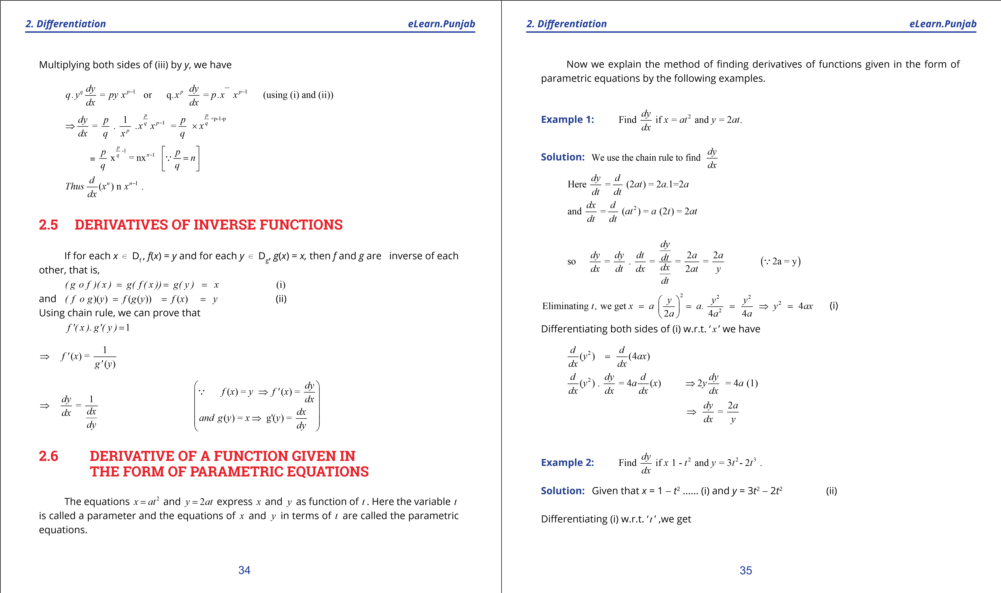

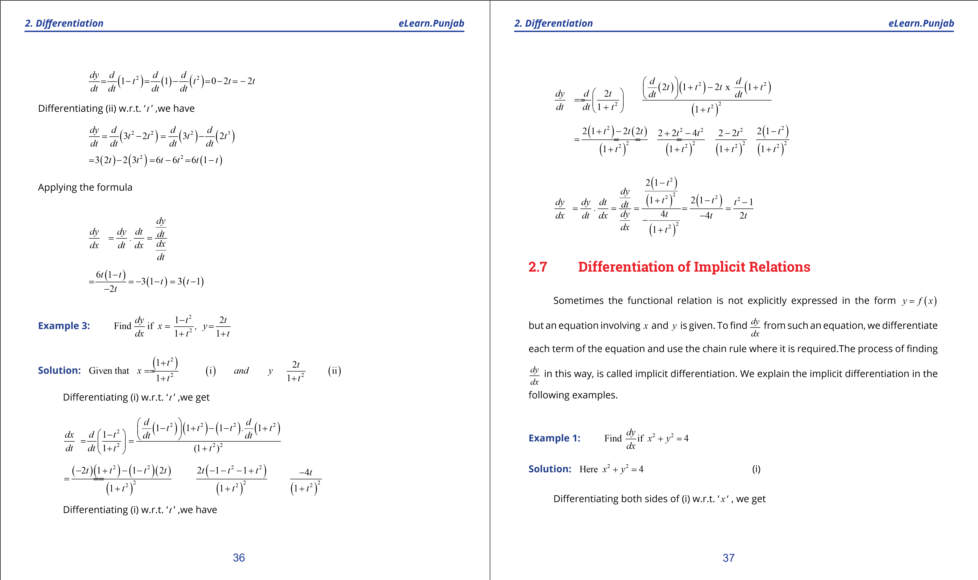

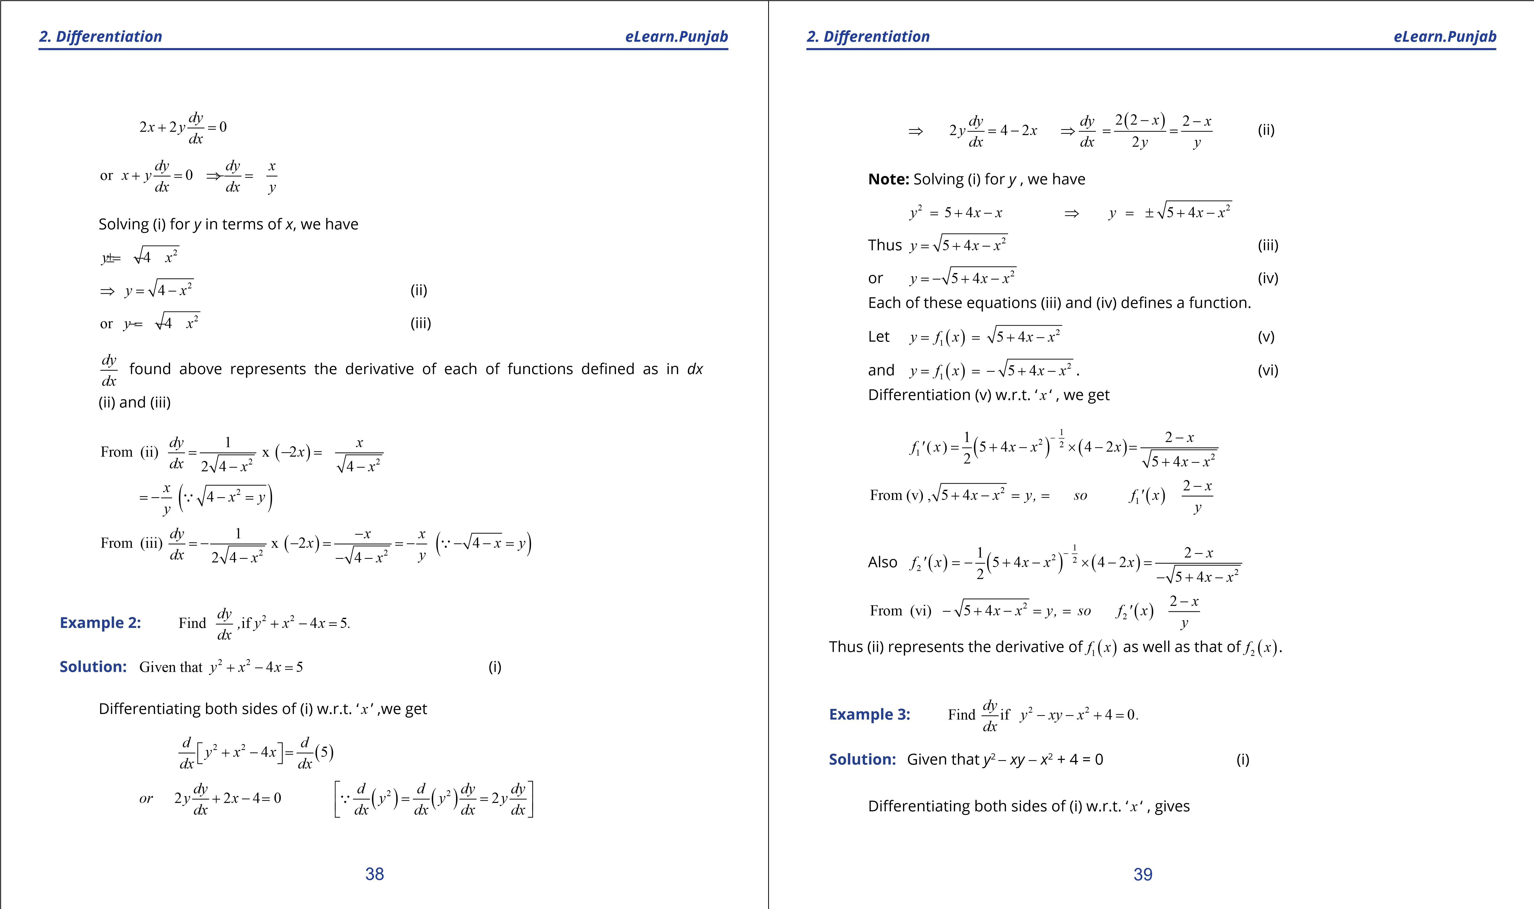

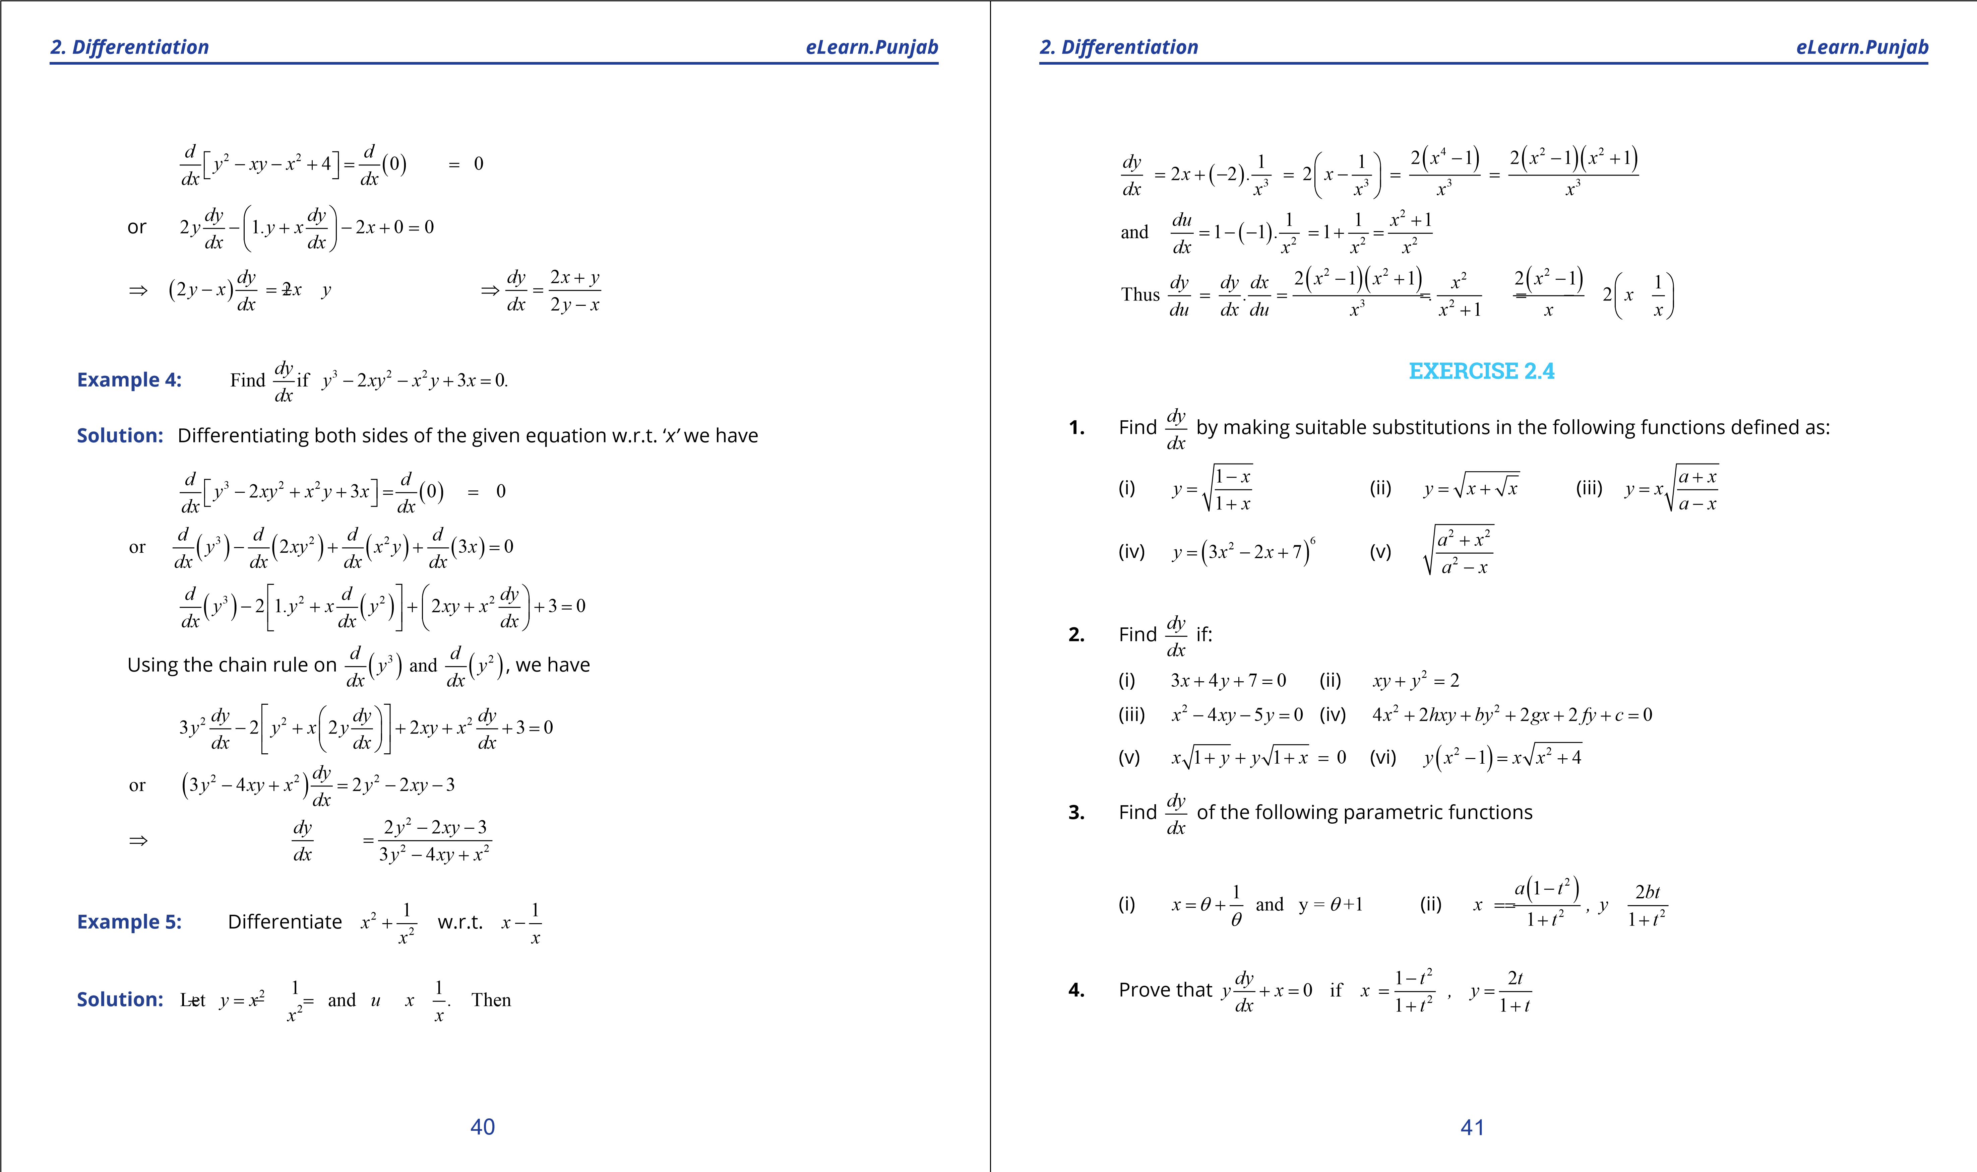

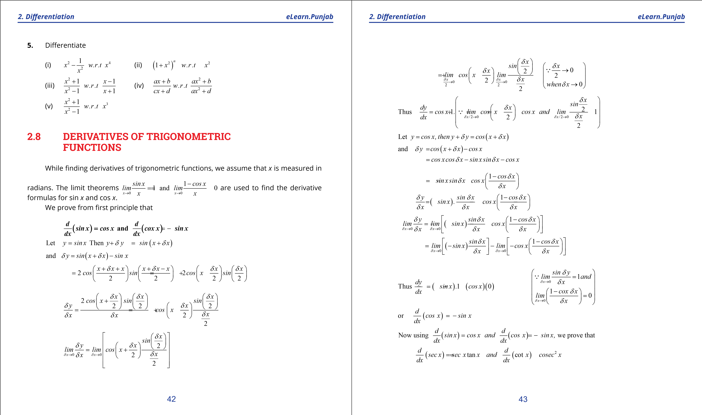

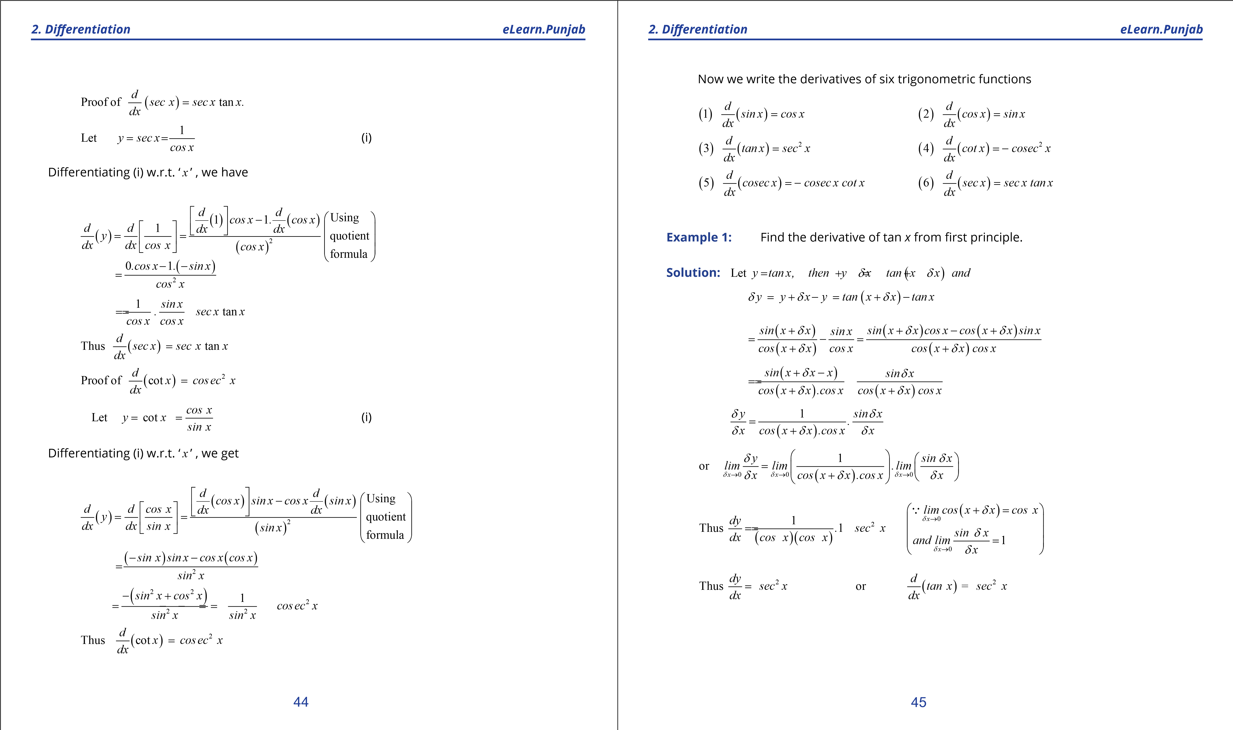

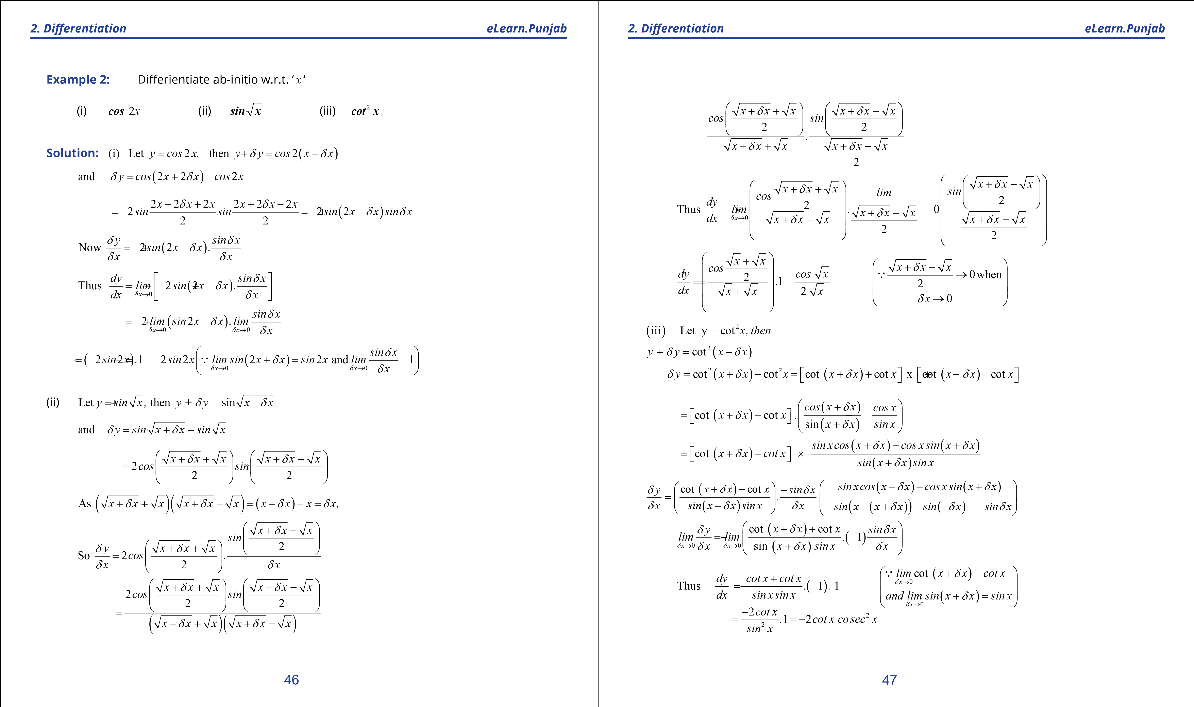

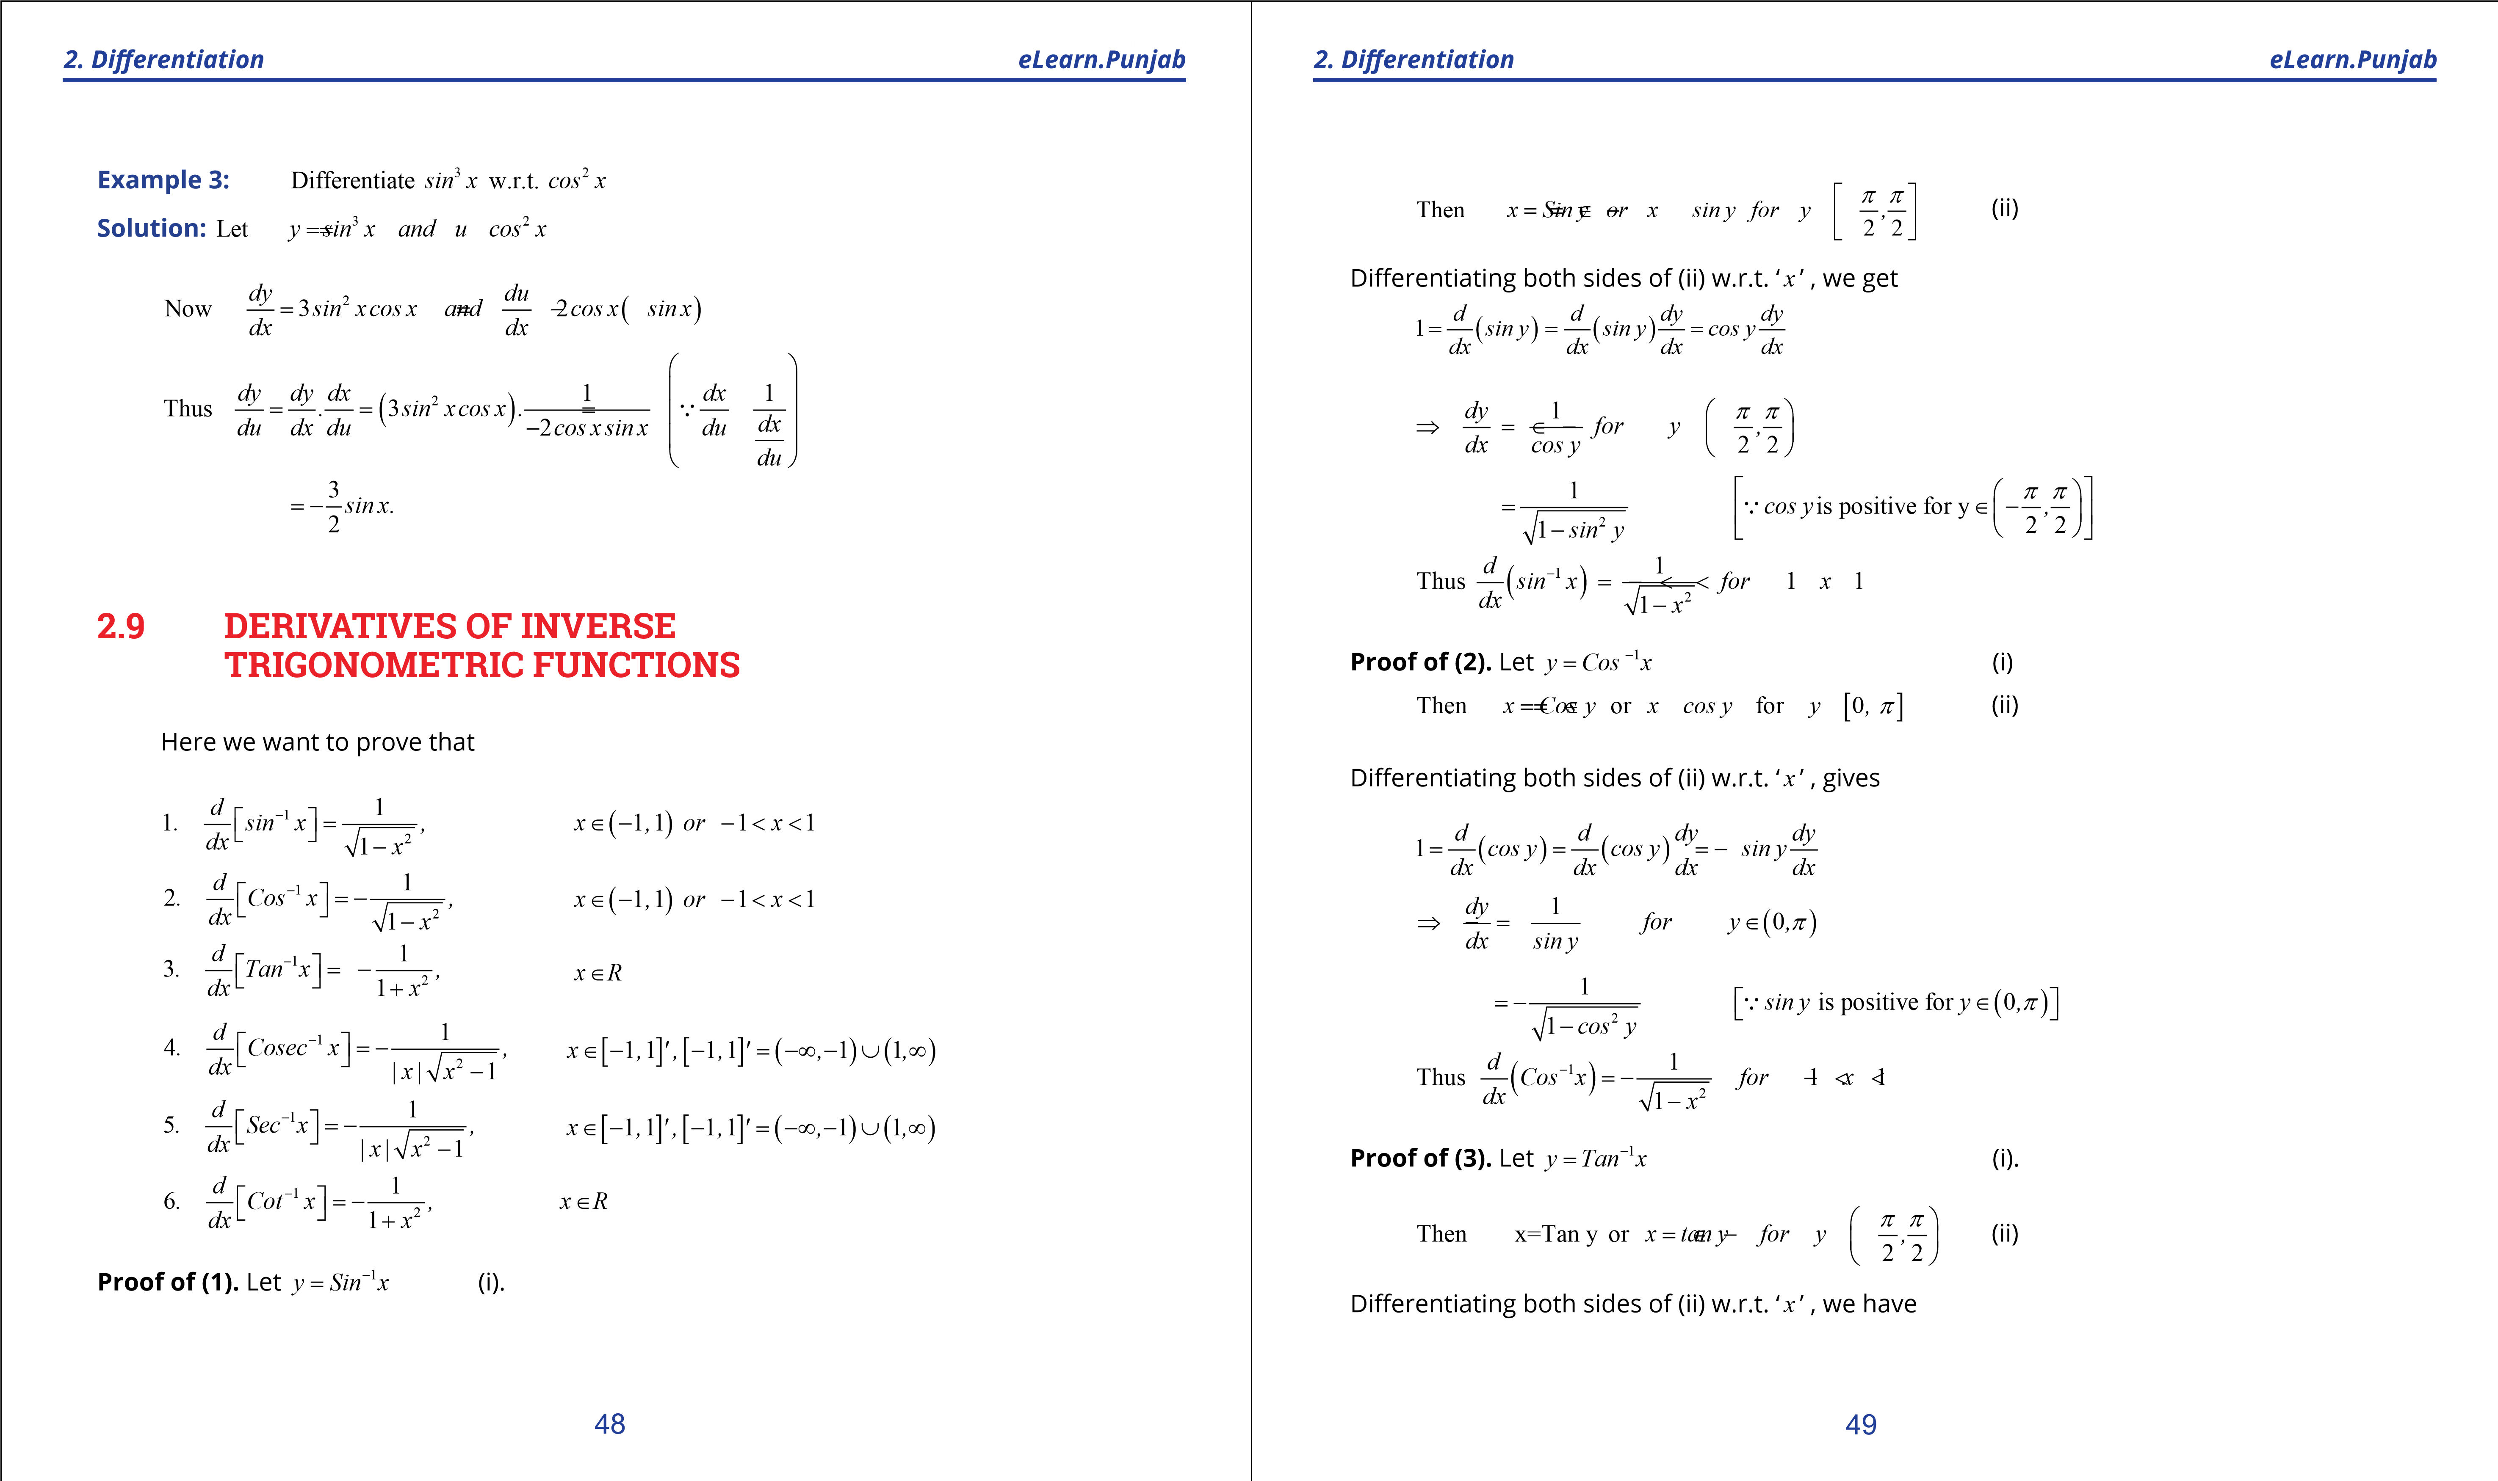

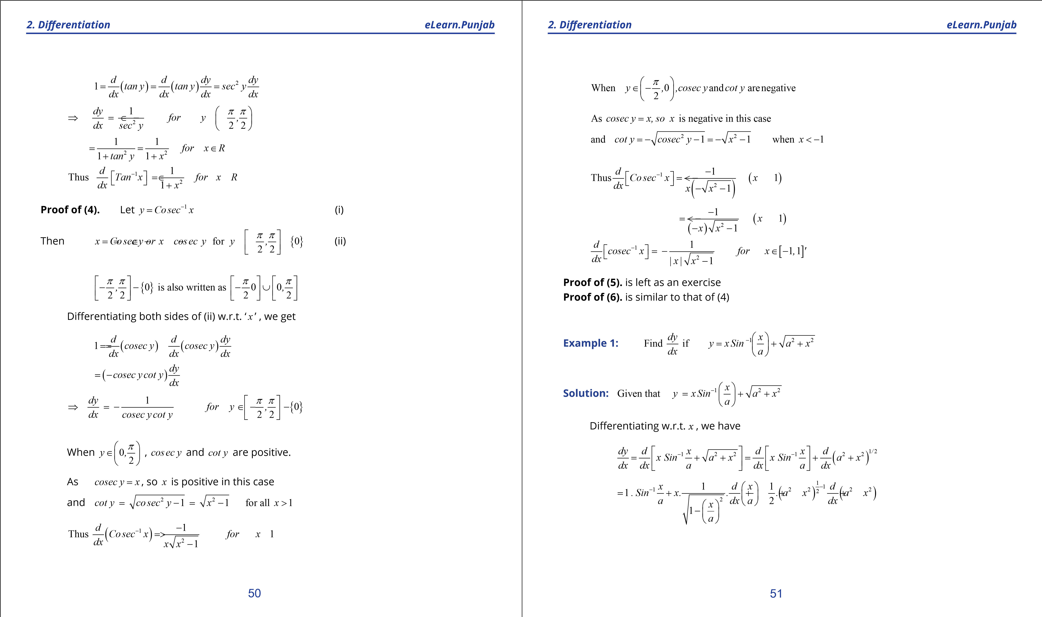

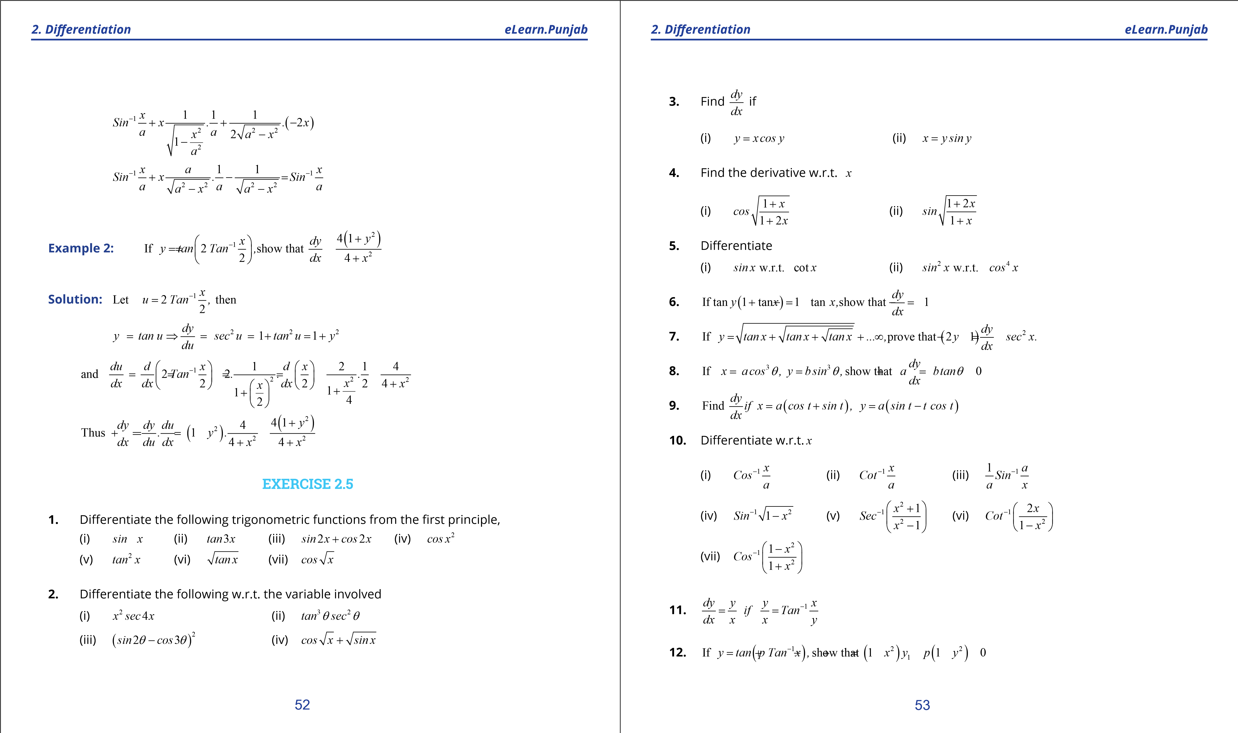

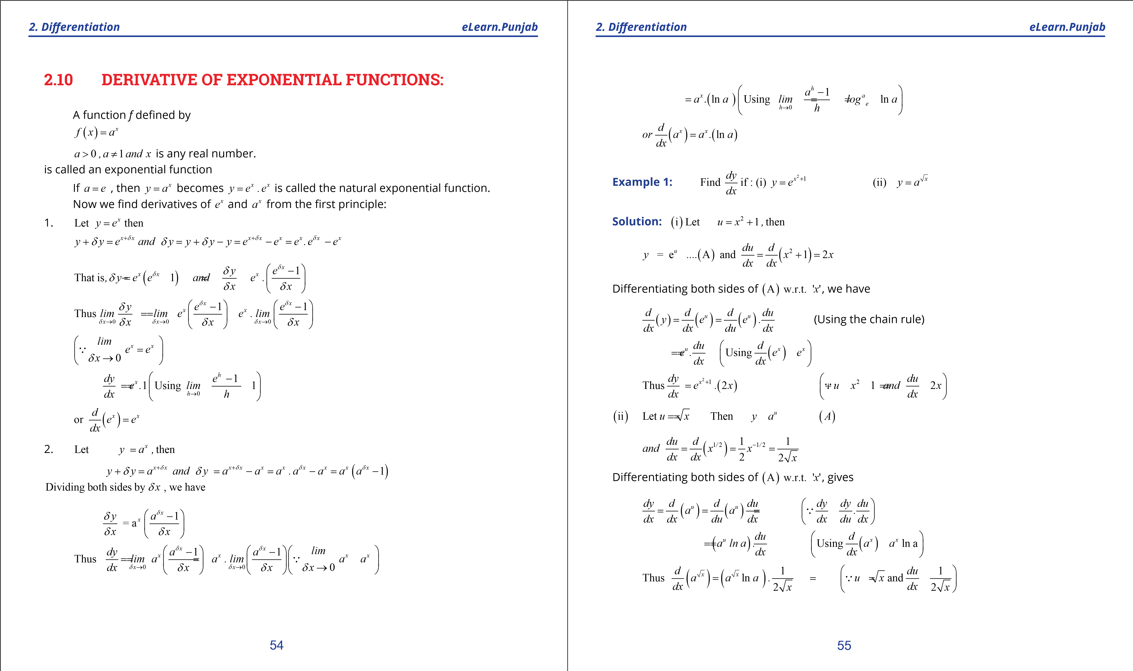

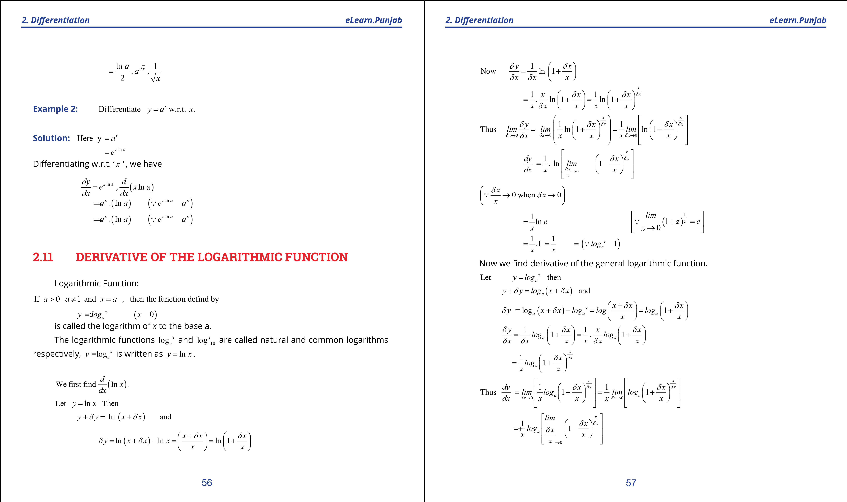

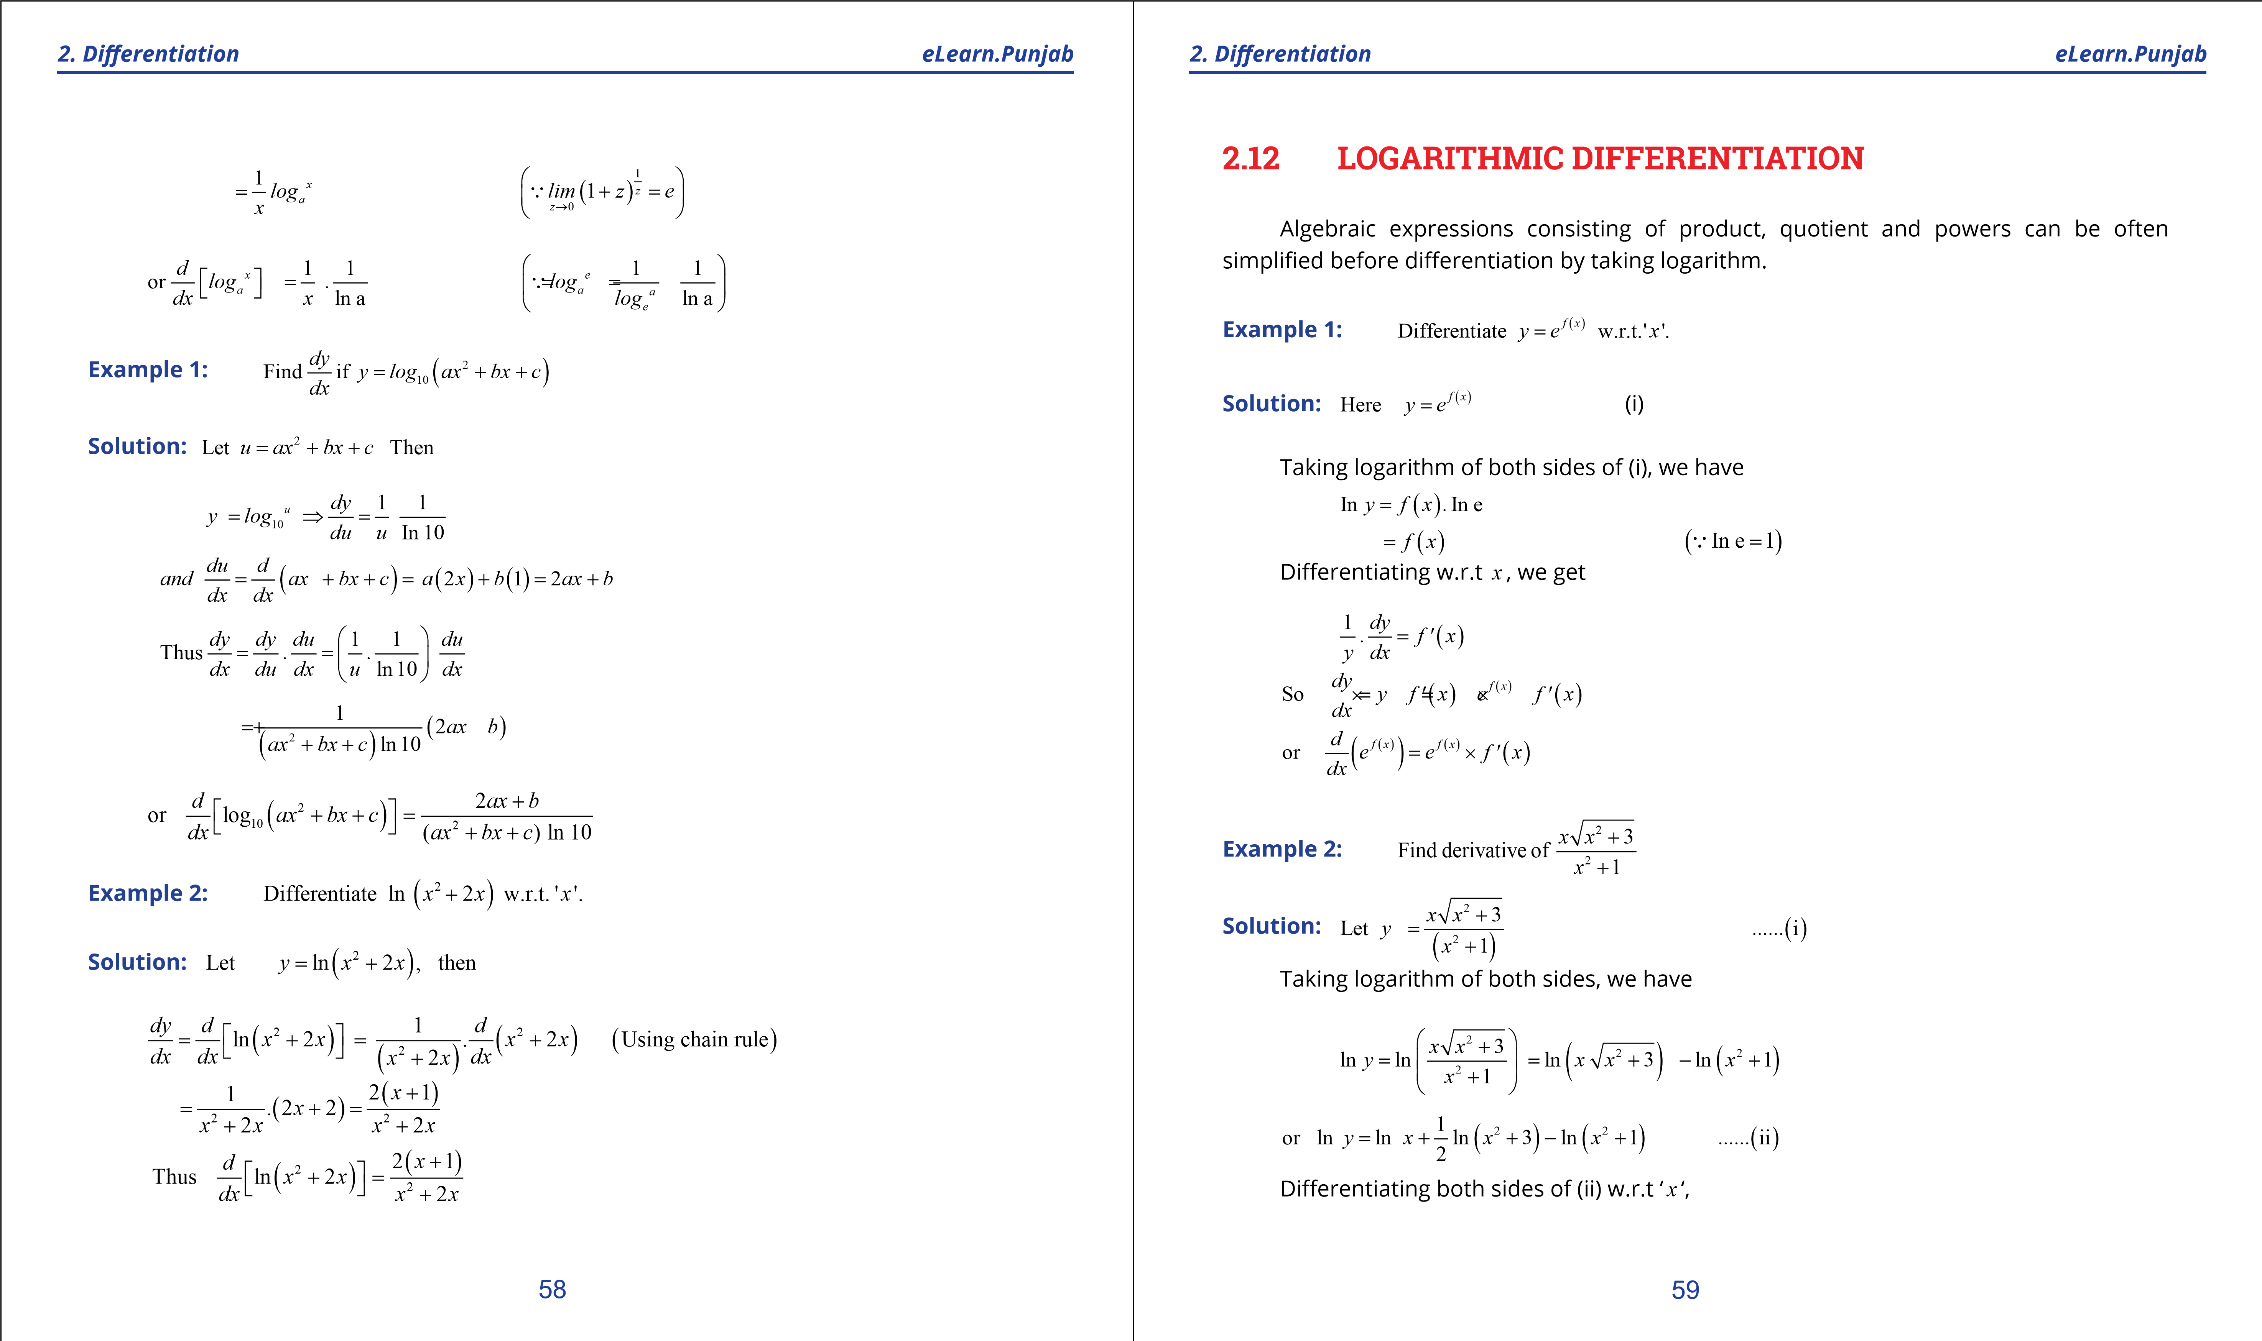

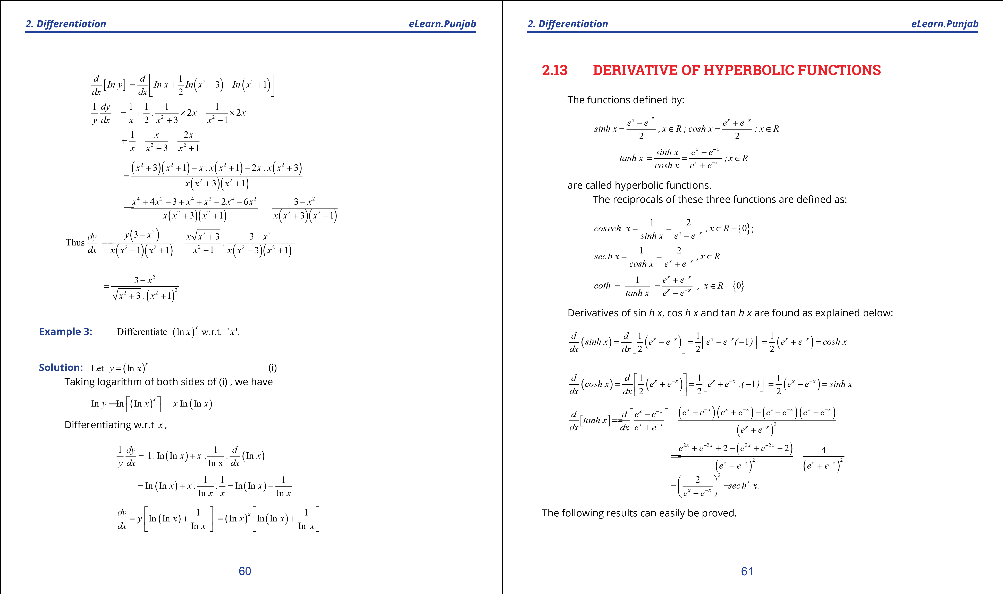

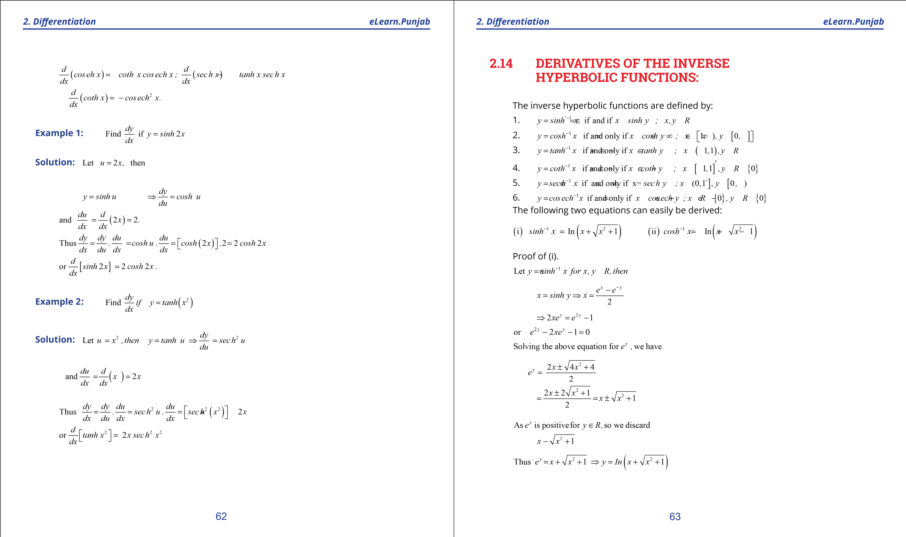

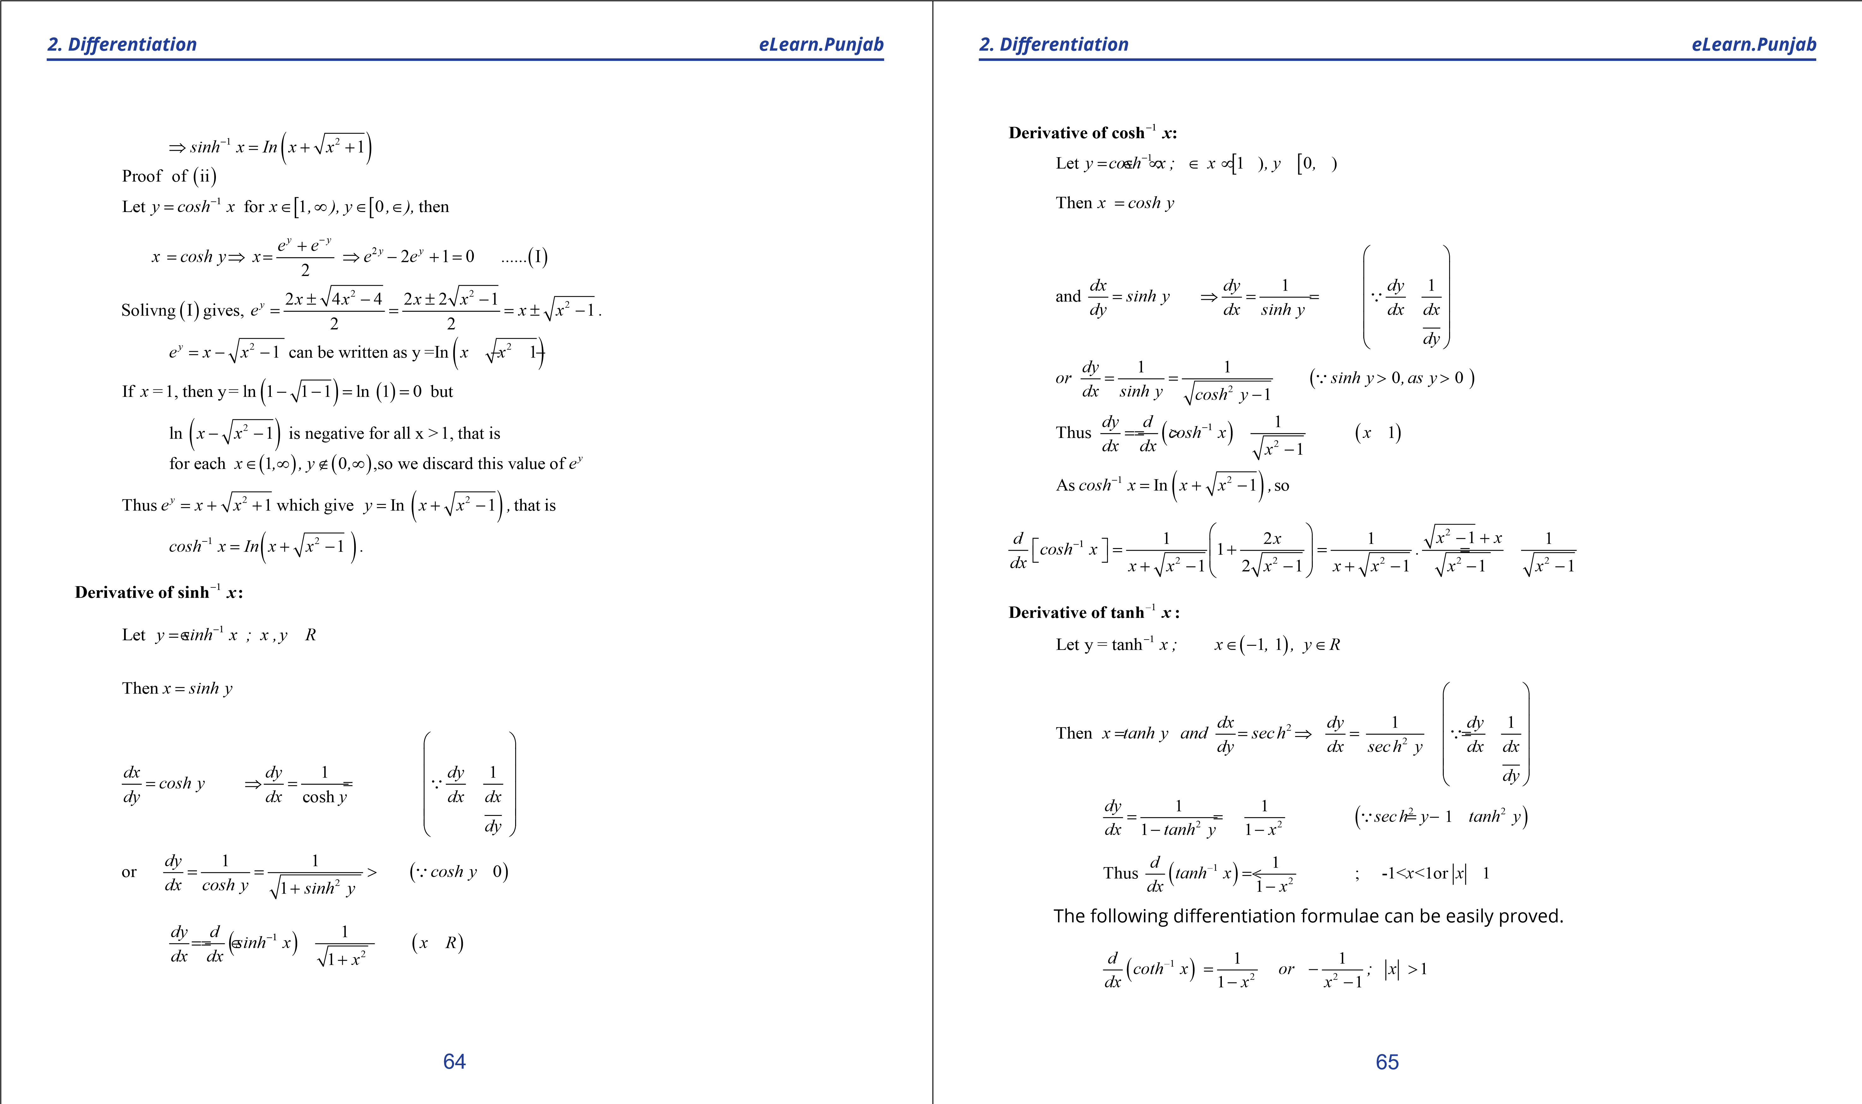

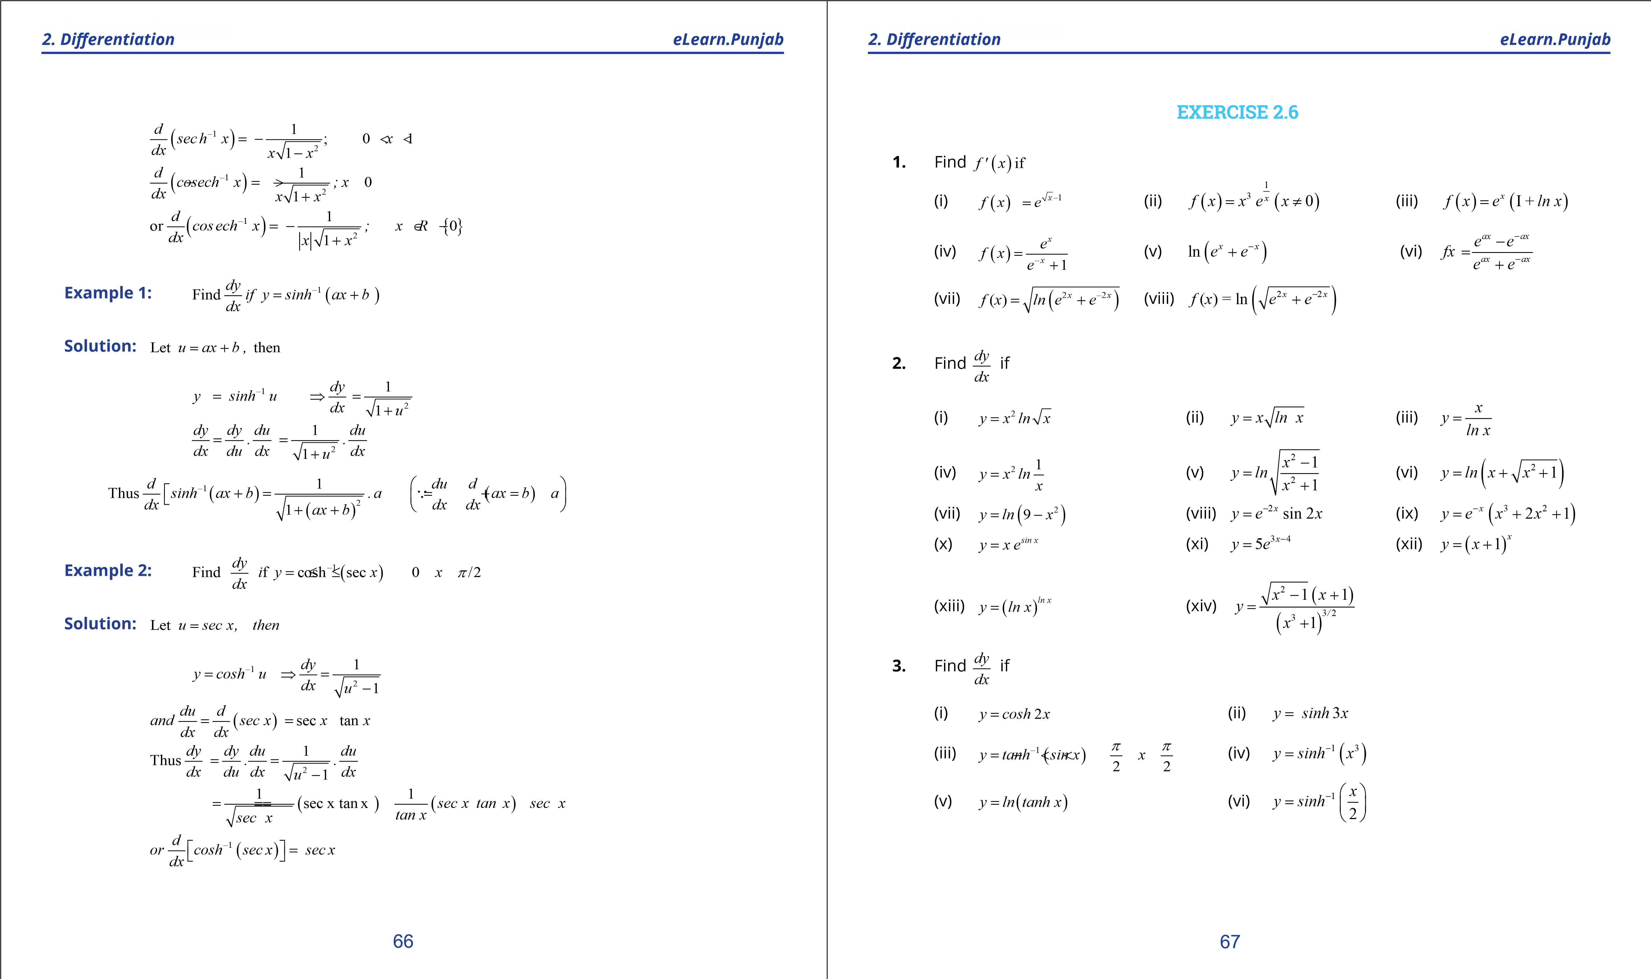

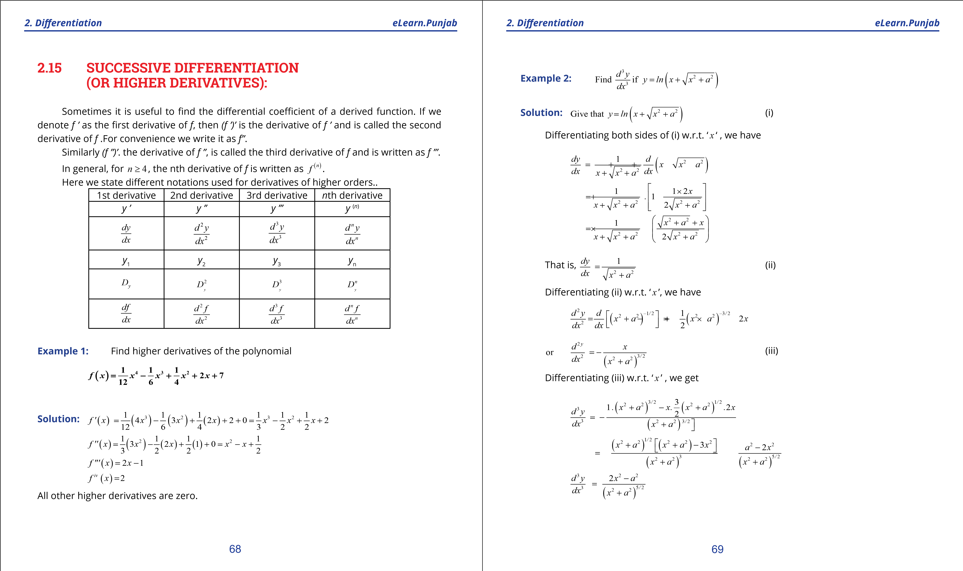

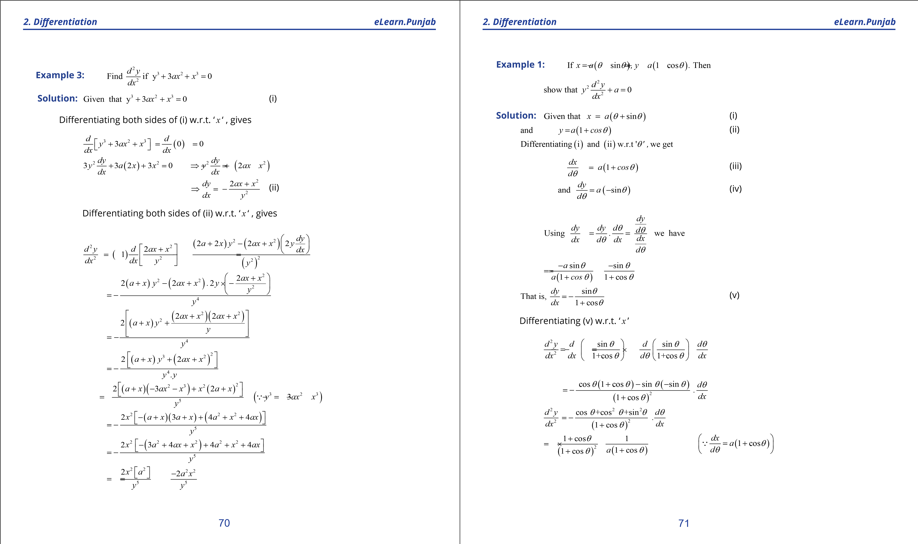

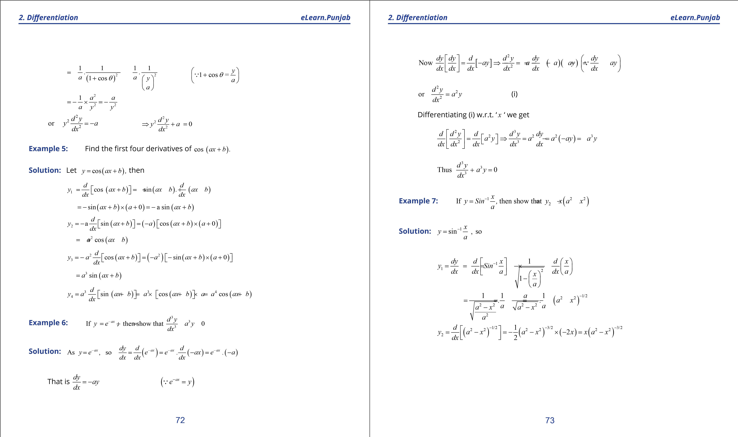

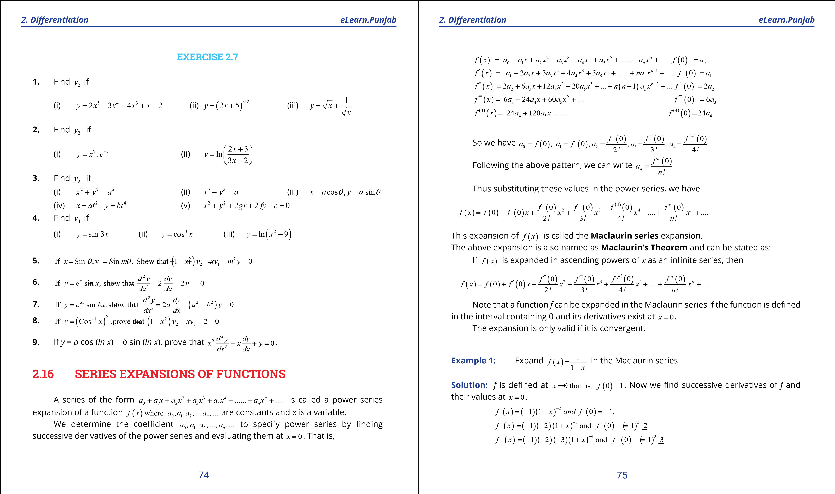

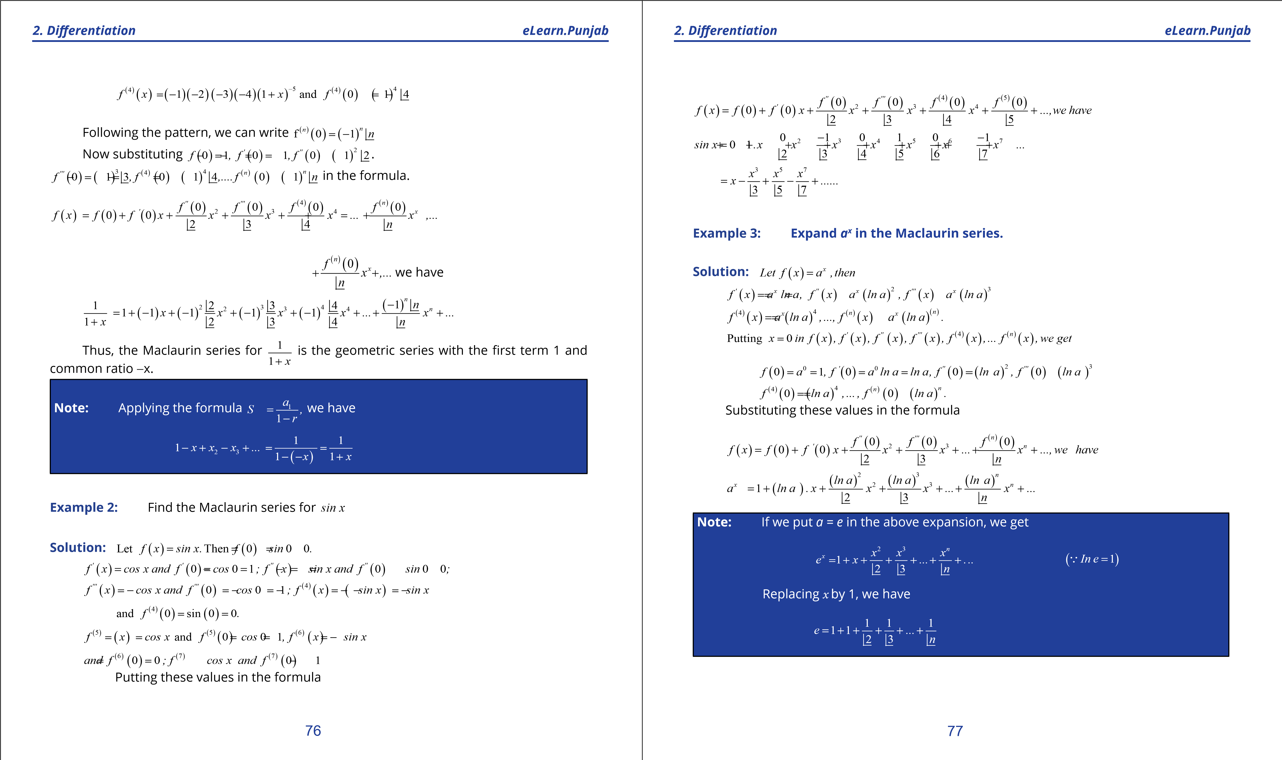

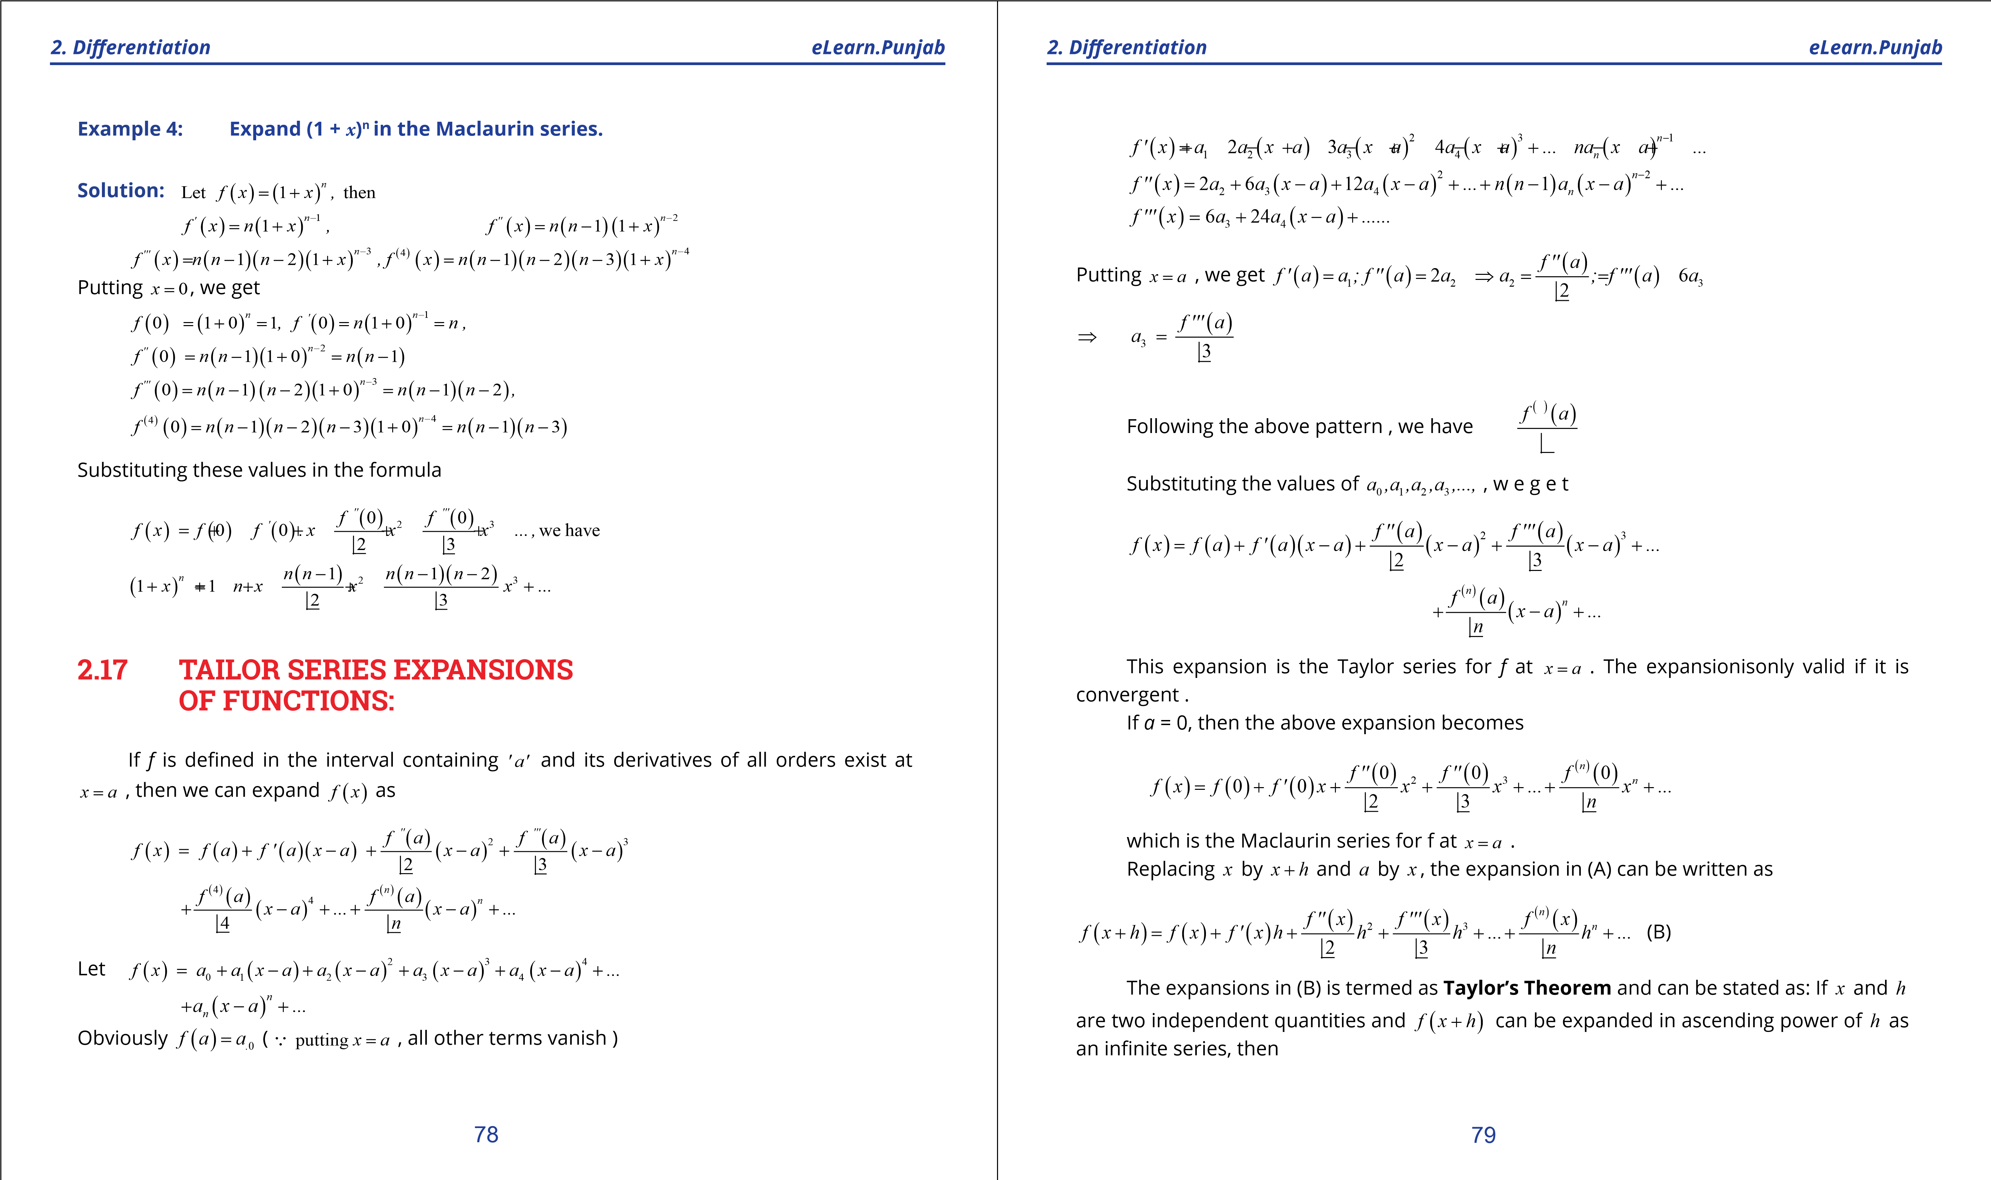

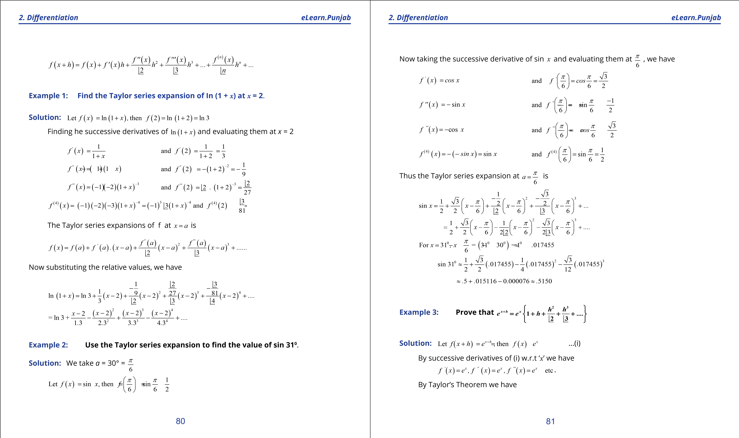

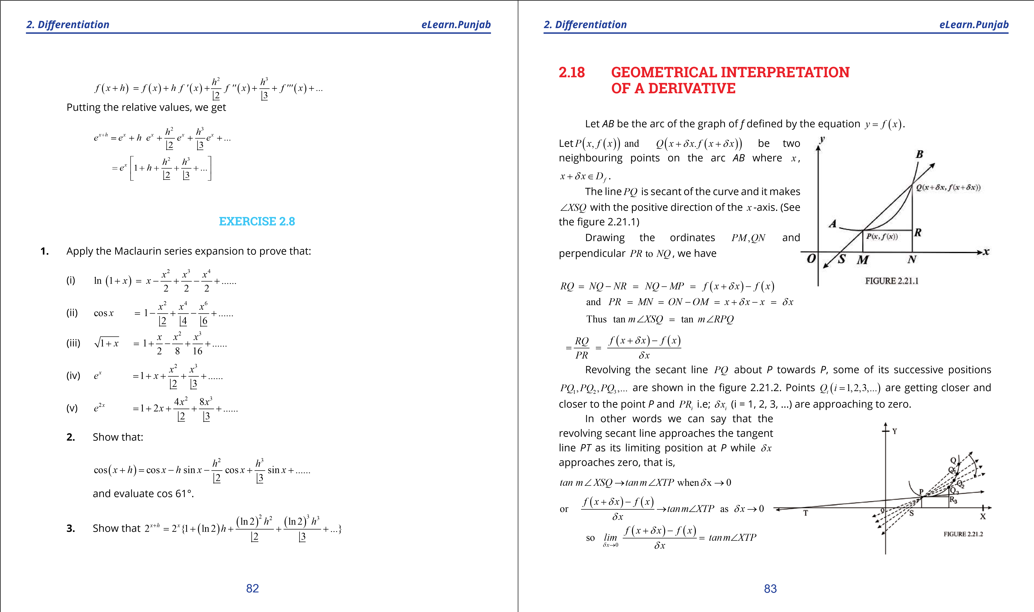

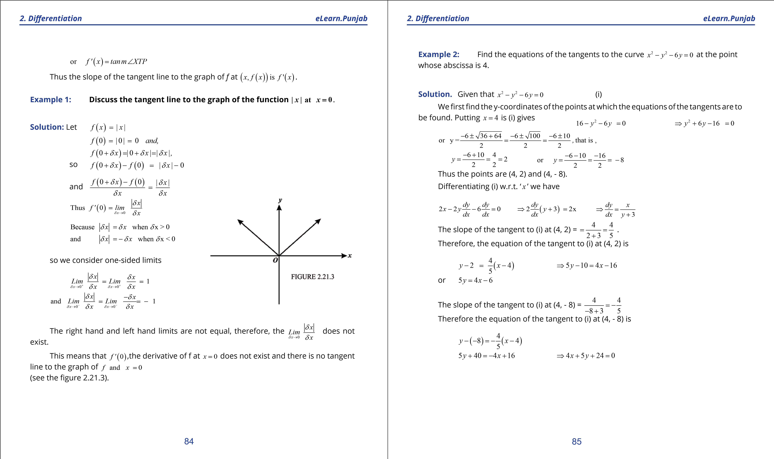

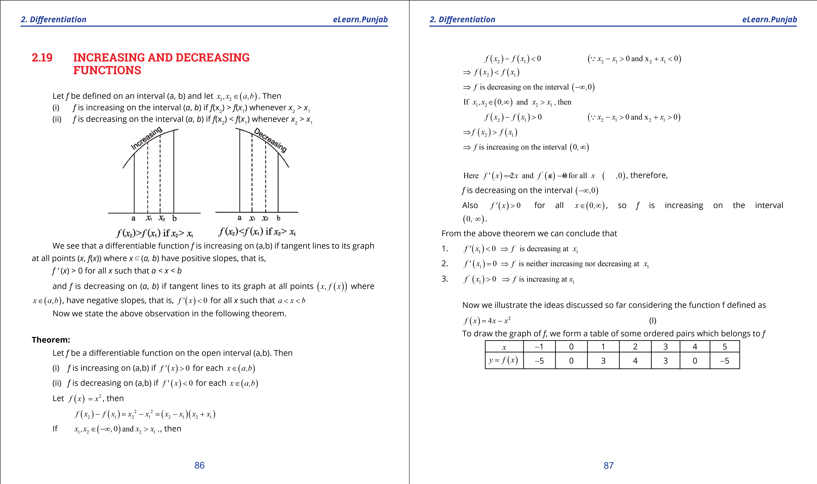

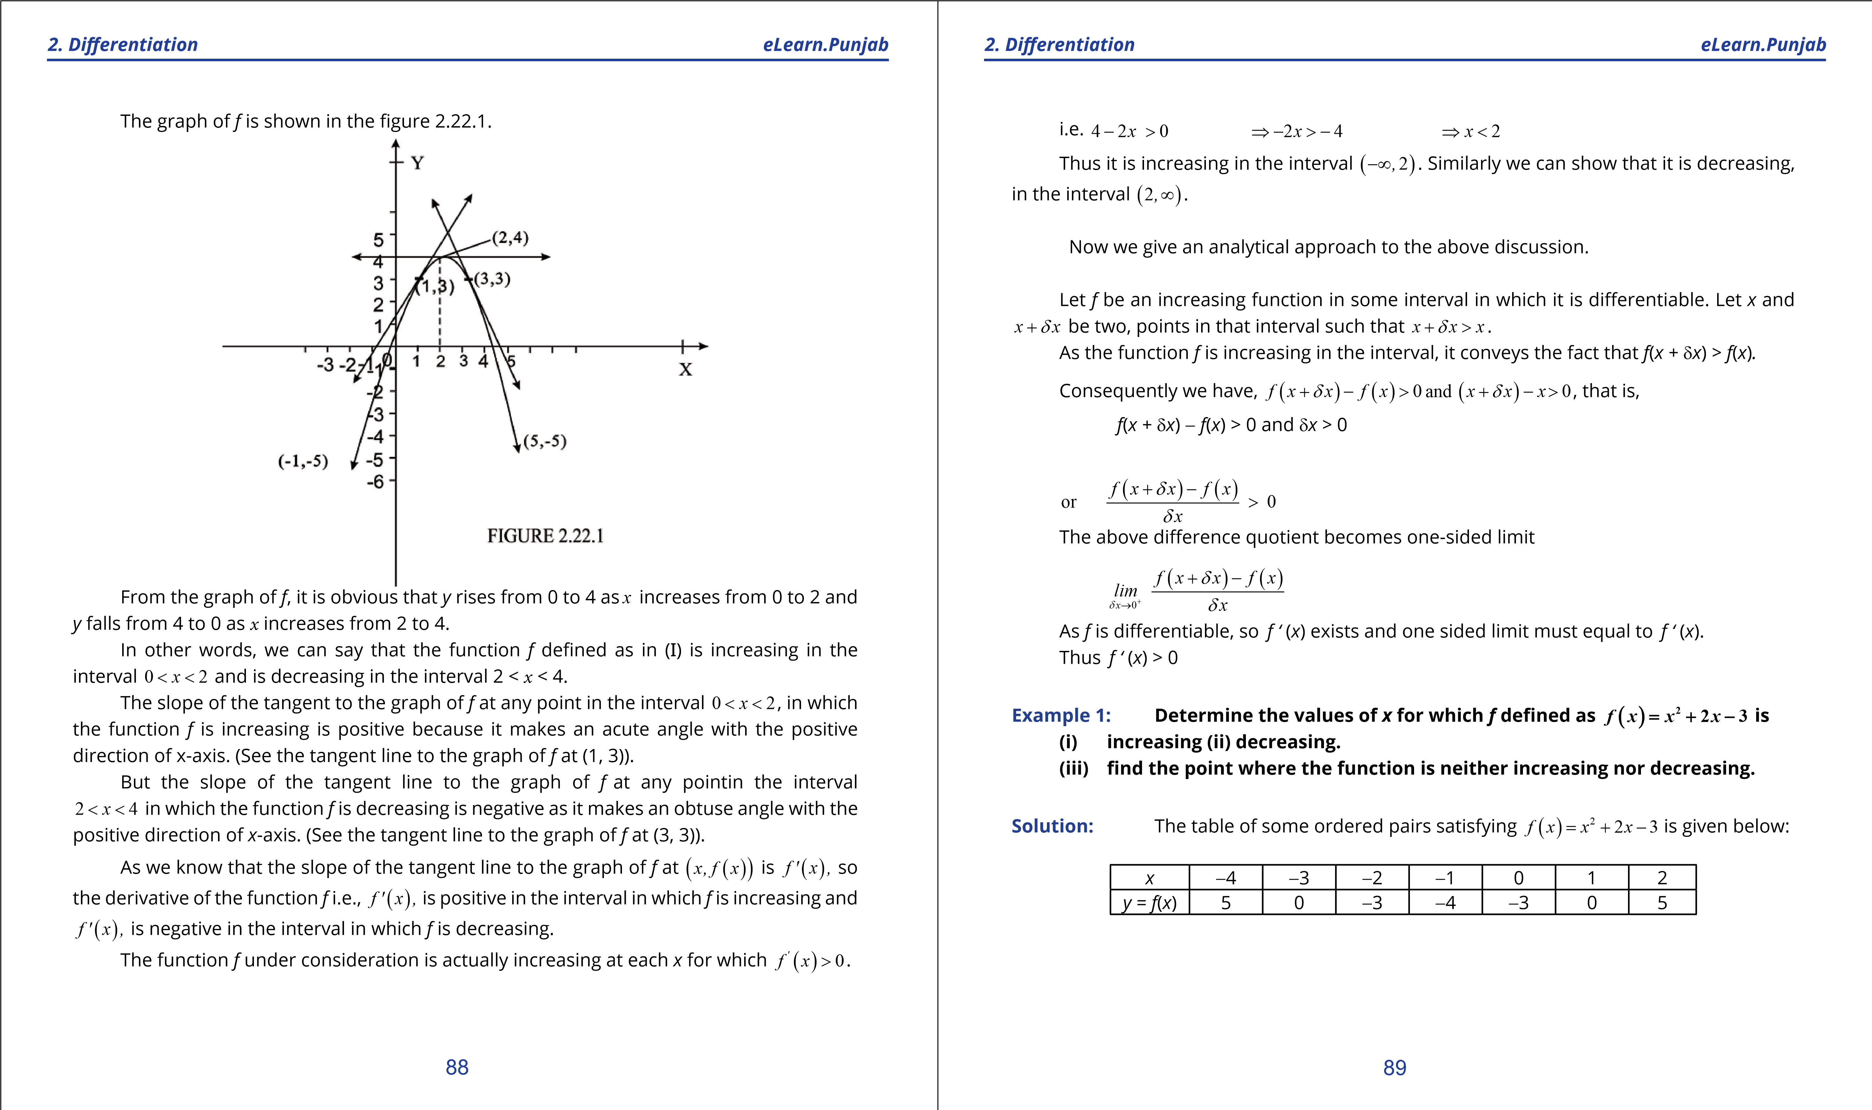

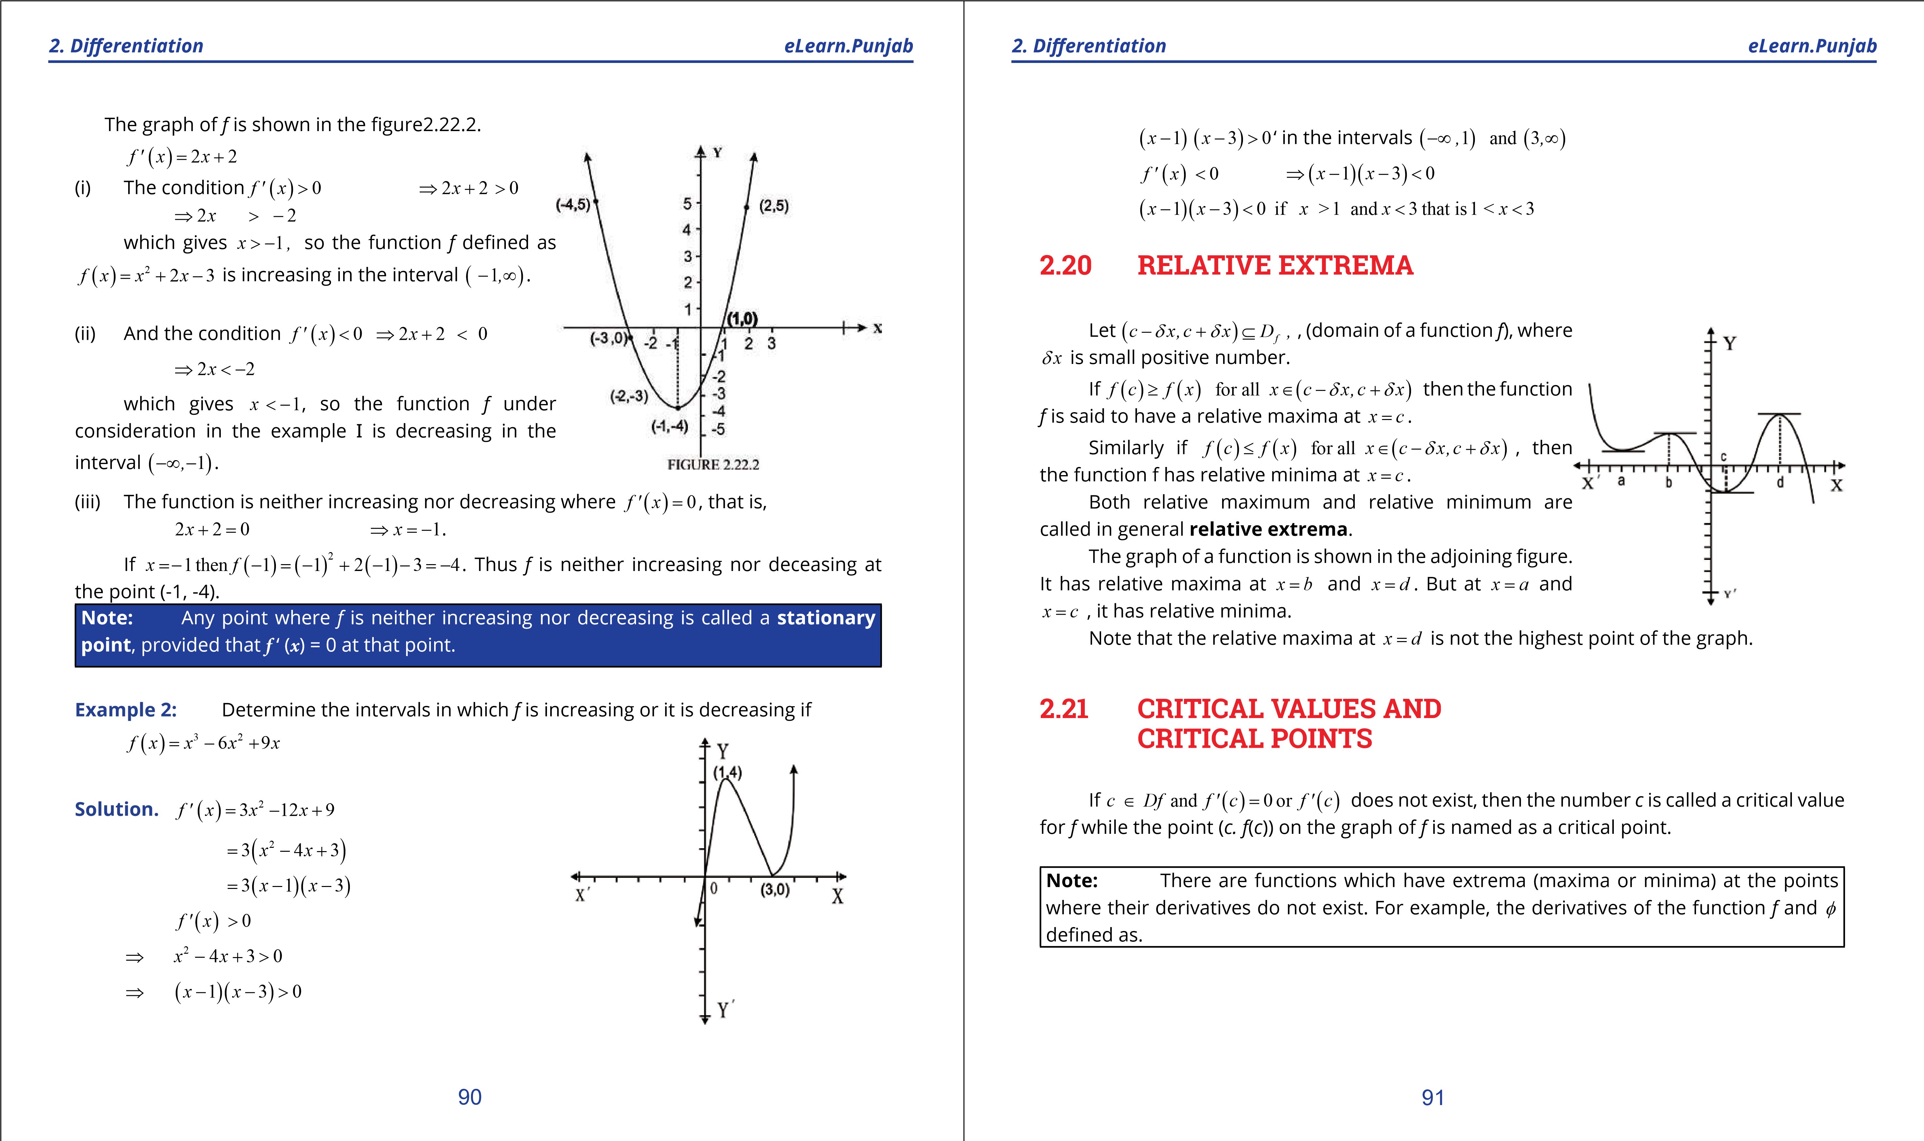

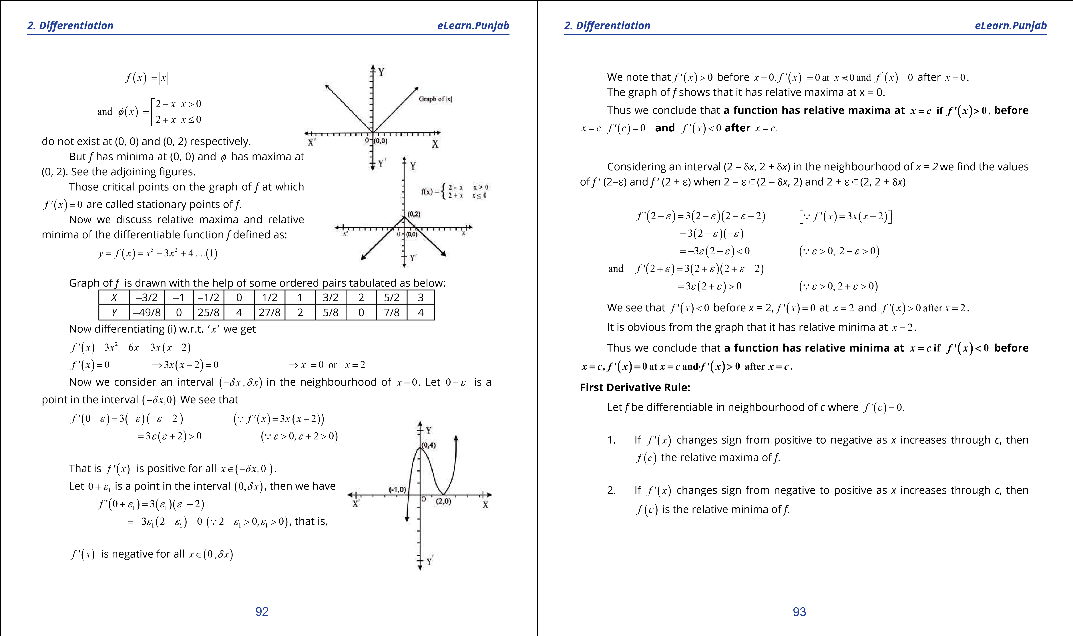

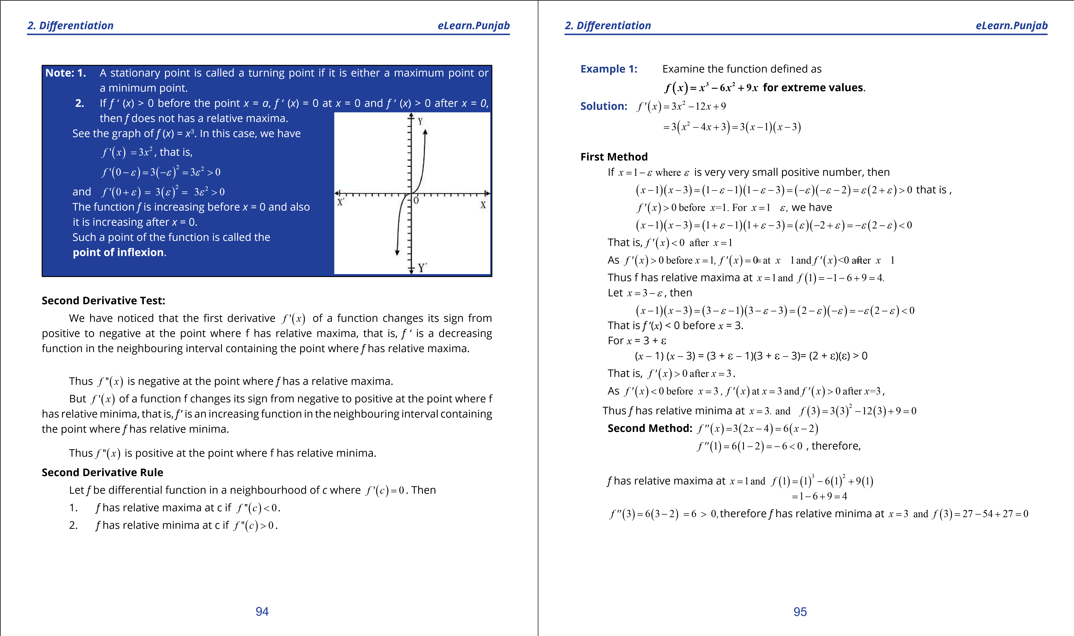

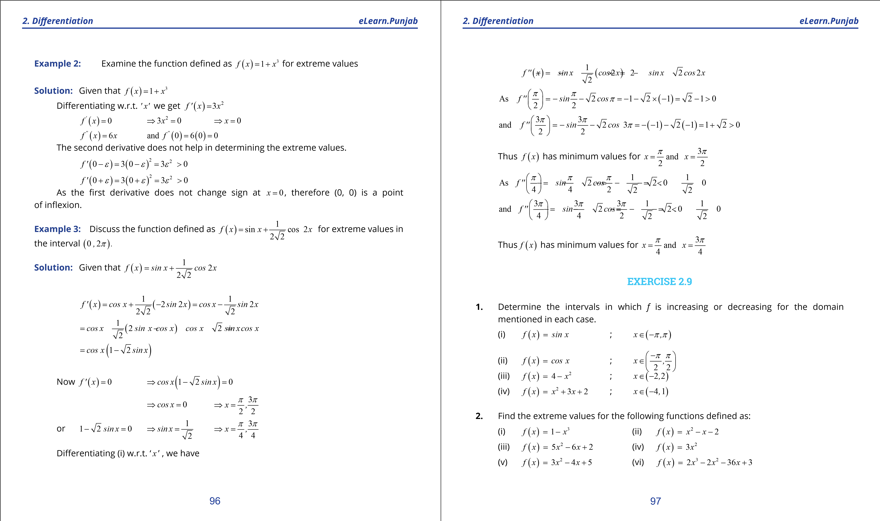

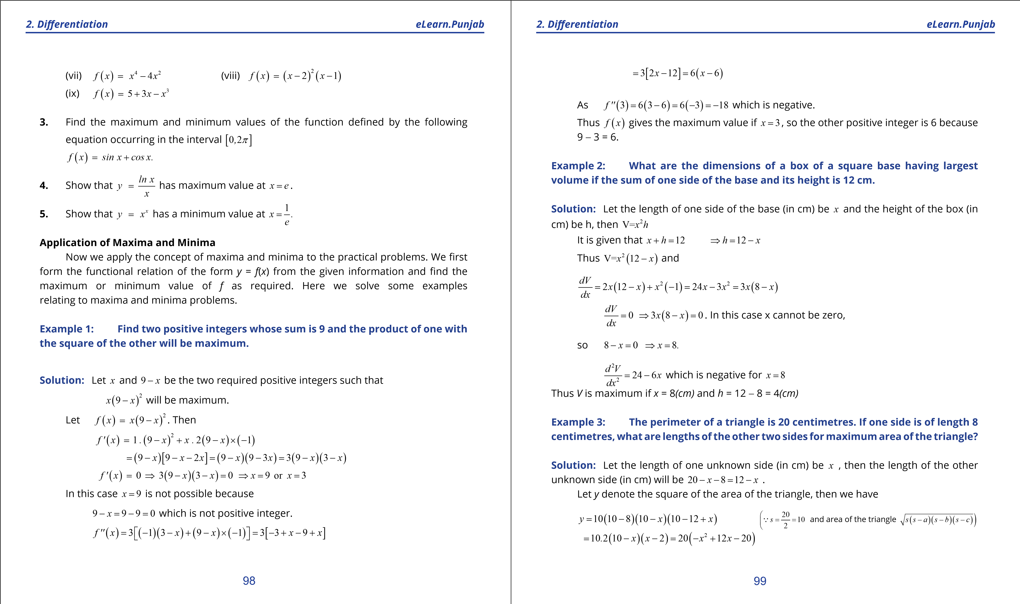

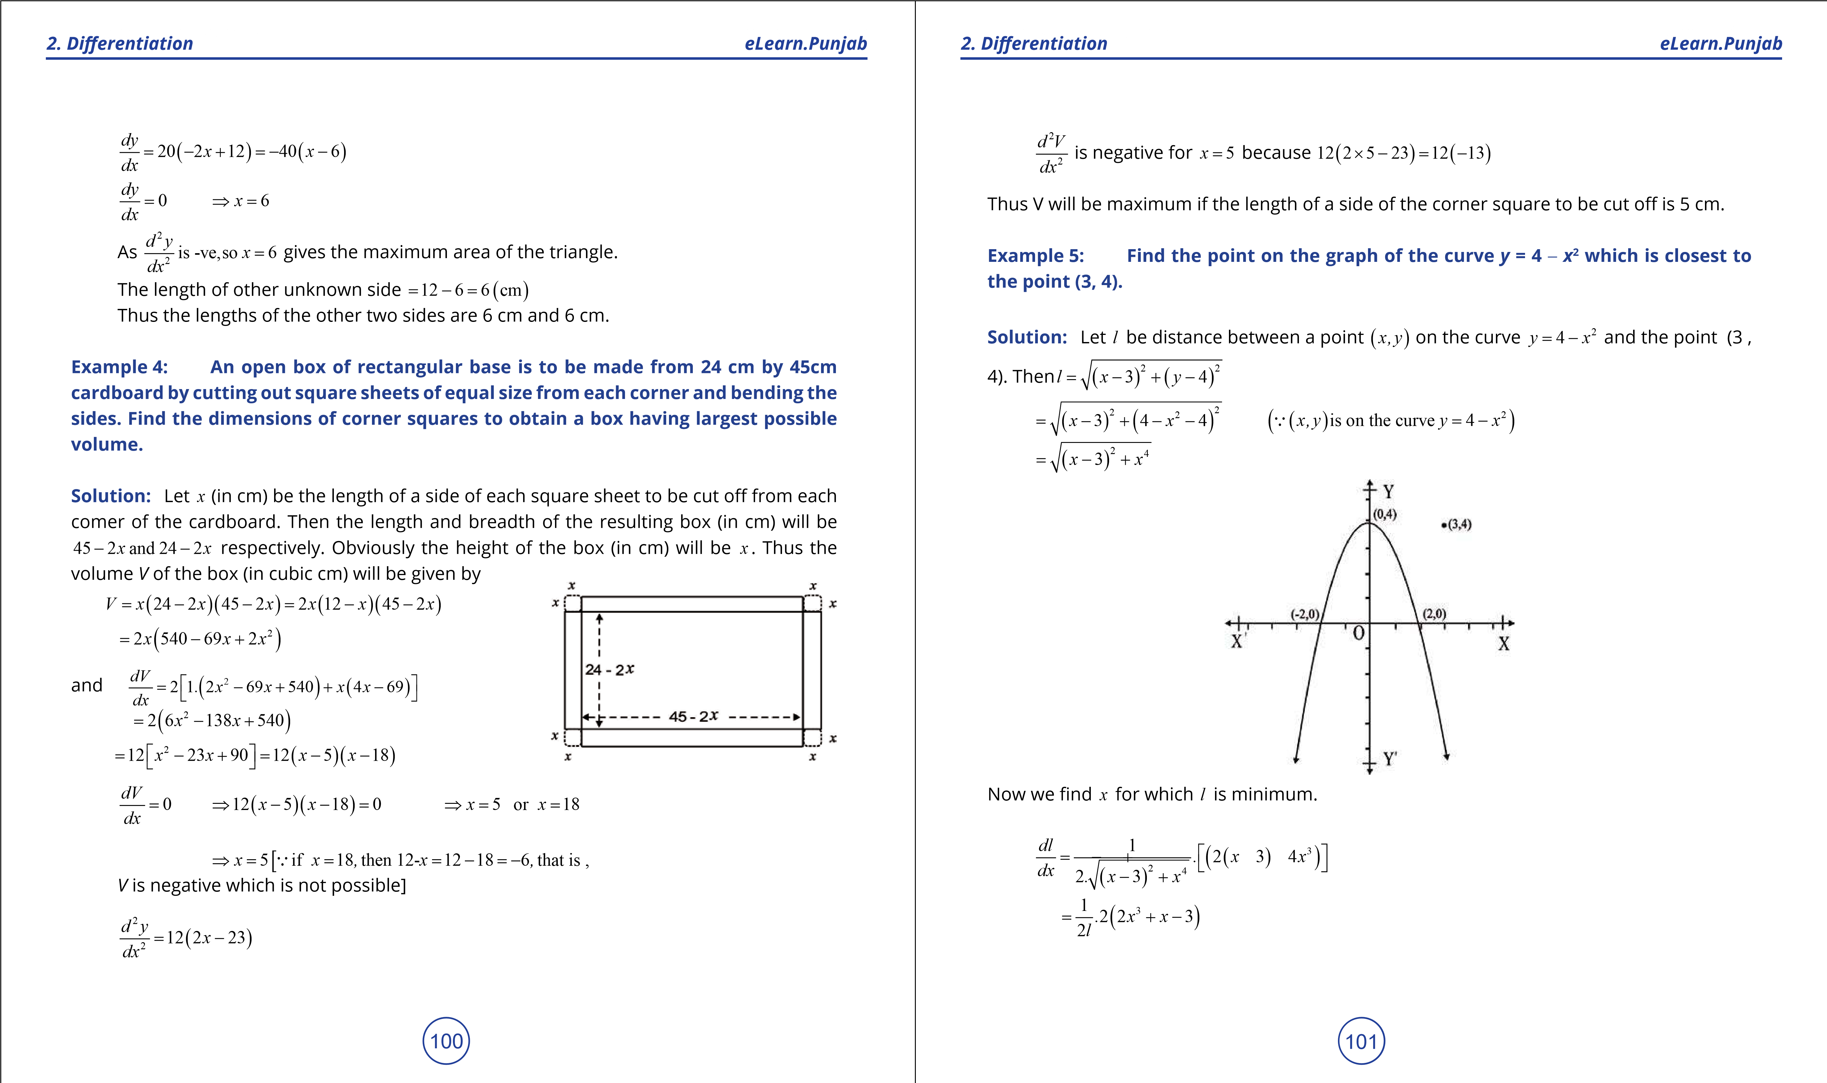

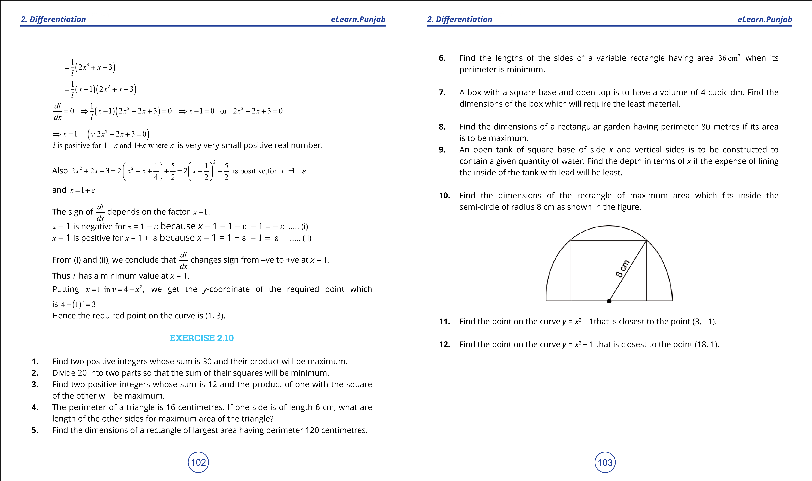

***version: 1.1***

# CHAPTER 3 Integration

*Animation 3.1: Integration*

*Source and credit: eLearn.Punjab*

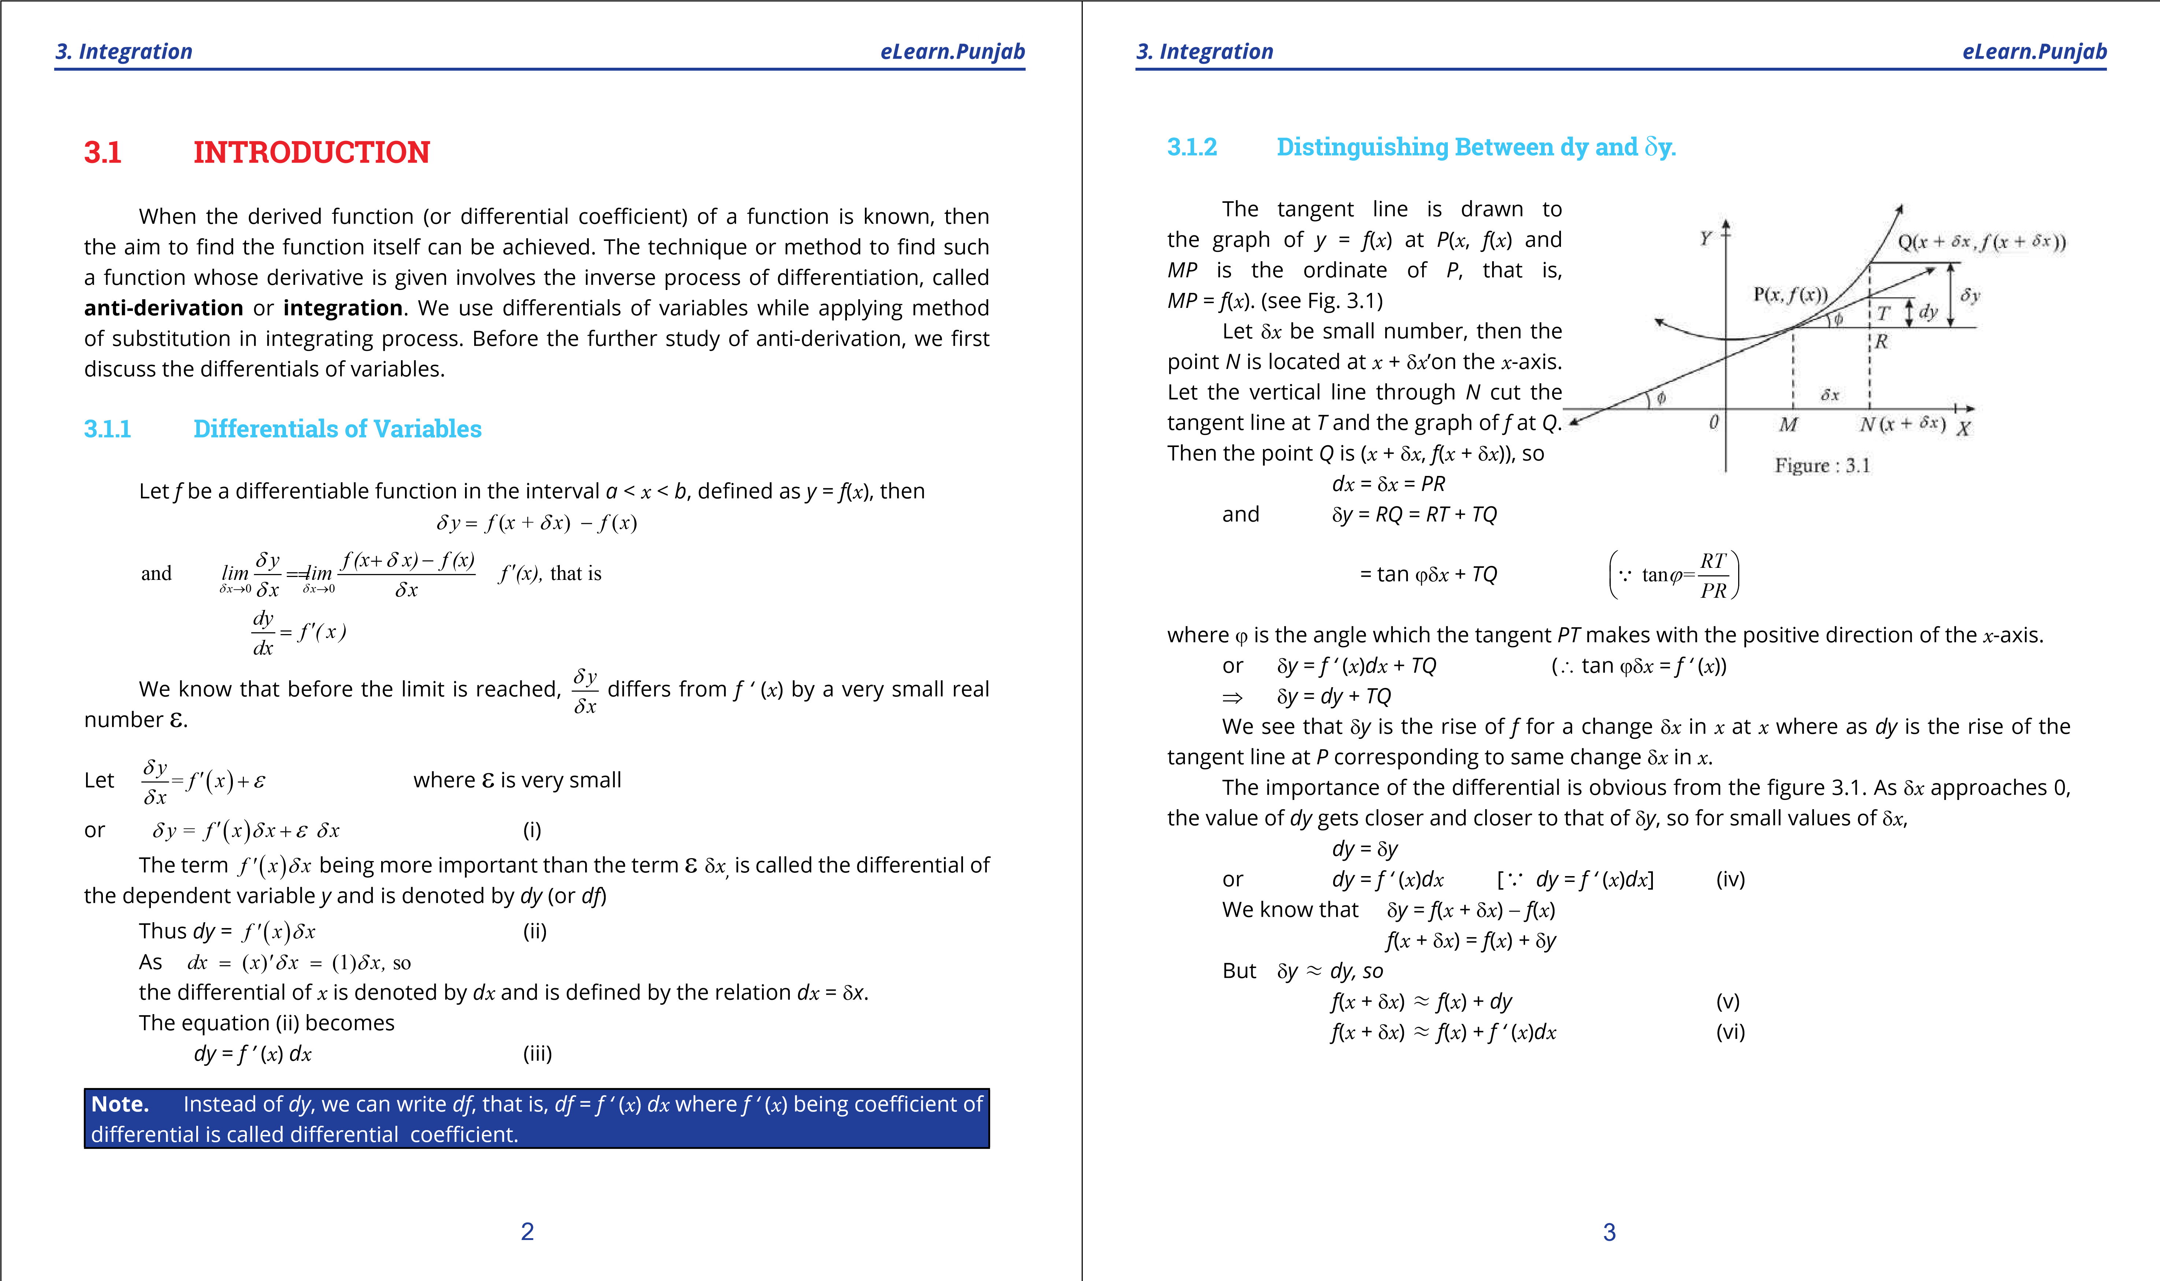

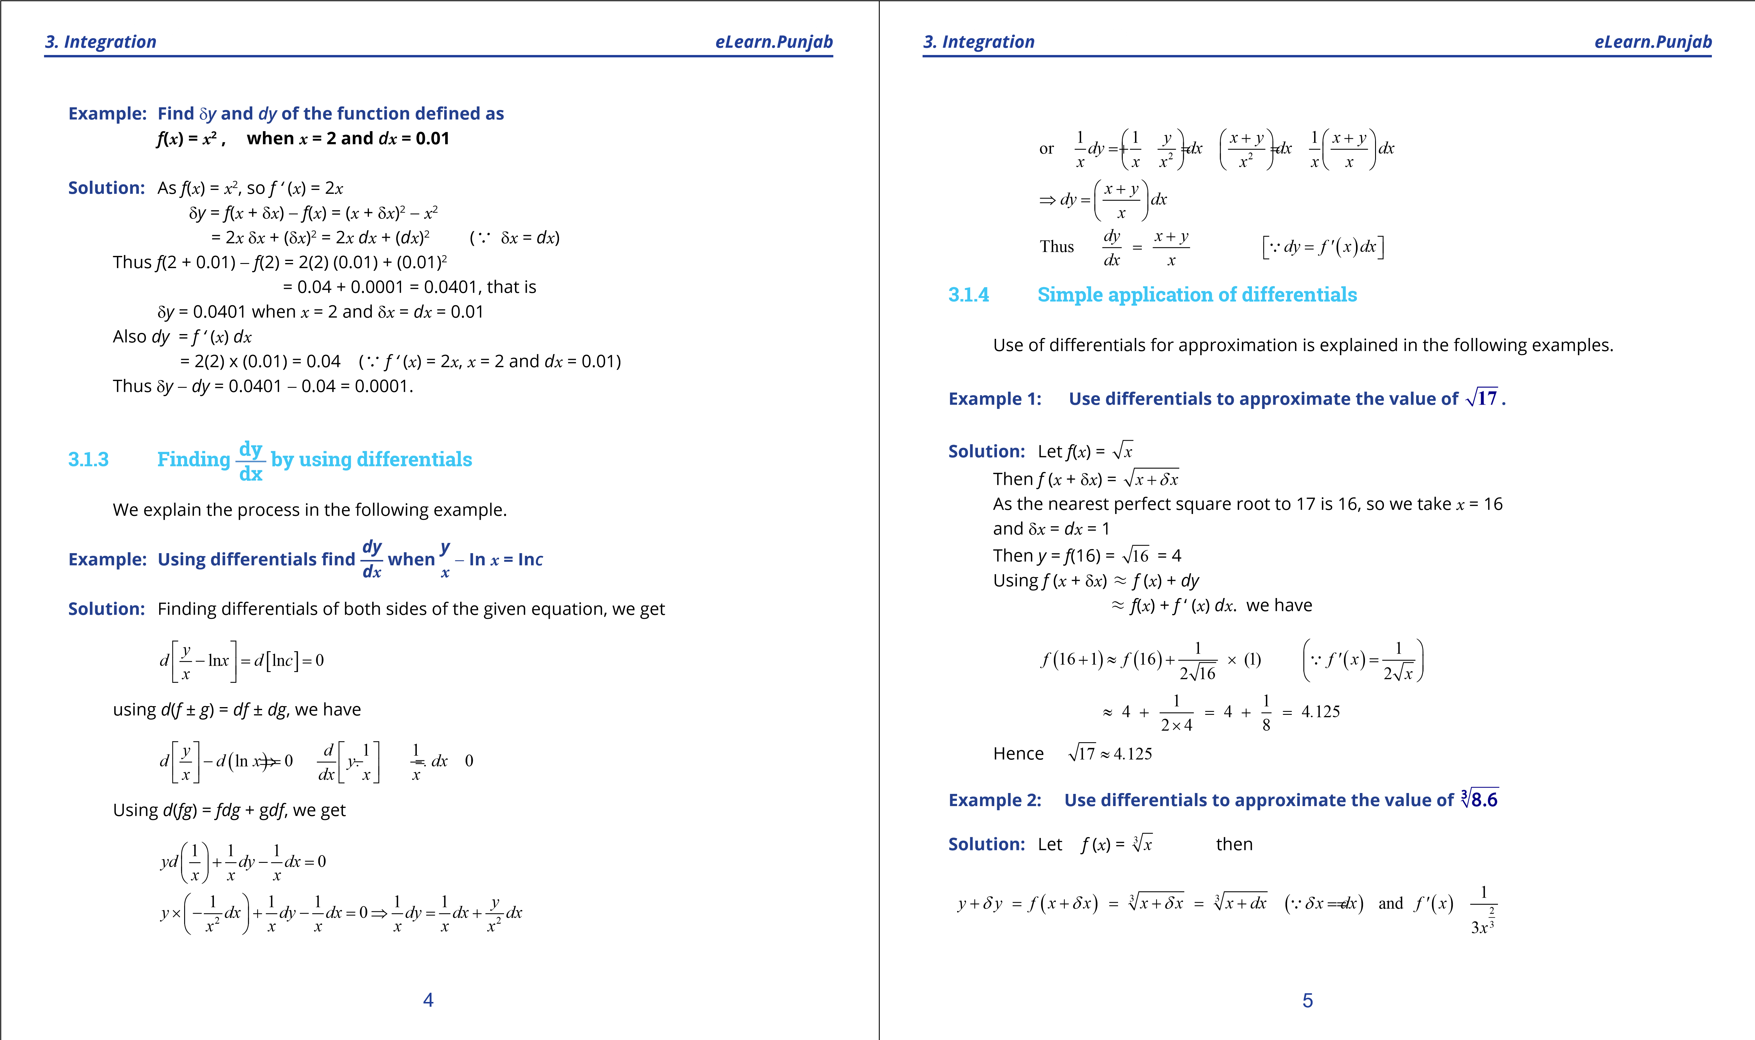

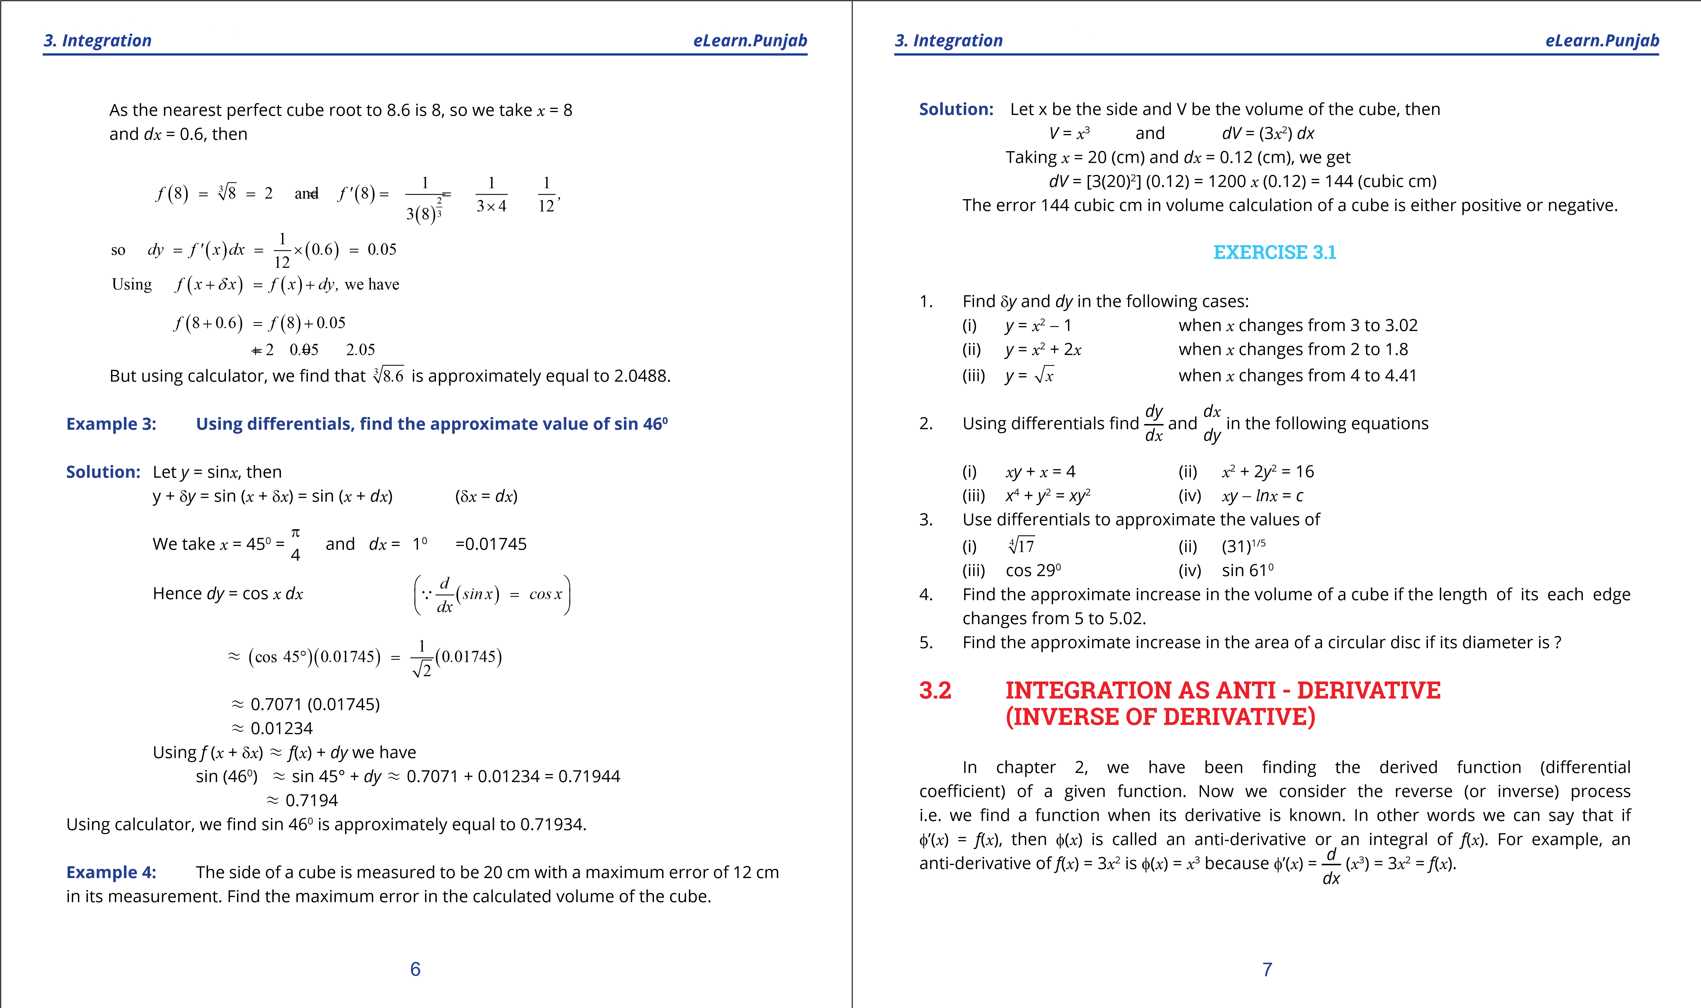

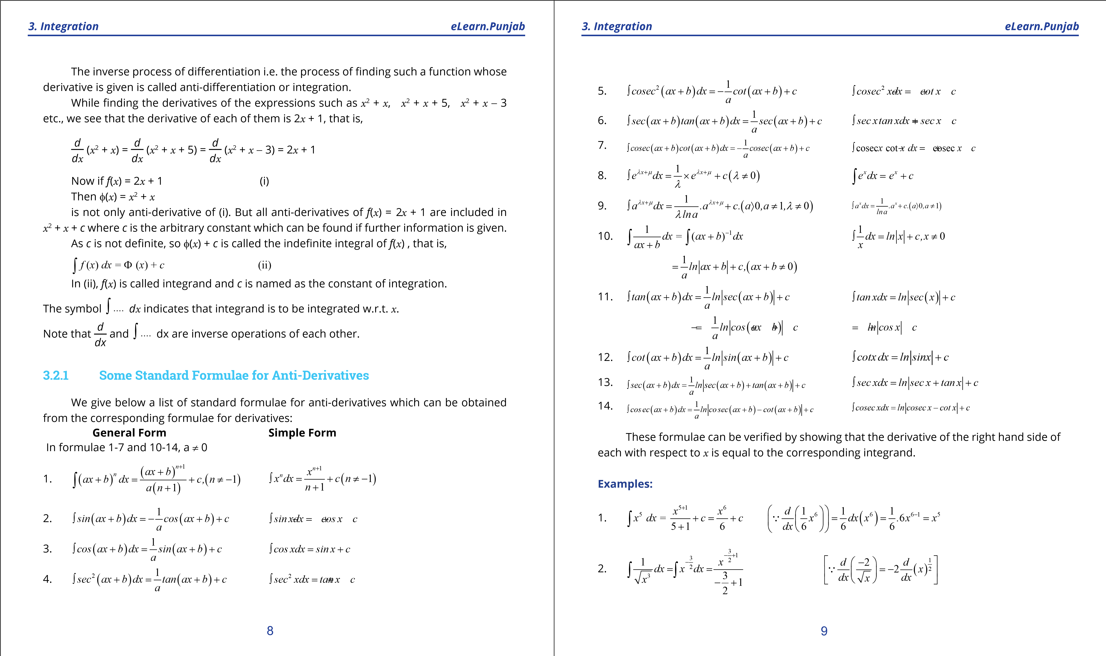

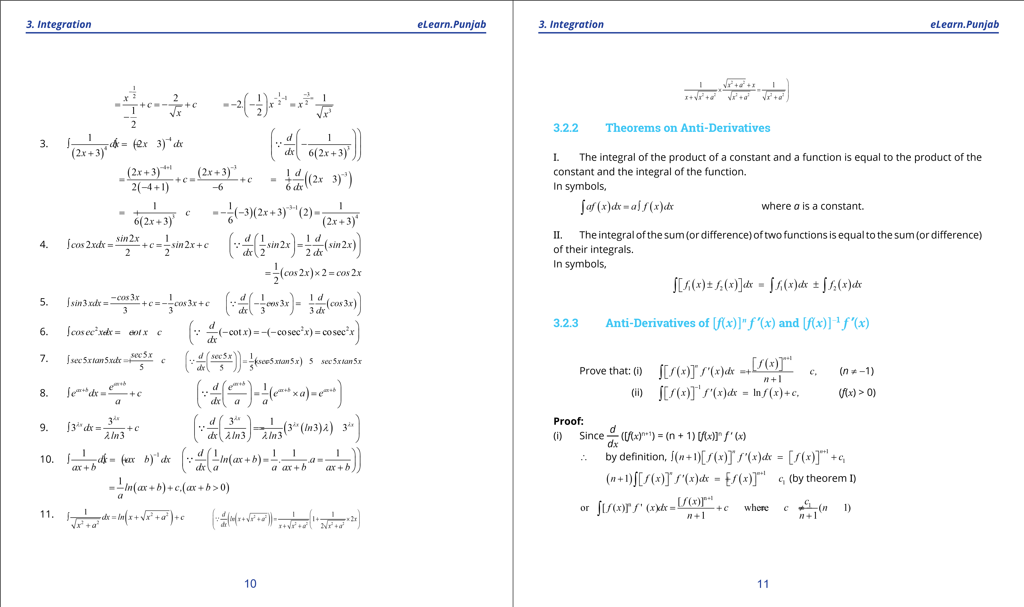

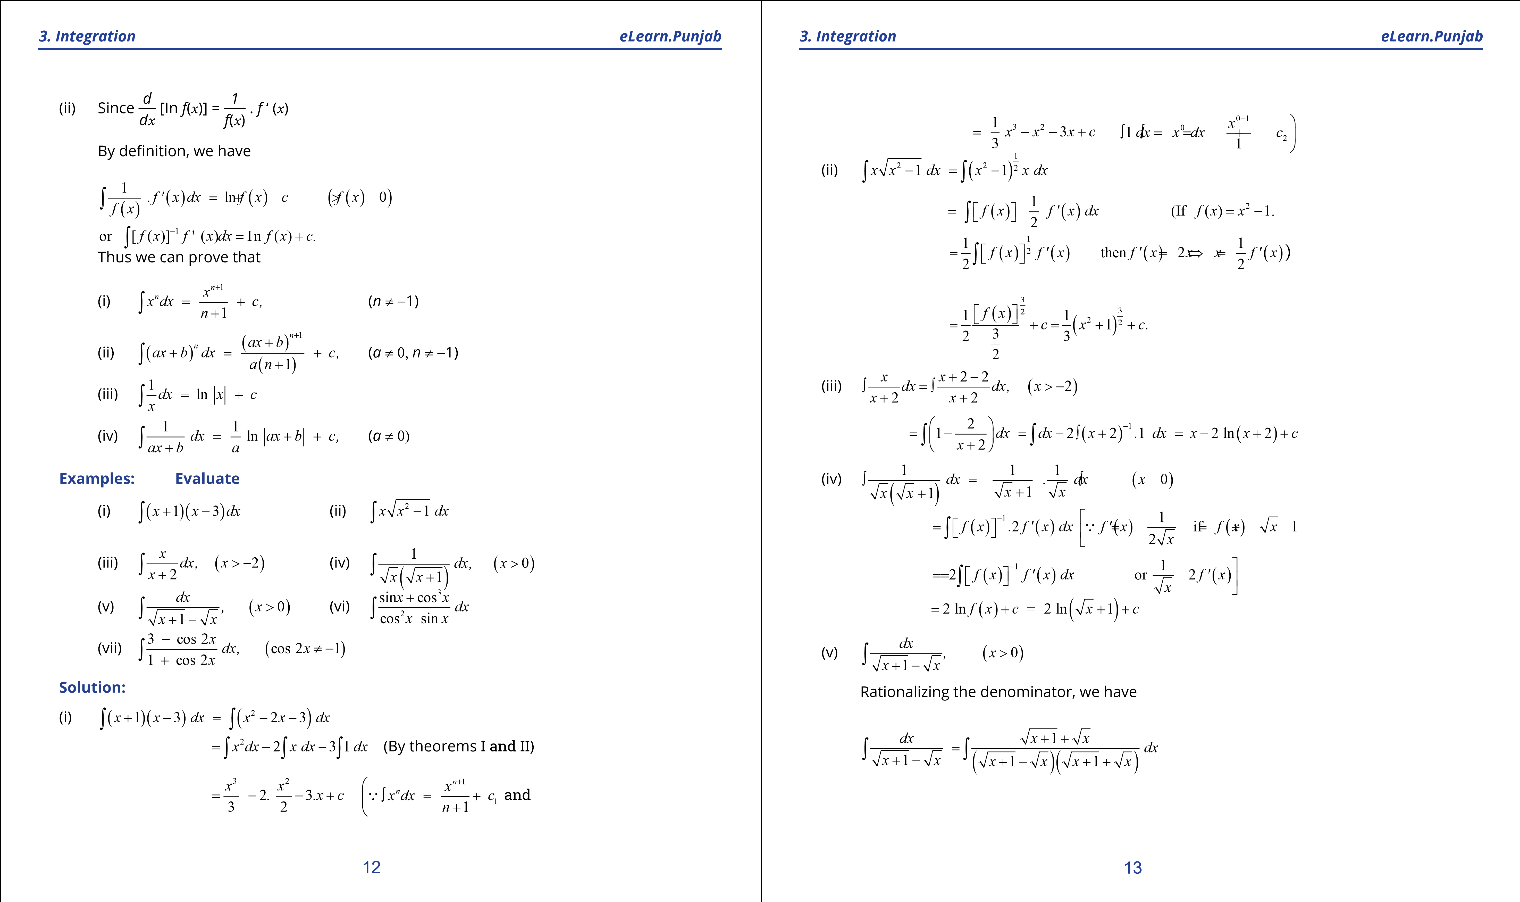

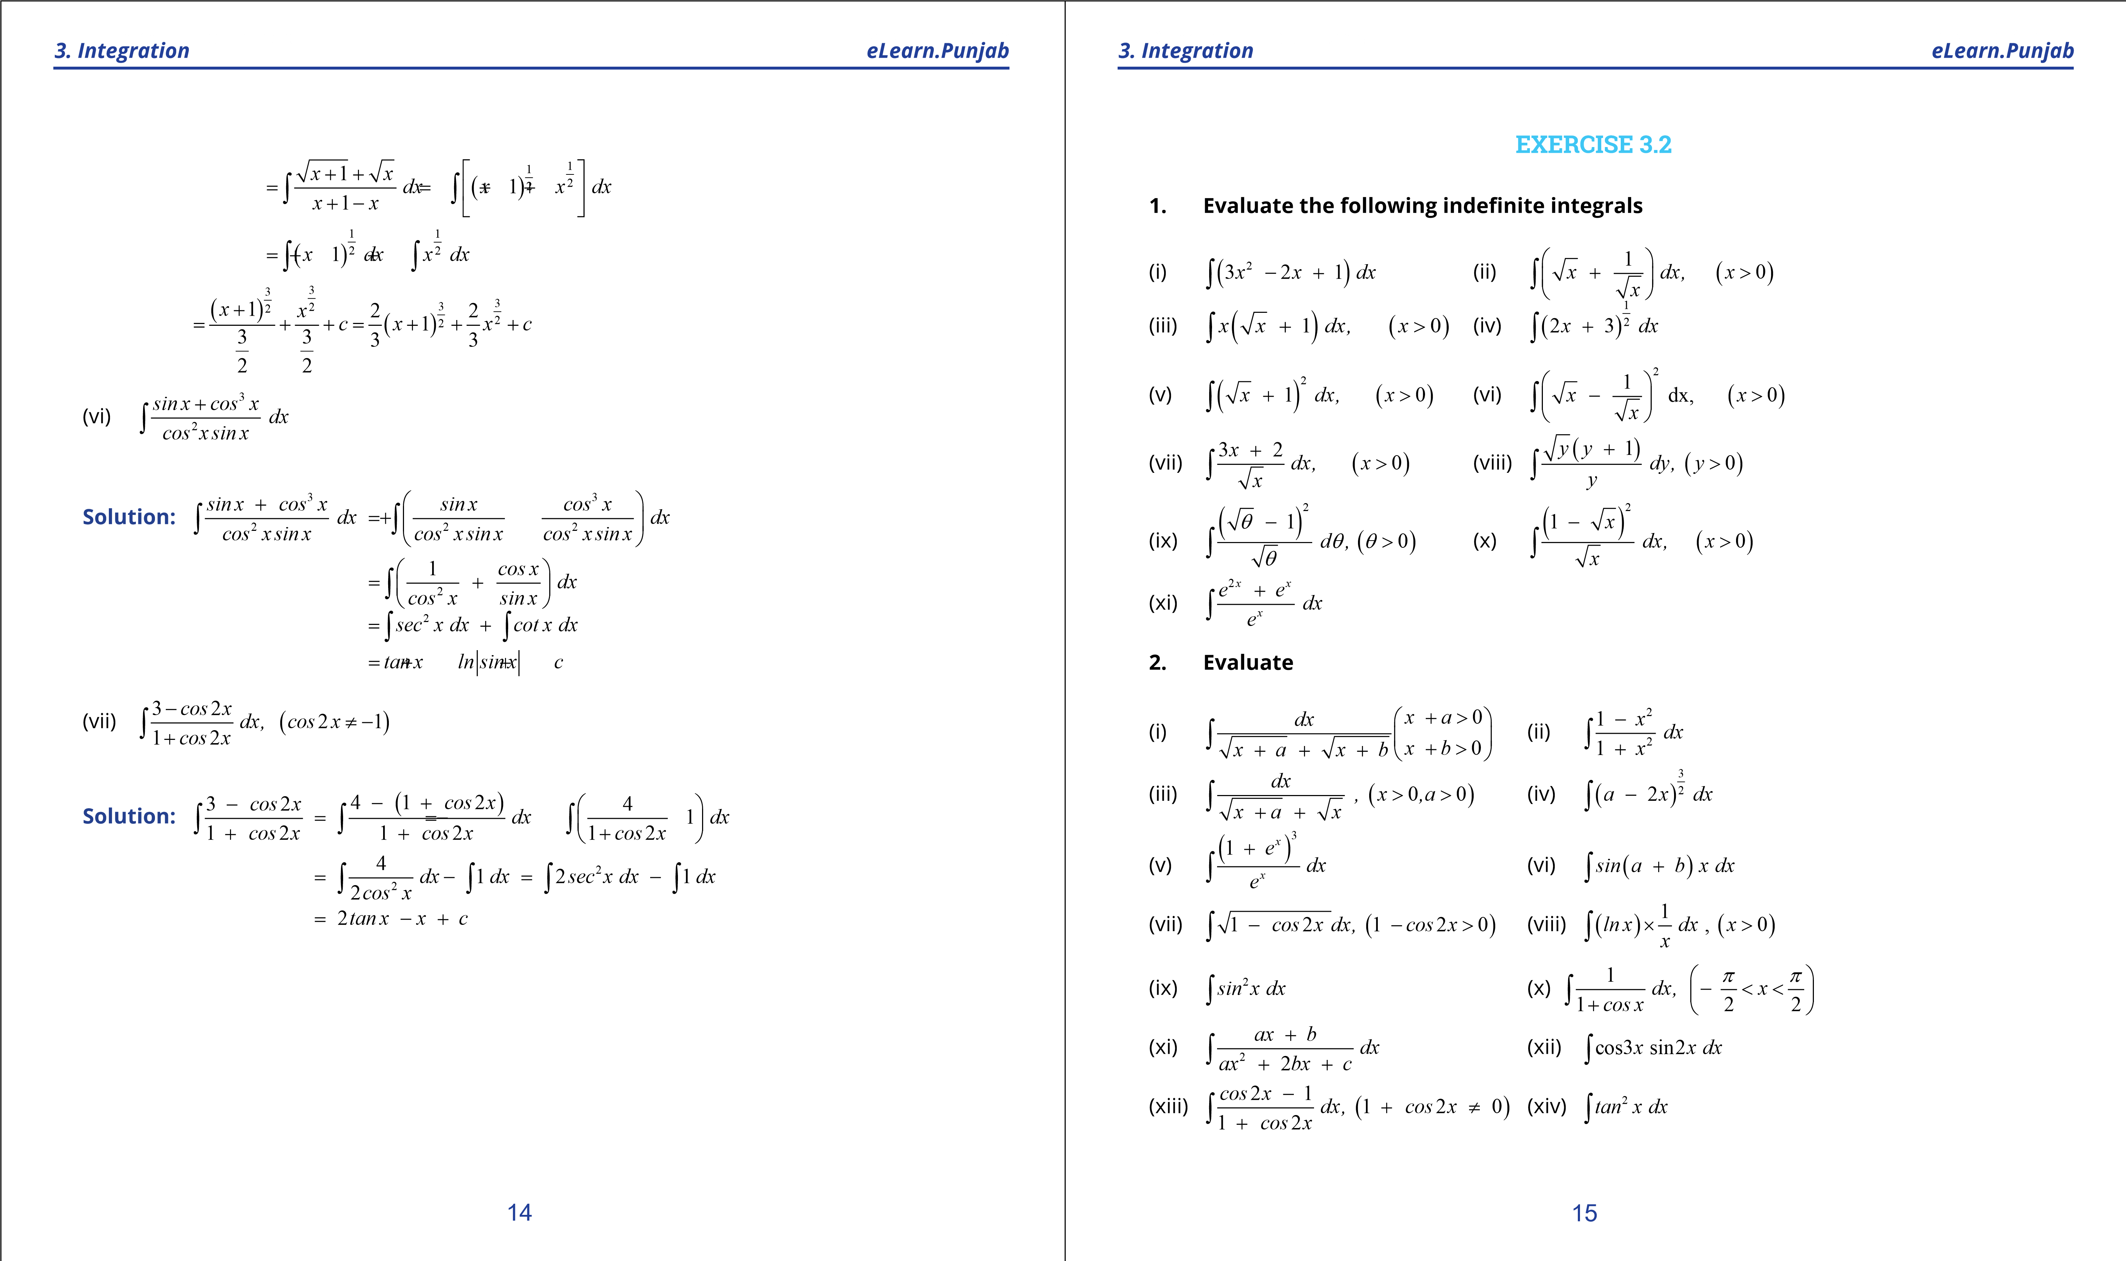

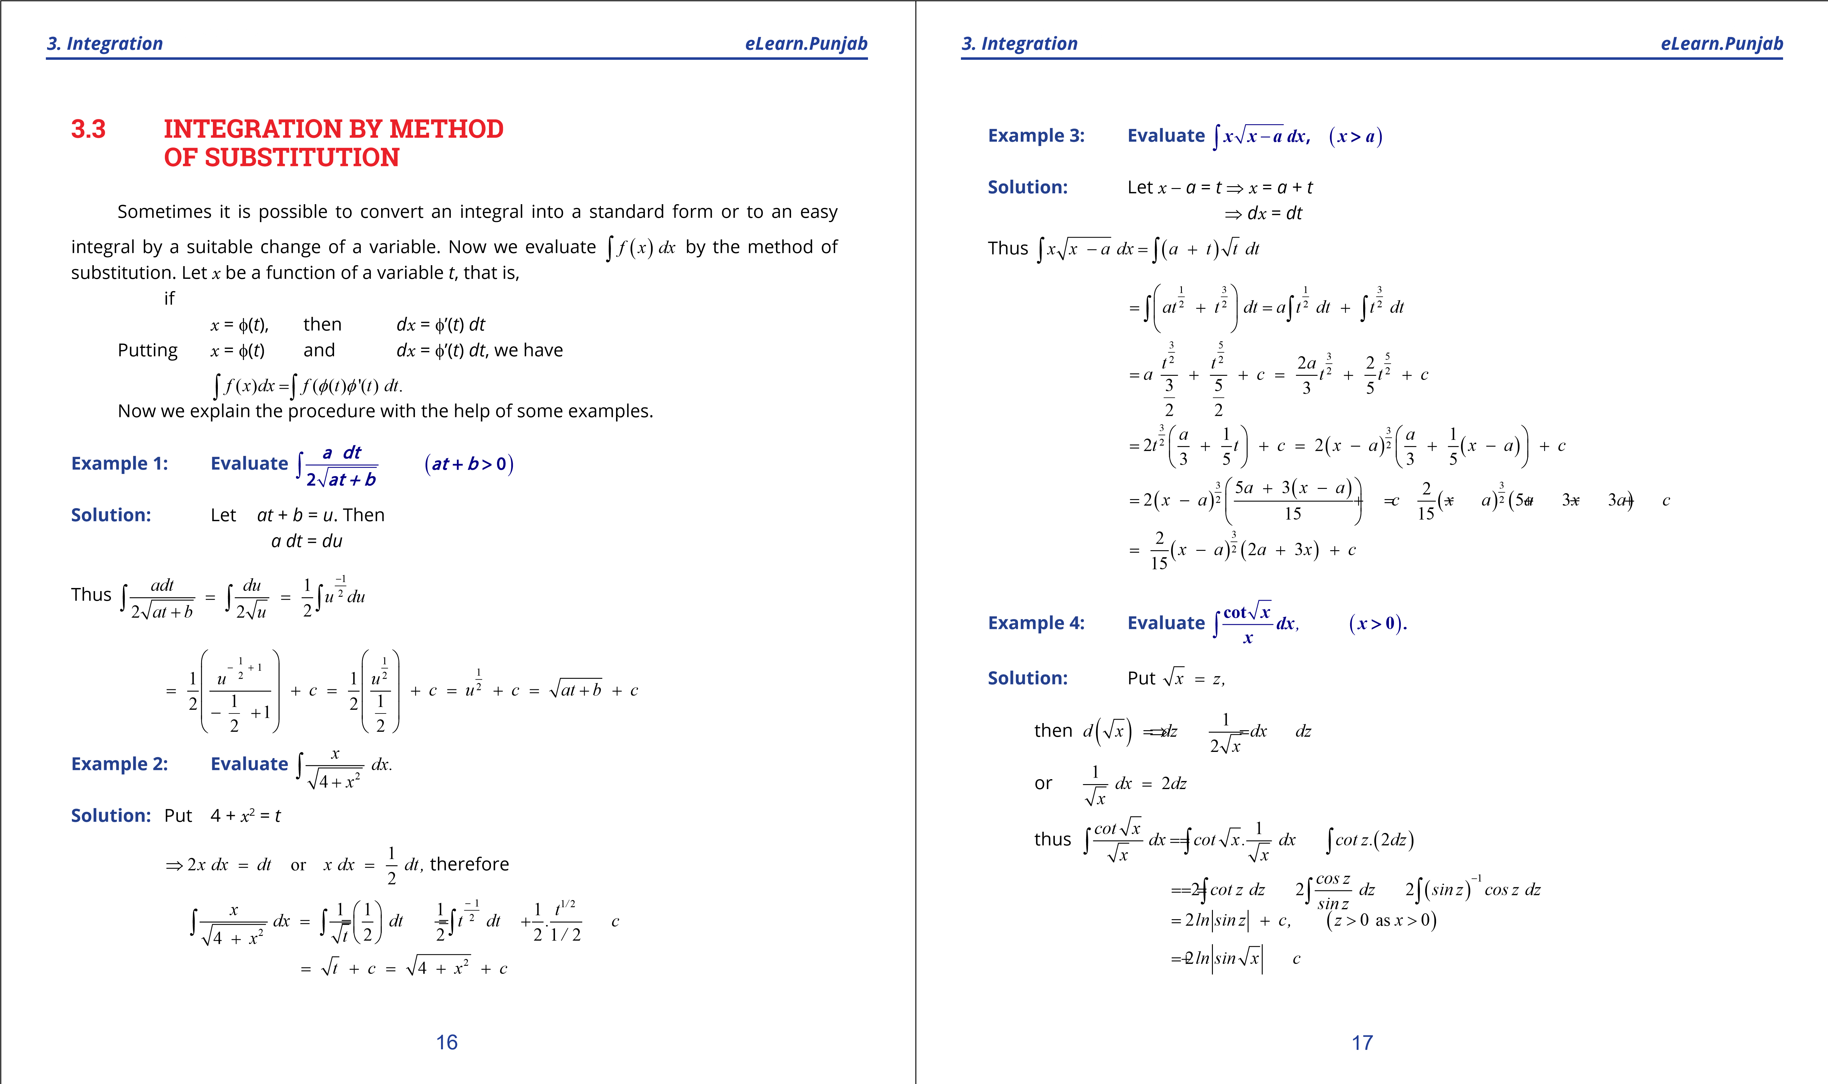

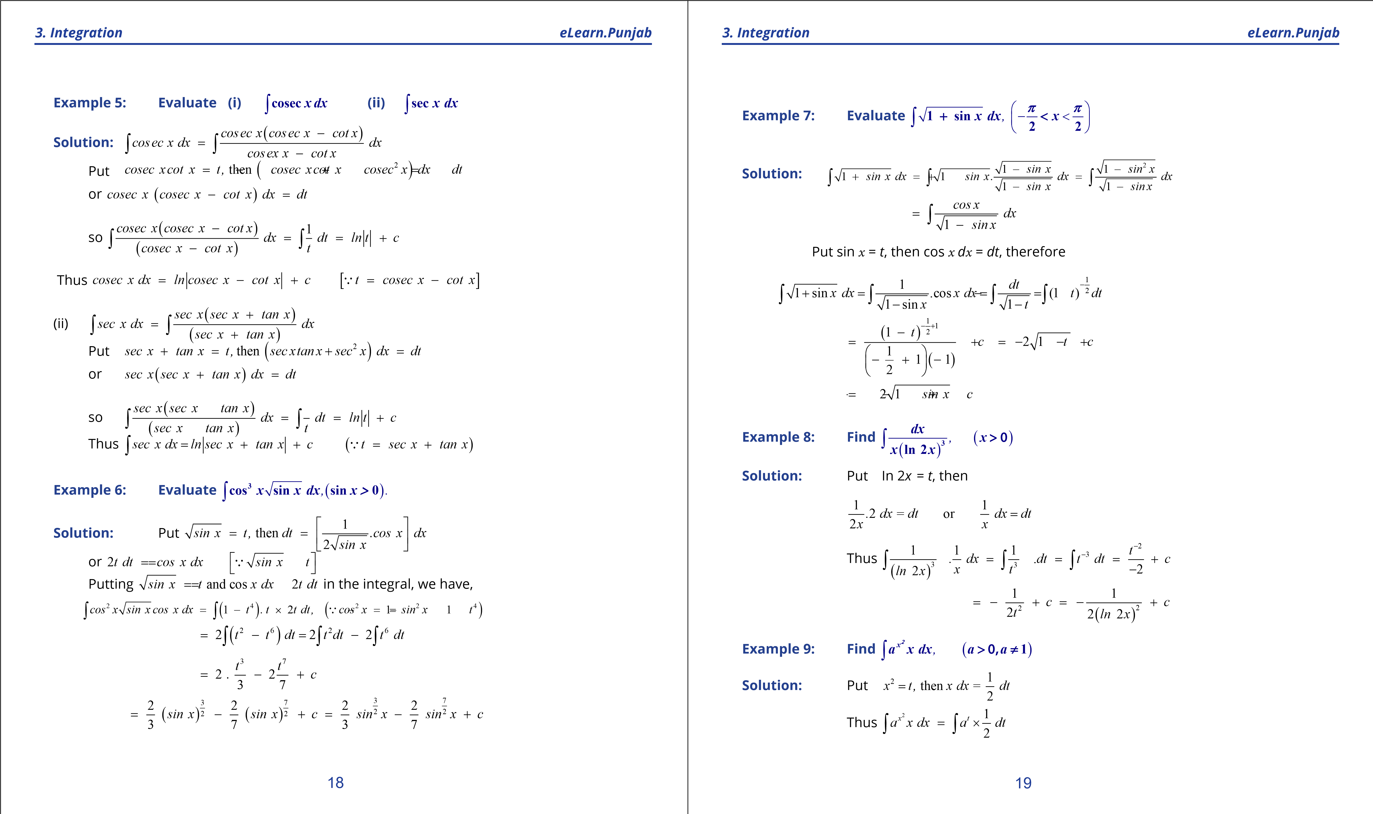

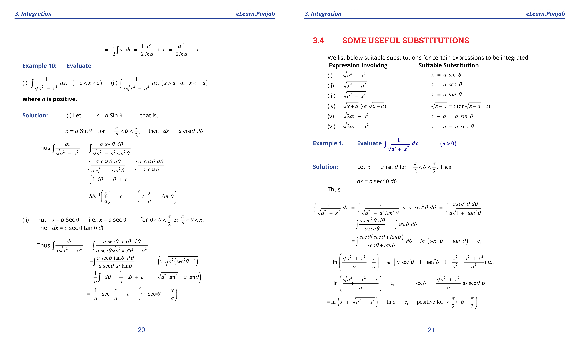

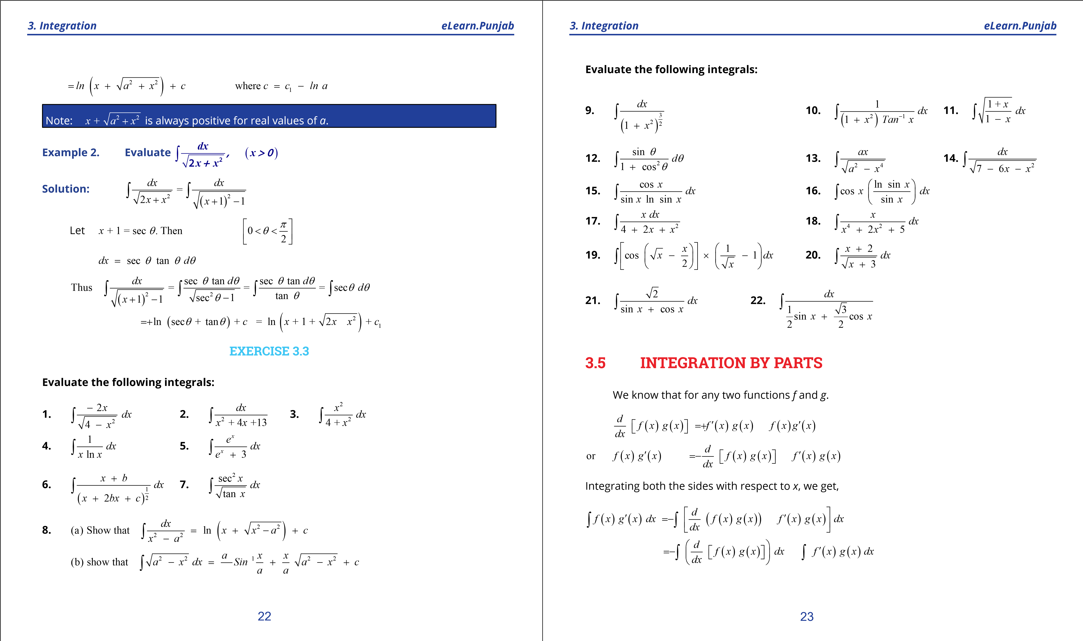

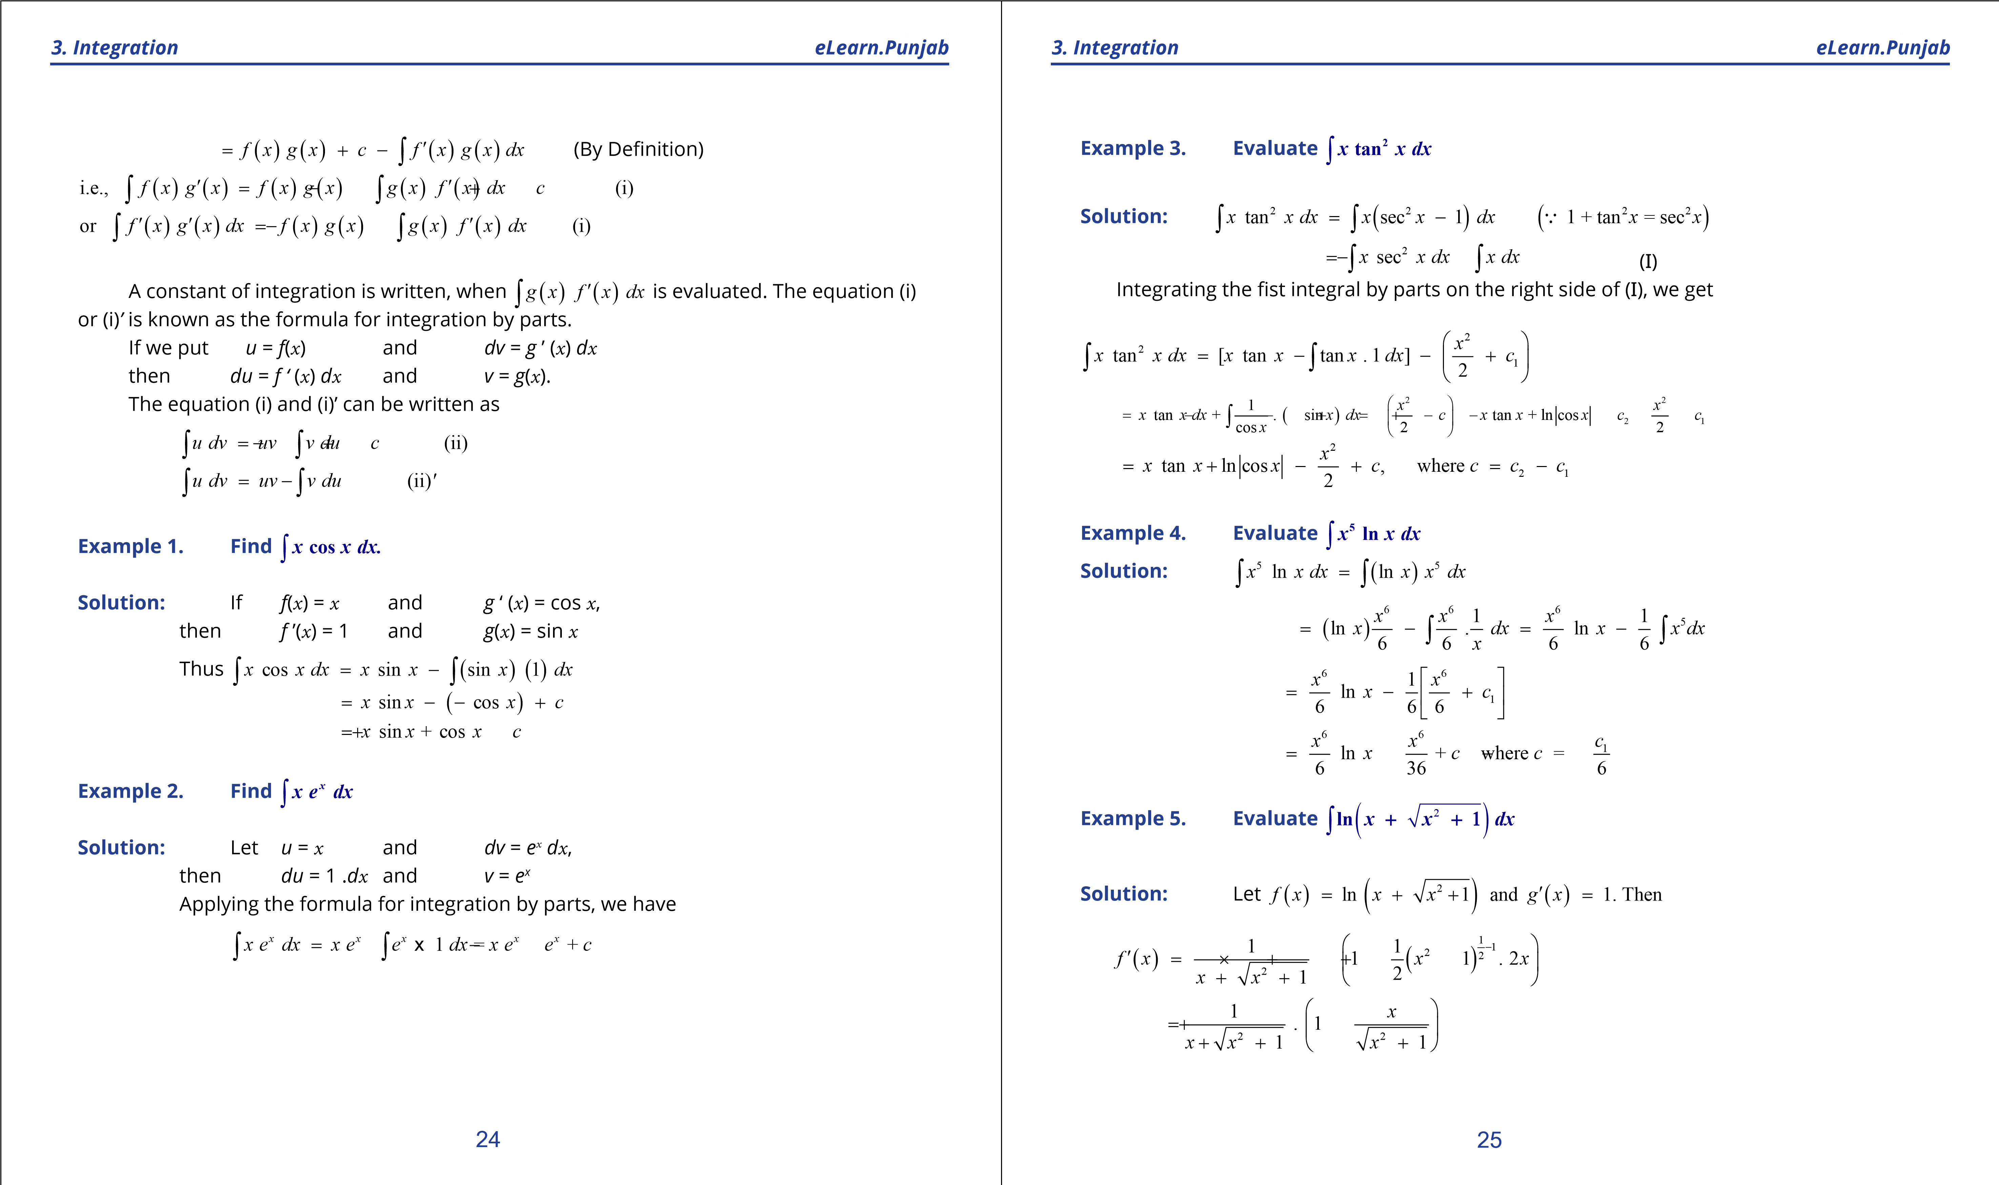

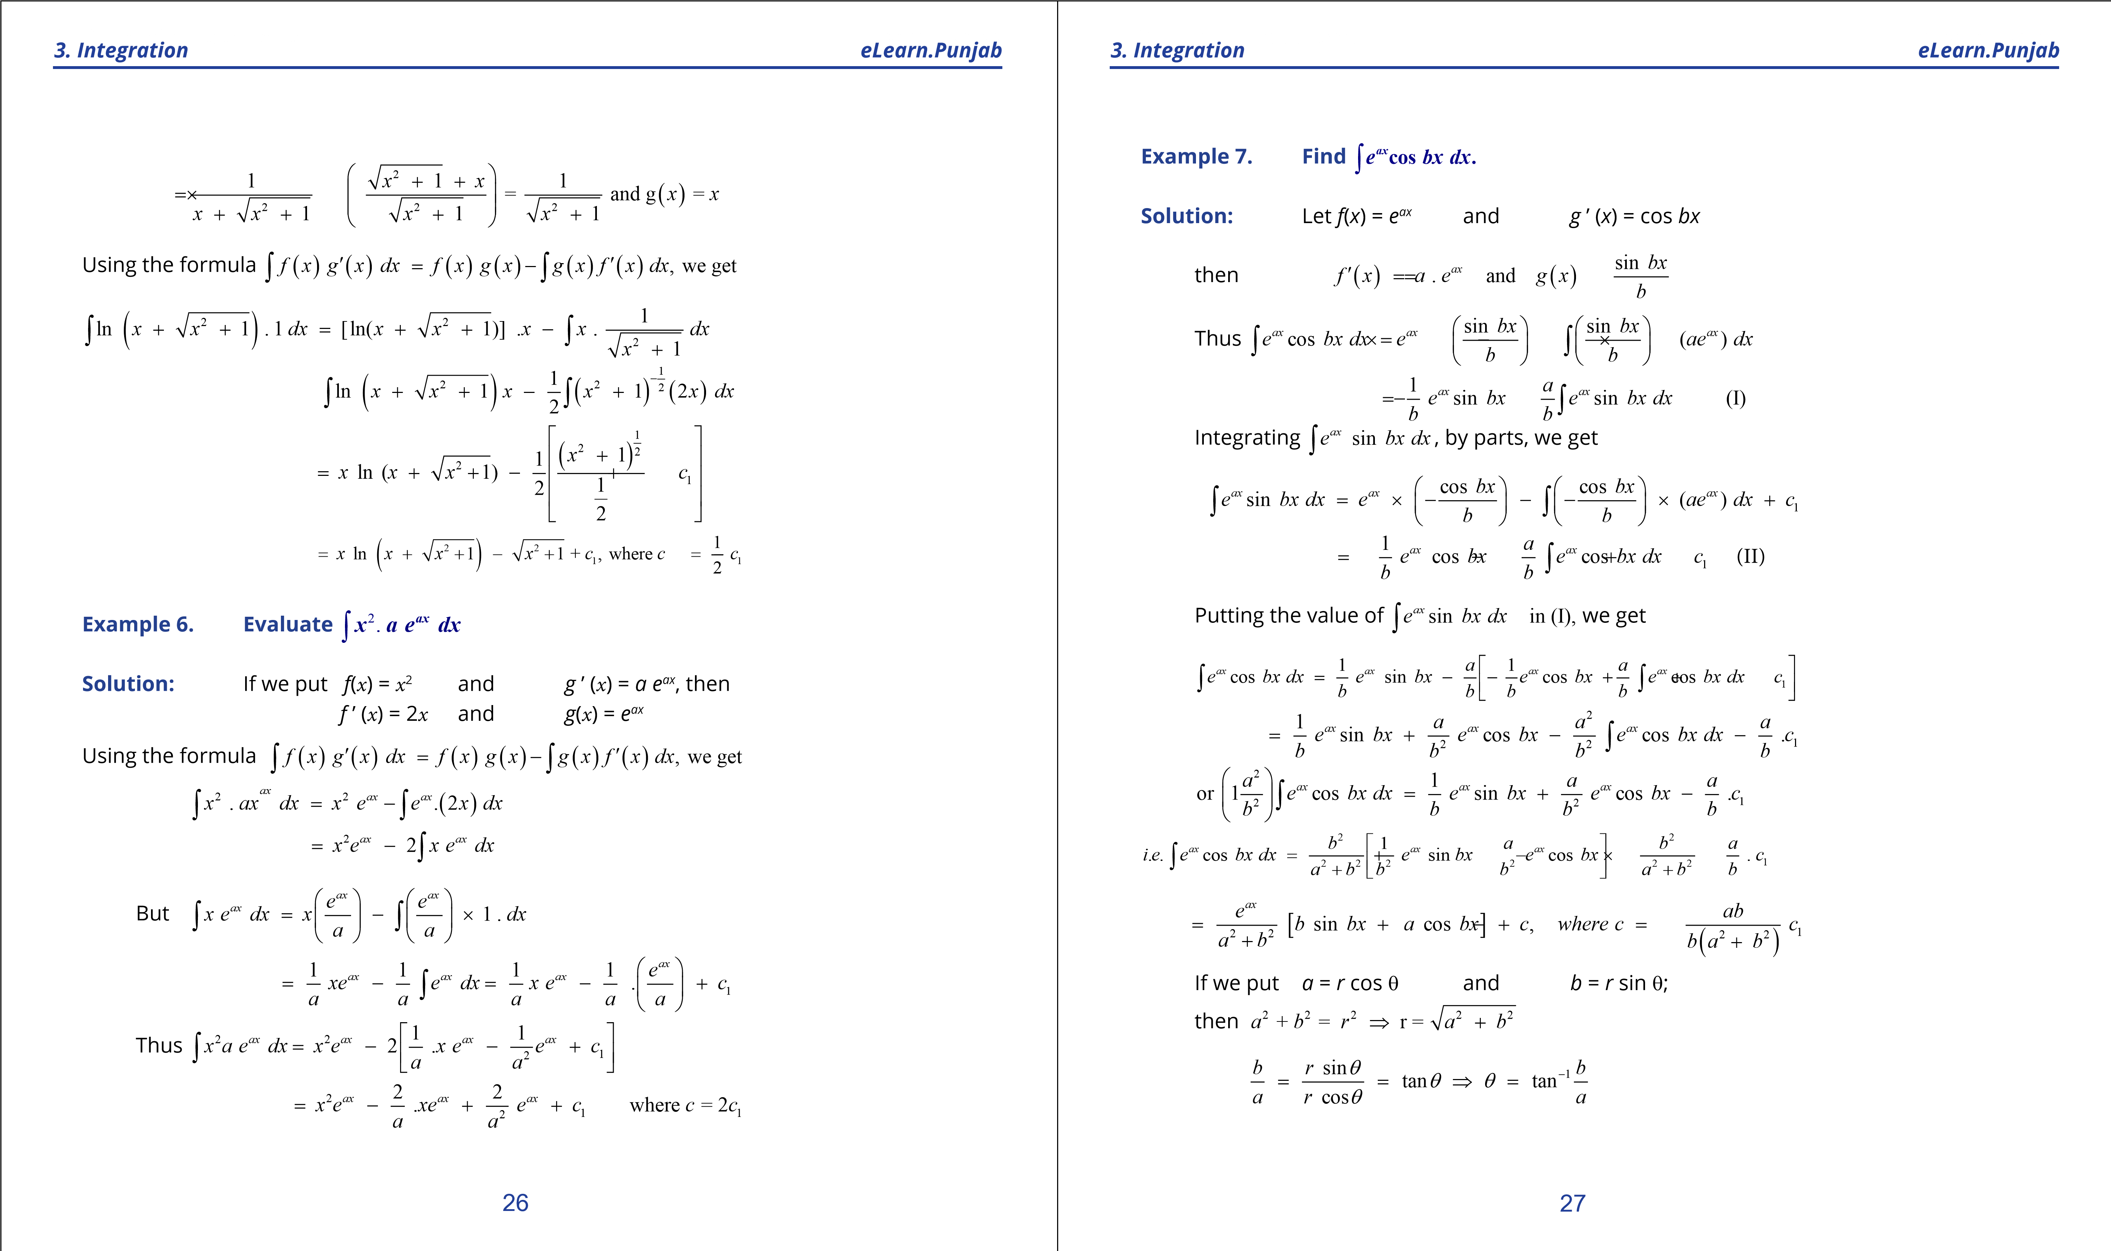

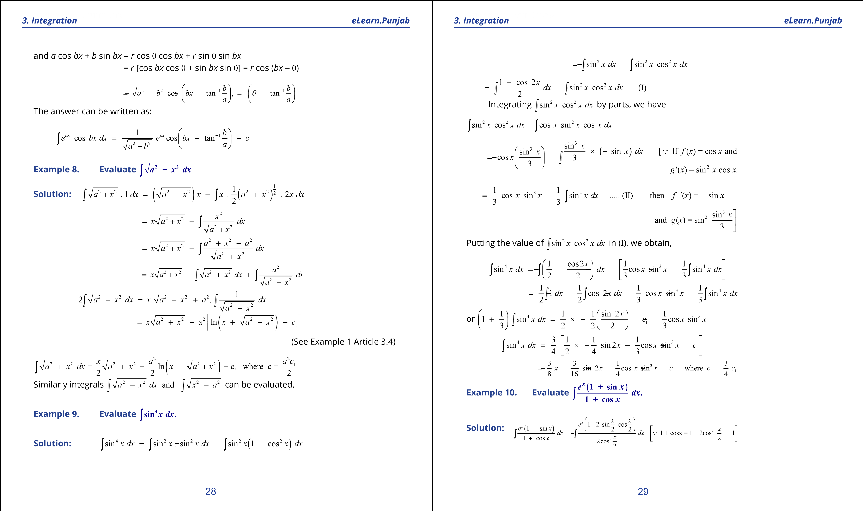

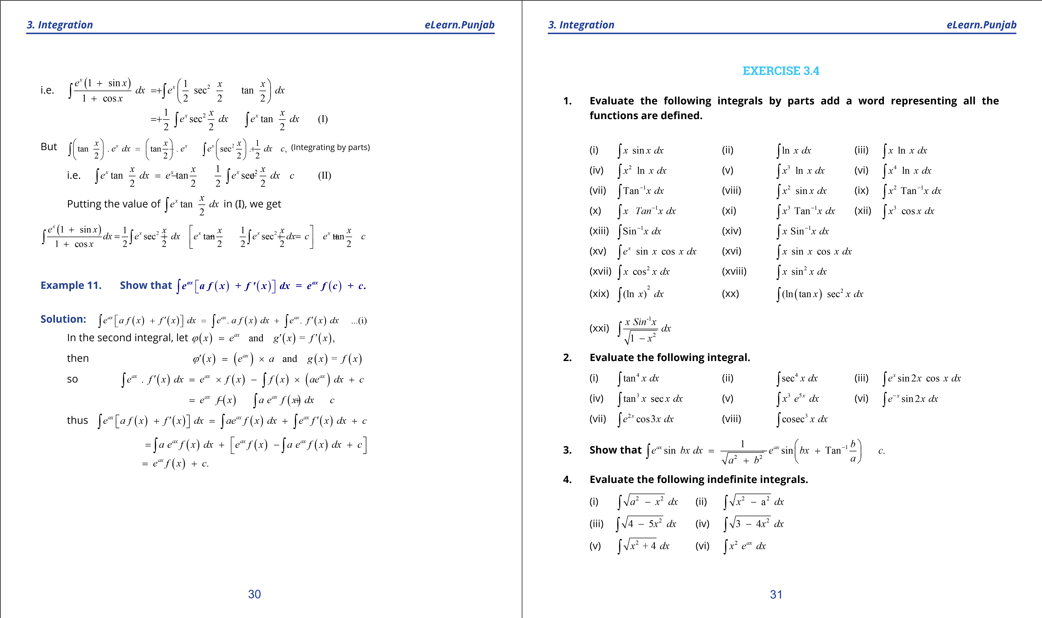

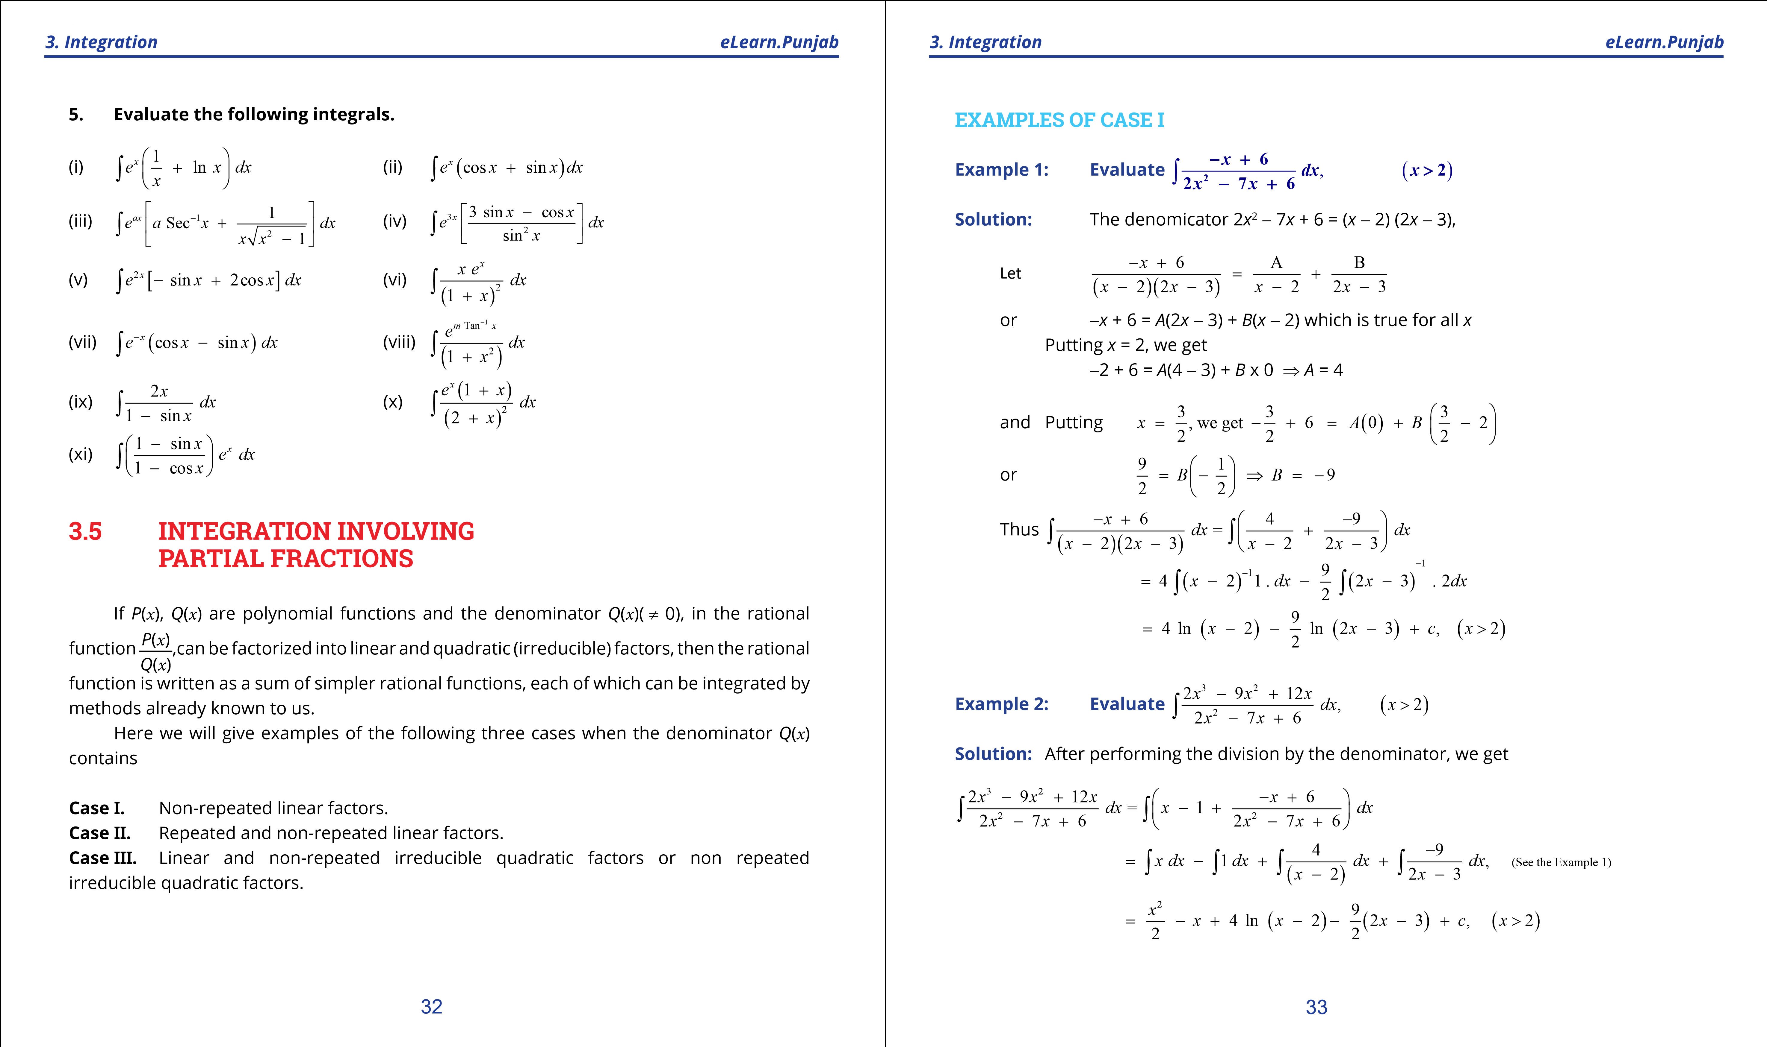

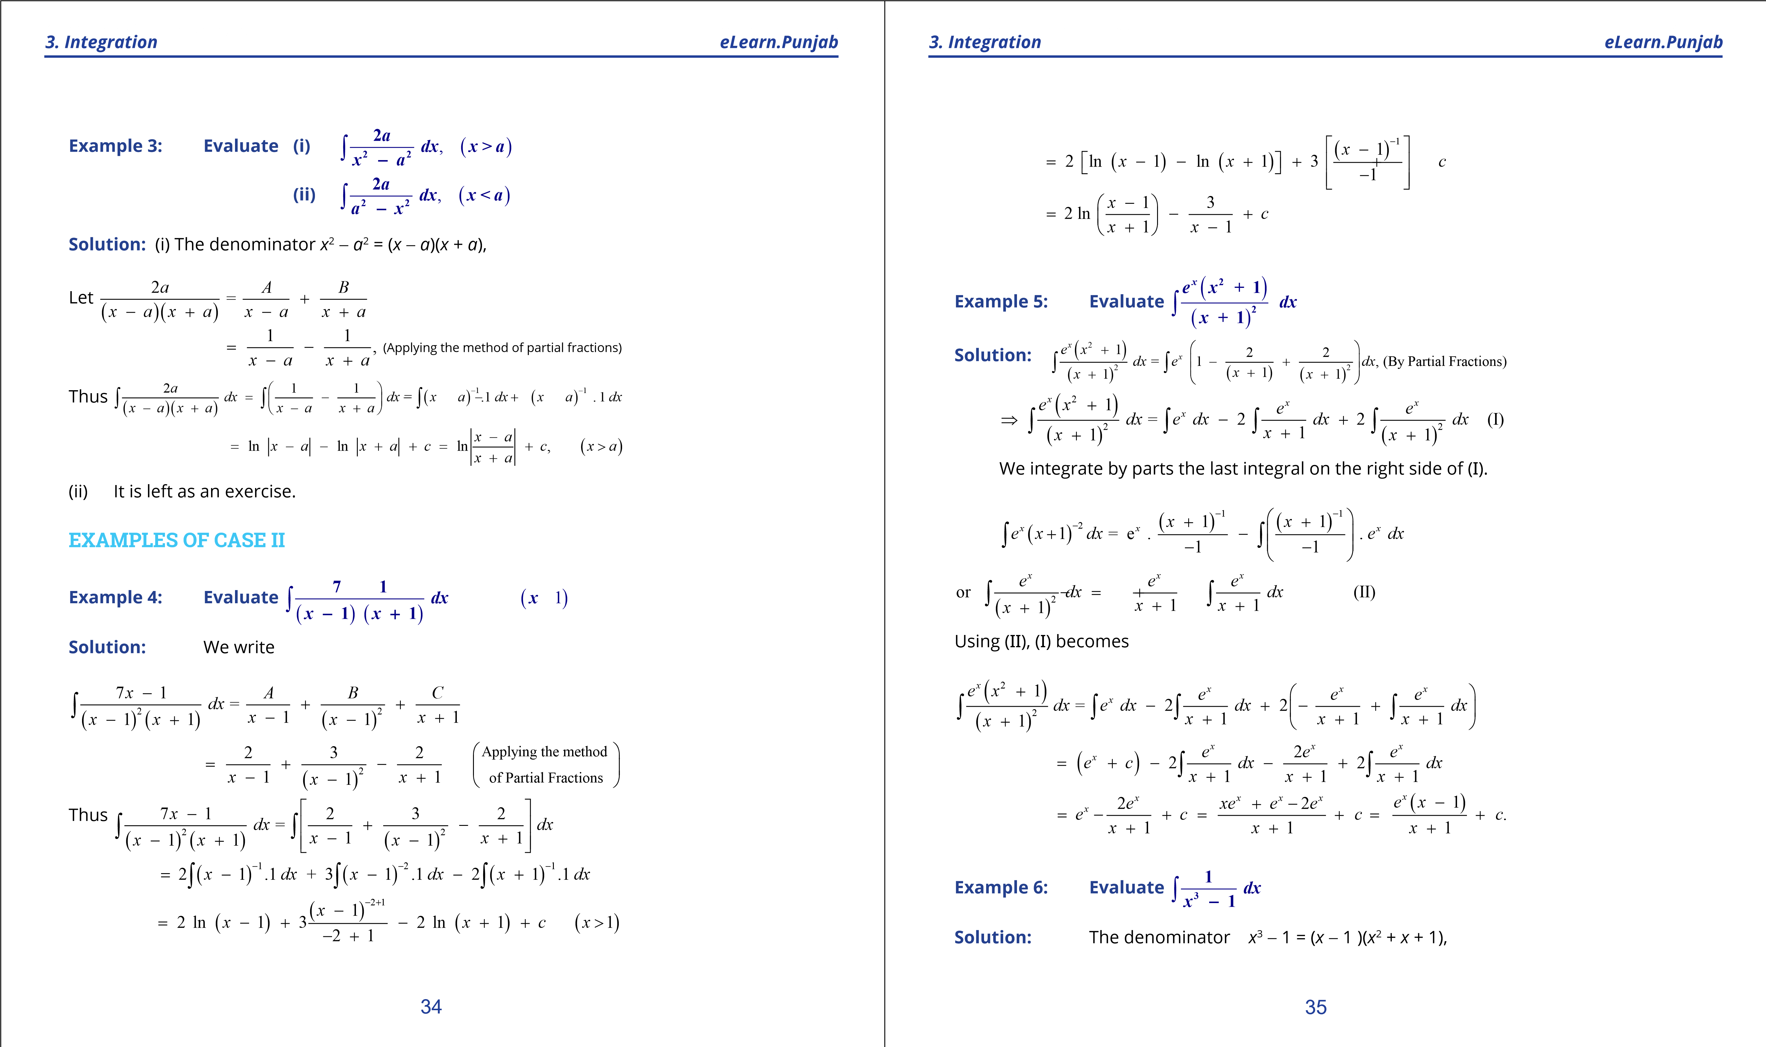

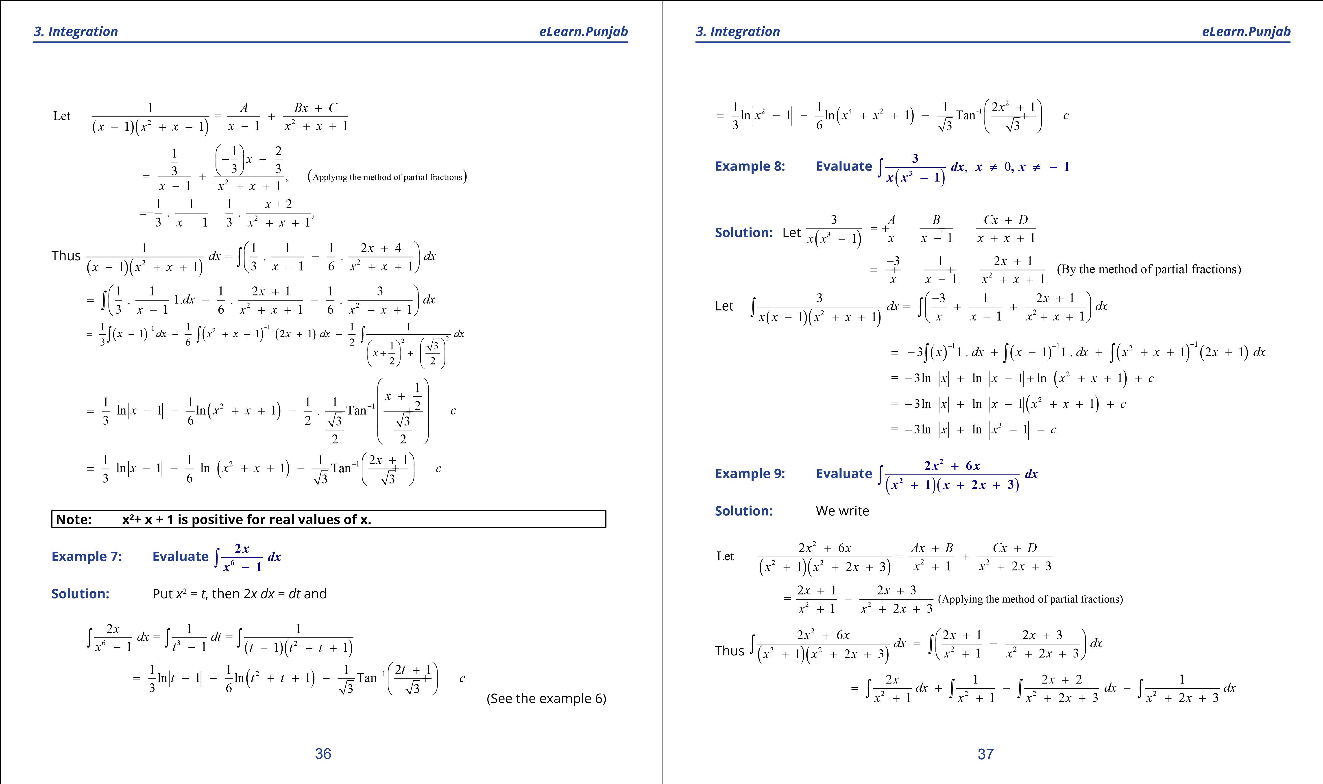

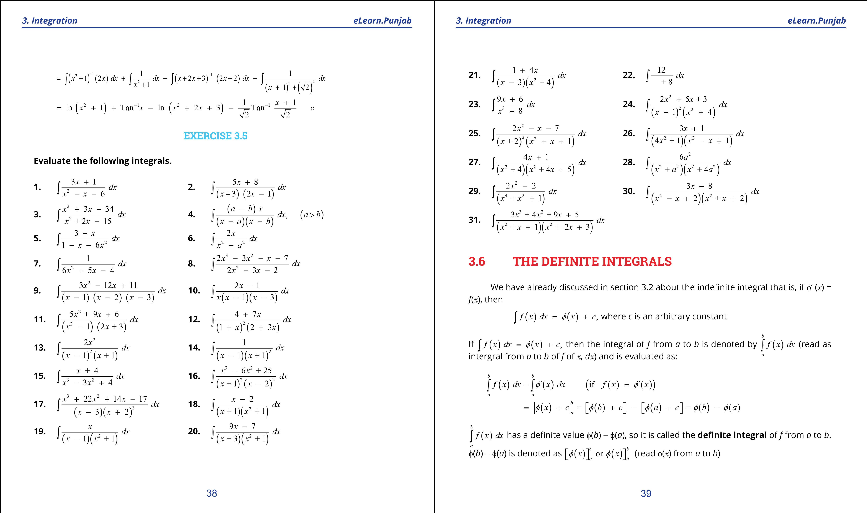

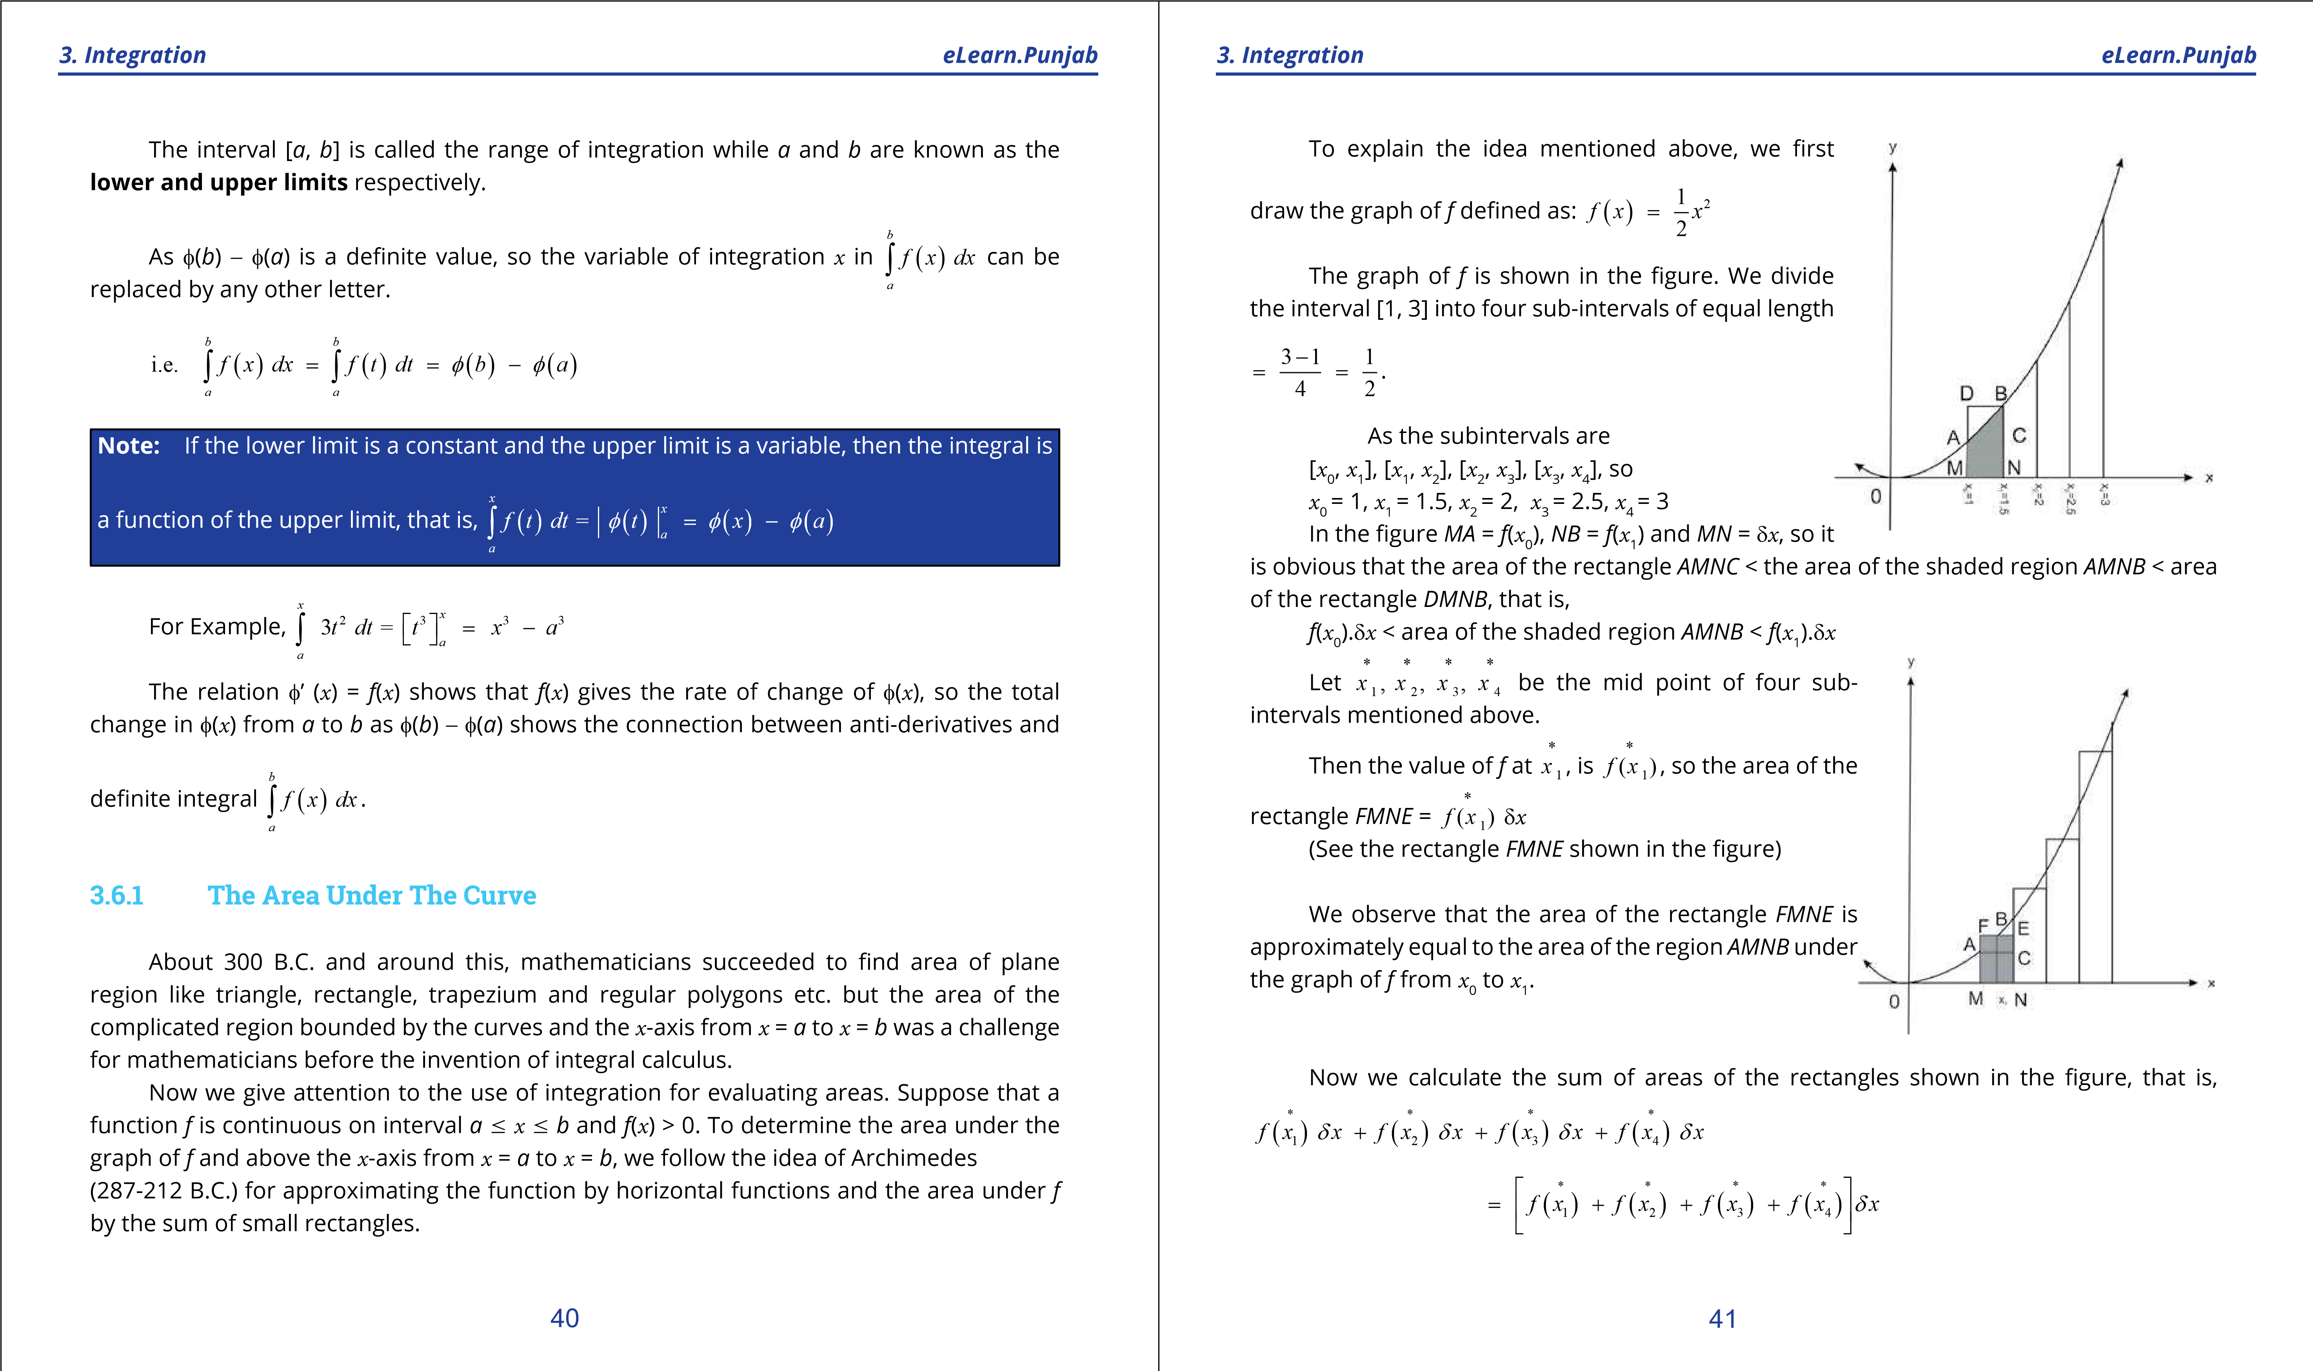

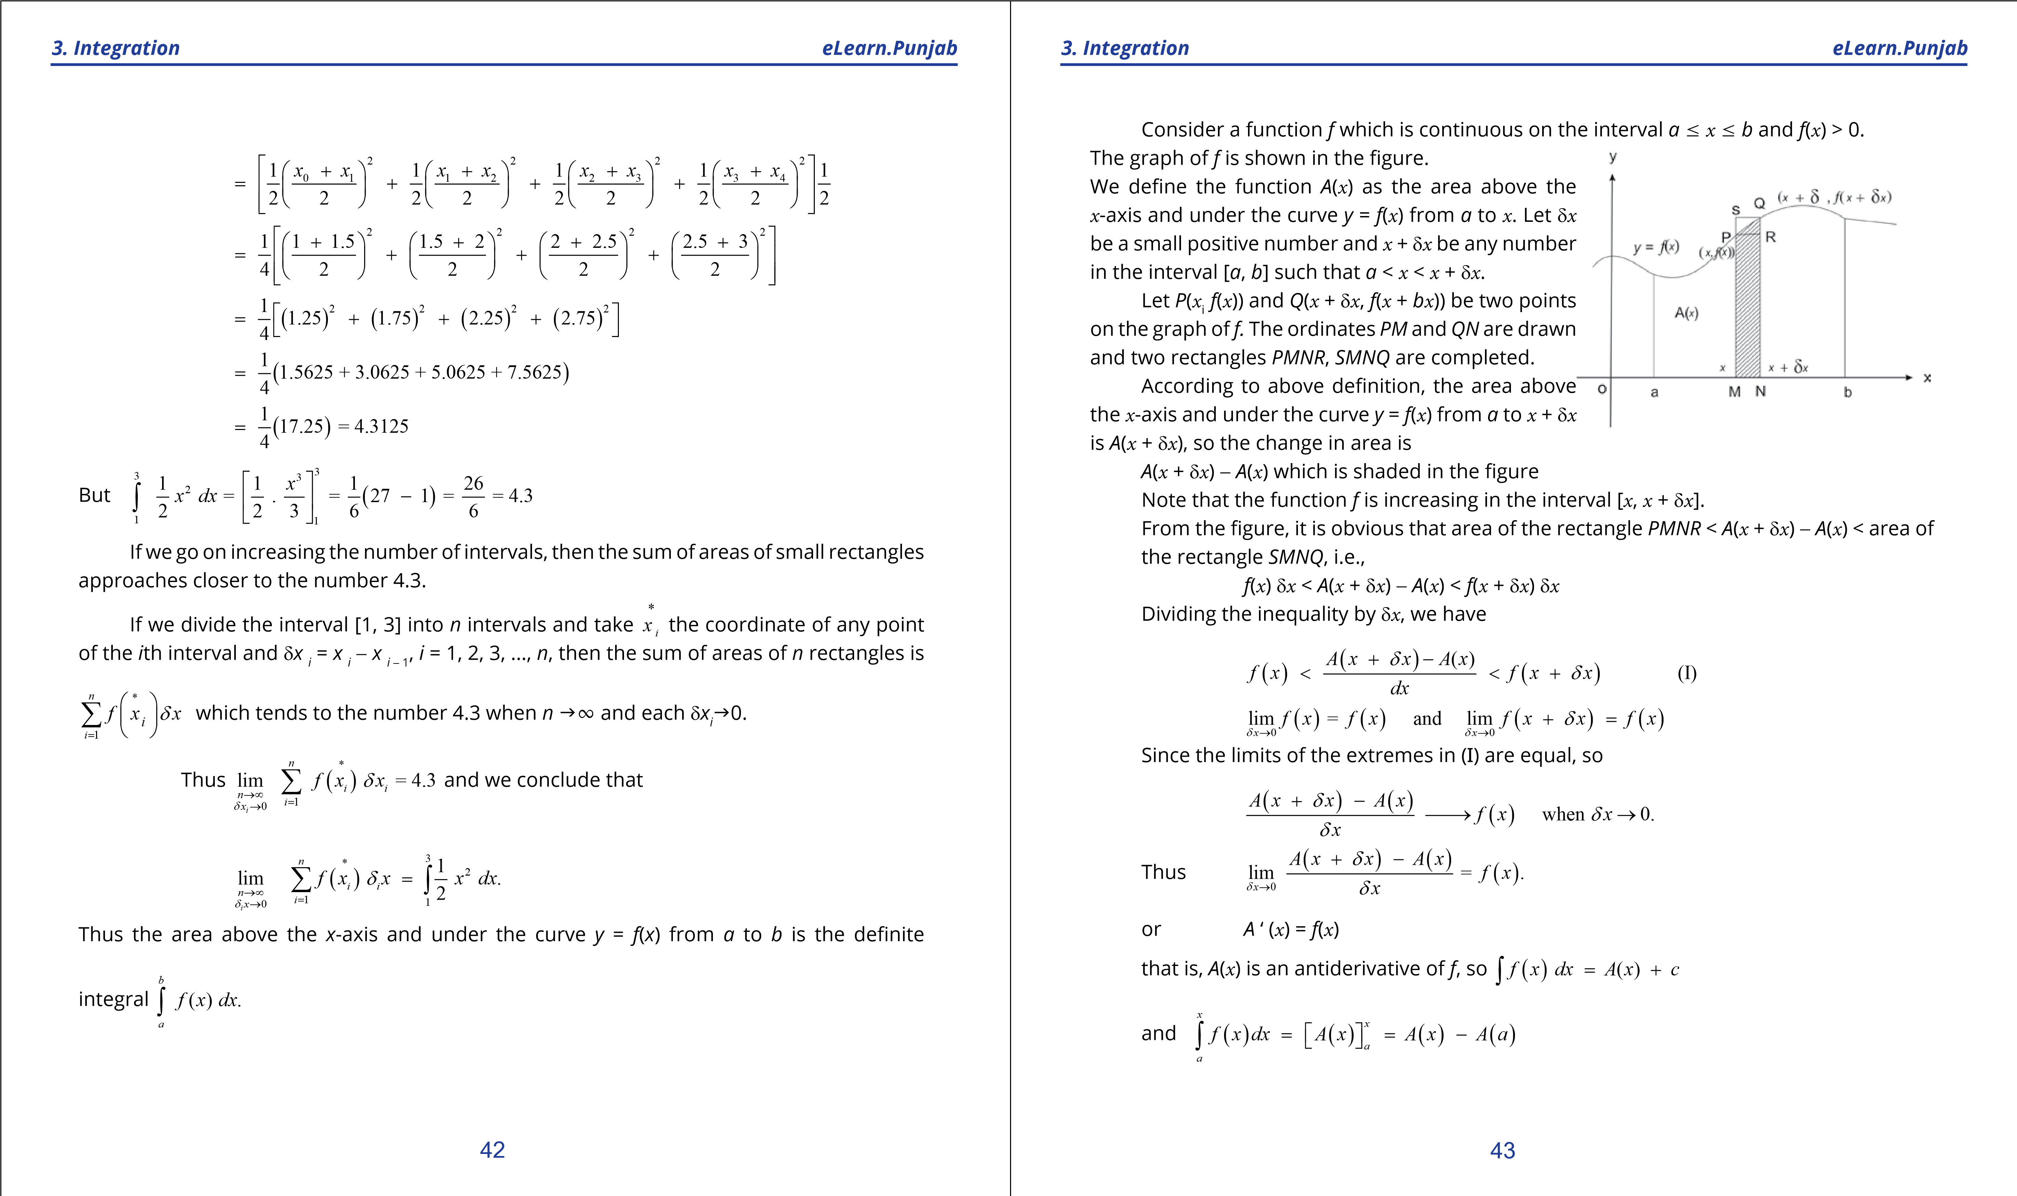

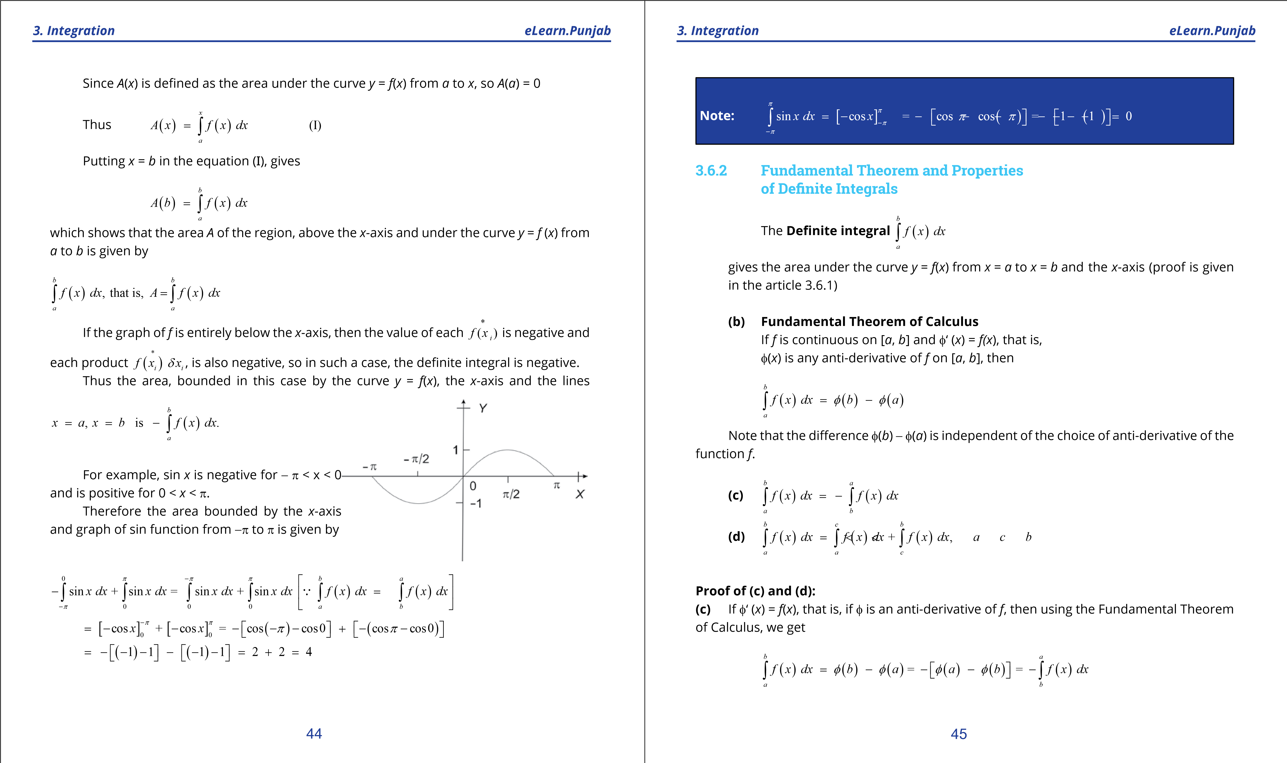

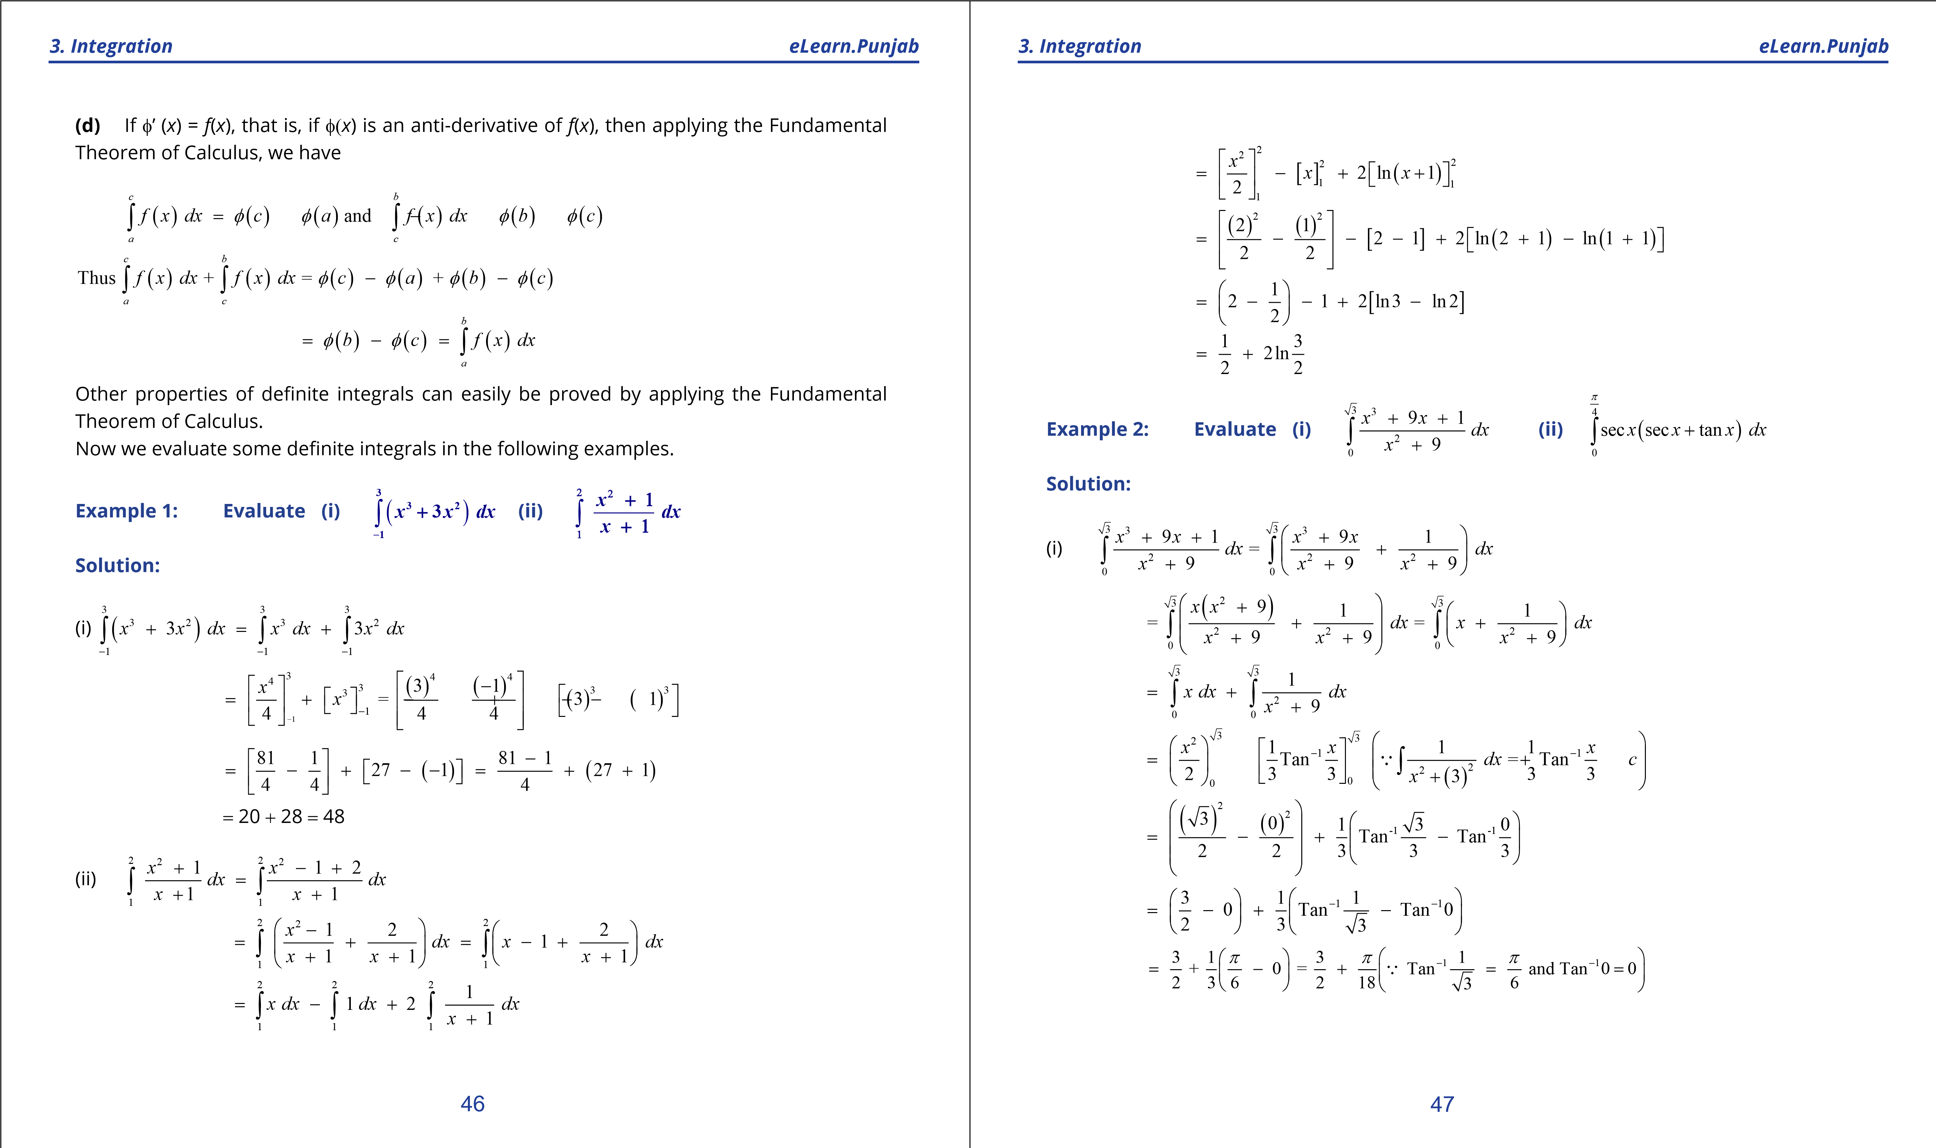

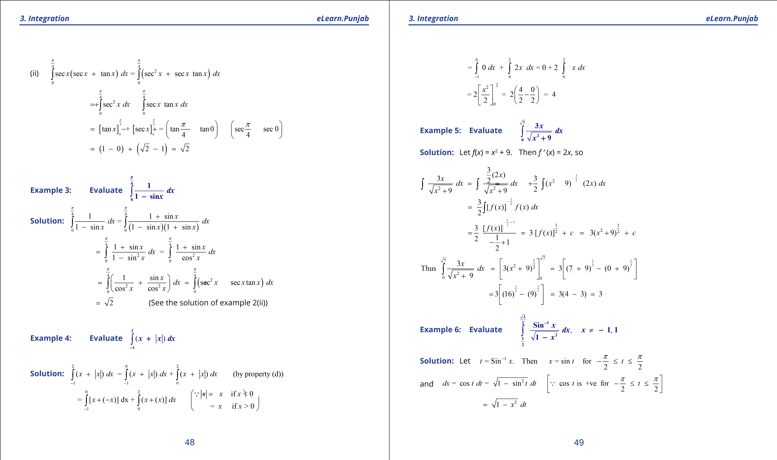

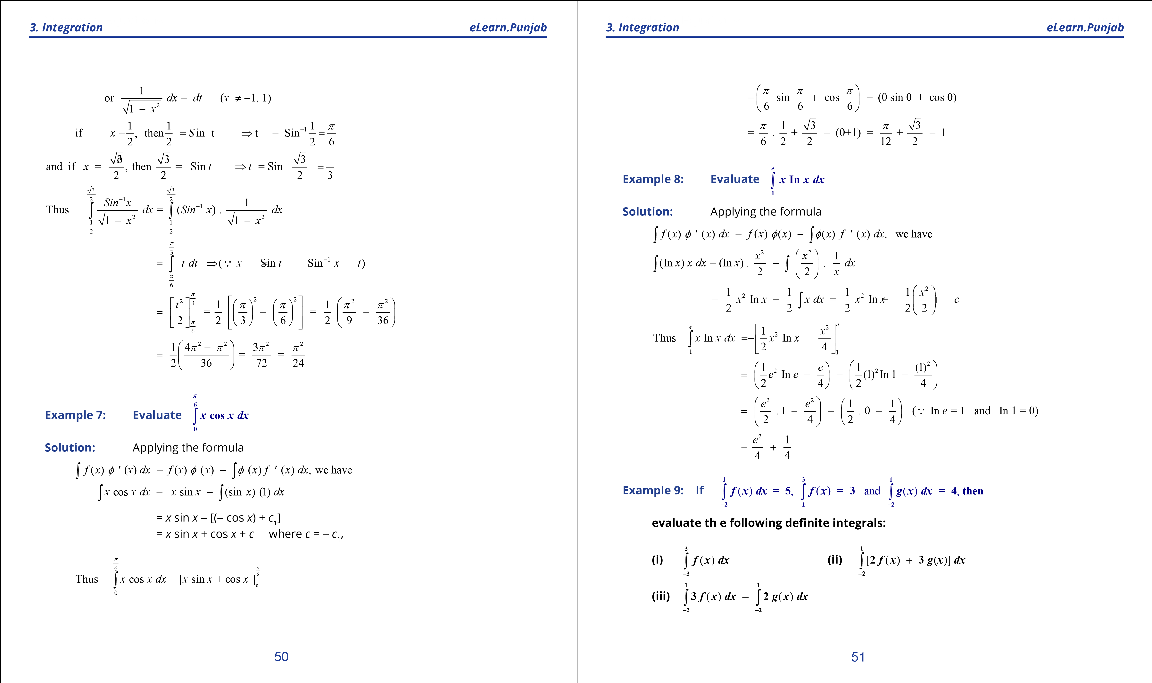

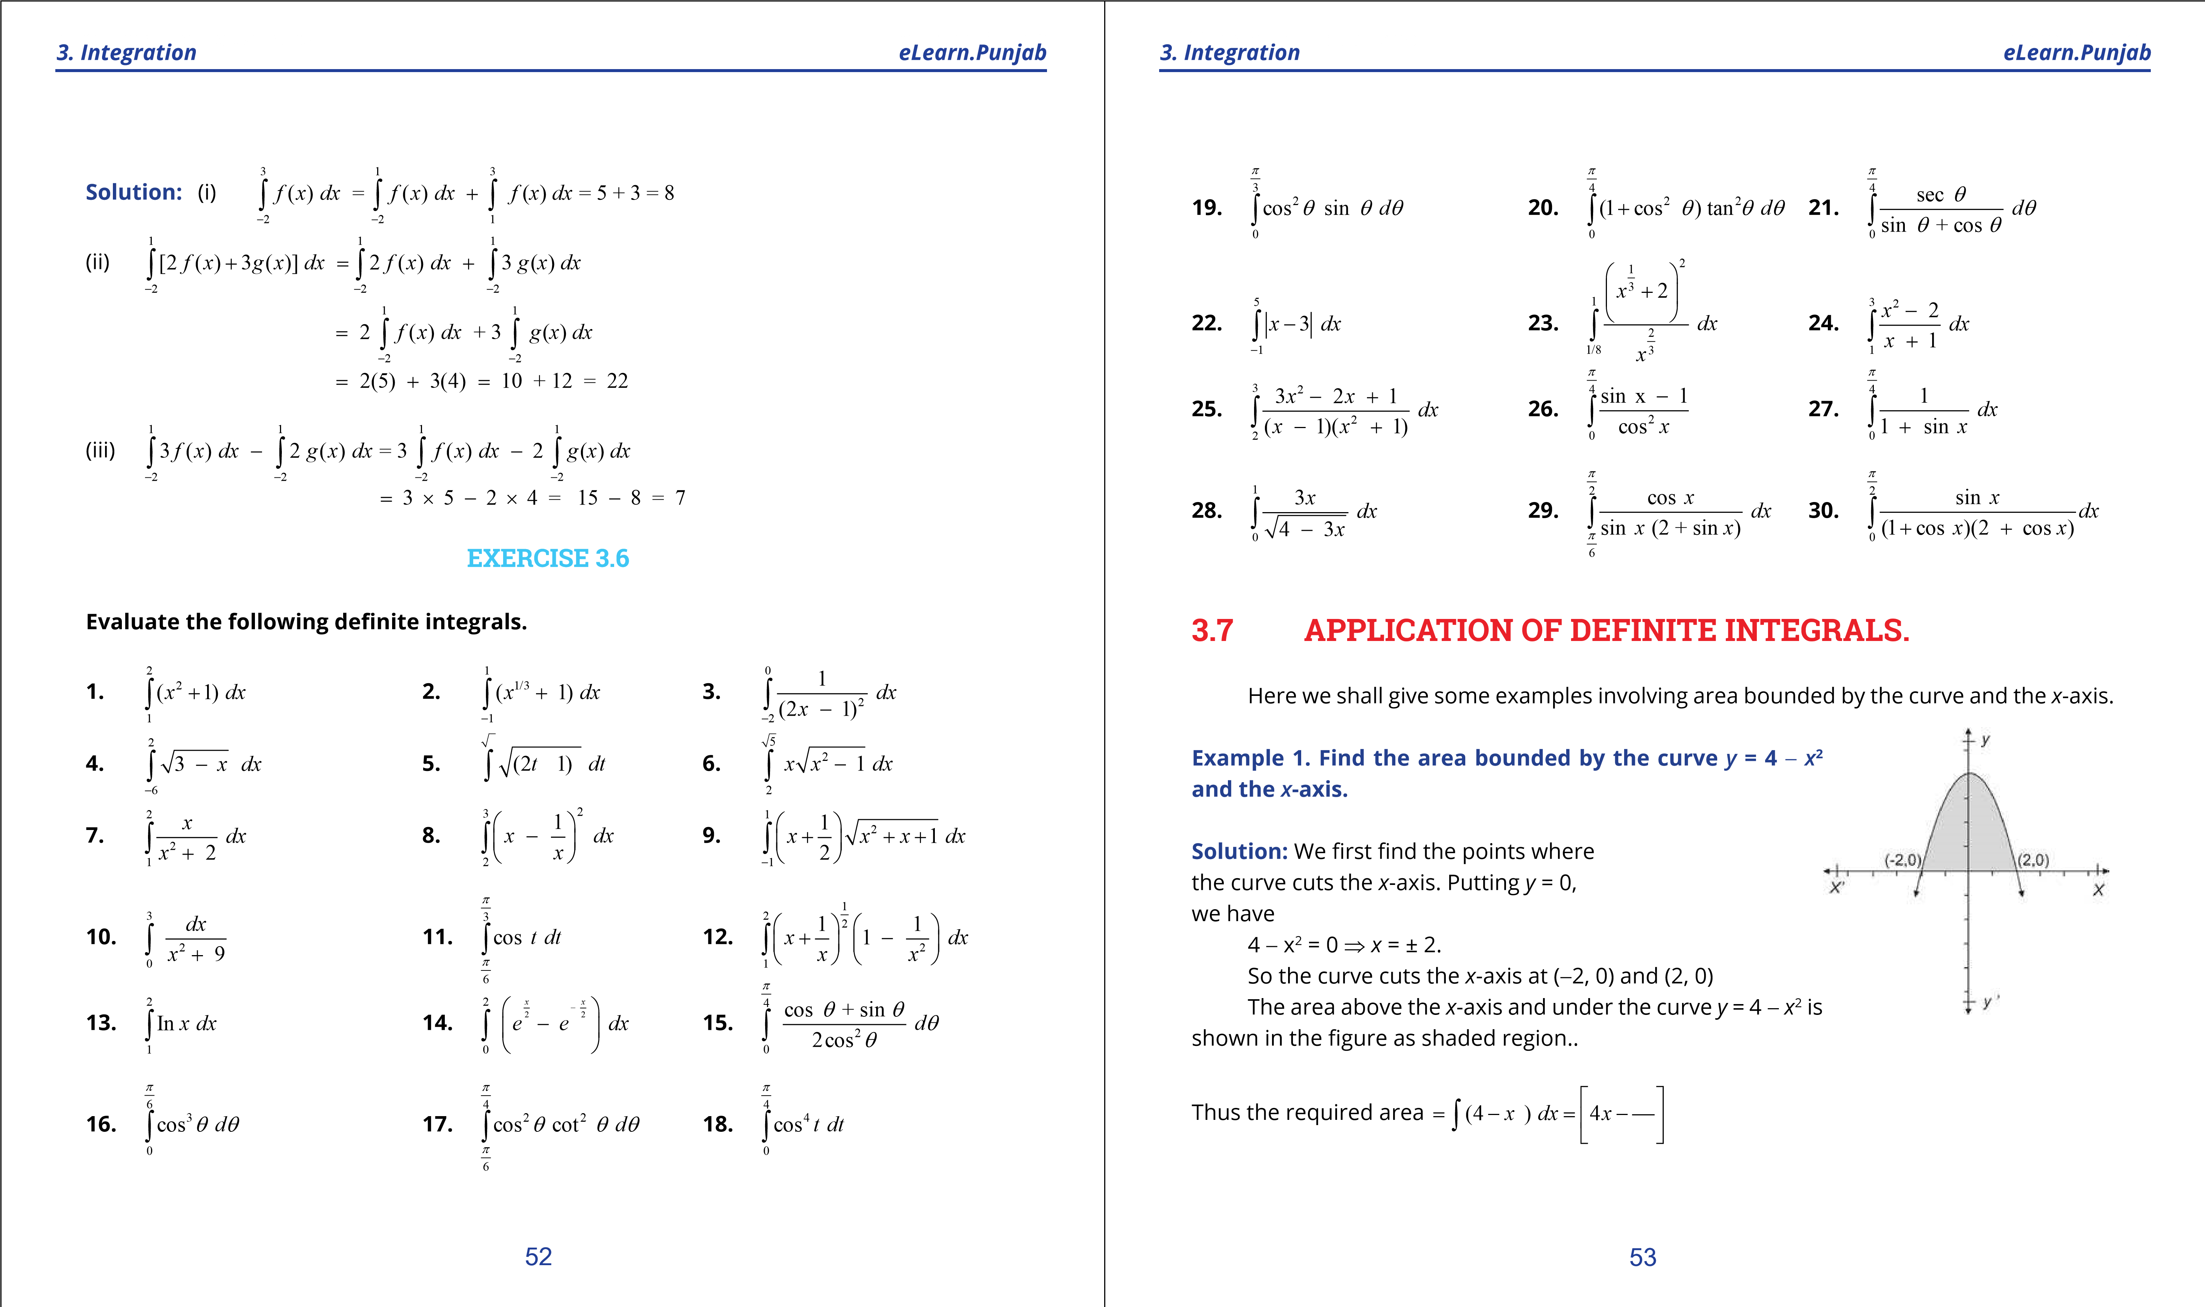

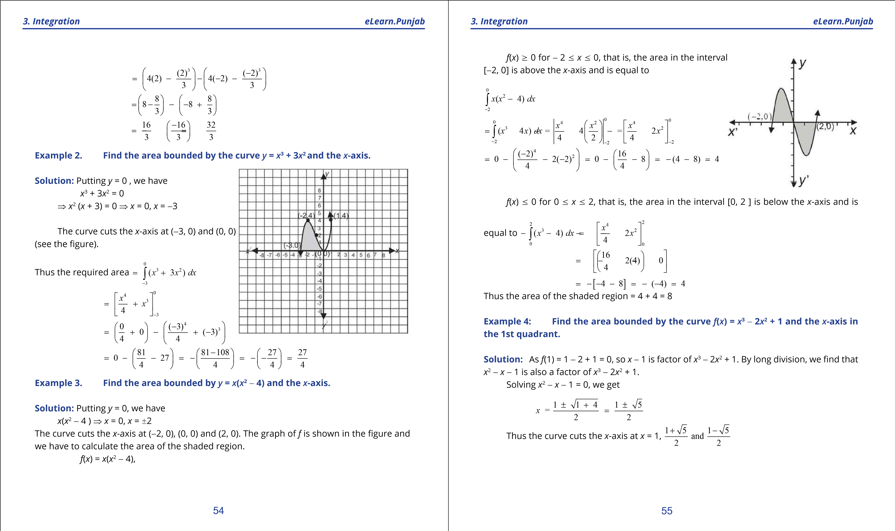

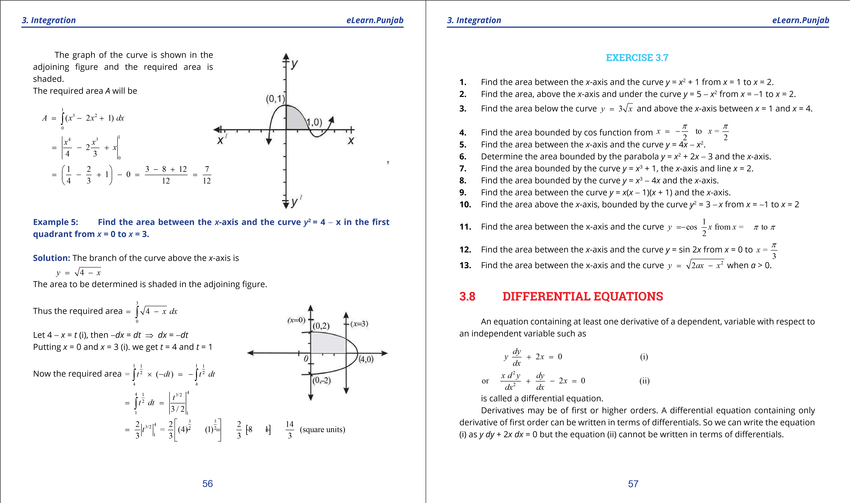

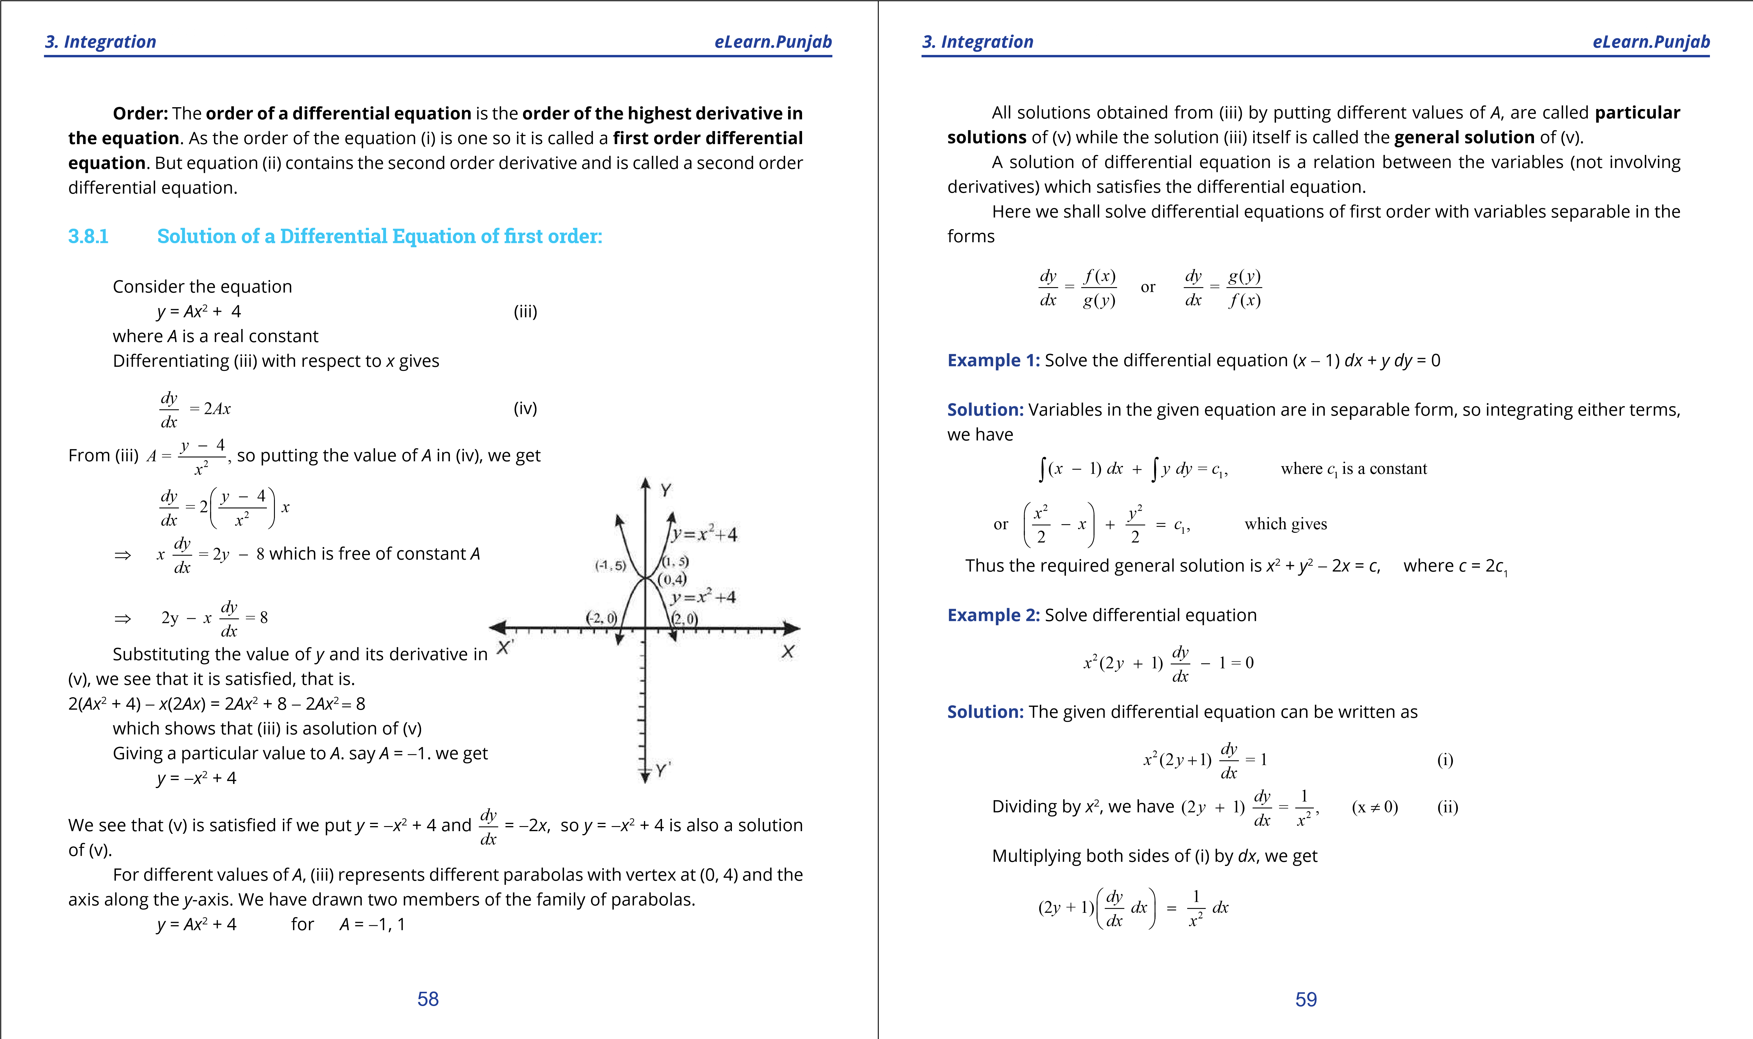

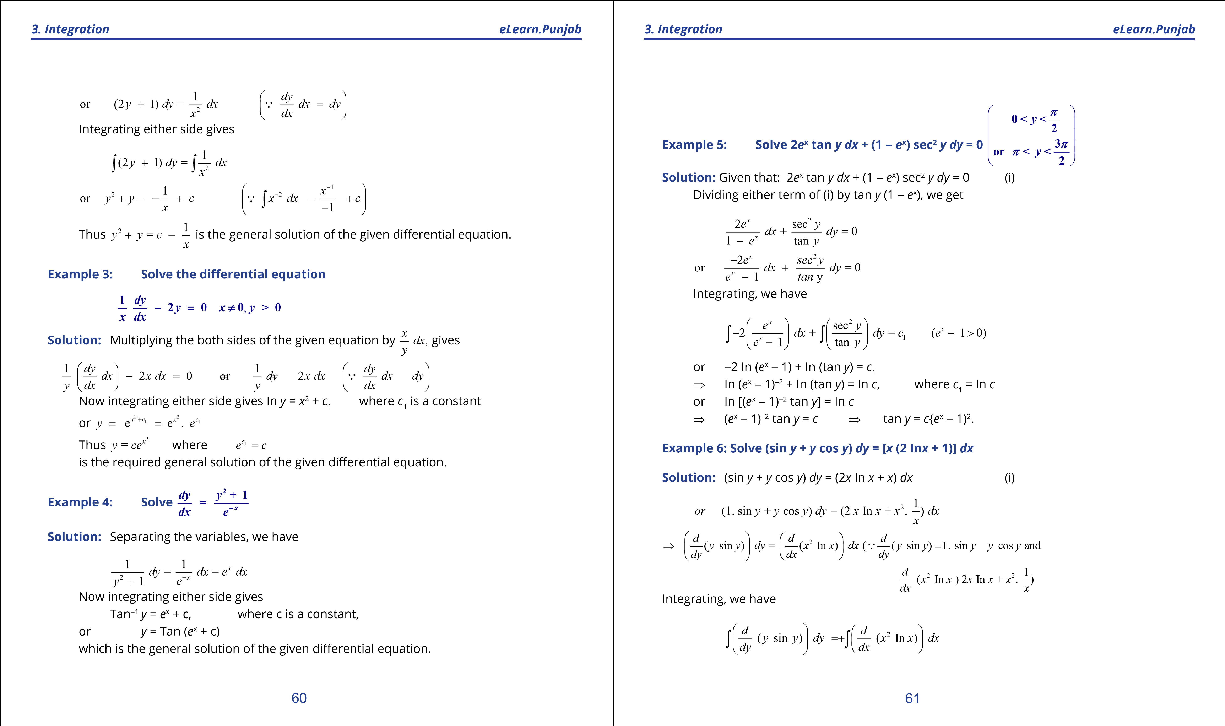

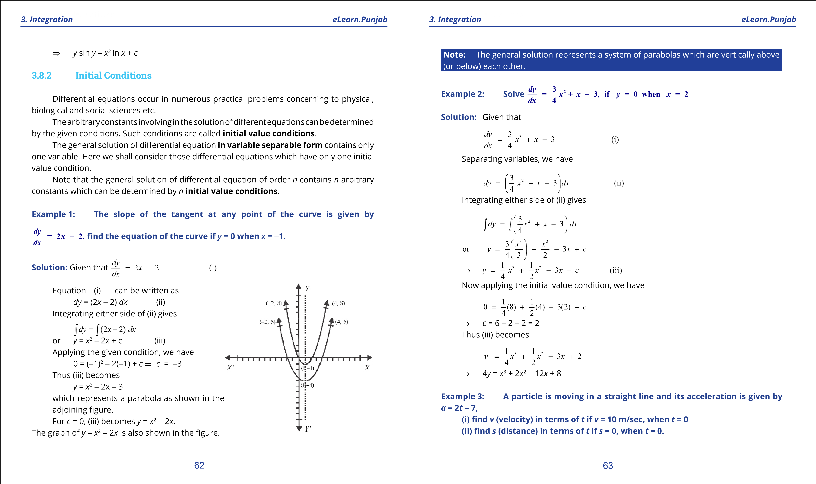

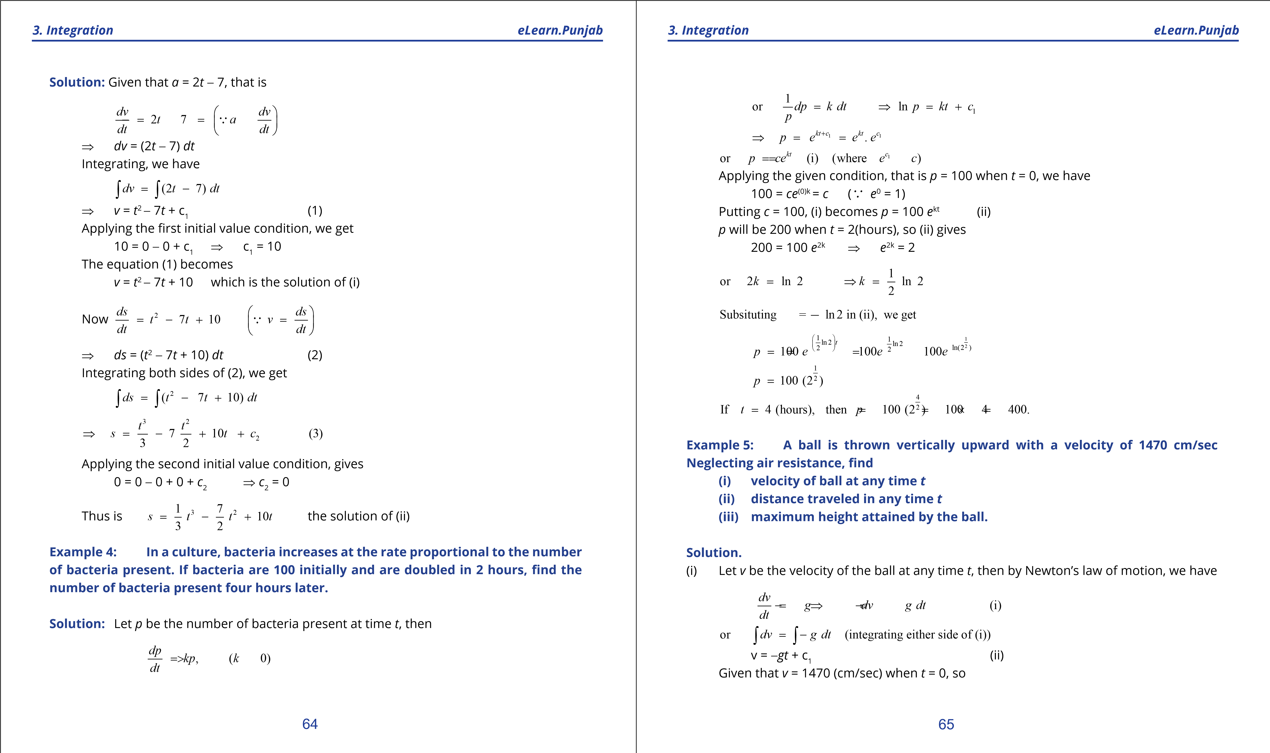

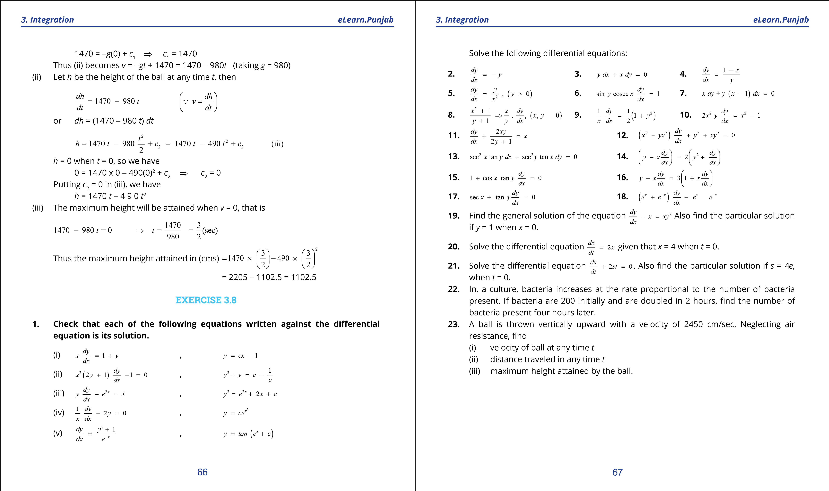

***version: 1.1***

CHAPTER

# 4 Analytic Geometry Introduction to

*Animation 4.1: Coordinate System*

*Source and credit:* [*eLearn.Punjab*](http://elearn.punjab.gov.pk/)

**1. Quadratic Equations eLearn.Punjab 1. Quadratic Equations eLearn.Punjab**

***4. Introduction to Analytic Geometry eLearn.Punjab 4. Introduction to Analytic Geometry eLearn.Punjab***

## 4.1 INTRODUCTION

**Geometry** is one of the most ancient branches of mathematics. The Greeks systematically studied it about four centuries B.C. Most of the geometry taught in schools is due to Euclid who expounded thirteen books on the subject (300 B.C.). A French philosopher and m athematician Rene Descartes (1596-1650 A.D.) introduced algebraic methods in geometry which gave birth to analytical geometry (or coordinate geometry). Our aim is to present fundamentals of the subject in this book.

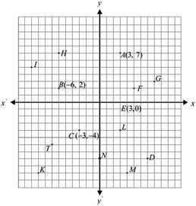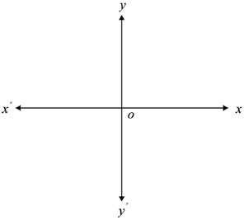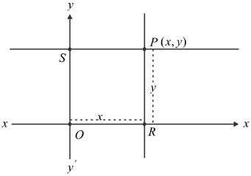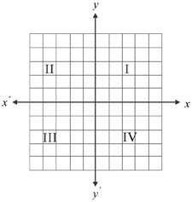

### ***Coordinate System***

Draw in a plane two mutually perpendicular number lines *x' x* and *y' y*, one horizontal and the other vertical. Let their point of intersection be *O* , to which we call the **origin** and the real number 0 of both the lines is represented by *O*. The two lines are called the **coordinate axes**. The horizontal line *x'Ox* is called the ***x*-axis** and the vertical line *y'Oy* is called the ***y*-axis**.

As in the case of number line, we follow the convention that all points on the *y*-axis above *x'Ox* are associated with positive real numbers, those below *x'Ox* with negative real numbers. Similarly, all points on the *x*-axis and lying on the right of *O* will be positive and those on the left of *O* and lying on the *x*-axis will be negative.

Suppose *P* is any point in the plane. Then ***P*** can be **located** by using an ordered pair of real numbers. Through *P* draw lines parallel to the coordinates axes meeting *x*-axis at *R* and *y*-axis at *S*.

Let the directed distance *OR* = *x* and the directed distance *OS* = *y* .

The ordered pair (*x*, *y*) gives us enough information to locate the point *P*. Thus, with every point *P* in the plane, we can associate an ordered pair of real numbers (*x*, *y*) and we say that *P* has **coordinates** (*x*, *y*). It may be noted that *x* and *y* are the directed distances of *P* from the *y*-axis and the *x*-axis respectively. The reverse of this technique also provides method for associating exactly one point in the plane with any ordered pair (*x*, *y*) of real numbers. This method of pairing of in a one-to-one fashion the points in a plane with ordered pairs of real numbers is called the **two dimensional rectangular** (or **Cartesian**) **coordinate system**.

If (*x*, *y*) are the coordinates of a point *P*, then the irst member (component) of the ordered pair is called the ***x*** -**coordinate** or **abscissa** of *P* and the second member of the ordered pair is called the ***y*** -**coordinate** or **ordinate** of *P*. Note that abscissa is always irst element and the ordinate is second element in an ordered pair.

The coordinate axes divide the plane into four equal parts called **quadrants**. They are deined as follows:

**Quadrant I:** All points (*x*, *y*) with *x* > 0, *y* > 0

**Quadrant II:** All points (*x*, *y*) with *x* < 0, *y* > 0

**Quadrant III:** All points (*x*, *y*) with *x* < 0, *y* < 0

**Quadrant IV:** All points (*x*, *y*) with *x* > 0, *y* < 0

The point *P* in the plane that corresponds to an ordered pair

(*x*, *y*) is called the graph of (*x*, *y*).

Thus given a set of ordered pairs of real numbers, the graph of the set is the aggregate of all points in the plane that correspond to ordered pairs of the set. **Challenge!**

i- Write down the coordinates of the points if not mentioned. ii- Locate (0, -1), (2, 2), (-4, 7) and (-3, -3).

### 2 3

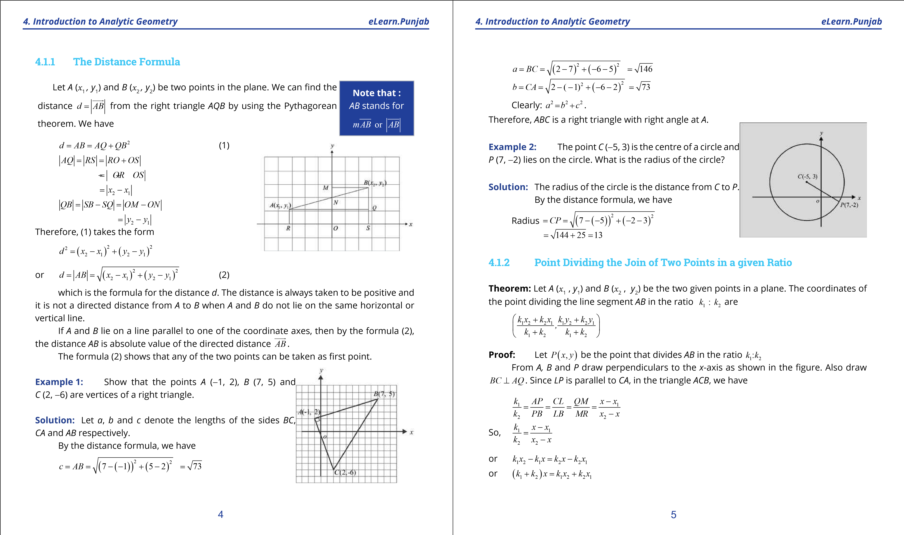

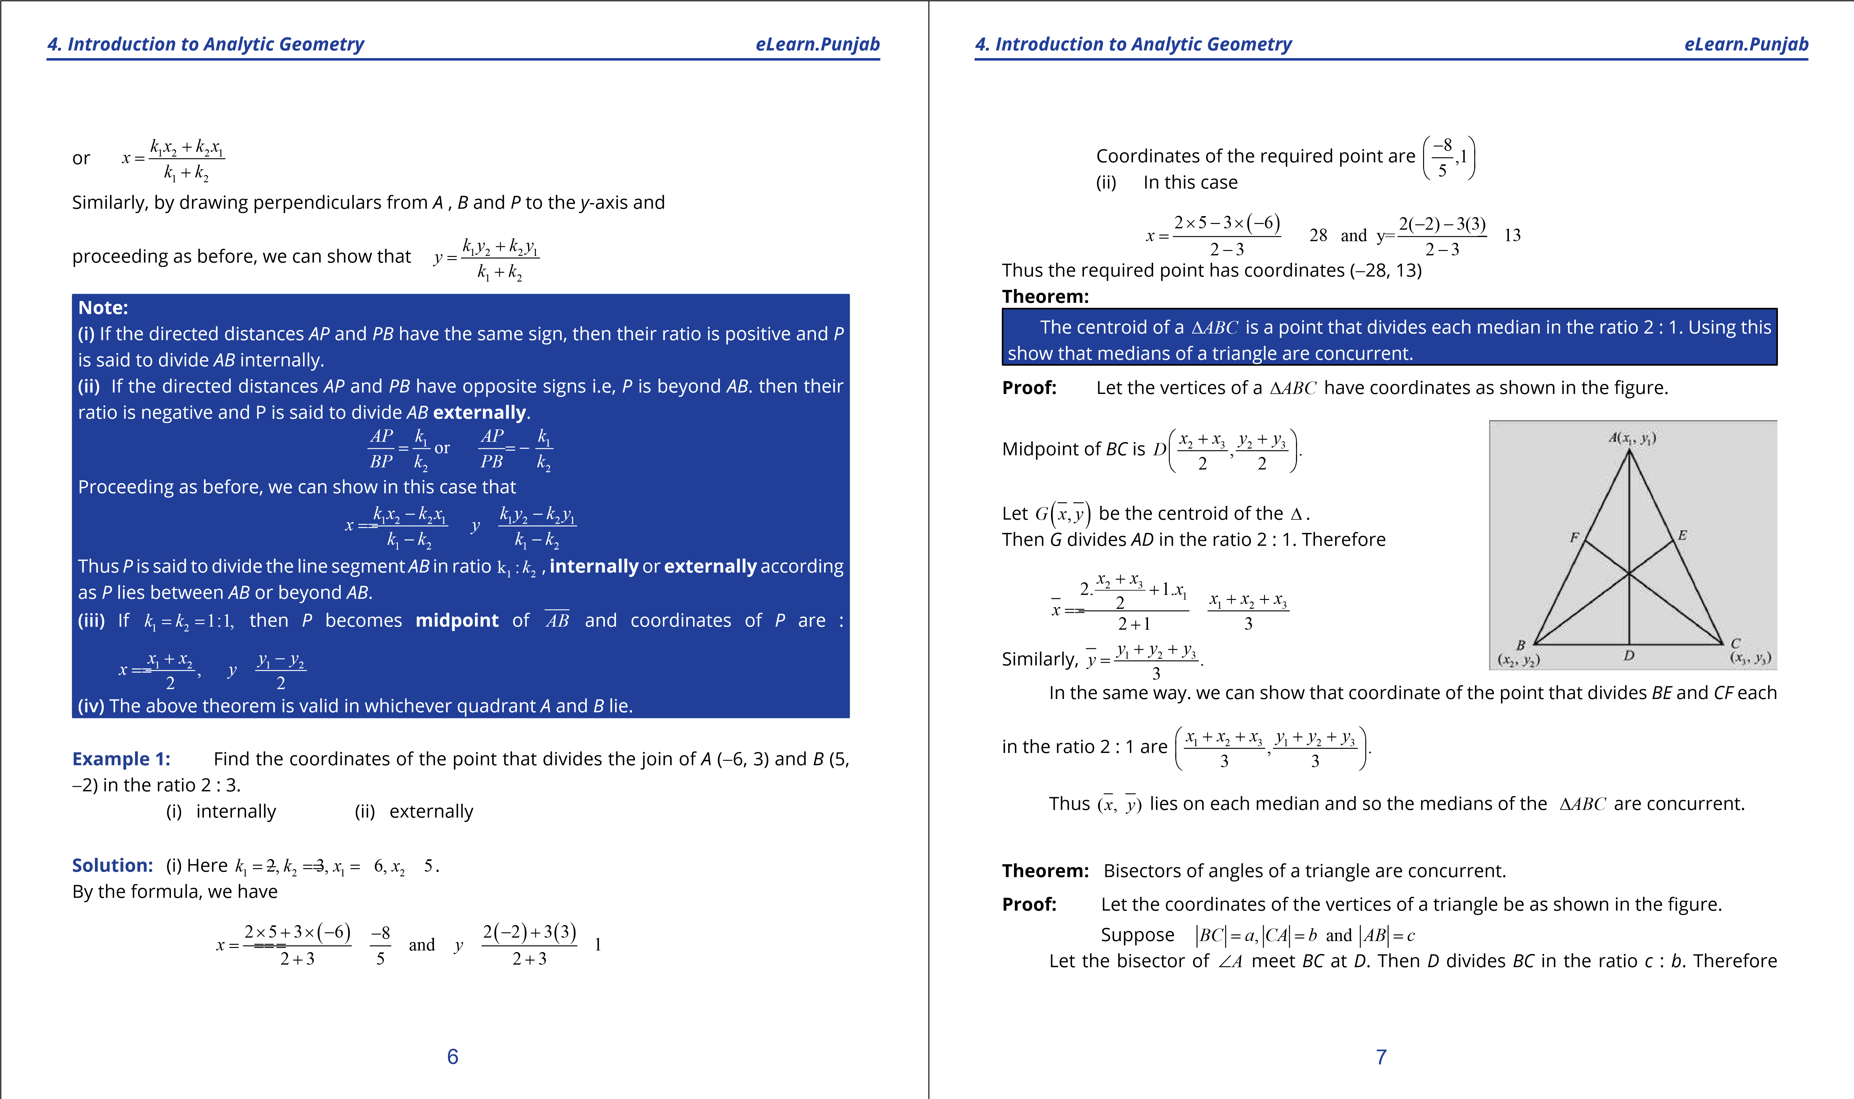

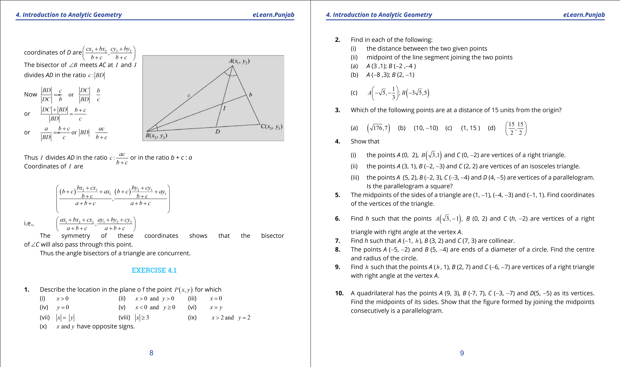

**1. Quadratic Equations eLearn.Punjab 1. Quadratic Equations eLearn.Punjab**

***4. Introduction to Analytic Geometry eLearn.Punjab 4. Introduction to Analytic Geometry eLearn.Punjab***

1. Find *h* such that the quadrilateral with vertices *A* (-3, 0), *B* (1, -2), *C* (5, 0) and *D* (1, *h*) is parallelogram. Is it a square?
2. If two vertices of an equilateral triangle are *A* (-3, 0) and *B* (3, 0), ind the third vertex. How many of these triangles are possible?
3. Find the points trisecting the join of *A* (-1, 4) and *B* (6, 2).
4. Find the point three-ifth of the way along the line segment from *A* (-5, 8) to *B* (5, 3).
5. Find the point *P* on the join of *A* (1, 4) and *B* (5, 6) that is twice as far from *A* as *B* is from *A* and lies
   1. on the same side of *A* as *B* does.
   2. on the opposite side of *A* as *B* does.
6. Find the point which is equidistant from the points *A* (5, 3),

*B* (-2, 2) and *C* (4, 2). What is the radius of the circumcircle of the ∆ABC?

1. The points (4, -2), (-2, 4) and (5, 5) are the vertices of a triangle. Find in-centre of the triangle. **18.** Find the points that divide the line segment joining *A x*( 1, *y*1 ) and *B x*( 2, *y*2 ) into four equal parts.

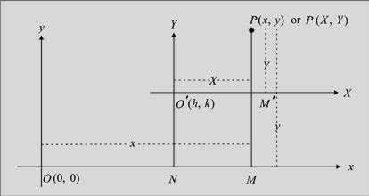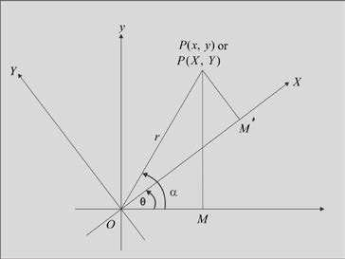

## 4.2 TRANSLATION AND ROTATION OF AXES

### ***Translation of Axes***

Let *xy*-coordinate system be given and

*O*' ( , )*h k* be any point in the plane. Through *O’* draw two mutually perpendicular lines *O’X* , *O’Y* such that *O’X* is parallel to *Ox*. The new axes *O’X* and *O’Y* are called **translation** of the *Ox* - and *Oy* - axes through the point *O’*. In translation of axes, origin is shifted to another point in the plane but the axes remain parallel to the old axes.

Let *P* be a point with coordinates (*x y*, ) referred to *xy*-coordinate system and the axes be translated through the point *O h k*'( , ) and *O’X, O’Y* be the new axes. If *P* has coordinates (*X*, *Y*) referred to the new axes, then we need to ind *X*, *Y* in terms of *x*, *y*.

Draw *PM* and *O’ N* perpendiculars to *Ox*. From the igure, we have

*OM* = *x MP*, = *y*, *ON* = *h NO*, ' = *k* = *MM* '

Now *X* = *O'M'* = *NM* = *OM* -*OM* -*ON* = *x* - *h*

Similarly, *Y* = *M P*' = *MP* - *MM* ' = *y k*

Thus the coordinates of *P* referred to *XY*-system are (*x* - *h y*, - *k*)

i.e. *X* = -*x h*

*Y* = *y* - *k*

Moreover, *x* = *X* + *h*, +*y* = *Y k*.

**Example 1:** The coordinates of a point *P* are (-6, 9). The axes are translated through the point *O*’ (-3, 2). Find the coordinates of *P* referred to the new axes.

**Solution.** Here *h*-= 3=, *k* 2

Coordinates of *P* referred to the new axes are (*X*, *Y*) given by

*X* = -6 - (-3) = -3 and *Y* = 9 - 2 = 7 Thus *P* (*X*, *Y*) = *P* (-3 ,7).

**Example 2:** The *xy*-coordinate axes are translated through the point *O’* (4, 6). The coordinates of the point *P* are (2, -3) referred to the new axes. Find the coordinates of *P* referred to the original axes.

**Solution:** Here *X* =-2,*Y* == 3, *h*= 4, *k* 6. We have *x* = *X* + *h* = 4 + 2 = 6 *y* = *Y* + *k* = - +3 6 = 3

Thus required coordinates are *P* (6, 3).

### ***Rotation of Axes***

Let *xy*-coordinate system be given. We rotate

*Ox* and *Oy* about the origin through an angle q q(0 < < 90 )□ so that the new axes are *OX* and *OY* as shown in the igure. Let a point *P* have coordinates (*x y*, ) referred to the *xy*-system of

### 10 11

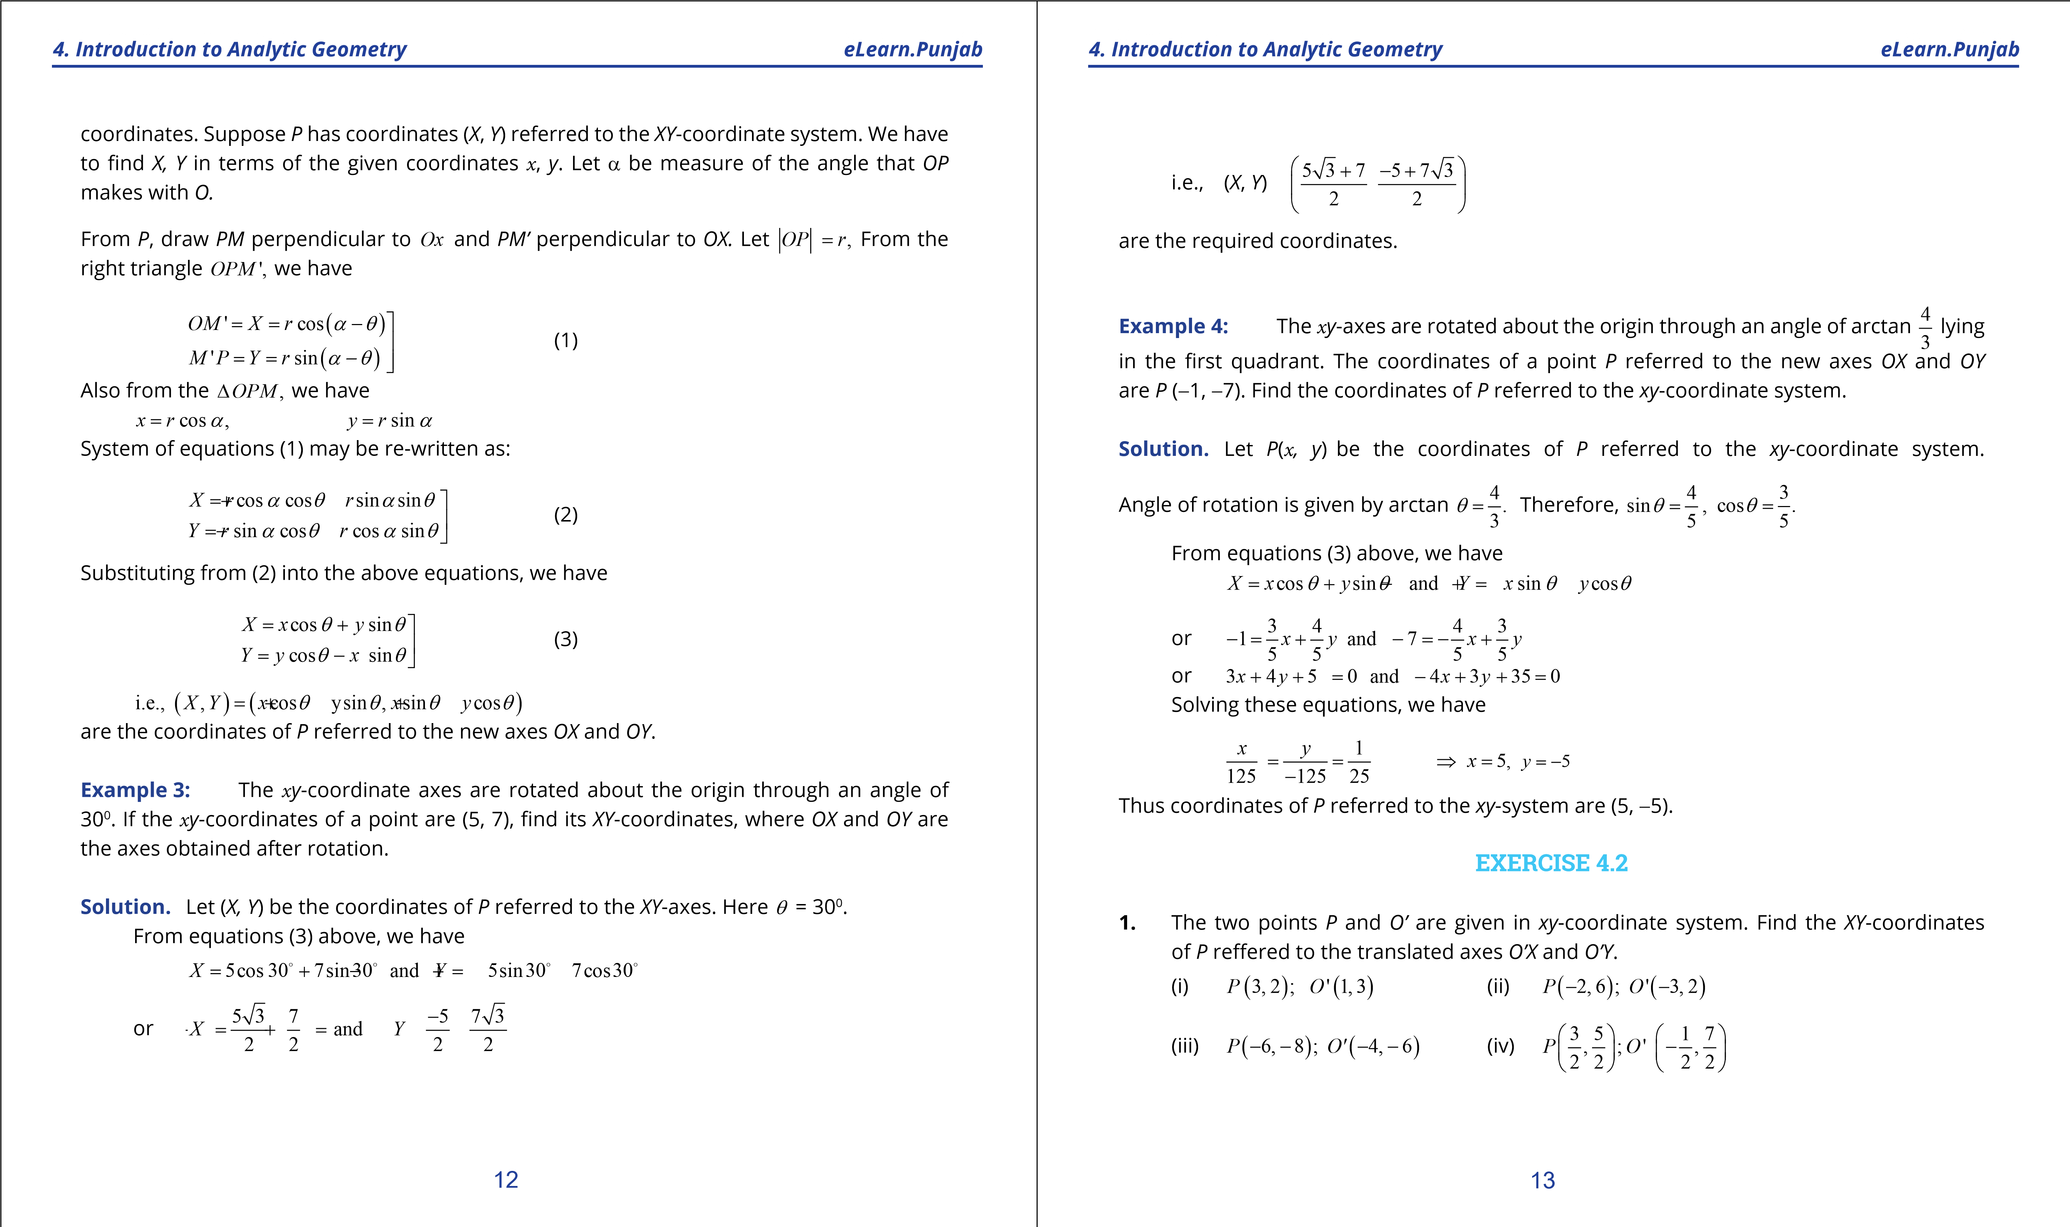

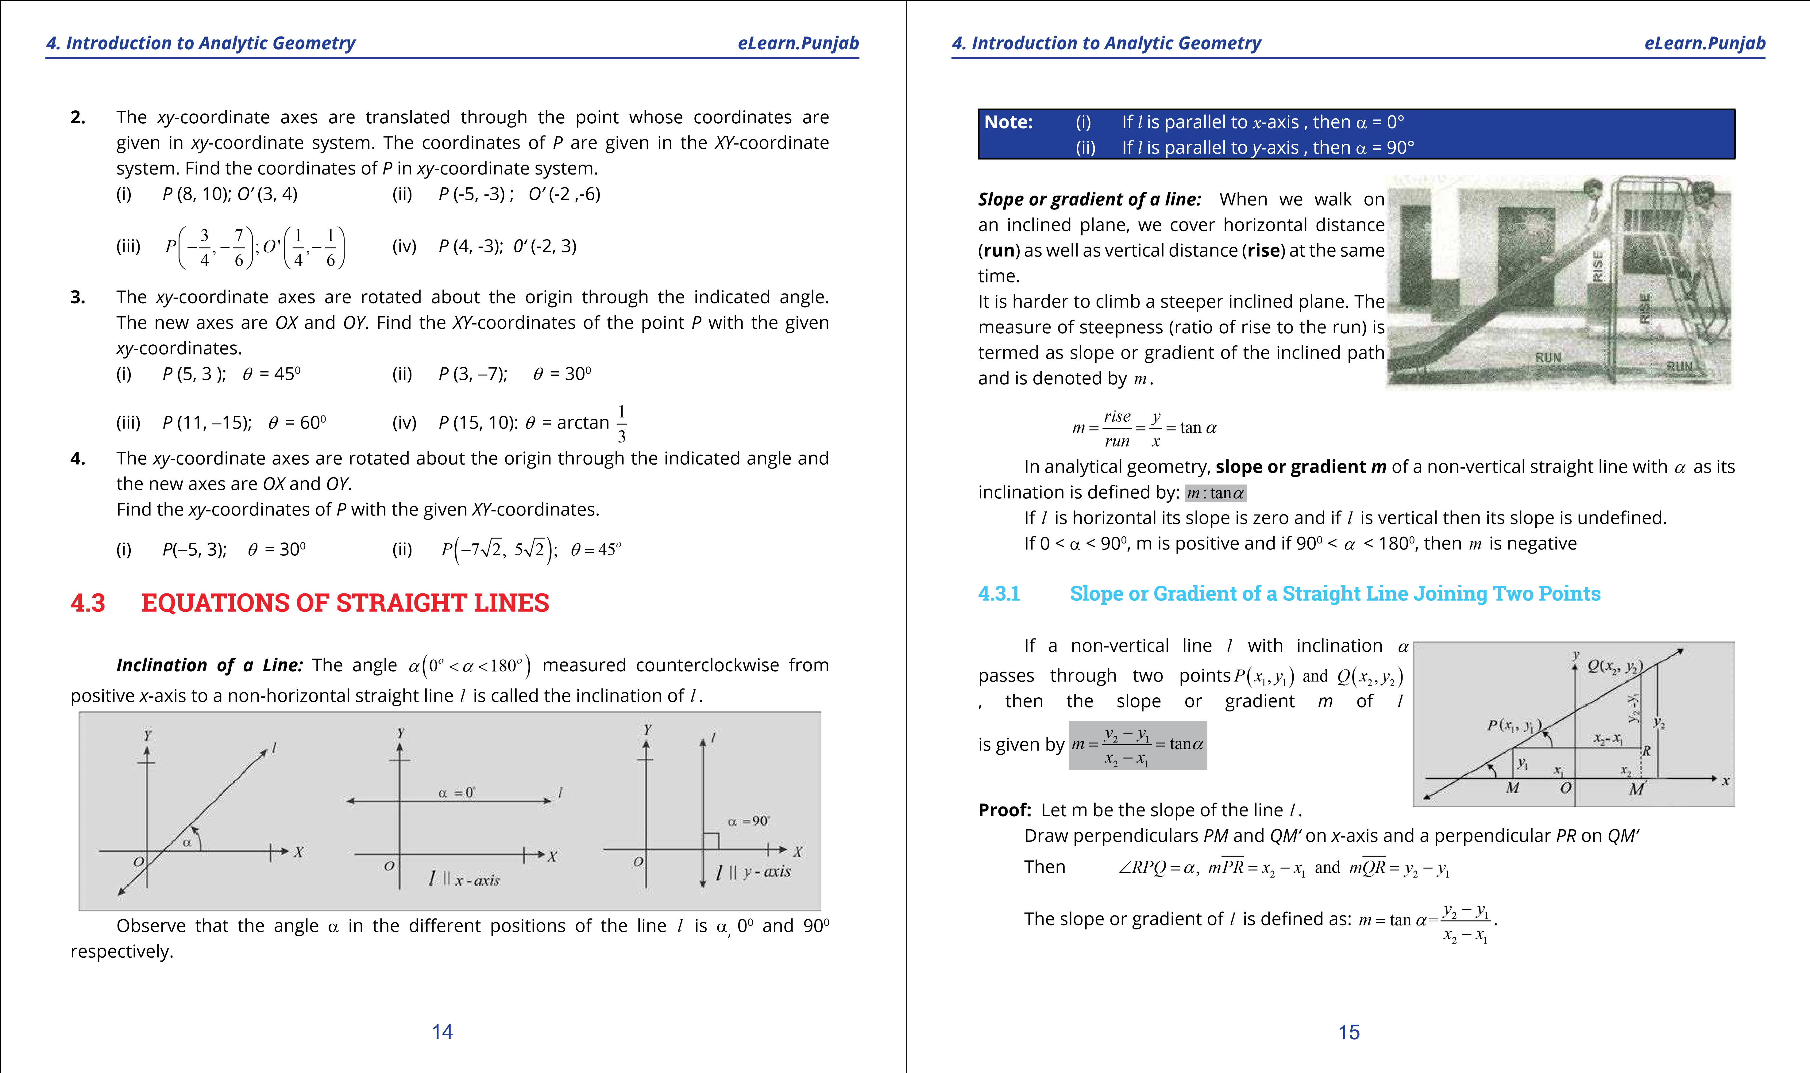

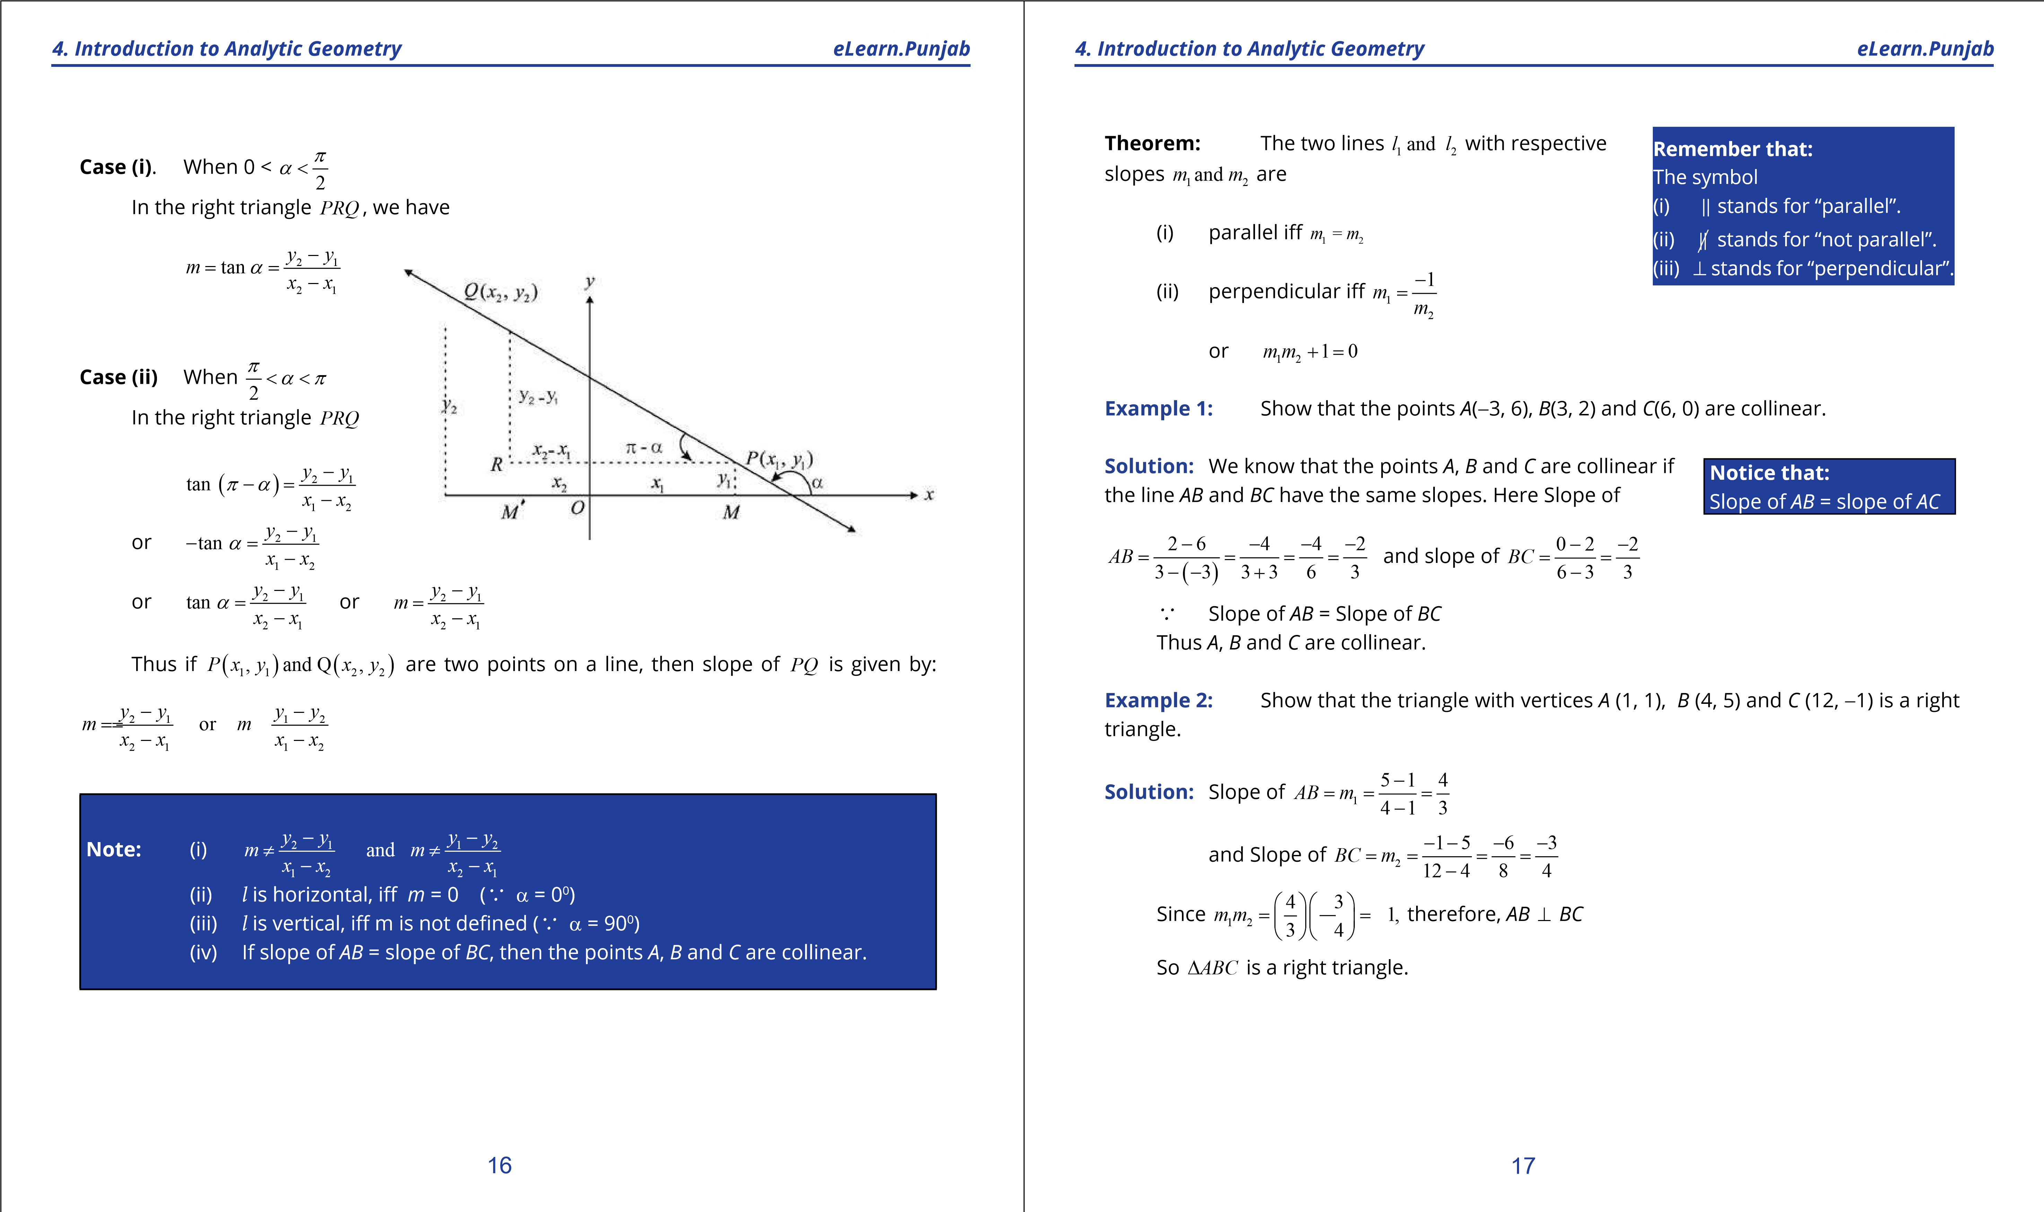

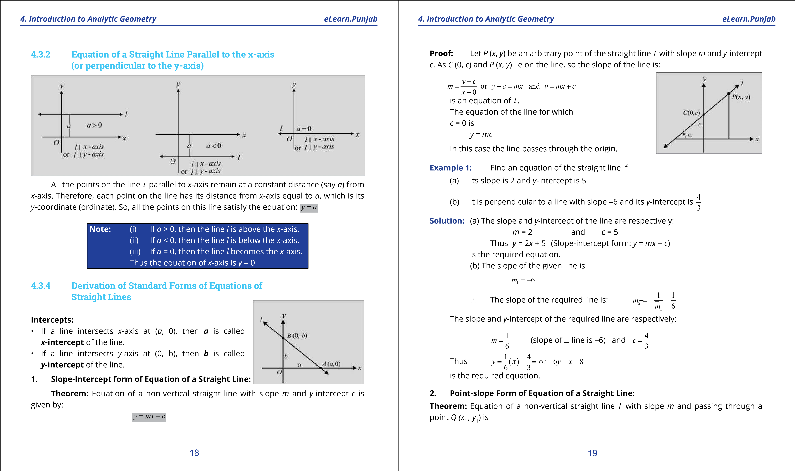

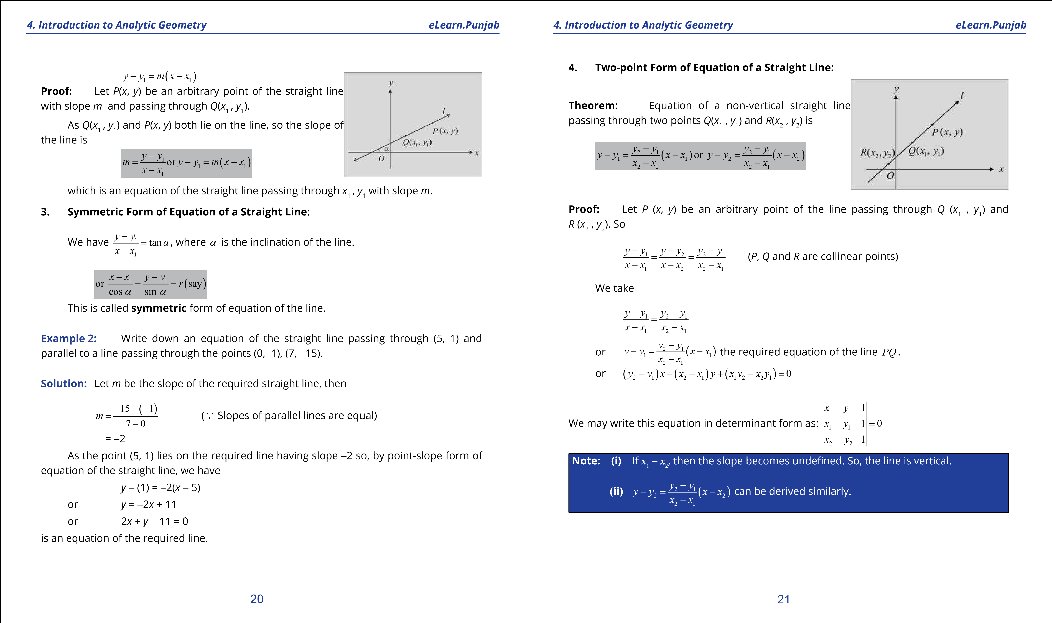

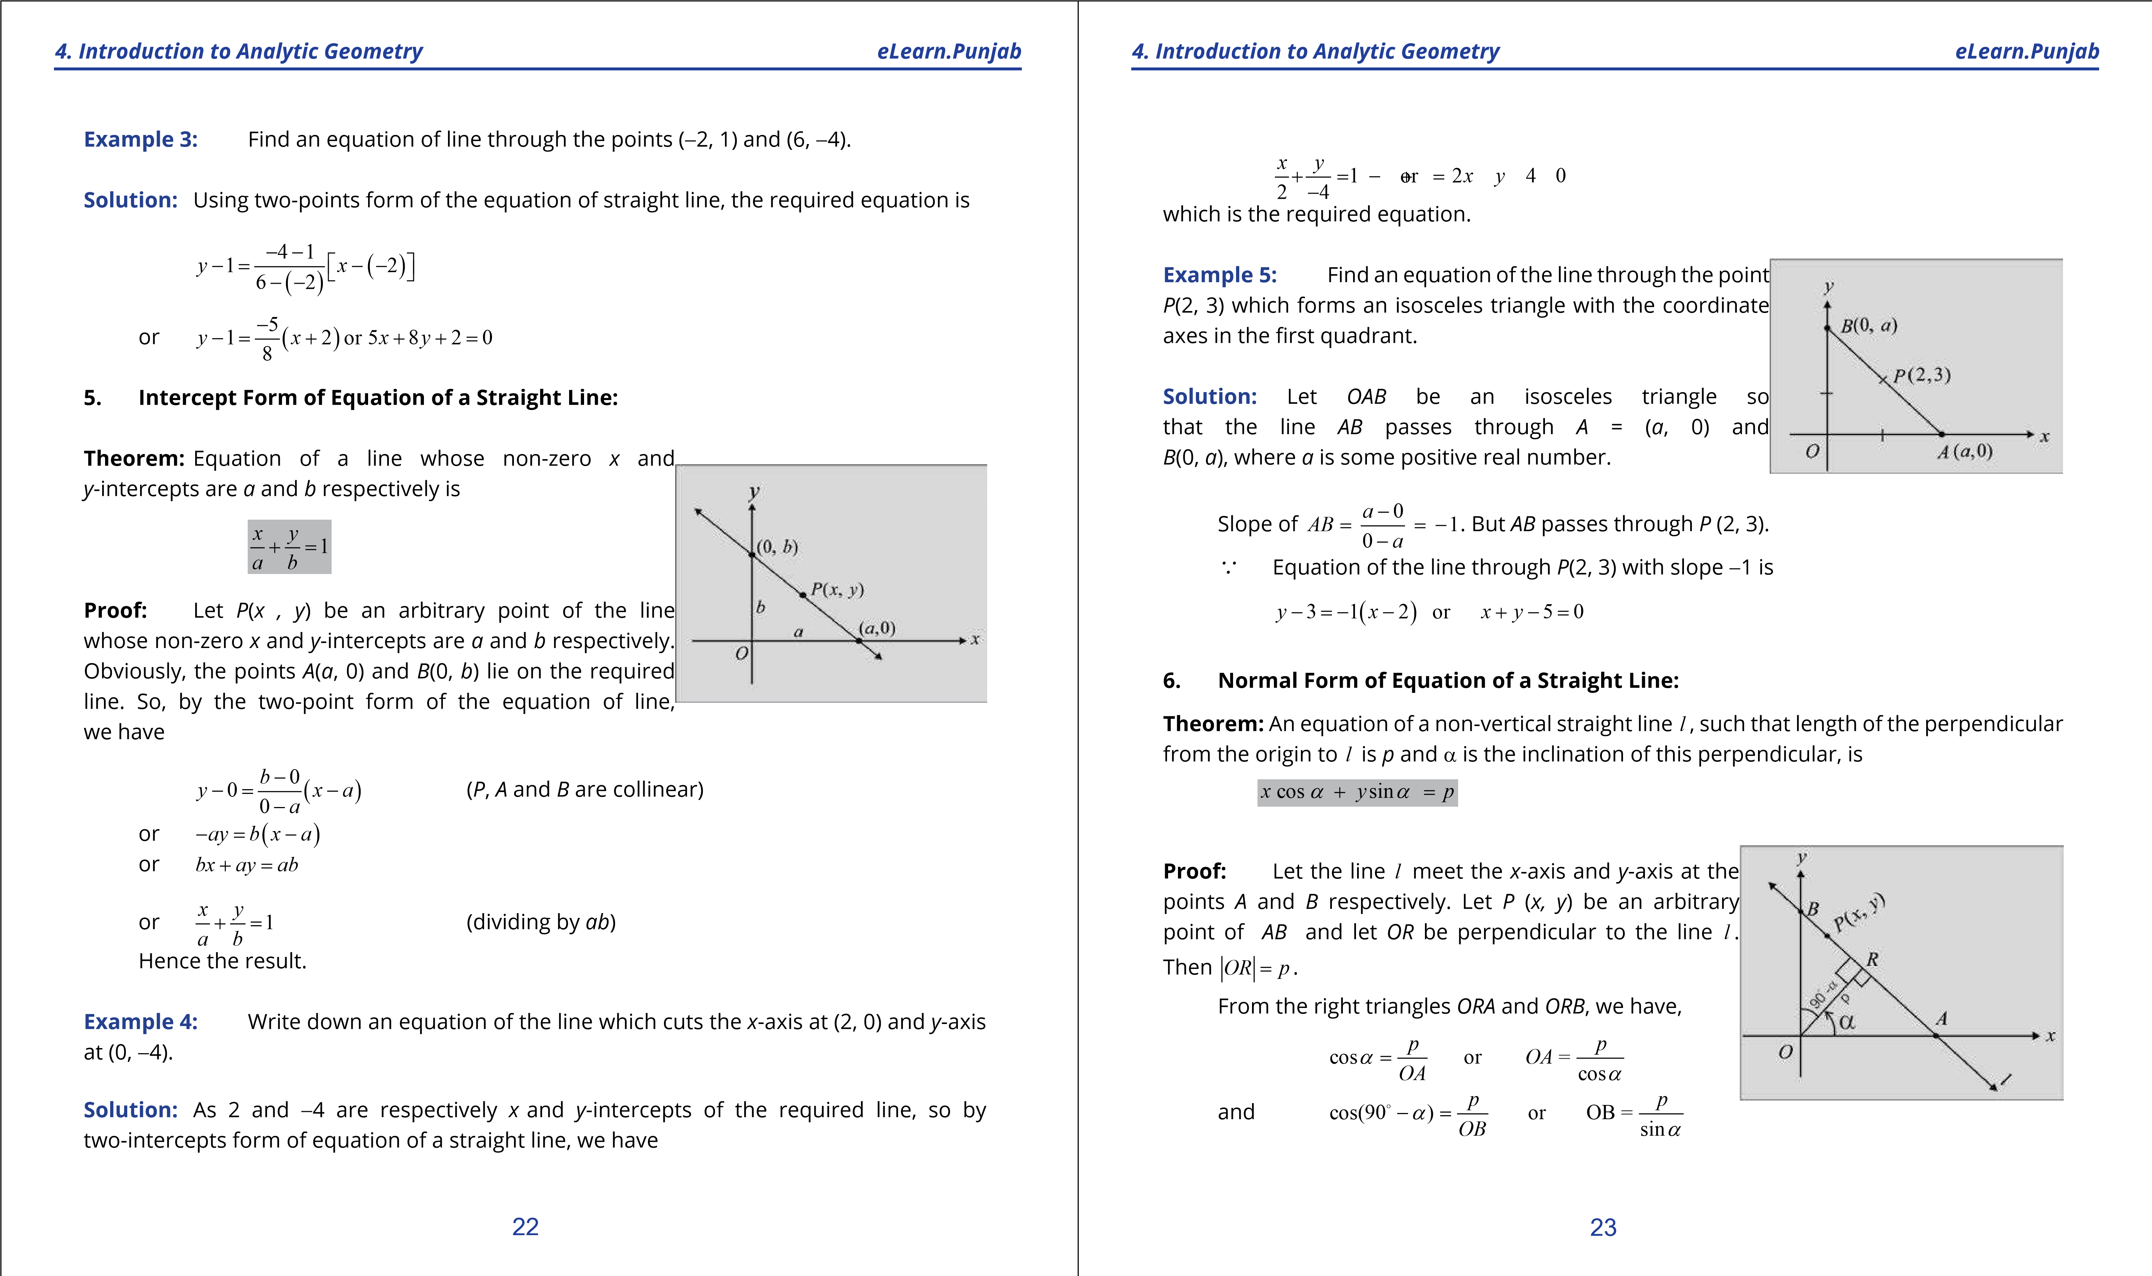

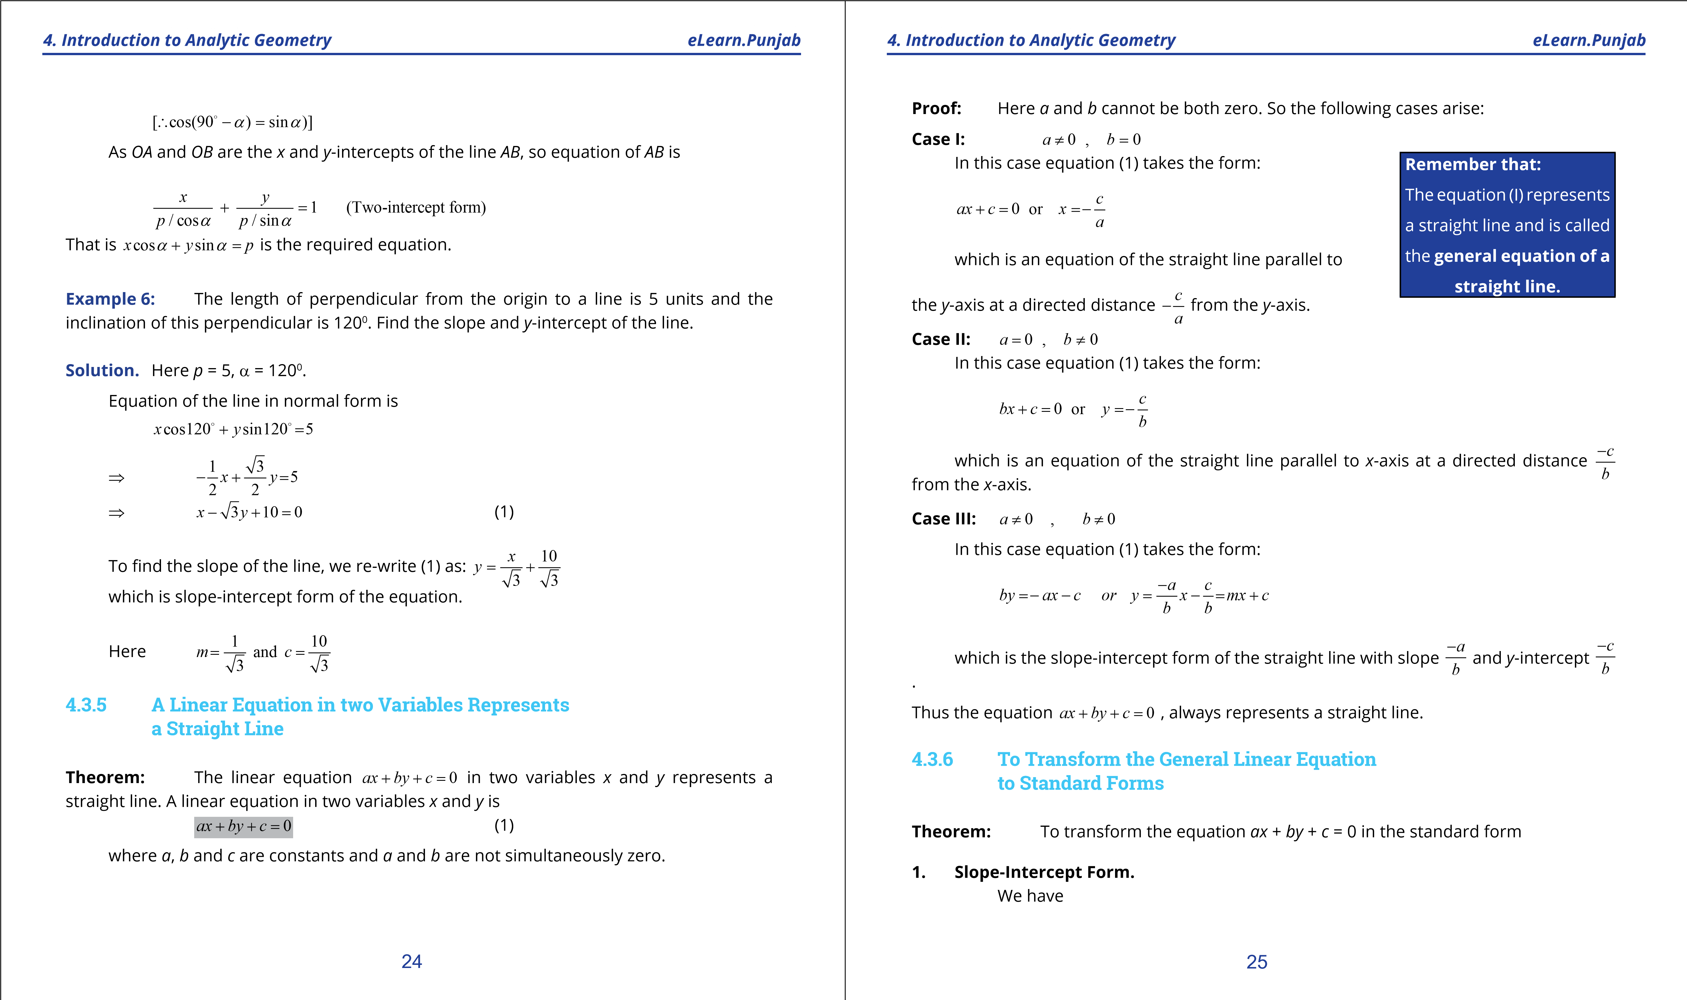

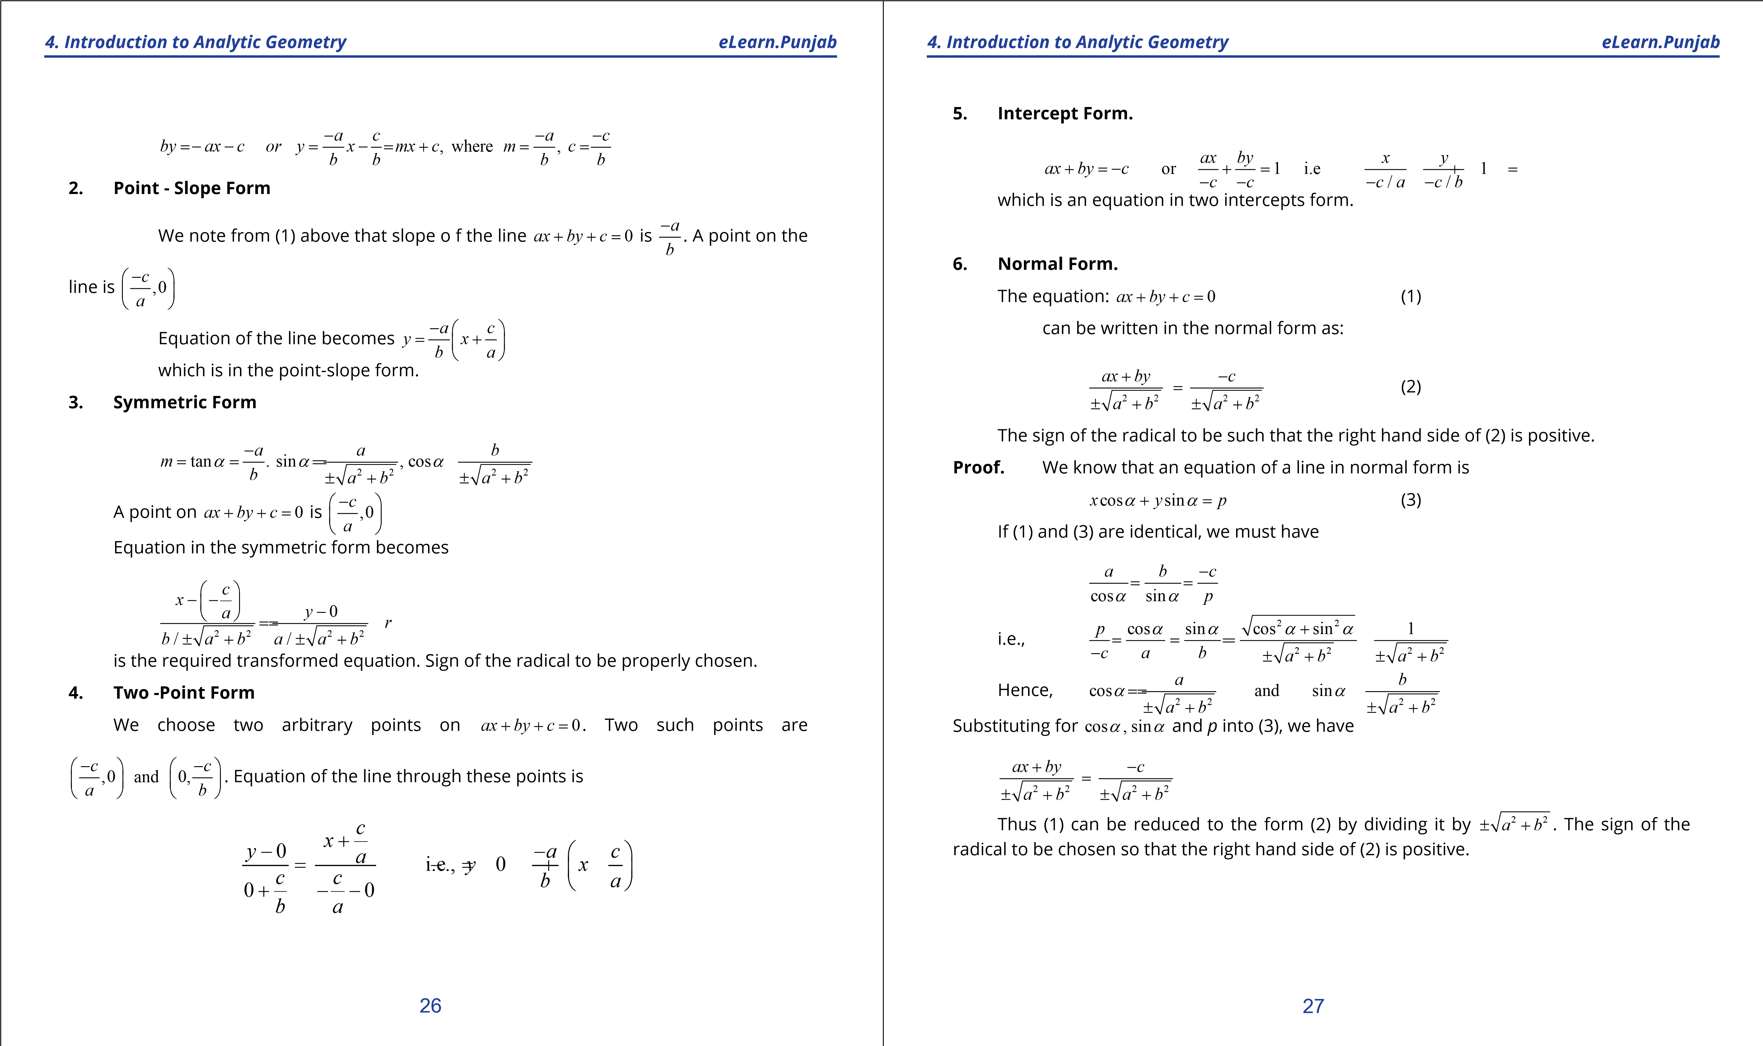

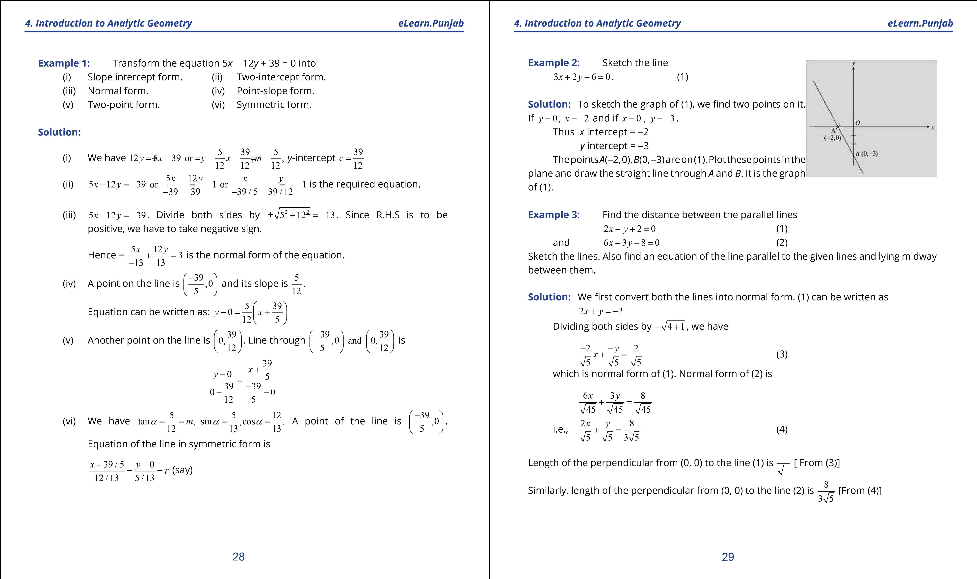

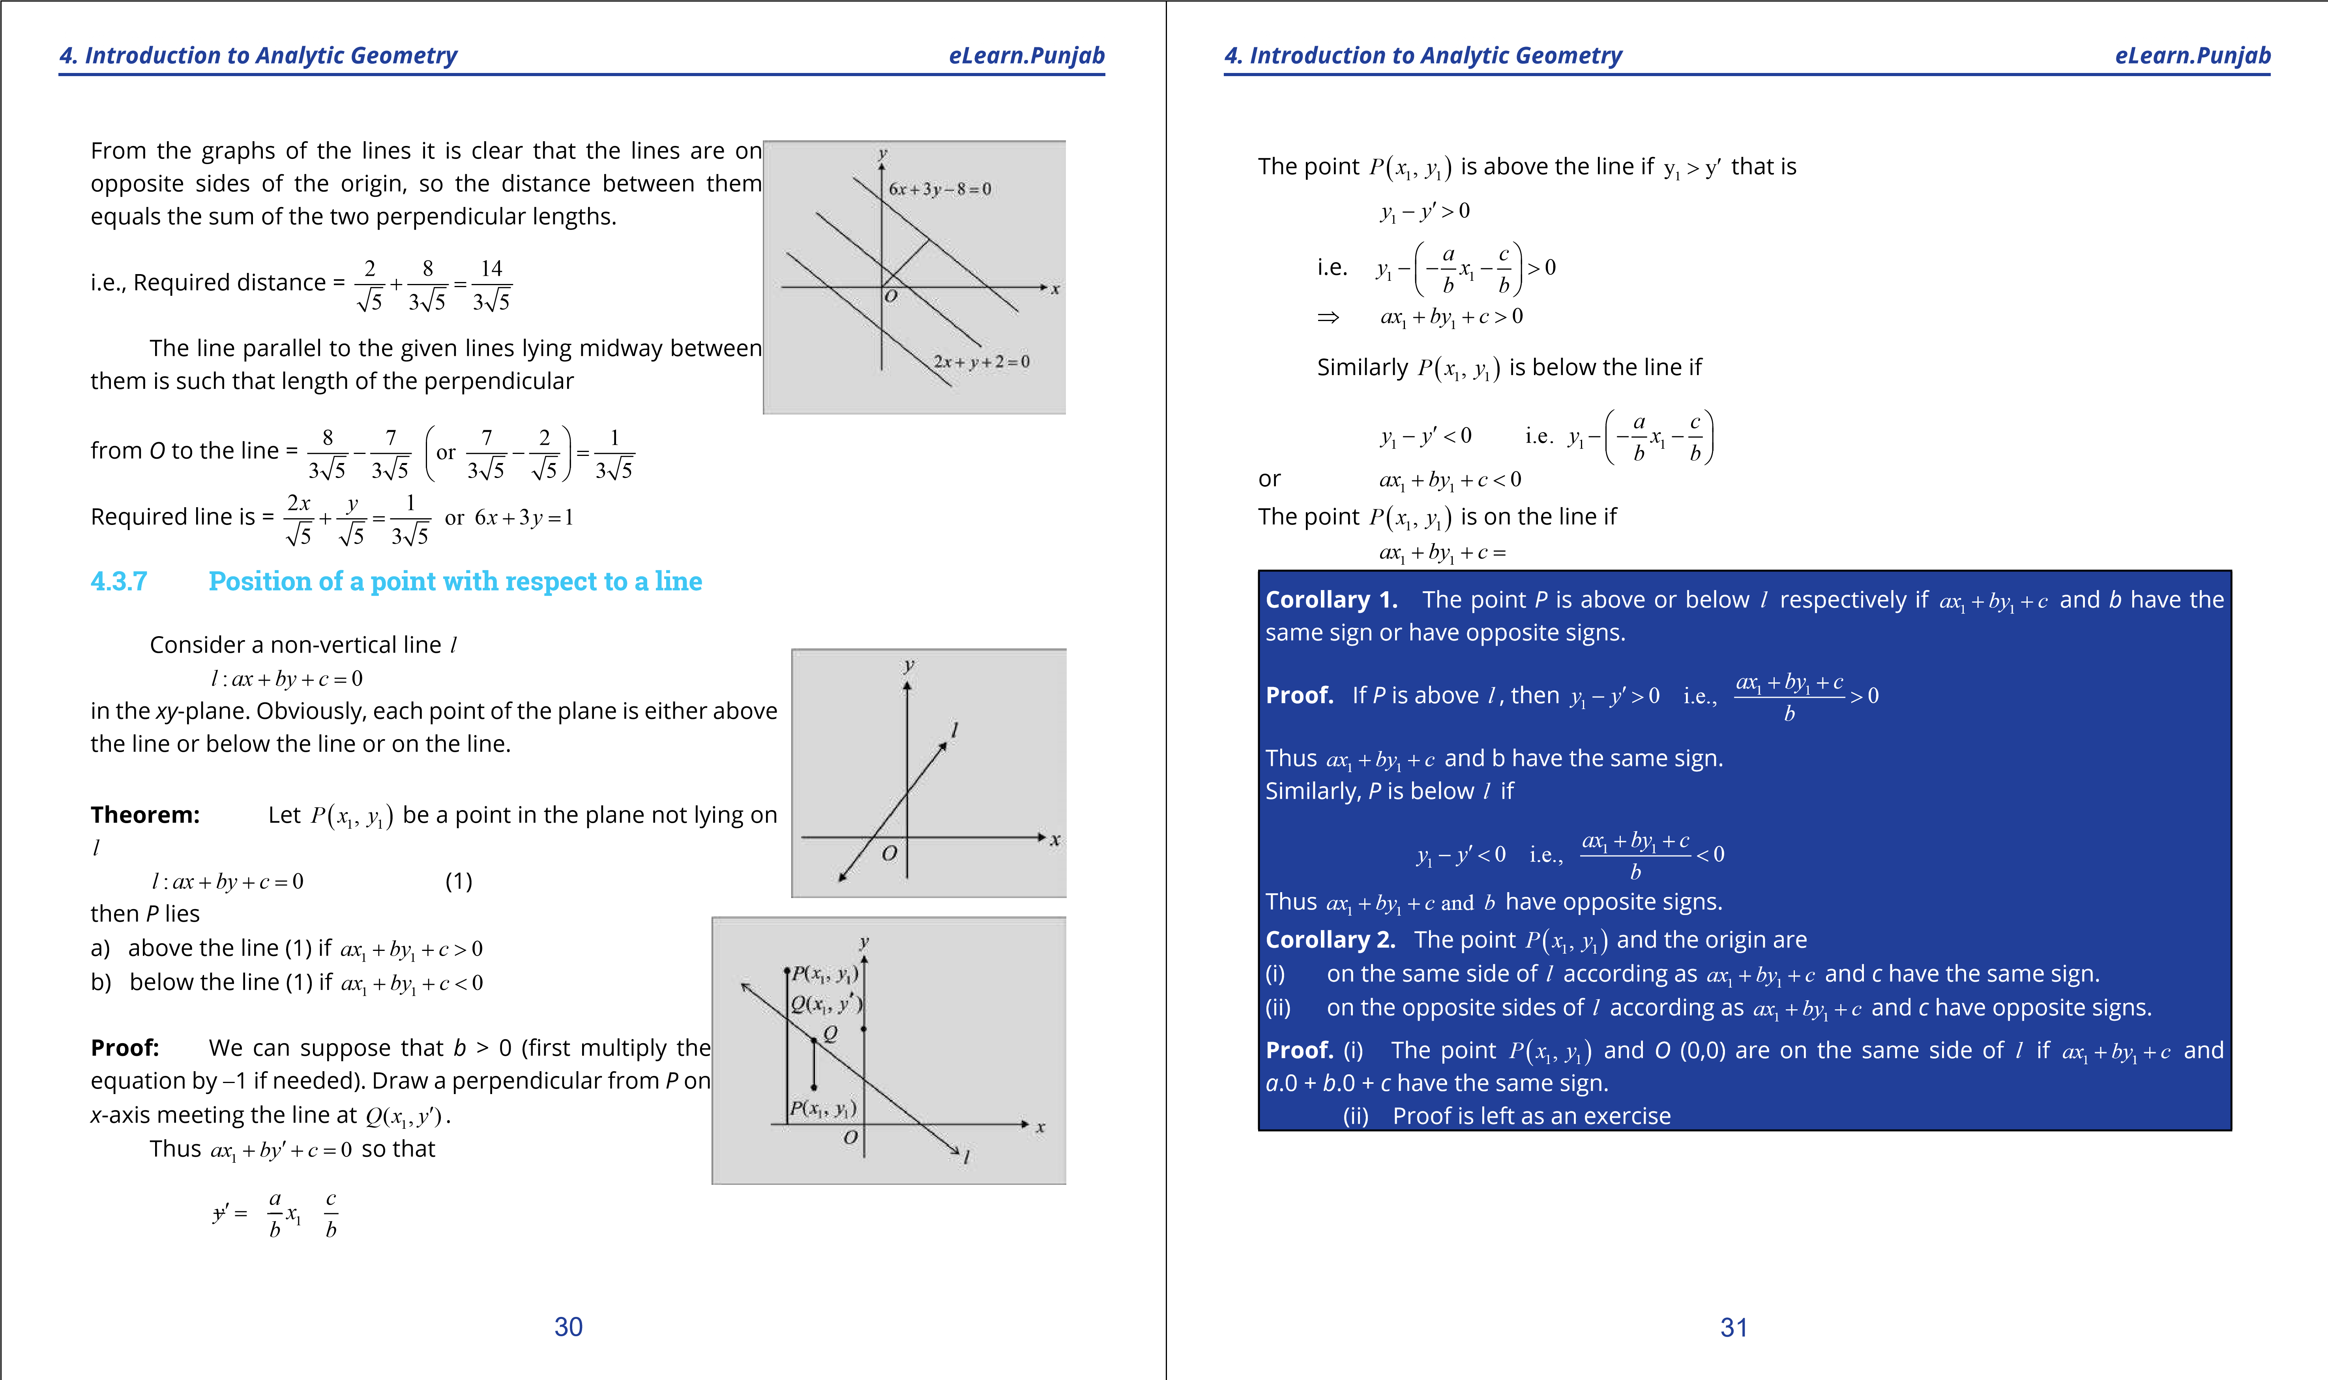

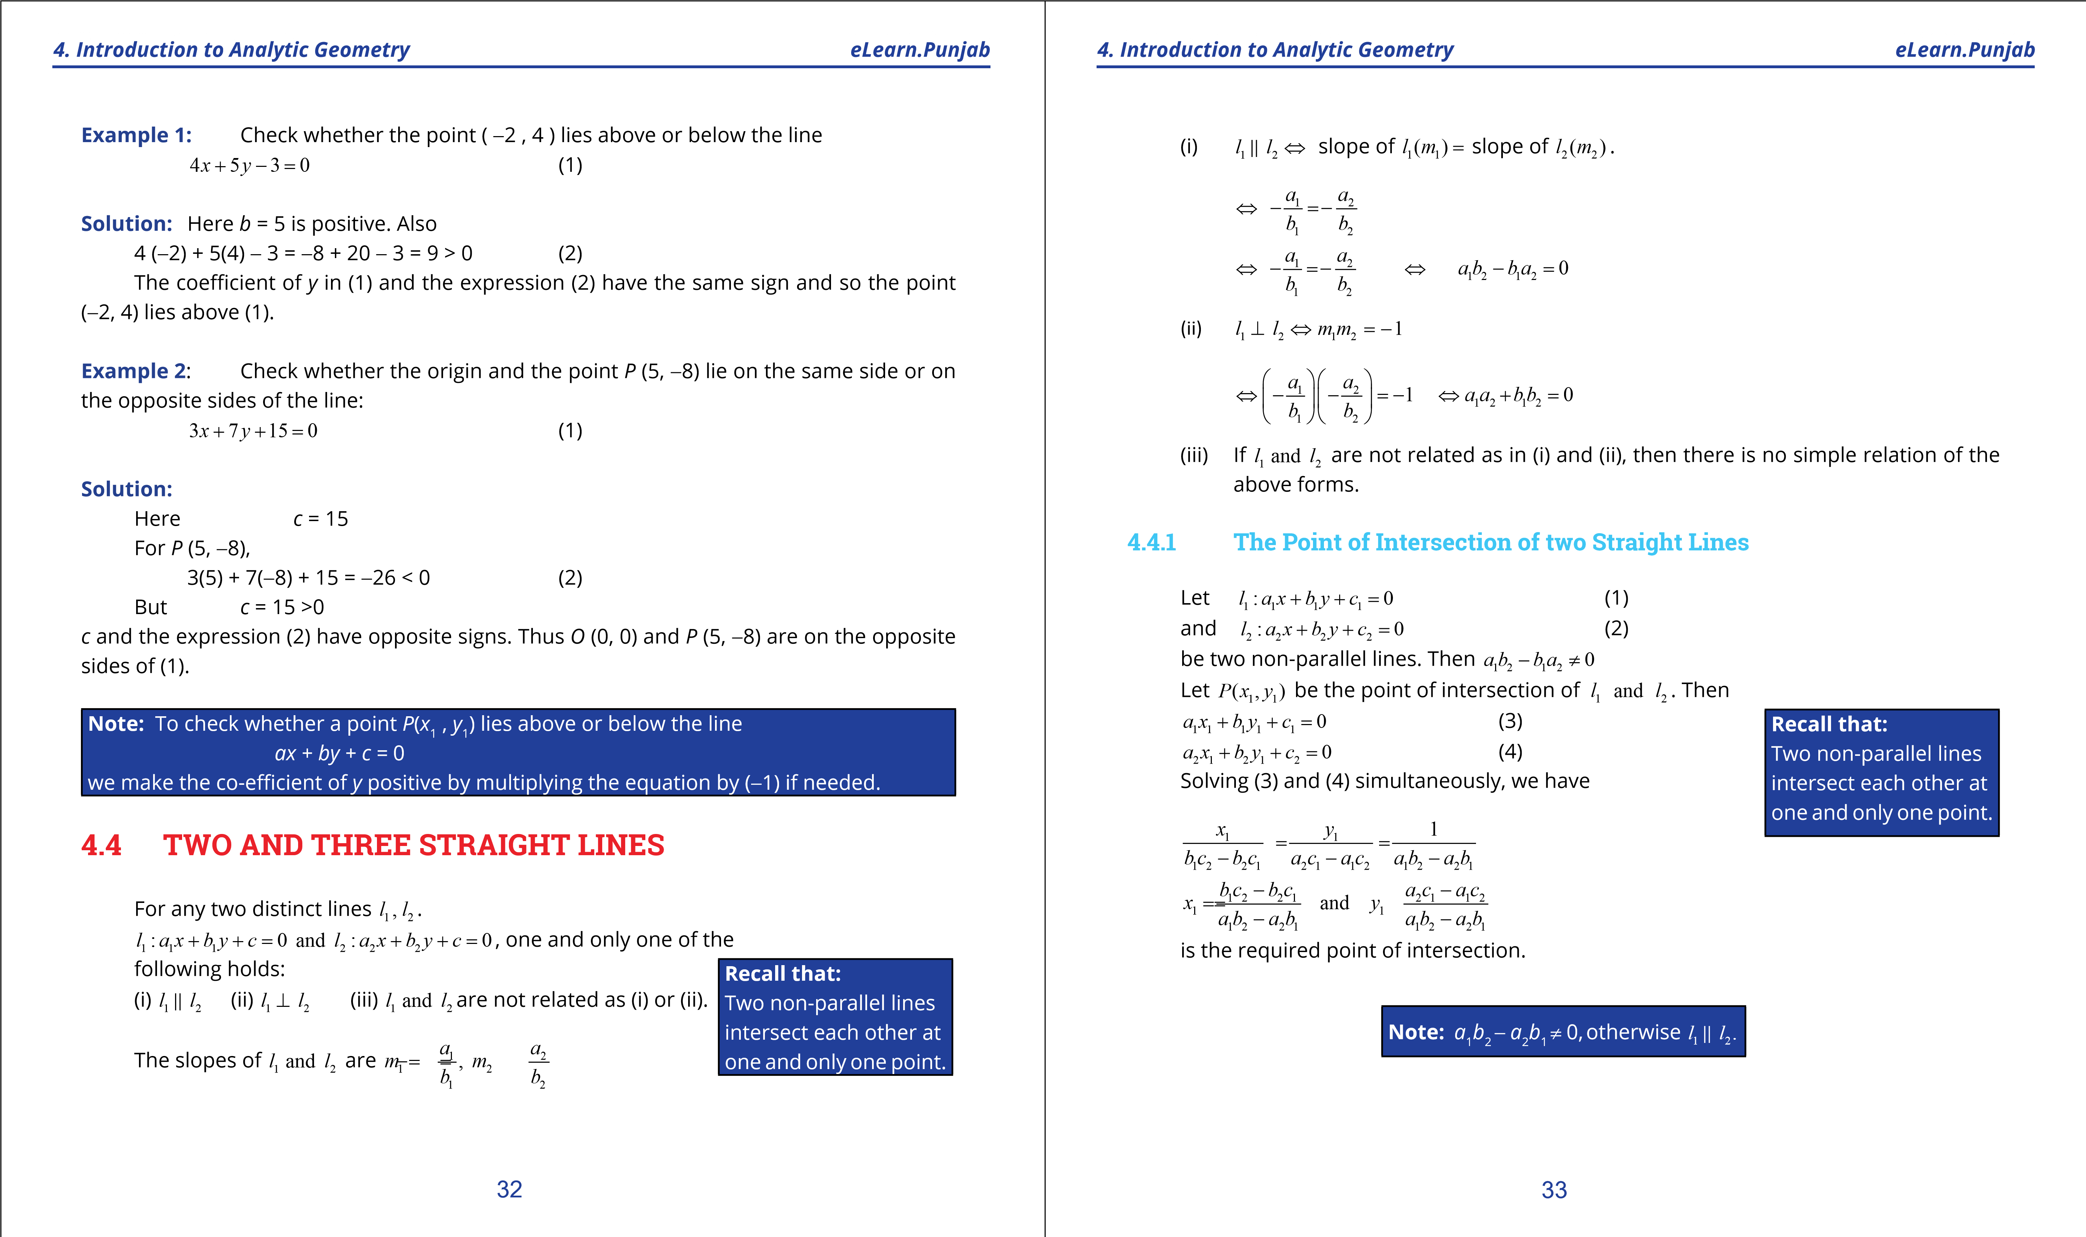

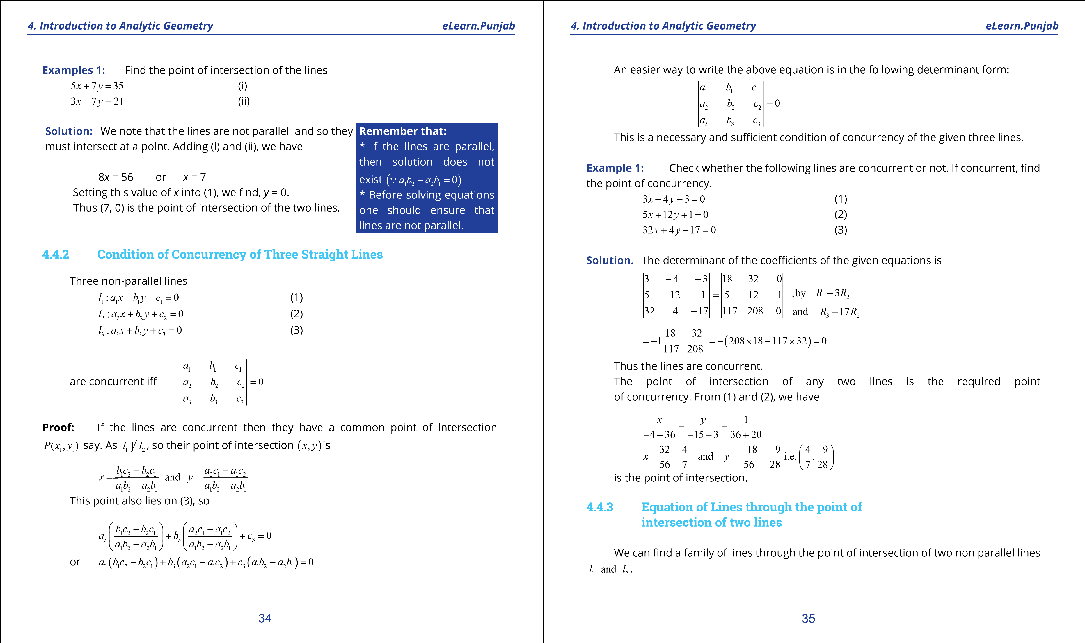

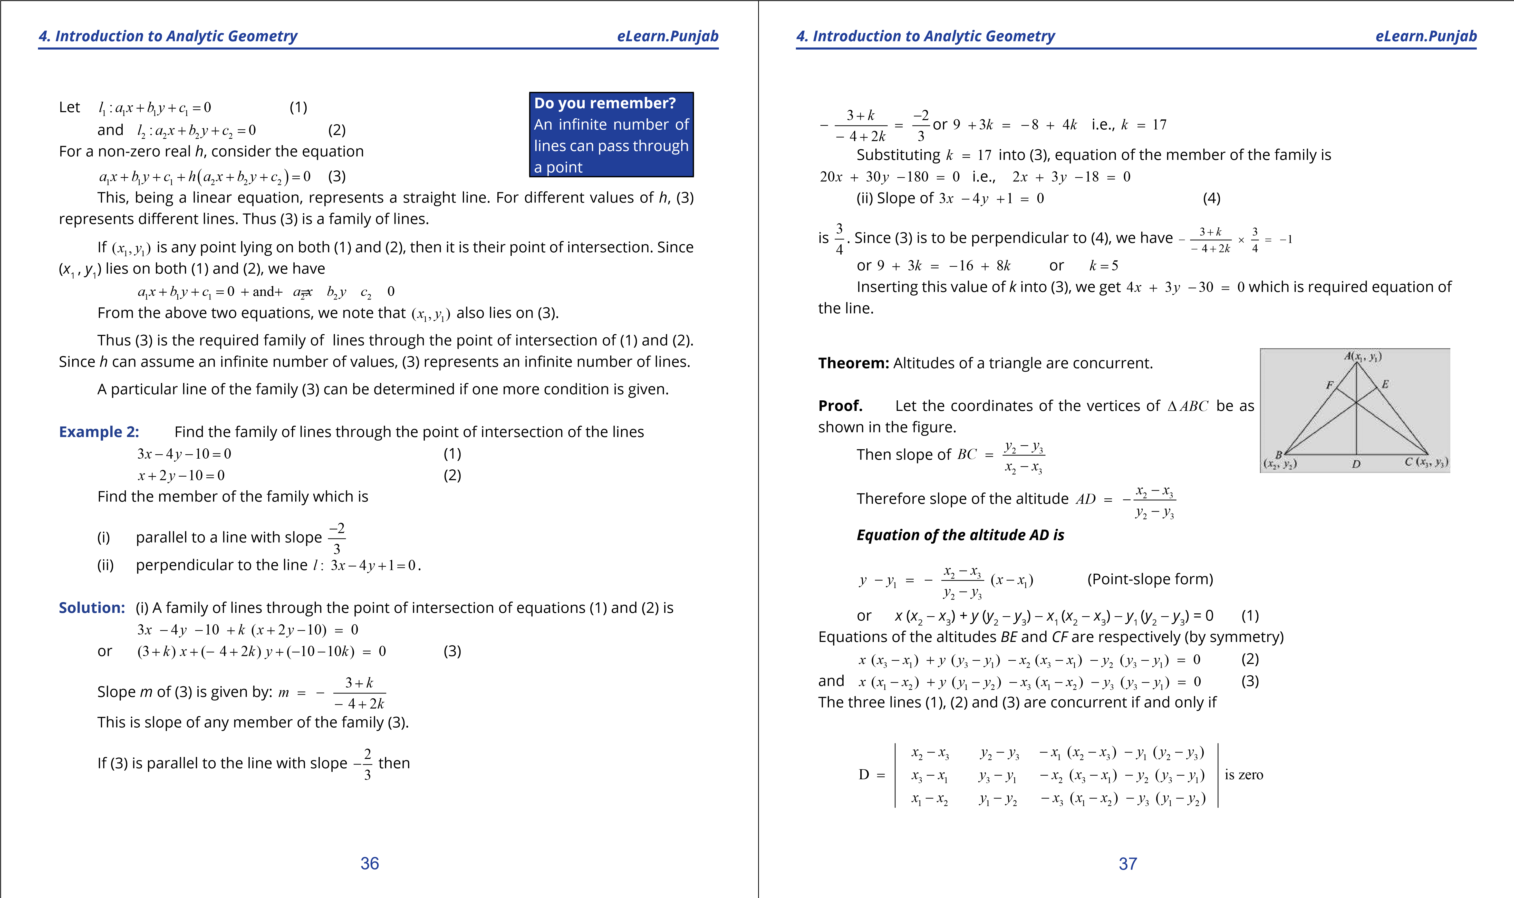

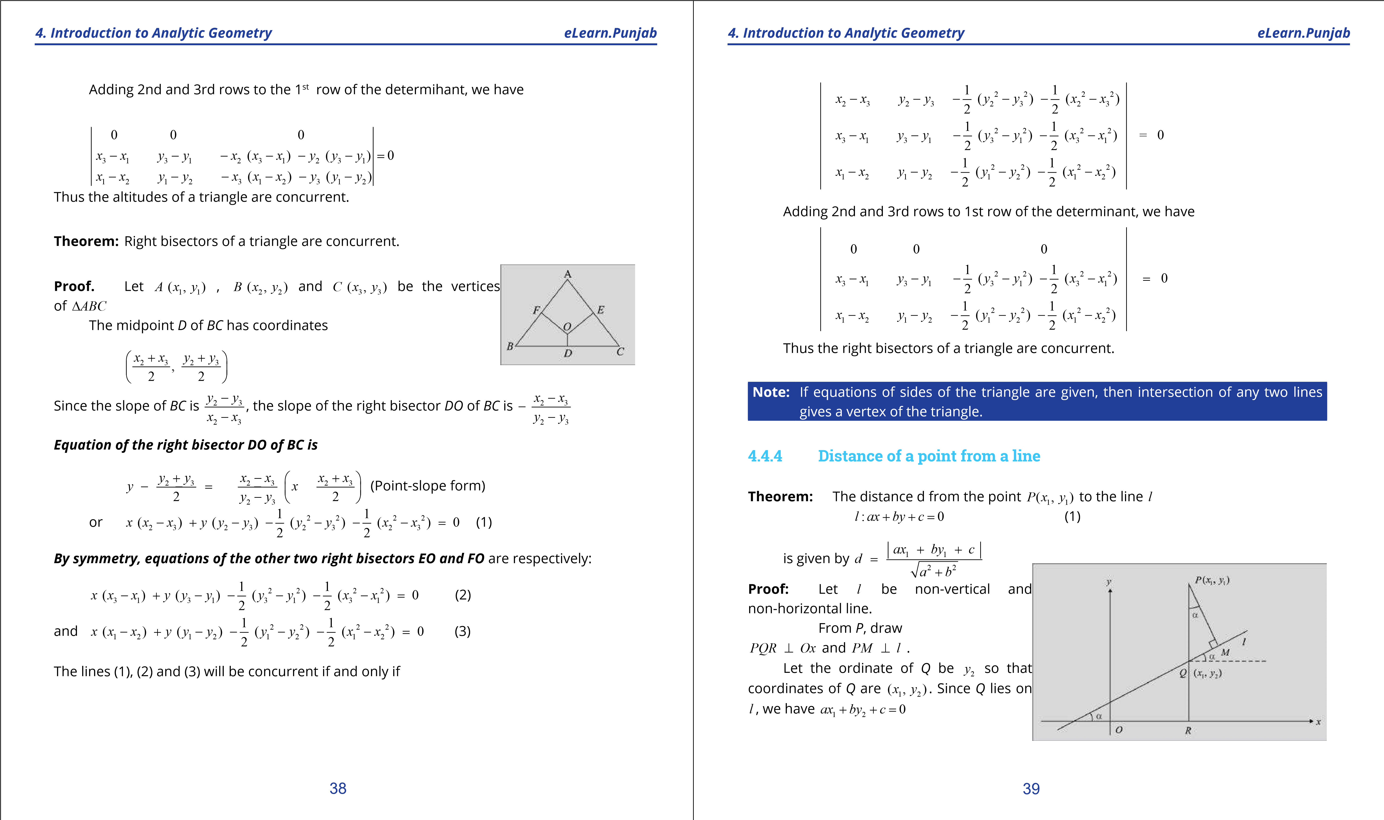

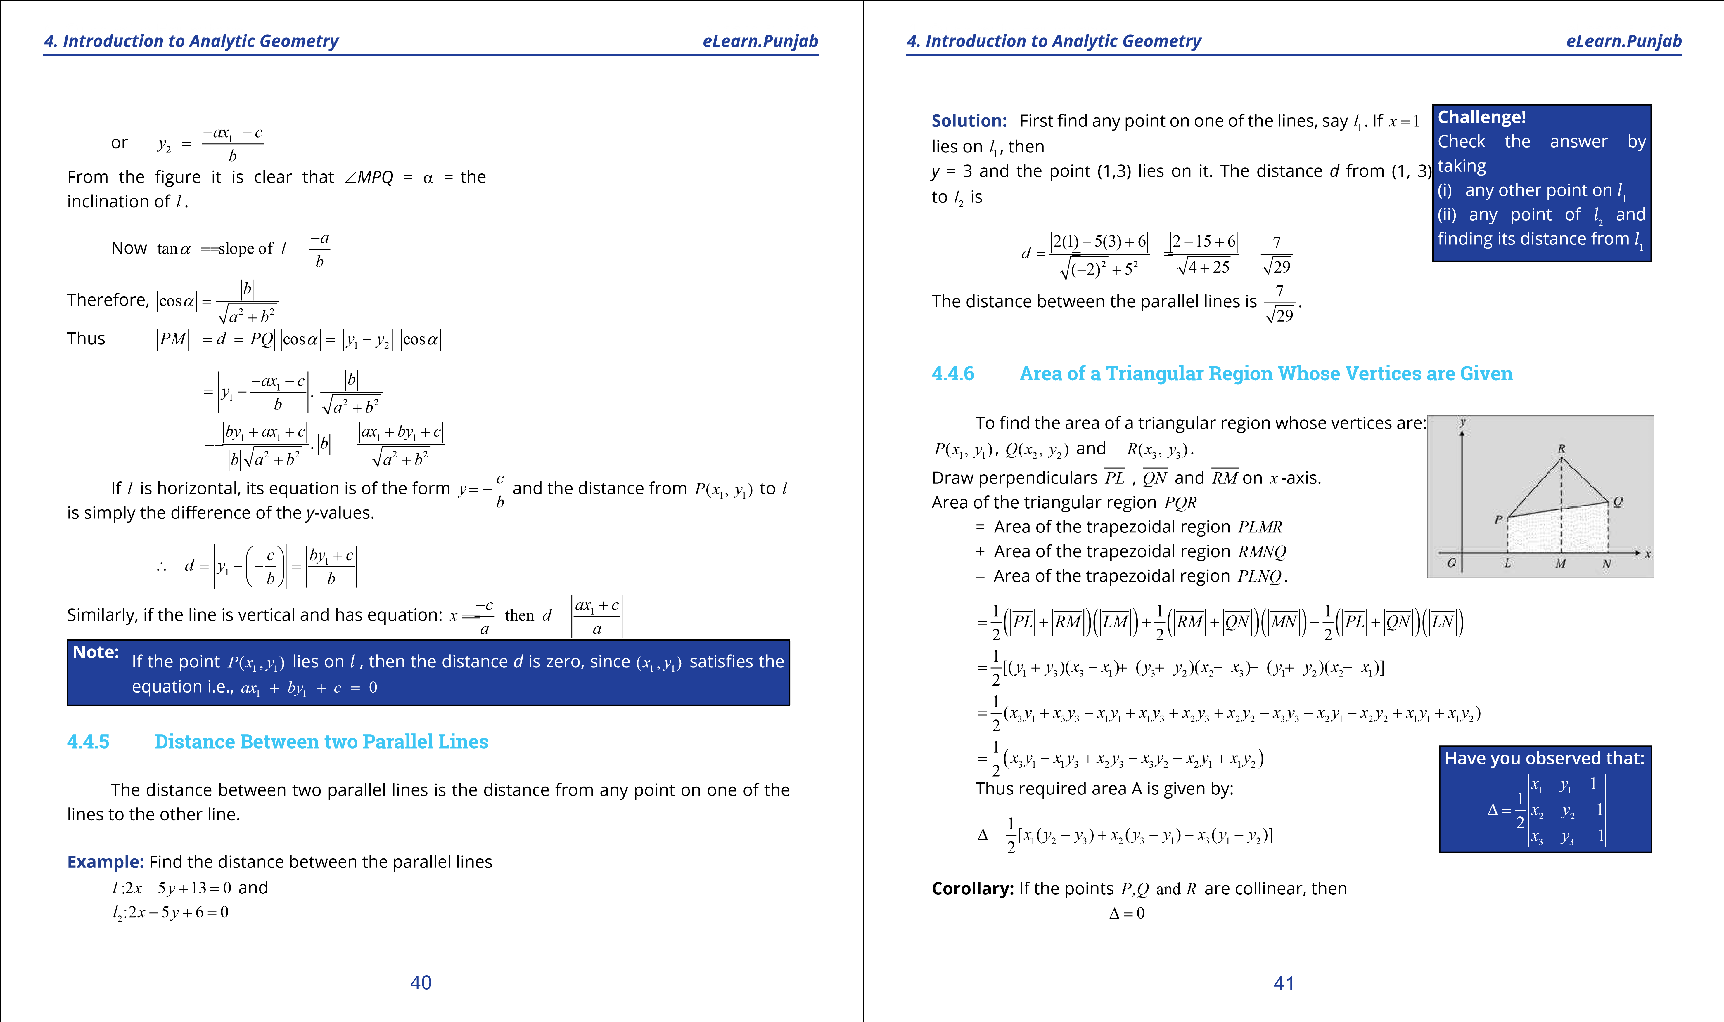

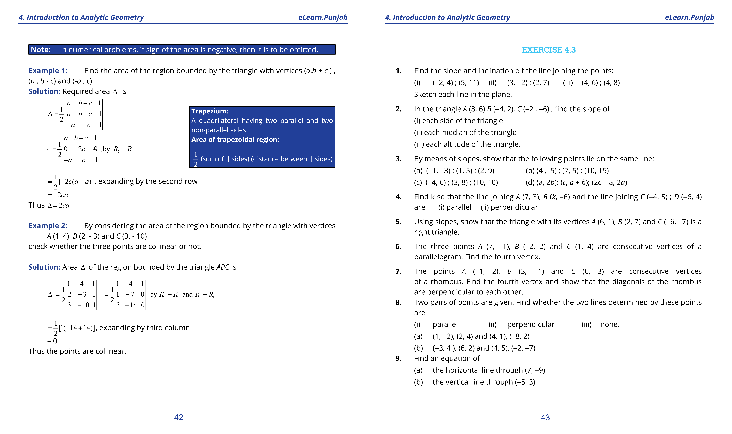

**1. Quadratic Equations eLearn.Punjab 1. Quadratic Equations eLearn.Punjab**

***4. Introduction to Analytic Geometry eLearn.Punjab 4. Introduction to Analytic Geometry eLearn.Punjab***

1. the line bisecting the irst and third quadrants.
2. the line bisecting the second and fourth quadrants.
3. Find an equation of the line
   1. through *A* (-6, 5) having slope 7
   2. through (8, -3) having slope 0
   3. through (-8 , 5) having slope undeined
   4. through (-5, -3) and (9, -1)
   5. *y*-intercept: -7 and slope: -5
   6. *x*-intercept: -3 and *y*-intercept: 4
   7. *x*-intercept: -9 and slope: -4
4. Find an equation of the perpendicular bisector of the segment joining the points *A* (3 ,5) and *B* (9, 8).
5. Find equations of the sides, altitudes and medians of the triangle whose vertices are *A* (-3, 2), *B* (5, 4) and *C* (3, -8).
6. Find an equation of the line through (-4, -6) and perpendicular to a line having

slope

1. Find an equation of the line through (11, -5) and parallel to a line with slope -24.
2. The points *A* (-1, 2), *B* (6, 3) and *C* (2, -4) are vertices of a triangle. Show that the line joining the midpoint *D* of *AB* and the midpoint *E* of *AC* is parallel

to *BC* and *DE* = *BC* .

1. A milkman can sell 560 litres of milk at Rs. 12.50 per litre and 700 litres of milk at Rs. 12.00 per litre. Assuming the graph of the sale price and the milk sold to be a straight line, ind the number of litres of milk that the milkman can sell at Rs. 12.25 per litre. **17.** The population of Pakistan to the nearest million was 60 million in 1961 and 95 million in 1981. Using *t* as the number of years after 1961, ind an equation of the line that gives the population in terms of *t*. Use this equation to ind the population in (a) 1947 (b) 1997.

3

2

-

1

2

1. A house was purchased for Rs.1 million in 1980. It is worth Rs. 4 million in 1996. Assuming that the value increased by the same amount each year, ind an equation that gives the value of the house after *t* years of the date of purchase. What was its value in 1990?
2. Plot the Celsius (*C*) and Fahrenheit (*F*) temperature scales on the horizontal axis and the vertical axis respectively. Draw the line joining the freezing point and the boiling point of water. Find an equation giving *F* temperature in terms of *C*.
3. The average entry test score of engineering candidates was 592 in the year 1998 while the score was 564 in 2002. Assuming that the relationship between time and score is linear, ind the average score for 2006.
4. Convert each of the following equation into

(i) Slope intercept form (ii) two intercept form (iii) normal form

* 1. 2*x* - 4*y* +11= 0 (b) 4*x* + 7*y* - 2 = 0 (c) 15*y* -8*x* +13= 0

Also ind the length of the perpendicular from (0, 0) to each line.

1. In each of the following check whether the two lines are
   1. parallel
   2. perpendicular
   3. neither parallel nor perpendicular
   4. 2*x* + *y* -3= 0 ; 4*x* + 2*y* + 5 = 0
   5. 3*y* = 2*x* +5 ; 3*x*+ 2*y*- 8= 0
   6. 4*y* + 2*x* - =1 0 ; *x* - 2*y* - 7 = 0
   7. 4*x* - *y* + 2 = -0 ;+ =12*x* 3*y* 1 0
   8. 12*x* + 35*y* - 7 = 0 ; 105*x* -36*y* +11= 0
2. Find the distance between the given parallel lines. Sketch the lines. Also ind an equation of the parallel line lying midway between them.
   1. 3*x* - 4*y* + 3= 0 ; 3*x* - 4*y* + 7 = 0
   2. 12*x* + 5*y* - 6 = 0 ; 12*x* + 5*y* +13= 0
   3. *x* + 2*y* -5 = 0+ ;= 2*x* 4*y* 1

### 44 45

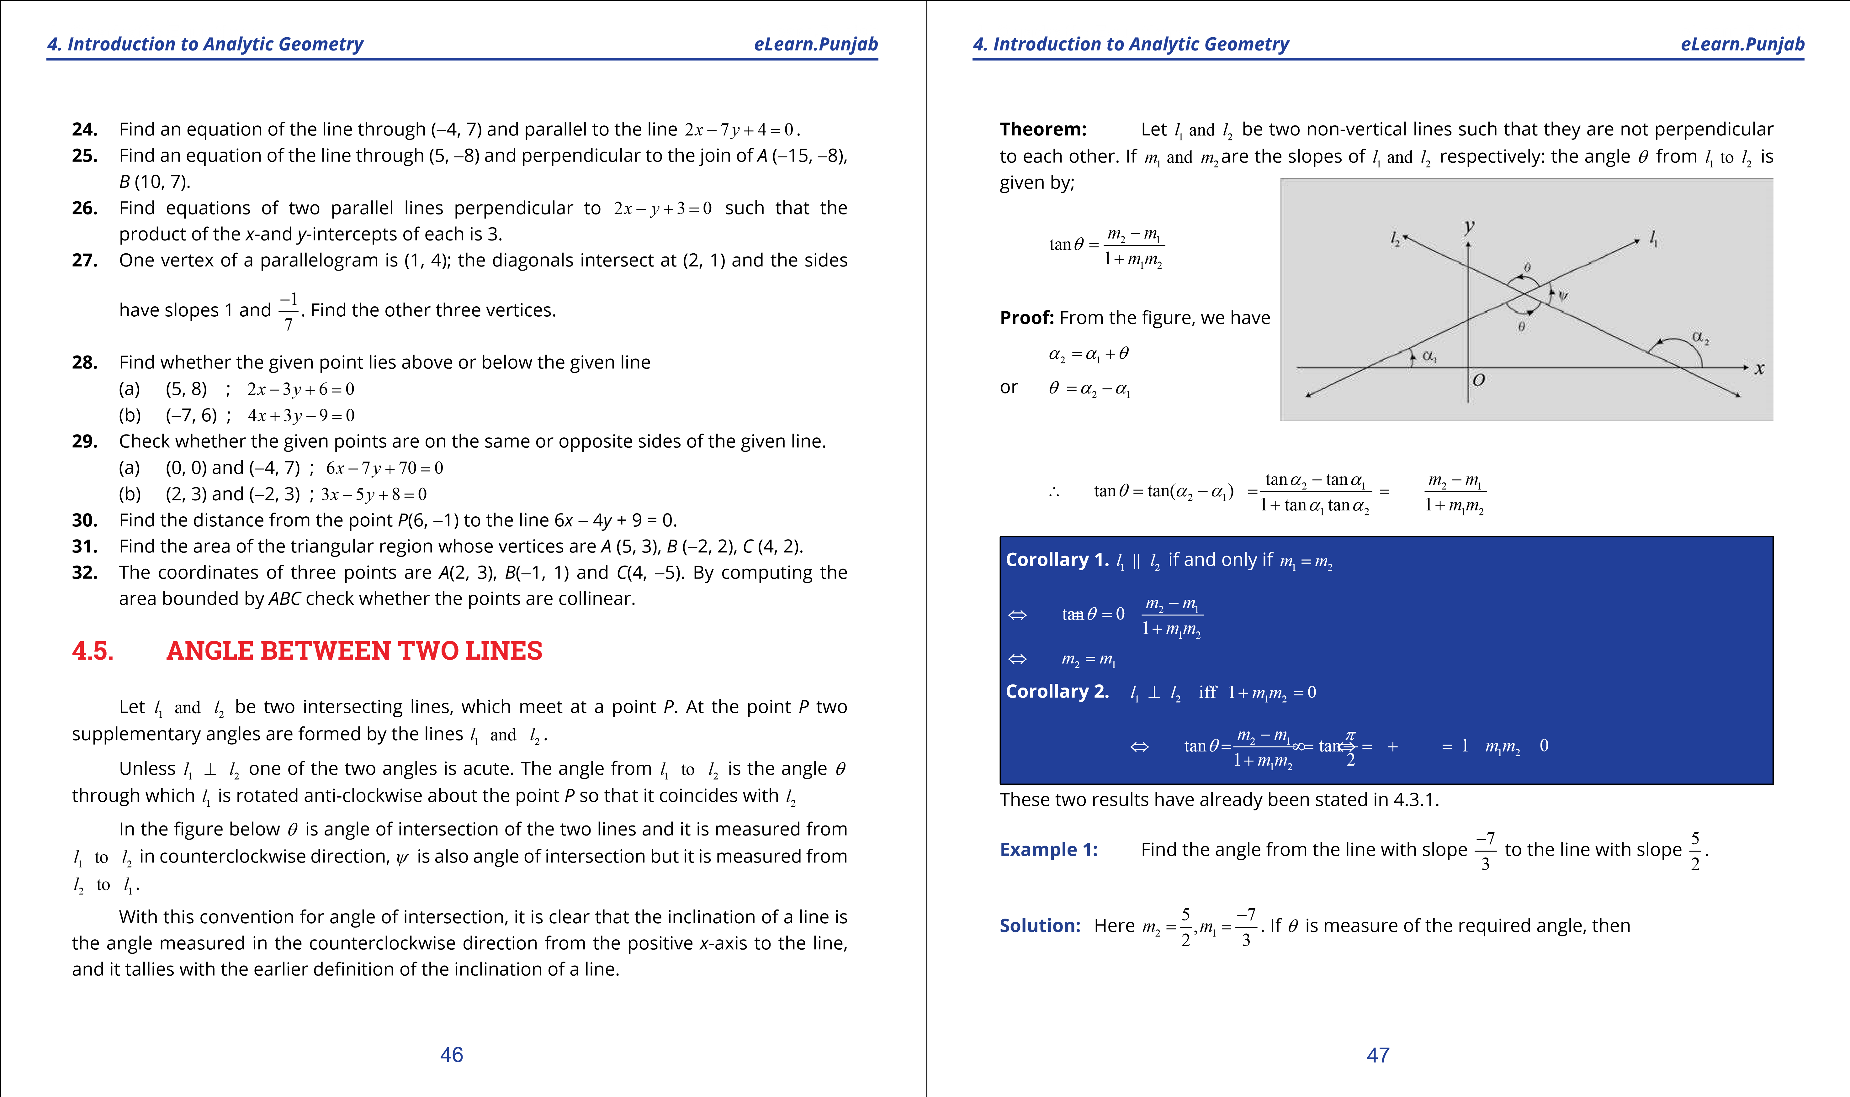

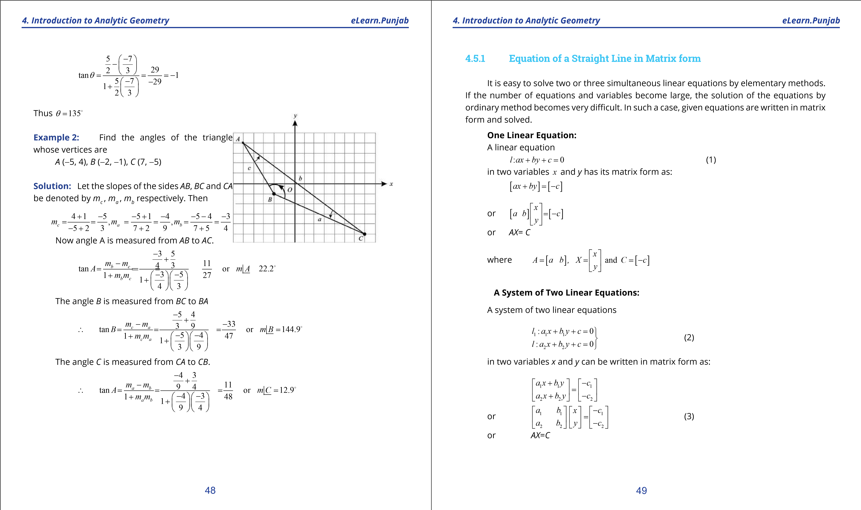

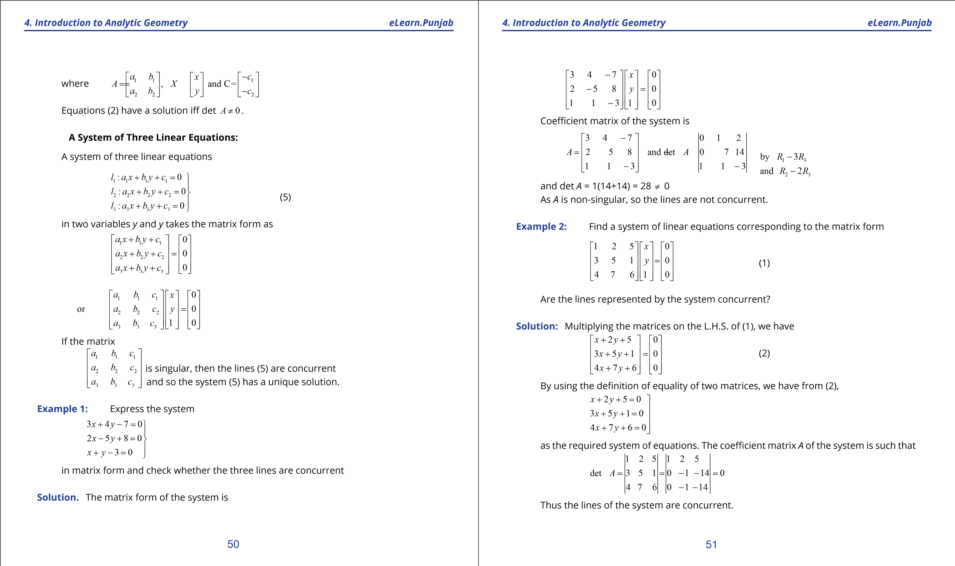

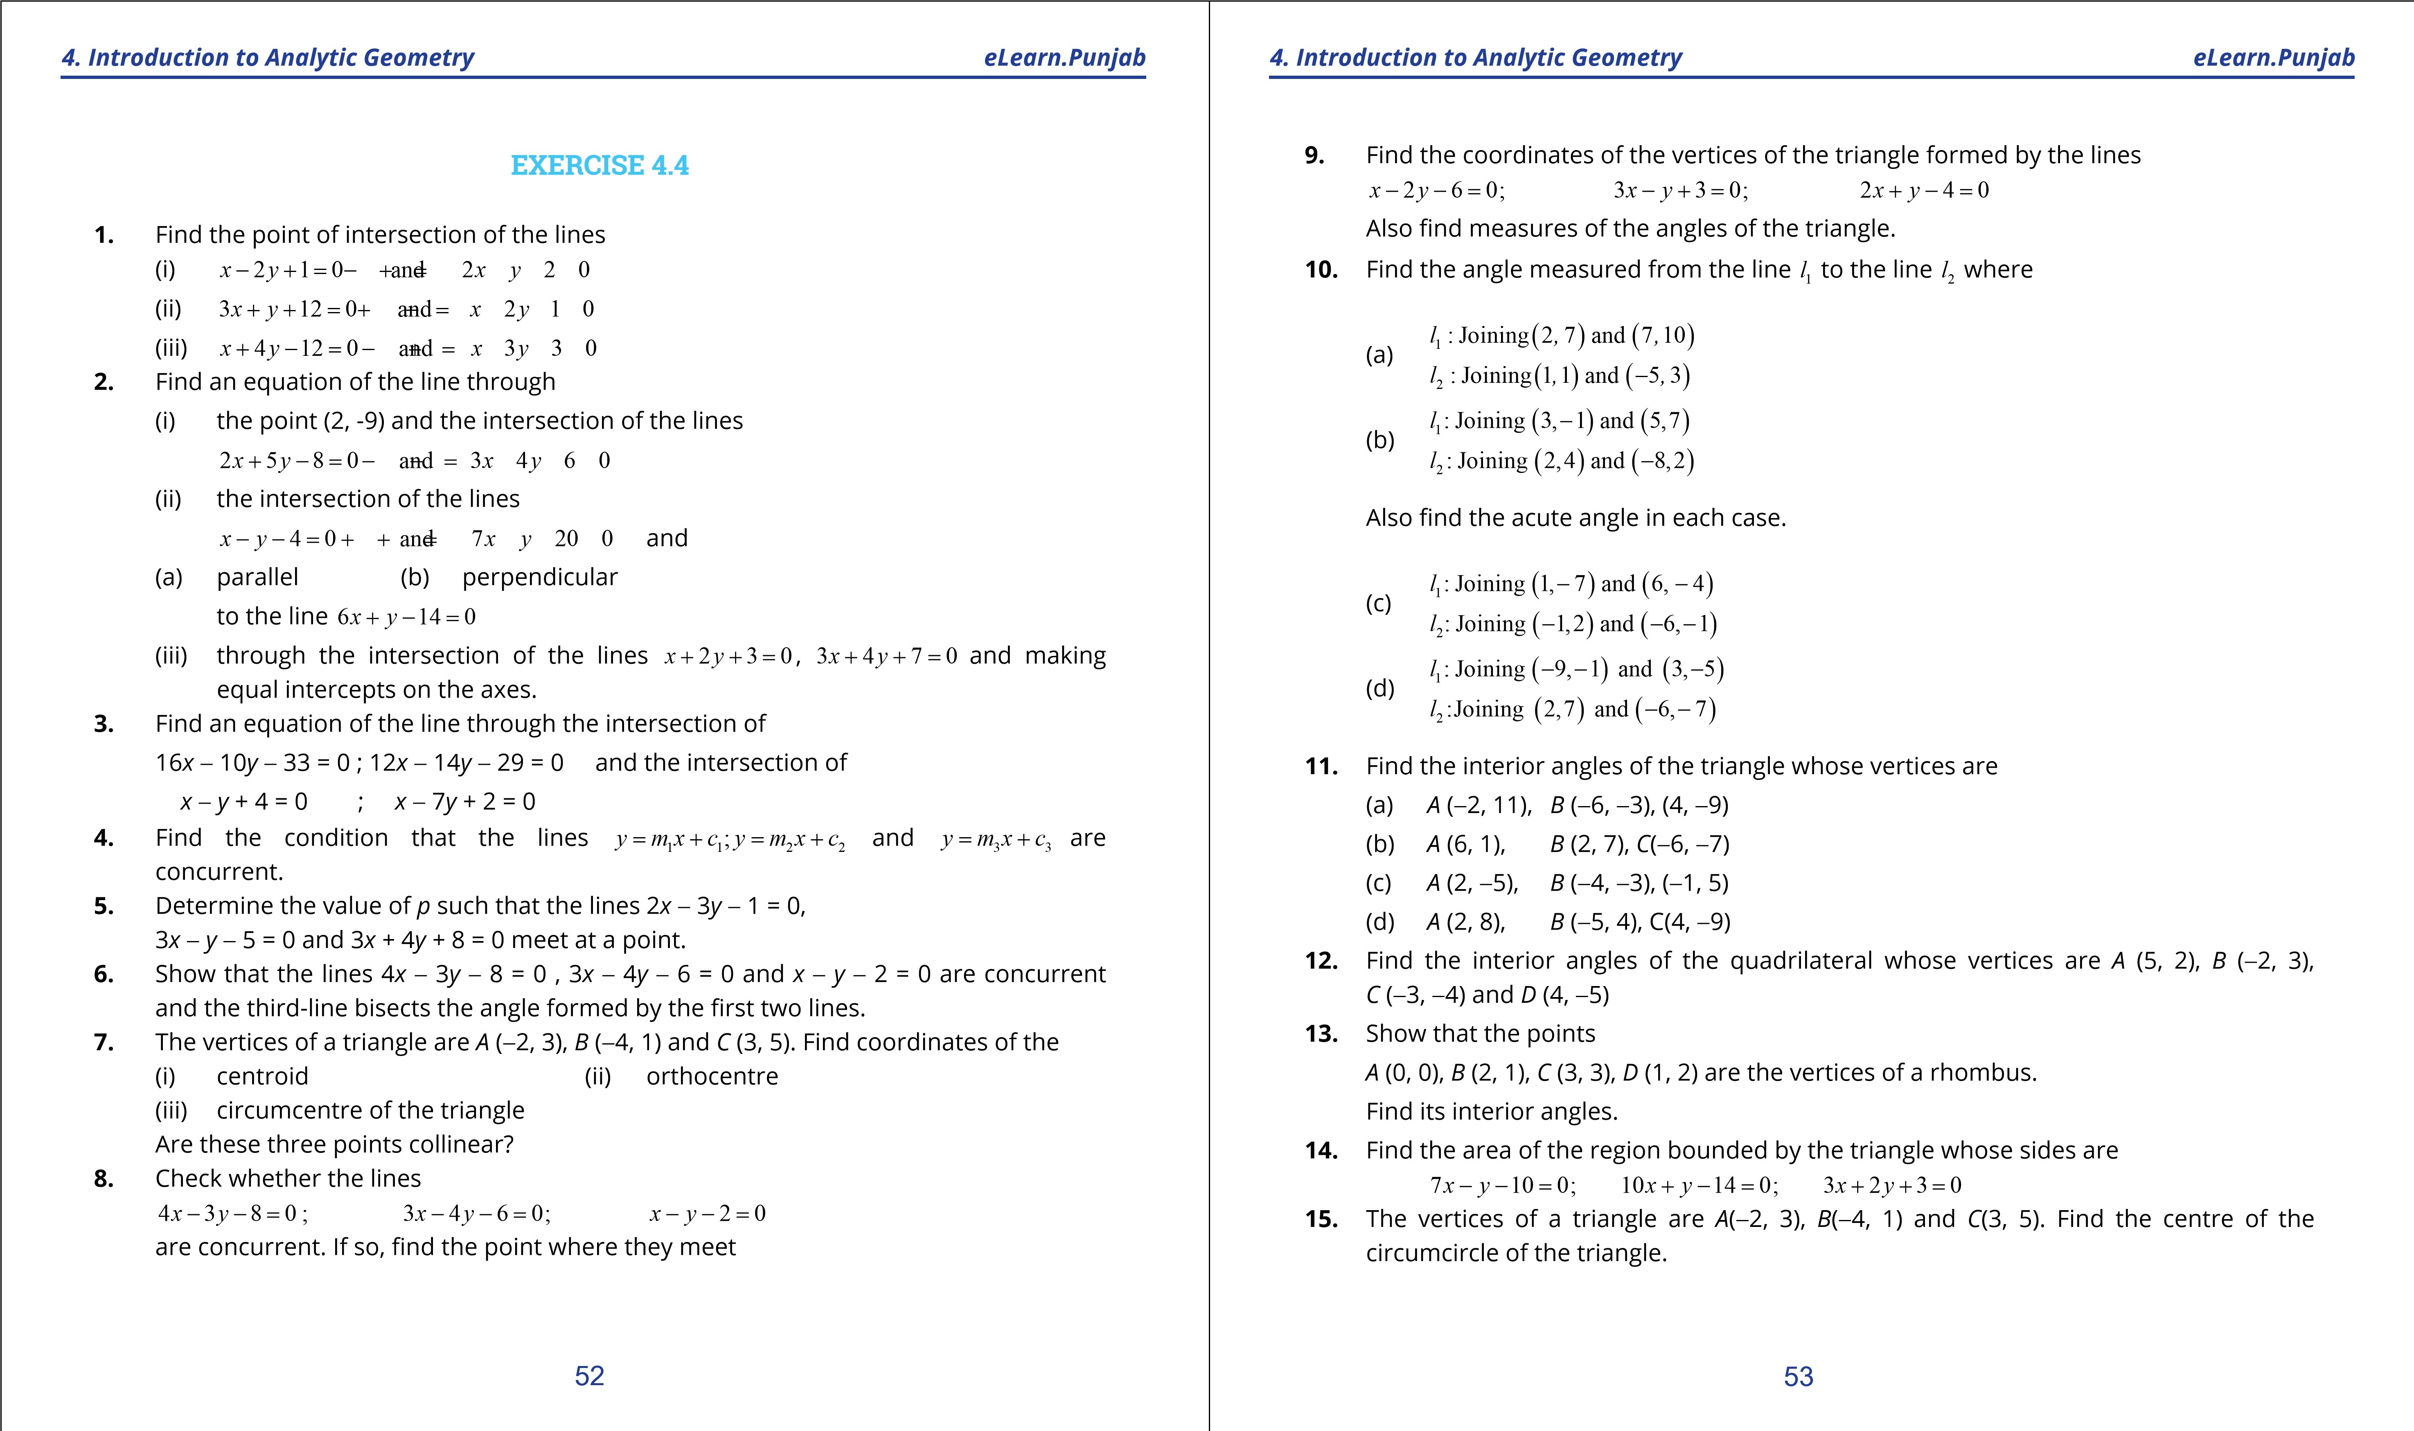

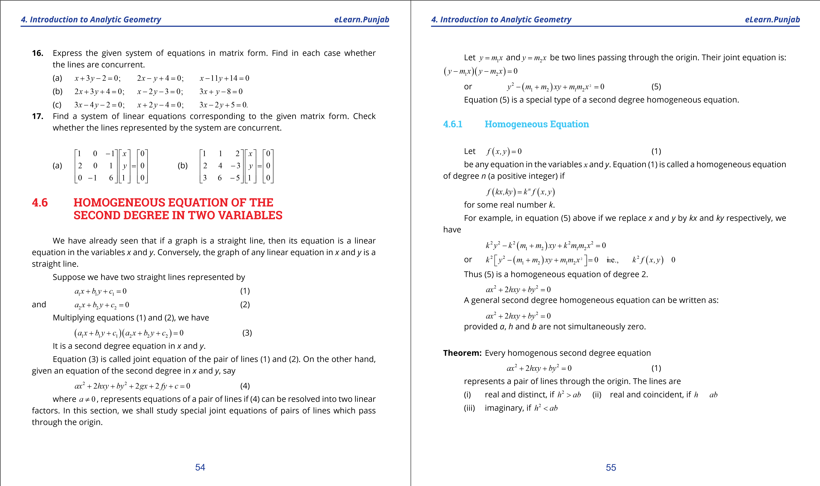

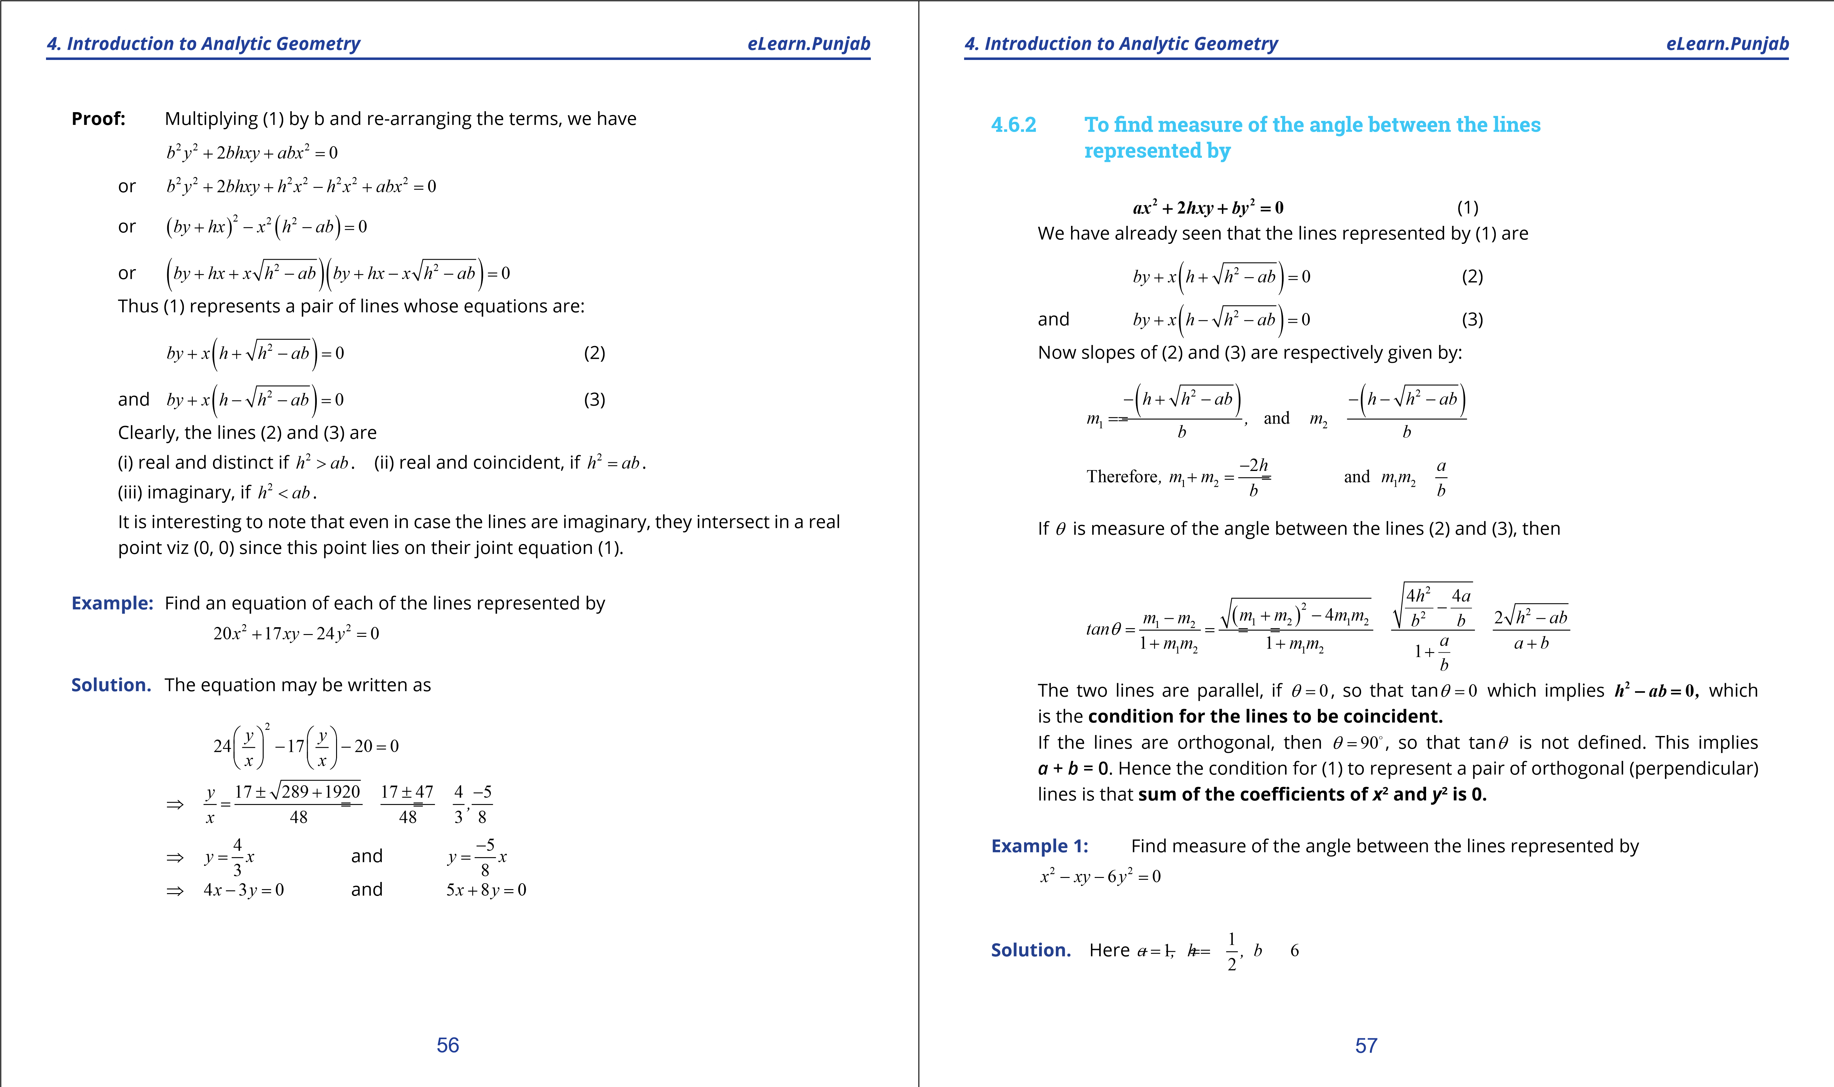

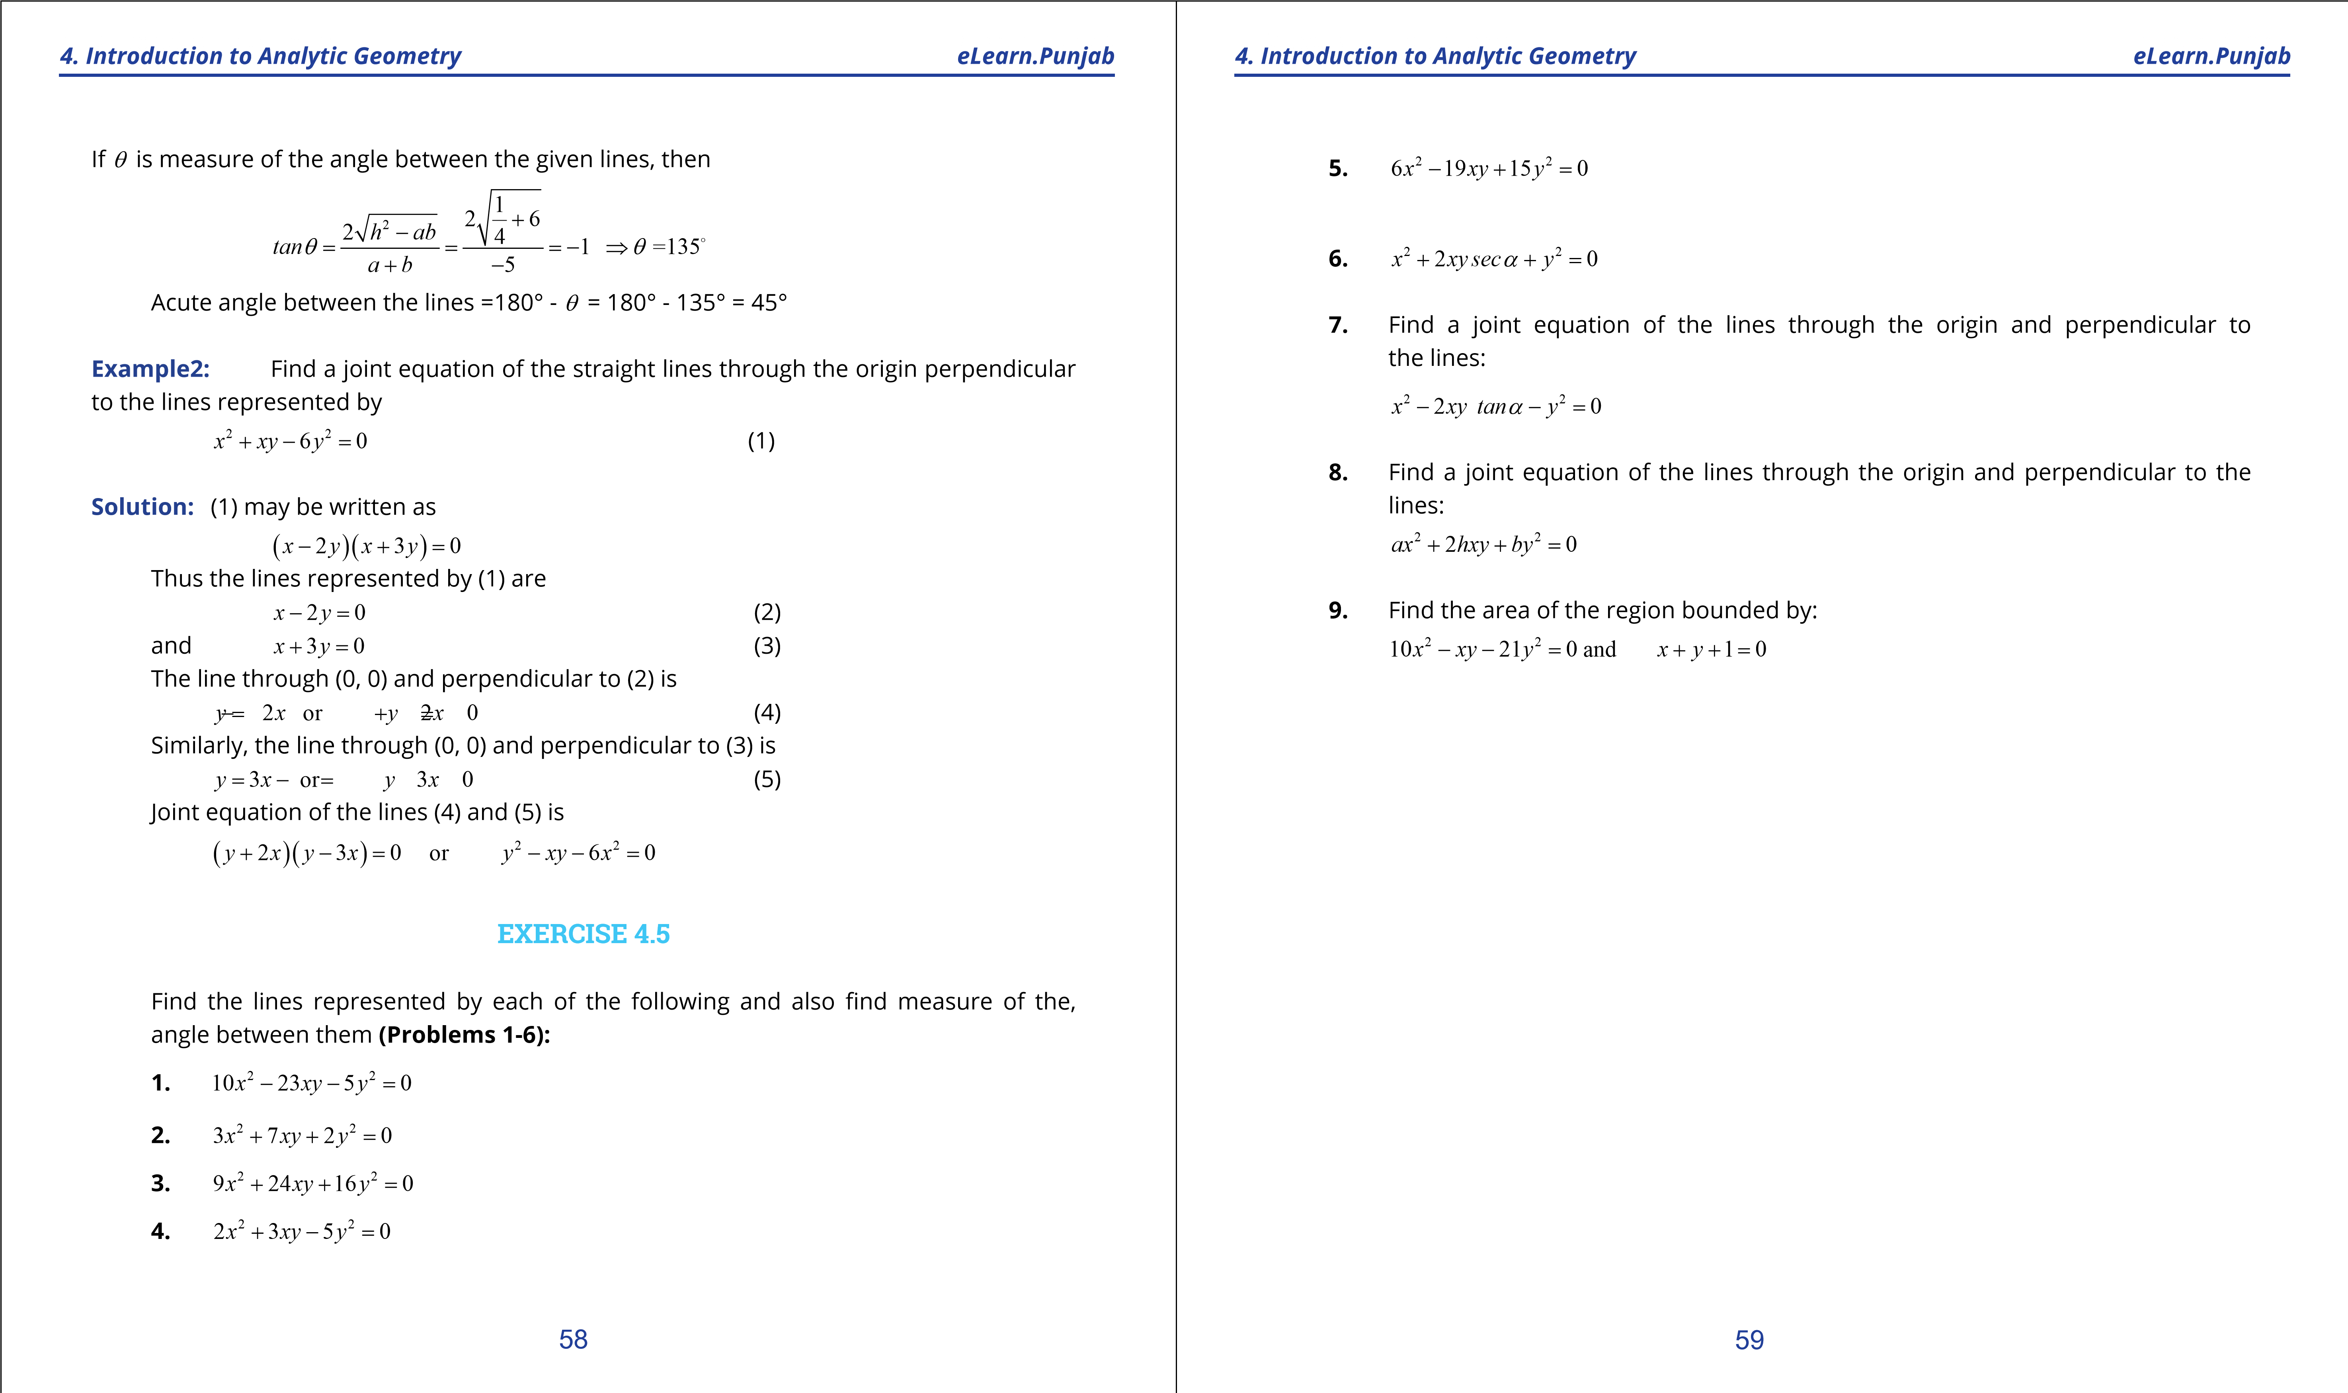

***version: 1.1***